**Forces and motion practise questions**

**1.0** The distance taken for a car to stop after an emergency depends on two things:

The thinking distance: how far the car travels while the driver processes the information.

The braking distance: how far the car travels after the driver presses the break.

**1.1** Each distance is affected by different factors.

Tick the boxes to show whether each factor affects the thinking distance, the braking distance or both.

[2 marks]

|  |  |  |  |
| --- | --- | --- | --- |
| **Factor** | **Thinking distance** | **Braking distance** | **Both** |
| Speed of car |  |  |  |
| Water on road |  |  |  |
| Driver’s tiredness |  |  |  |
| Driver’s alcohol consumption |  |  |  |
| Condition of car’s brakes |  |  |  |

**1.2 Figure 1** shows part of a displacement-time graph of a car journey.

**Figure 1**

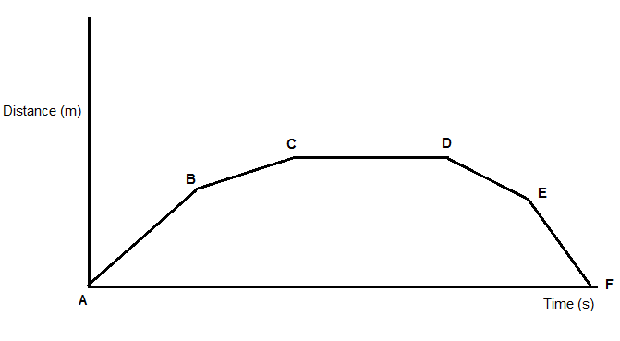

Time (s)

Displacement (m)

Complete the gaps with letters from the diagram.

[4 marks]

The car was moving forwards between ____ and ____.

The car was stationary between ____ and ____.

The car is moving slowest between ____ and ____.

The car was moving backwards between ____ and ____.

**1.3** What is the difference between speed and velocity?

Put ticks in the boxes.

[2 marks]

|  |  |  |
| --- | --- | --- |
|  | **Speed** | **Velocity** |
| Has size |  |  |
| Has direction |  |  |
| Scalar |  |  |
| Vector |  |  |

**1.4** On the axes below, draw a **velocity-time** graph for a car that:

● Moves at constant velocity

● Slows down

● Stops

[3 marks]

Velocity (m/s)

Time (s)

**2.0 Figure 2** shows a girl and a boy on a see saw.

**Figure 2**

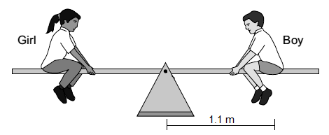

**2.1** The boy has a mass of 27 kg.

Calculate the boy’s weight.

The acceleration due to gravity is 9.8 m/s2.

Give your answer to 2 significant figures.

[2 marks]

Boy’s weight = ________ N

**2.2** The see-saw is balanced.

Calculate the girl’s moment about the pivot of the see-saw.

Give your answer in newton-metres.

[3 marks]

Moment = ________ Nm

**2.3** Use the idea of moments to explain what happens when another child sits behind the girl.

[3 marks]

_____________________________________________________________________

_____________________________________________________________________

_____________________________________________________________________

_____________________________________________________________________

_____________________________________________________________________

_____________________________________________________________________

**2.4** State one similarity and one difference between a see-saw and a lever.

[2 marks]

Similarity______________________________________________________

_____________________________________________________________________

Difference_____________________________________________________________

_____________________________________________________________________

**3.0** A student wants to measure the spring constant of a spring.

The equipment she uses is shown in **Figure 3.**

The scale measures distance in cm.

**Figure 3**

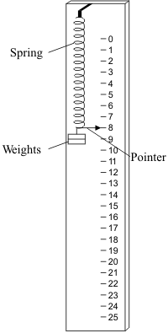

**3.1** Explain why the mark for 0 cm is slightly below the top of the spring in the **Figure 3**.

[1 mark]

_____________________________________________________________________

_____________________________________________________________________

**3.2** As the student carries out the experiment, her head moves slightly up and down when taking readings.

State the type of error this movement would have caused.

[1 mark]

_____________________________________________________________________

**3.3** How does the pointer make the measurement of length more **accurate**?

[1 mark]

_____________________________________________________________________

_____________________________________________________________________

**3.4** Explain how the student could use the equipment in **Figure 3** to measure the spring constant of the spring.

[4 marks]

_____________________________________________________________________

_____________________________________________________________________

_____________________________________________________________________

_____________________________________________________________________

_____________________________________________________________________

_____________________________________________________________________

_____________________________________________________________________

_____________________________________________________________________

**3.5** The spring constant of the spring was 15.6 N/m.

Calculate the extension of the spring if the energy stored in it was 1.95 J.

Give your answer to 2 significant figures.

[3 marks]

Extension = _________ cm

**4.0** A boy wanted to try scuba diving.

He found **Figure 4** on a website.

**Figure 4**

**4.1** Explain why the pressure increases with depth.

[2 marks]

_____________________________________________________________________

_____________________________________________________________________

**4.2** A typical scuba diving mask has an area of 0.015 m2.

The world record for scuba diving is 332 m.

Calculate the force on a scuba diving mask at this depth.

The acceleration due to gravity, *g*, is 9.8 m/s2 and the density of water is 1000 kg/m3.

Give your answer in standard form to 2 significant figures.

[4 marks]

Force = __________________ N

**5.0 Figure 5** shows a person using a device called a jetpack. Water is forced downwards from the jetpack and produces an upwards force on the person.

**Figure 5**

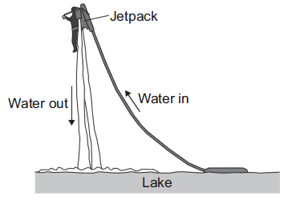

**5.1** Explain why the jetpack moves upwards when water is forced downwards.

Include reference to the relevant law of physics in your answer.

[3 marks]

_____________________________________________________________________

_____________________________________________________________________

_____________________________________________________________________

_____________________________________________________________________

**5.2** Read the following information.

|  |  |
| --- | --- |
| Combined mass of jetpack and person | 84 kg |
| Force water ejected from jet pack | 1900 N |
| Starting velocity of person | 0.0 m/s |
| Acceleration due to gravity, *g* | 9.8 m/s2 |

Calculate the maximum speed the person reaches after moving 5 m upwards.

In your answer:

● Calculate the combined weight of the jetpack and person

● Calculate the resultant force on the jetpack

● Calculate the acceleration of the jetpack and person

● Use *v2 = u2 + 2as* to calculate the maximum velocity of the person.

Use two significant figures at each step in your calculation.

Show your working.

[6 marks]

_____________________________________________________________________

_____________________________________________________________________

_____________________________________________________________________

_____________________________________________________________________

_____________________________________________________________________

_____________________________________________________________________

_____________________________________________________________________

_____________________________________________________________________

_____________________________________________________________________

_____________________________________________________________________

Maximum velocity = ________ m/s

**MARK SCHEME**

|  |  |  |  |  |
| --- | --- | --- | --- | --- |
| **Qu No.** |  | **Extra Information** | | **Marks** |
| 1.1 |  | | Allow ticks in Thinking distance and Braking distance instead of both.  All five ticks correct: **2** marks  3 or 4 ticks correct: **1** mark | 2 |
| 1.2 | A and C  C and D  B and C  D and F | | Both points required for each mark. | 1  1  1  1 |
| 1.3 |  | | **1** mark for Speed  **1** mark for Velocity | 2 |
| 1.4 | Horizontal line above the x axis  Line drops to x axis  Line continues along x axis | Allow curved or straight line.  Do **not** allow vertical line | | 1  1  1 |

|  |  |  |  |
| --- | --- | --- | --- |
| **Qu No.** |  | **Extra Information** | **Marks** |
| 2.1 | W = mg = 27 x 9.8  = 260 (N) | If answer 264.6 (N) given, award one mark. | 1  1 |
| 2.2 | Recognition that girl’s moment = boy’s moment  Moment = 260 (N) x 1.1 (m)  = 286 (Nm) | May be implicit in calculation below.  Allow 264.6 (N) x 1.1 (m)  Allow 291(.06) (Nm) | 1  1  1 |
| 2.3 | The anticlockwise moment increases  Making it more than the clockwise moment  So the children on the left / the girl moves downwards  Or  The boy moves upwards | Accept so moments are no longer balanced | 1  1  1 |

|  |  |  |  |
| --- | --- | --- | --- |
| 2.4 | Similarity  One from:   * Includes a pivot * Idea of rotation * Idea of clockwise on one side, anticlockwise on the other   Difference  Idea that lever is a force multiplier / seesaw should be balanced forces | Ignore size and for play / work | 1  1 |

|  |  |  |  |
| --- | --- | --- | --- |
| **Qu No.** |  | **Extra Information** | **Marks** |
| 3.1 | To allow for size of spring / to measure extension of the spring |  | 1 |
| 3.2 | Random error |  | 1 |
| 3.3 | Easier to read the scale / smaller parallax |  | 1 |
| 3.4 |  |  |  |
| **Level 2:** | A detailed and coherent description of how to measure the spring constant. Answer includes multiple measurements and uses the gradient of a graph. | | 3-4 |
| **Level 1:** | A simple description of how to measure the spring constant. Likely to only include one reading and make reference to F = kx. | | 1-2 |
|  | No relevant content | | 0 |
| **Indicative content** | | | |
|  | Change weight on spring  Measure extension for each weight  Reference to table of results  Plot graph of extension (y-axis) against weight (x-axis) (or vice versa)  Gradient is 1/spring constant (or gradient is spring constant if axes swapped)  Reference to F = kx / Hooke’s law | |  |
| 3.5 | = 0.5 m / 50 cm | Allow **2** marks for an answer of 0.25 m / 25cm (student has forgotten to square root)  Award **2** marks for 50 cm  Award **2** marks for correct answer to more than 2 significant figures. | 1  1  1 |

|  |  |  |  |
| --- | --- | --- | --- |
| **Qu No.** |  | **Extra Information** | **Marks** |
| 4.1 | Water molecules colliding with a surface create pressure  At increasing depth more molecules (above a surface) |  | 1  1 |
| 4.2 | Pressure at depth = h ρ g  = 332 × 1000 × 9.8  = 3253600  Force = pressure × area  = 3253600 x 0.015  = 48,804 N  = 4.9 × 104 N. | Allow ecf from first marking point. | 1  1  1  1 |

|  |  |  |  |
| --- | --- | --- | --- |
| **Qu No.** |  | **Extra Information** | **Marks** |
| 5.1 | Newton’s third law  Jetpack forces the water down  So water exerts an equal (magnitude) and opposite (direction) force on the jetpack (so it moves up) |  | 1  1  1 |
| 5.2 | Combined weight = 84 × 9.8 = 820 N  Resultant force = 1900 – 820 = 1100 N  Acceleration = F/m = 1100 / 84  = 13 m/s2  v2 = u2 + 2as = 0 + 2 x 13 x 5 = 130  v = 11 m/s |  | 1  1  1  1  1  1 |