**Module 4.3 Charge & current**

|  |  |  |  |  |
| --- | --- | --- | --- | --- |
| **Topic area** | **Text book pre-reading** | **Syllabus ref** | **Max possible score in exam questions** | **Your score in exam questions** |
| Kirchoff’s Laws | p168 | 4.3.1 | 8 |  |
| Resistors in series and parallel | p169 | 4.3.1 | 9 |  |
| Circuit analysis | p170 | 4.3.1 | 16 |  |
| Internal resistance | p163-166 | 4.3.2 | 13 |  |
| Potential dividers | p172 | 4.3.3 | 12 |  |
| Sensing circuits | p173 | 4.3.3 | 16 |  |
| **Total** | | | **75** |  |

|  |  |
| --- | --- |
| **By the end of this topic you should be able to…..** | **Check** |
| State Kirchhoff's first and second law and apply these to analysis of circuits |  |
| Calculate the total resistance of a circuit with resistors in series and parallel. |  |
| Analyse circuits with more than one source of e.m.f. |  |
| Describe what is meant by internal resistance in terms of terminal p.d. and "lost volts", describe how internal resistance of a cell can be obtained experimentally and calculate this in circuits |  |
| Describe how a potential divider works to change voltage split with components such as LDRs and thermistors. Use the potential divider equations in circuit analysis and describe how you could build a circuit for a specific function using the ideas of a potential divider. |  |

**Glossary of key terms**

Kirchoff’s first law

Kirchoff’s second law

Internal resistance

**Equations given in exam**

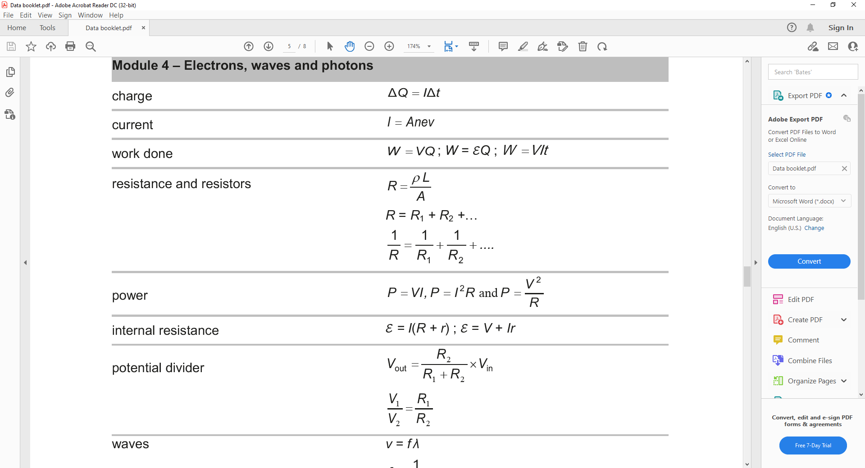

**Kirchoff’s laws**

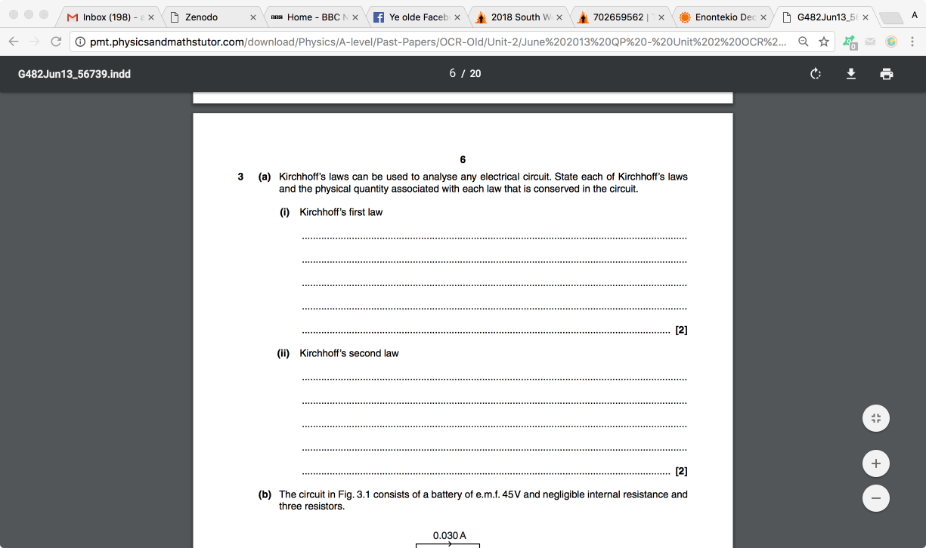



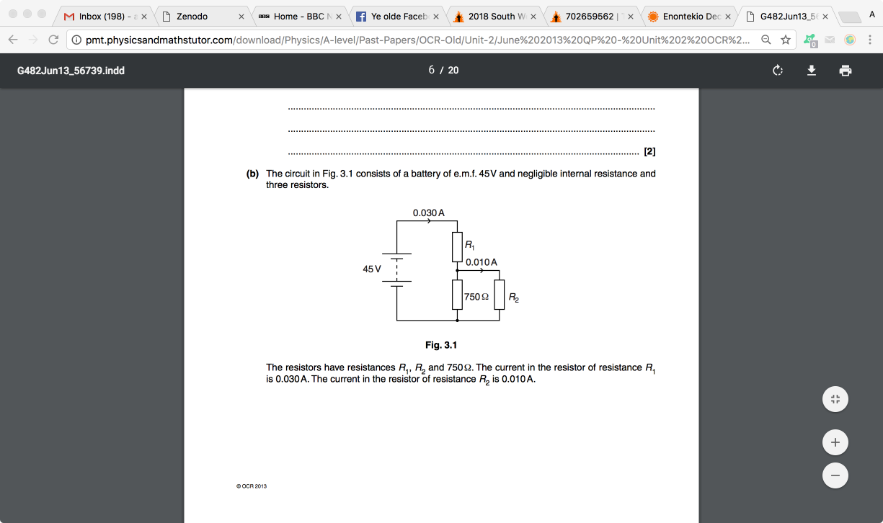

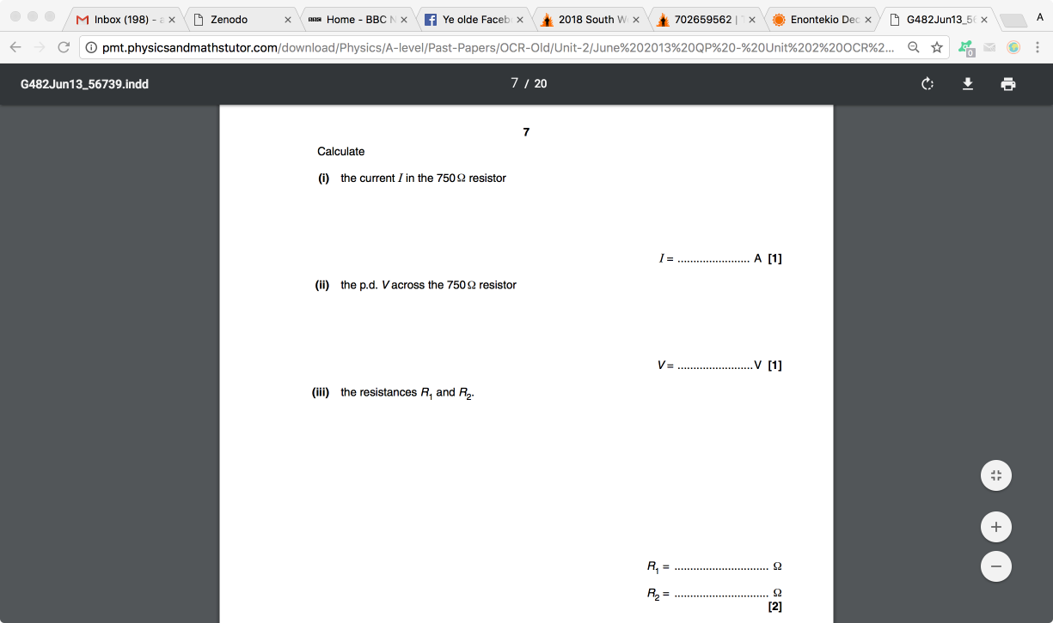



**Multiple resistors**

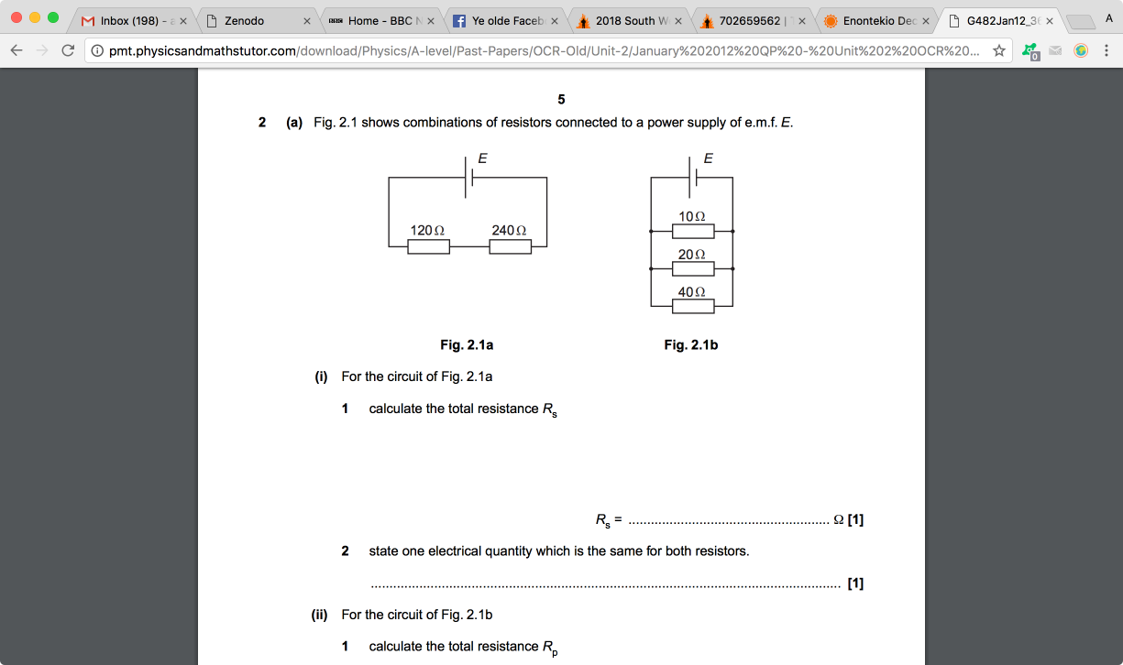



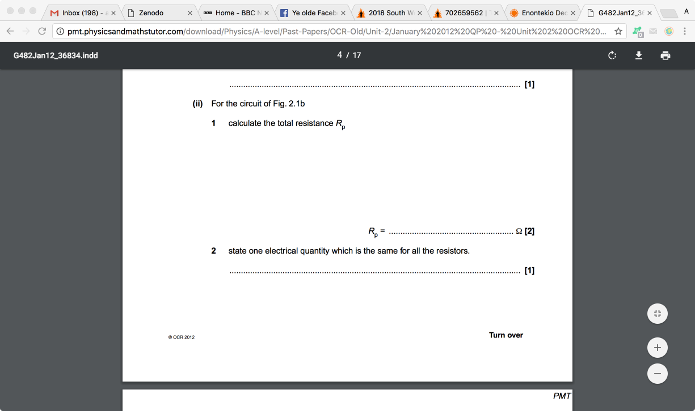

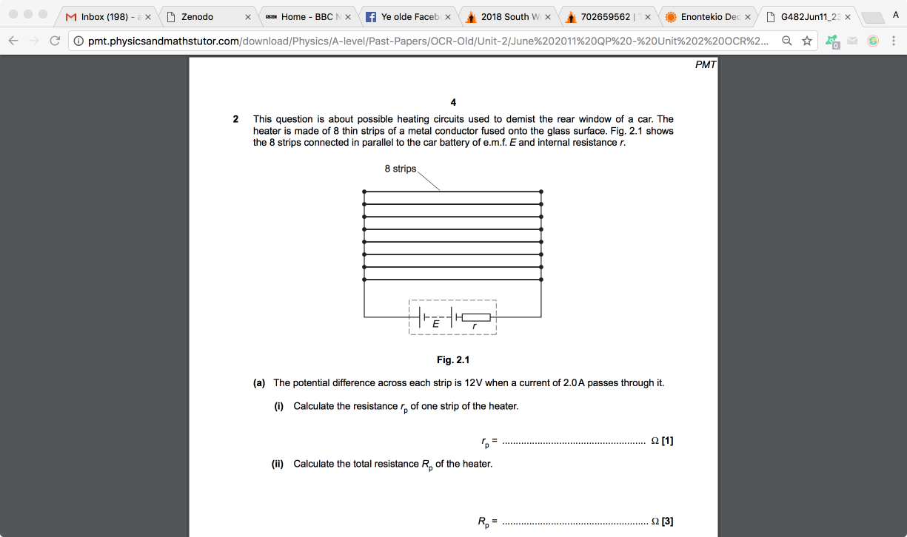**Circuit analysis**

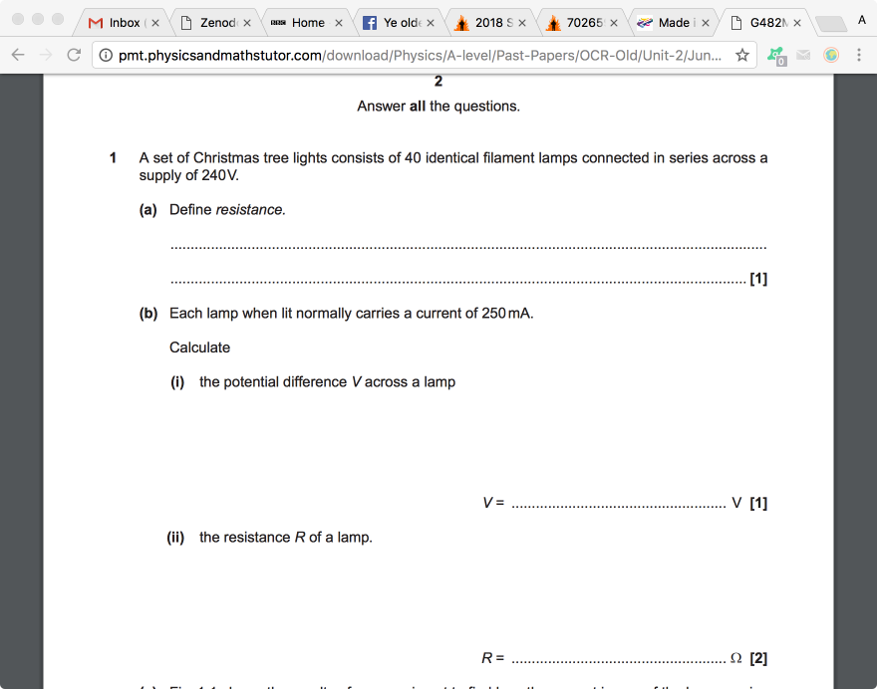



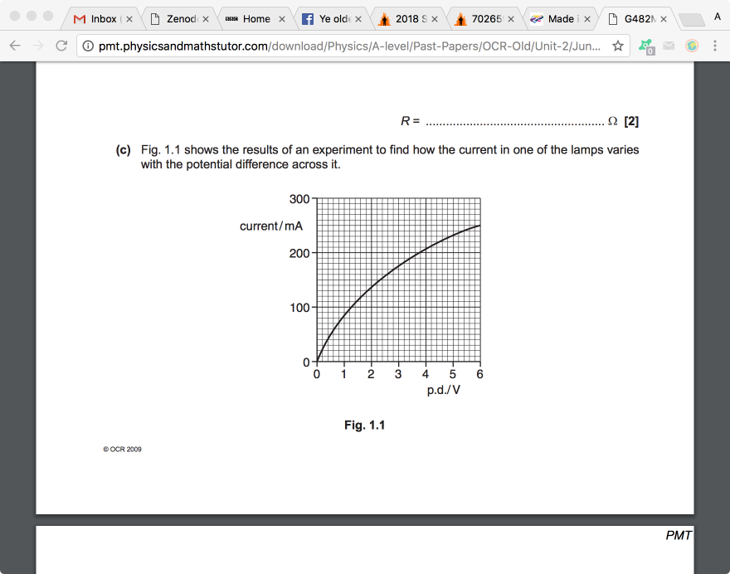

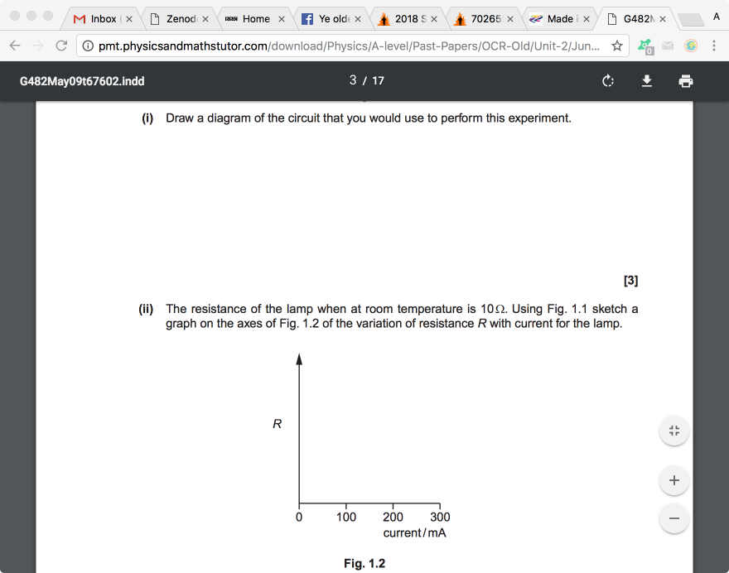



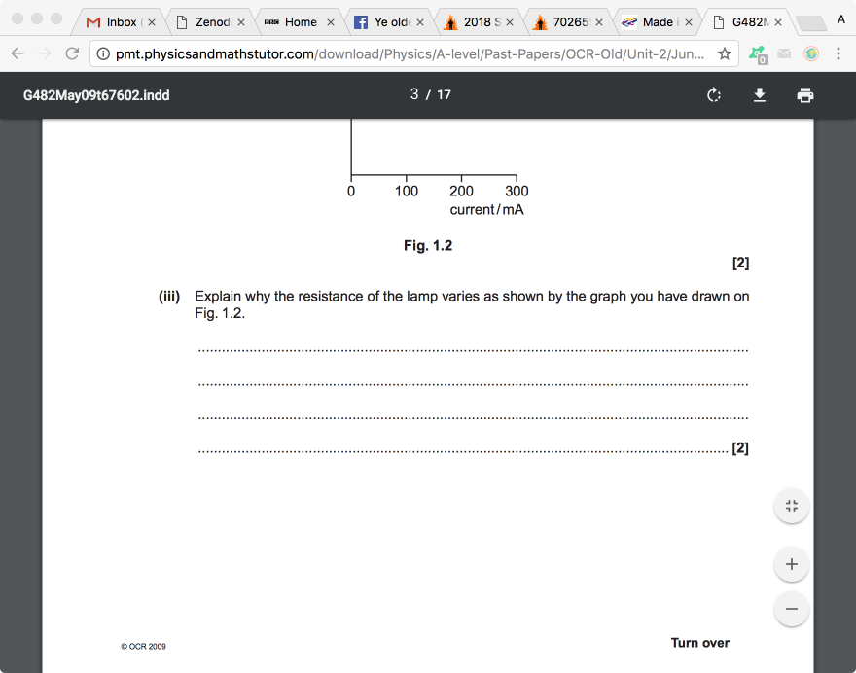

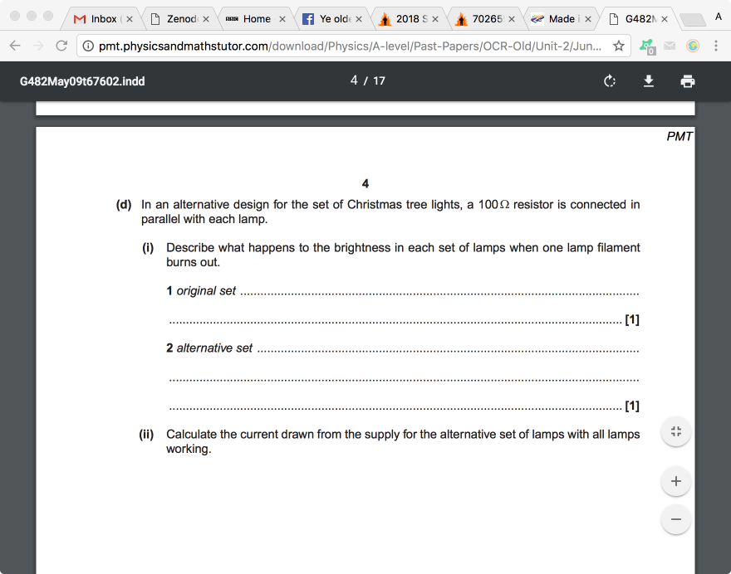

**Current = _______________ [3]**

**Internal resistance**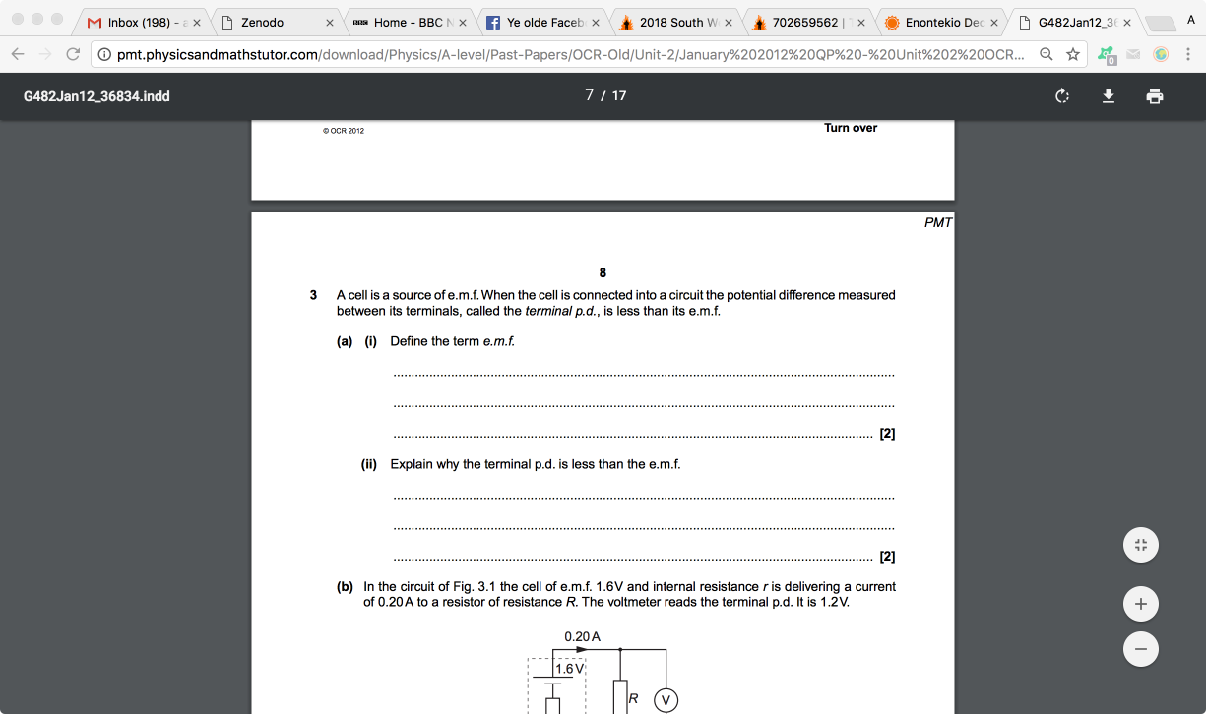

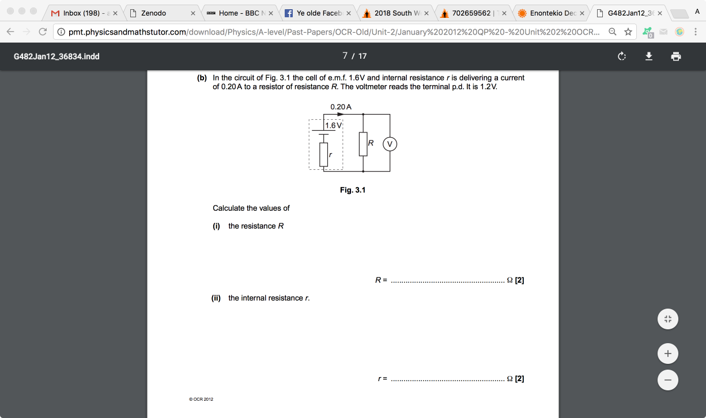

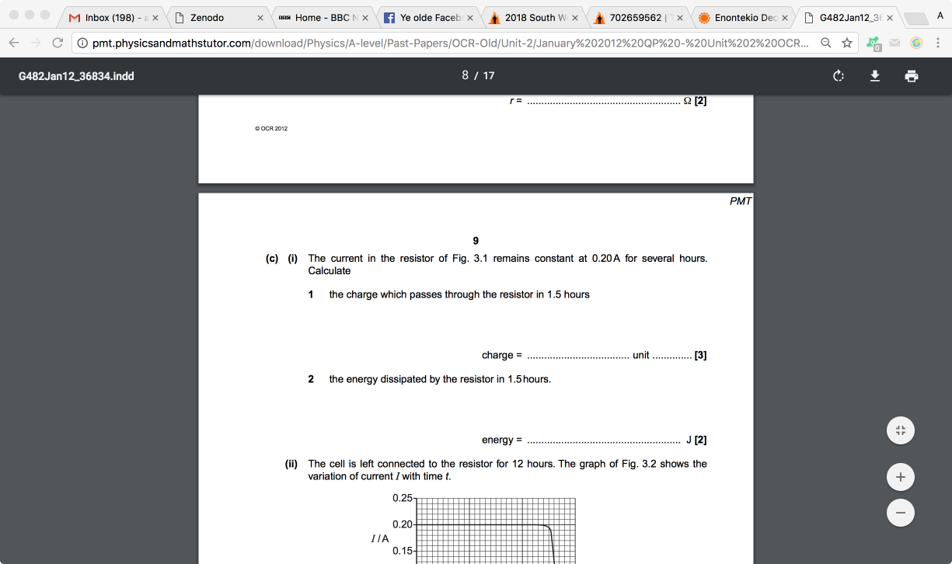

**Potential divider circuits**

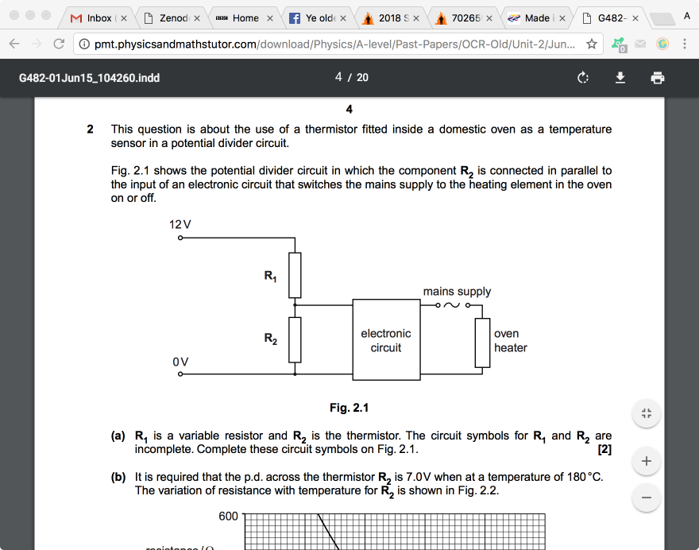

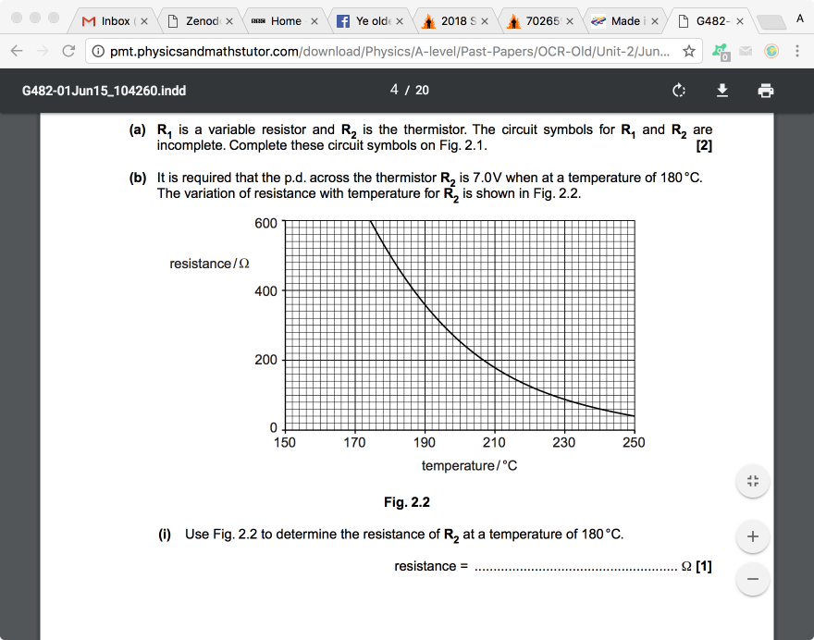

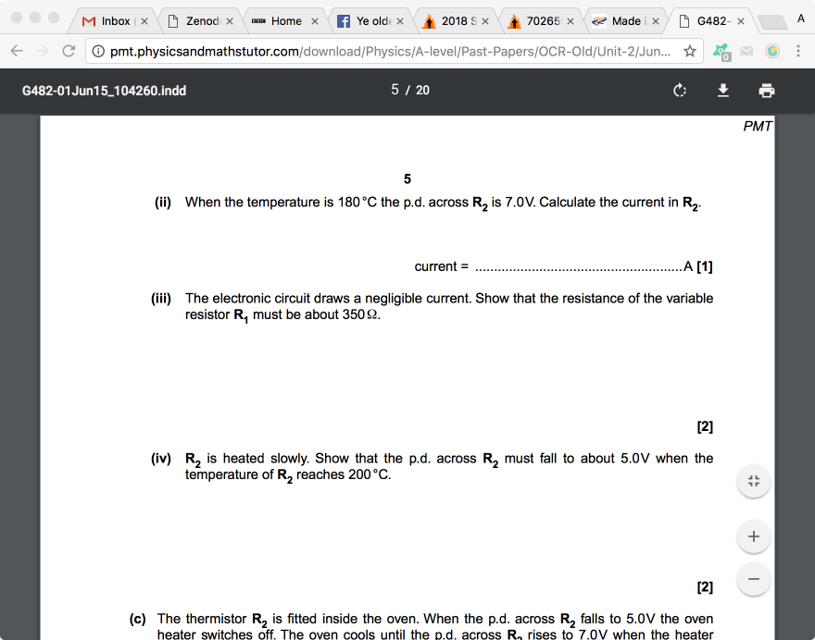

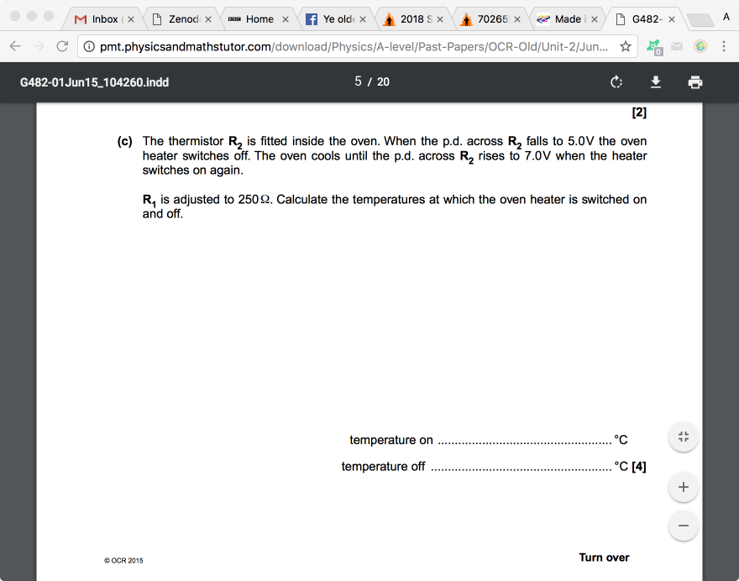

**Sensing circuits**

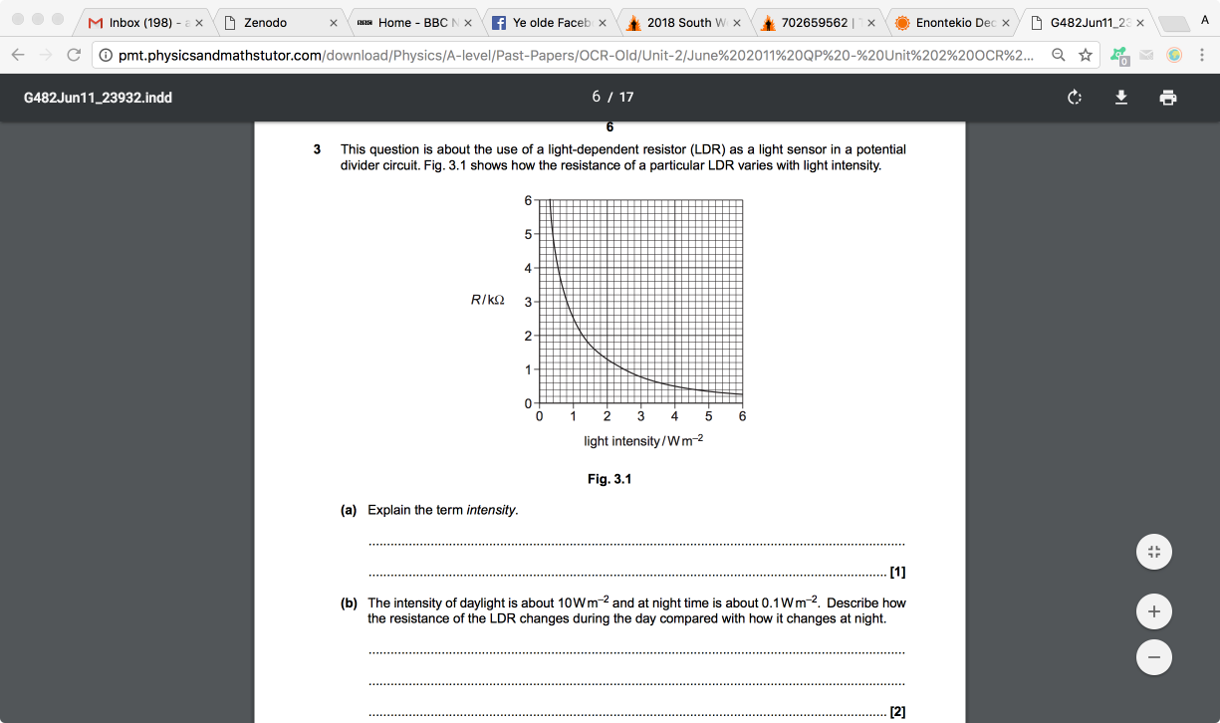

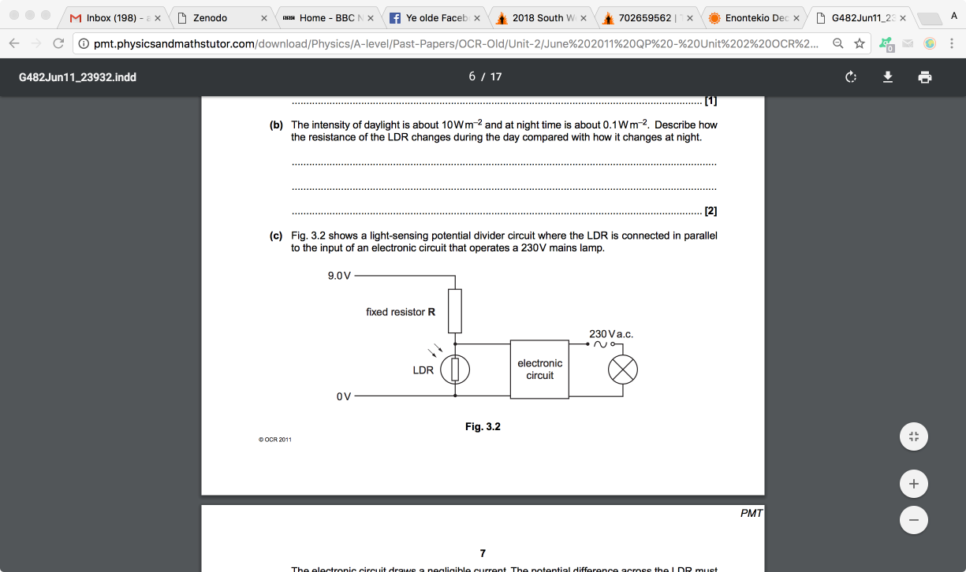

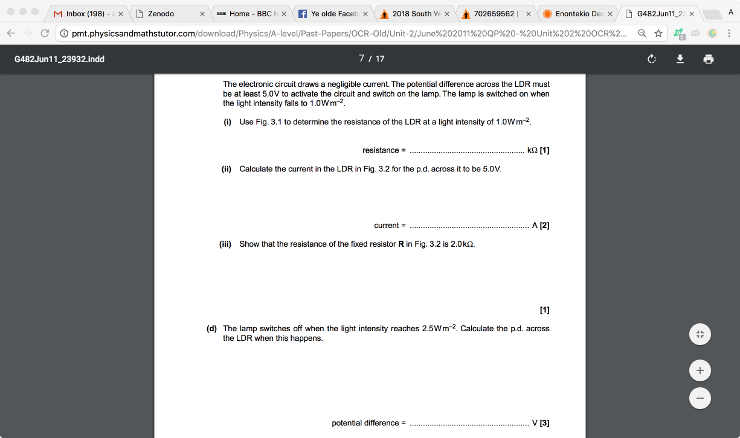

|  |  |  |  |  |  |
| --- | --- | --- | --- | --- | --- |
|  | |  |  | | --- | --- | |  |  | | **1.** | * Students are given a light dependent resistor (LDR) and asked to design a circuit for a light meter to monitor changes in light intensity. The meter reading must rise when the light intensity increases.  The incident light may cause the resistance of the LDR to vary between 1500 Ω and 250 Ω.  The students are asked to use the d.c. supply and one of the resistors from **(a)** above and either a voltmeter or ammeter.  Draw a suitable circuit.  Explain why the reading on the meter increases with increasing light intensity and which of the three fixed resistors gives the largest scale change on the meter for the change in light intensity.    ____________________________________________________________________________________________________  ____________________________________________________________________________________________________  ____________________________________________________________________________________________________  ____________________________________________________________________________________________________  ____________________________________________________________________________________________________  ____________________________________________________________________________________________________  ____________________________________________________________________________________________________  ____________________________________________________________________________________________________  ____________________________________________________________________________________________________  ____________________________________________________________________________________________________  ____________________________________________________________________________________________________  ____________________________________________________________________________________________________  _________________________________________________________________________________________________ **[6]** | |