  Energy resources practise questions and answers
  Name: | ________________________
  Class: | ________________________
  Date: | ________________________

Time: | 50 minutes
Marks: | 50 marks
Your score:

What went well:

How to improve:

Q1.
On a very windy hilltop there are two wind generators side by side.
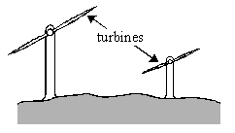
The bar charts show the lengths of the turbine blades and the electrical outputs of the two wind generators.
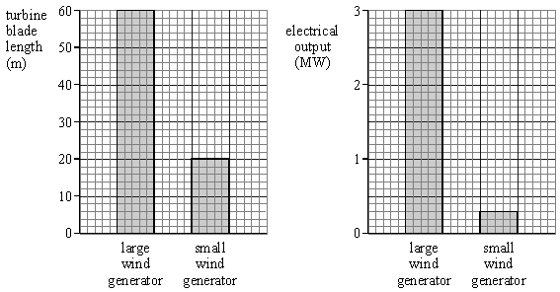
Complete the following table.

 | LENGTH OF TURBINE  BLADE (m) | ELECTRICAL OUTPUT  (MW)
Large wind generator | 60
Small wind generator
(Total 3 marks)
Q2.
(a) Water waves are a renewable energy source.
The government wants more electricity to be generated from renewable energy sources. Some people do not think this is a good idea.
What reasons could a government scientist give to show people that using more renewable energy sources is a good idea?
___________________________________________________________________
___________________________________________________________________
___________________________________________________________________
___________________________________________________________________
(2)
(b) The diagram shows a wave-powered generator. The generator transforms kinetic energy from the waves to electrical energy.
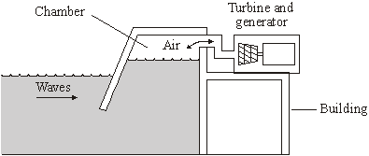
AQA GCSE SCIENCE CORE FOUNDATION STUDENT’S BOOK by Graham Hill,
Nigel Heslop, Christine Woodward,Steve Witney and Toby Houghton. Published by
Hodder and Stoughton 2006 © Reproduced by permission of John Murray (Publishers) Ltd
The following sentences describe how the wave generator works. The sentences are in the wrong order.
R Waves push air up and down a chamber inside the building.
S The turbine turns the generator.
T The generator transforms kinetic energy to electrical energy.
U The air rushes through a turbine making it spin.
V Strong waves move towards the wave-powered generator.
Arrange these sentences in the correct order. Start with letter V.

V
(3)
(Total 5 marks)

Q3.
The map below shows an industrial region (shaded).
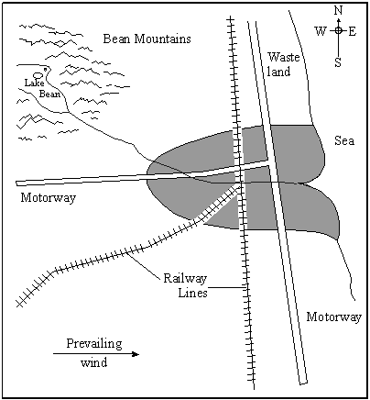
The prevailing wind is from the west. There is a nearby mountainous area, from which a river flows through the region. The major road and rail links are shown.
A power station is to be built to supply electrical energy to the region. The energy will be for a range of domestic and industrial uses.
The choice is between a coal fired power station, wind turbines and a hydroelectric scheme.
Three local groups each support a different option. Choose which option you would support and justify your choice by making reference to the financial, social and environmental implications of your choice compared with those of the alternative systems.
(Total 8 marks)

Q4.
State and explain the advantages and disadvantages of using nuclear power stations to produce electricity.
_______________________________________________________________________
_______________________________________________________________________
_______________________________________________________________________
_______________________________________________________________________________________________________________________________________
_______________________________________________________________________
_______________________________________________________________________
_______________________________________________________________________
(Total 4 marks)
Q5.
The map below shows the position of two towns, A and B, on the banks of a large river estuary.
A is an important fishing and ferry port. The wind usually blows from the west. The major roads and railways are shown.
A power station is to be built in area X to generate electricity for the region.
The choice is between a nuclear power station and a coal fired power station.
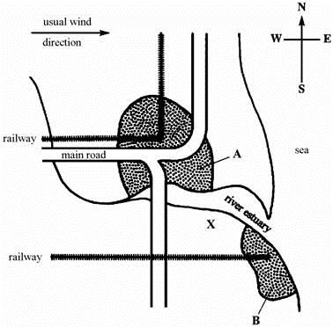

(a) State the advantages and disadvantages of the two methods of generating electrical energy.
___________________________________________________________________
___________________________________________________________________
___________________________________________________________________
___________________________________________________________________
___________________________________________________________________
___________________________________________________________________
___________________________________________________________________
___________________________________________________________________
___________________________________________________________________
___________________________________________________________________
___________________________________________________________________
___________________________________________________________________
(6)
(b) Which method would you choose for this site?
___________________________________________________________________
Explain the reason for your choice.
___________________________________________________________________
___________________________________________________________________
___________________________________________________________________
___________________________________________________________________
___________________________________________________________________
___________________________________________________________________
(3)
(Total 9 marks)

Q6.
The table shows the main sources of energy used in Britain in 1990.

coal | 35%
oil | 35%
gas | 24%
nuclear | 5%
moving water  (hydro) | 1%
(a) Finish the pie-chart, using the figures in the table.
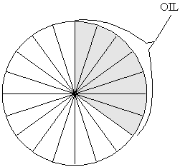
(4)
(b) Complete the following sentences.
To release energy from coal, gas and oil they must be burned.
Coal, gas and oil are all _______________________________
(1)
(c) Which one of the energy sources in the table is renewable? ___________________
Write down the name of one other renewable energy source. __________________
(2)
(d) How does the amount of energy obtained from nuclear sources in 1990 compare with the amount obtained from moving water?
___________________________________________________________________
___________________________________________________________________
(2)
(Total 9 marks)

Q7.
Use of renewable sources of energy is expected to increase. The table shows the comparative costs of producing 1 kWh of electricity from different energy sources.

Types of energy sources used in the UK | Cost of producing 1 kWh of electrical energy
Fossil fuels(non-renewable) | Coal 1.0 p  Gas 1.4 p  Oil 1.5 p
Nuclearfuels (non-renewable) | Nuclear 0.9 p
Renewable | Hydroelectric 0.2 p  Wind 0.9 p
Installation and decommissioning costs are notincluded
At present about 2% of electricity generated in the UK uses renewable energy sources. Consider the three types of energy sources in the table and give one advantage and one disadvantage for each (other than installation and decommissioning costs).

Advantage | Disadvantage
Using fossil fuels  ___________________________________  ___________________________________  ___________________________________ | Using fossil fuels  ___________________________________  ___________________________________  ___________________________________
Using nuclear fuels  ___________________________________  ___________________________________  ___________________________________ | Using nuclear fuels  ___________________________________  ___________________________________  ___________________________________
Using renewable sources  ___________________________________  ___________________________________  ___________________________________ | Using renewable sources  ___________________________________  ___________________________________  ___________________________________
(Total 6 marks)

Q8.
Electricity may be produced from a number of different energy resources.
(i) Complete the table below.
The first one has been done for you.

Device | Energy resource | Useful energy transfer from resource
Coal-fired power station  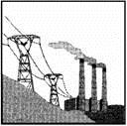 | Coal | Chemical electrical
Hydroelectric power station  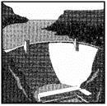 | Stored water | __________ electrical
Solar cell in calculator   | Sun | __________ electrical
Wind turbine  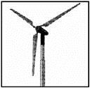 | Wind | __________ electrical

Gas-fired power station  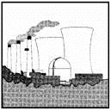 | Gas | __________ electrical
(4)
(ii) Give one of the five energy resources opposite, which is not classified as renewable.
___________________________________________________________________
(1)
(iii) State another non-renewable energy resource.
___________________________________________________________________
(1)
(Total 6 marks)
Mark schemes
Q1.
3
20 0.3
each for 1 mark
[3]
Q2.
(a) any two from:
• (burning) fossil fuels produces greenhouse gases / pollutant gases / acid rain / leads to global warming
accept a named fossil fuel
accept a named pollutant gas
• nuclear fuels produce dangerous waste
accept radioactive for dangerous
accept reference to dangers of nuclear fuels
• fossil fuels are non-renewable
accept running out of fuels
• renewable energy resources produce no pollutant gases
• large amounts of energy are available
accept renewable won’t run out
• running costs are low
accept any reasonable benefit of renewables
accept any reasonable drawback of non-renewables
do not accept better for the environment on its own
2
(b) R U S T
all in correct order
allow 2 marks for 2 correct
allow 1 mark for one correct
3
[5]
Q3.
To gain marks the candidate must
1. Select one option Advantages ) Max 4
2. State 8 valid advantages/disadvantages/relevant Disadvantages) Min 1
comparisons with either of the alternatives Comparisons )
If no A or D or C then Max 4
No option then Max 4
Look for As, Ds for chosen scheme.
Then for Cs compared with A/D for chosen scheme.
Below are listed some of the relevant mark scoring points.
Advantages Disadvantages
Wind Land available to North Initial cost
No pollution Many windmills/much land
Close/low transmission costs Calm day problem
No fuel costs Few long term jobs
Renewable energy resource
Coal Waste land to North Pollution
Prevailing wind to East Initial costs
Good road/rail transport Fuel costs
Close/low transmission costs Non-renewable energy
Save coal industry Resource
Overall labour intensive
Hydroelectric No pollution Possible drought
Mountains/lake/river nearby Distant/transmission costs
No fuel costs Few jobs created
Renewable energy source Possible expensive underground
transmission cable
Construction of dam affects environment
[8]
Q4.
Read all the answer first. See below.
Mark the first two advantages and disadvantages (√ or X) ignoring
neutral answers. Only allow a third advantage if there is only one
disadvantage given. Only allow a third disadvantage if only one advantage is given.
max. 3 advantages (e.g. cheap fuel, good availability, saving fossil fuels,
low running costs, reliable, more energy / kg, less fuel needed, no
greenhouse gases emitted, no SO₂ causing acid rain)
max. 3 disadvantages (e.g. danger to health of local community, non
renewable, high cost of decommissioning, long half life of waste
materials, need for safe storage of waste, high cost of commissioning,
danger involved in transporting fuel / waste)
max. 4 marks
[4]
Q5.
(a) must give one advantage and one disadvantage of each to get 4 marks
and 2 further scoring points
Advantages and disadvantages relevant to:
(1) health risk
(5) cost
(6) environmental factors
(7) transport/ storage
e.g. common coal / nuclear – high cost of building both
anti-nuclear examples
nuclear fuel transported on roads/rail in region
possible effects on public health in surrounding area
high cost of de-commissioning
long life very active waste materials produced
how waste materials stored safely for a long time
anti-coal examples
unsightly
pollution
supplies of fuel limited
acid rain
non-renewable
pro-nuclear examples
fuel cheap
no foreseeable fuel shortage
pro-coal examples
safe
reliable
large coal reserves
disposal of solid waste is easier
to max 6
6
(b) choice 0 marks
any three valid reasons each with explanation, which may or may not
be comparisons with other fuel
But
at least two of which must be relevant to this site
3
[9]
Q6.
(a) sectors nearer to correct value than to 1% either side
coal 35%
nuclear 5%
gas 24%
moving water 1%
each for 1 mark -
to a maximum of 3 marks
deduct 1 mark if sector left blank
three sectors labelled correctly w.r.t. rank order of size
for 1 mark
4
(b) (fossil) fuels (allow combustible/flammable/non renewable)
1
(c) moving water/hydro
wind/waves/tides/solar (allow geothermal/
wood/biomass)
each for 1 mark
2
(d) any indication that we get more (energy from nuclear sources)
gains 1 mark
but
5 times as much/more
gains 2 marks
2
[9]
Q7.
do not give any credit for renewable or non-renewable or installation or decommissioning costs
fossil fuel advantage
1
a reliable source of energy
fossil fuel disadvantage
pollution by carbon dioxide /
accept causes acid rain
accept highest costs / more expensive than nuclear / more expensive than renewable
1
nuclear advantage
do not produce gases that increase the
greenhouse effect or cause acid rain
accept nuclear is cheaper than fossil
1
nuclear disadvantage
accidents / waste can release very dangerous radioactive material radiation
accept it produces waste that stays dangerously radioactive for thousands of years or radioactive waste has to be stored safely for thousands of years
1
renewable advantage
there are no fuel costs
almost pollution free (apart from noise and visual)
accept cheaper than fossil
1
renewable disadvantage
not a reliable source of energy except for hydroelectric
accept (most) require large areas of land
accept visual / noise pollution
1
[6]
Q8.
(i) gravitational or potential
do not accept stored
1
light
credit solar
1
kinetic or movement
credit moving
1
chemical
1
(ii) any one from
gas
coal
1
(iii) any one from
oil
do not accept petrol or paraffin
peat or turf
nuclear
credit coal or gas if not given as answer to part (ii)
do not accept wood or fossil fuel or chemical
1
[6]

