**Electrical charge, current, power and resistance**

|  |  |  |  |  |
| --- | --- | --- | --- | --- |
| **Topic area** | **Text book pre-reading** | **Syllabus ref** | **Max possible score in exam questions** | **Your score in exam questions** |
| Key terms, equation and units |  |  | 10 |  |
| Charge and current | p 142-143 | 4.1.1 | 10 |  |
| Electron drift velocity | p 144-145 | 4.1.2 | 4 |  |
| Electromotive force | p 146-147 | 4.2.2 | 9 |  |
| Resistance and Ohm’s Law | p 148 | 4.2.3 | 6 |  |
| I-V characteristics of components | p 155-157 | 4.2.3 | 13 |  |
| Resistivity | p 148-150 | 4.2.4 | 6 |  |
| LDRs and Thermistors | p 152-154 | 4.2.3&4 | 6 |  |
| Energy and power | p 158-160 | 4.2.5 | 12 |  |
| Paying for electricity | p 161-162 | 4.2.5 | 3 |  |
| **Total** | | | **79** |  |

|  |  |
| --- | --- |
| **By the end of this topic you should be able to…..** | **Check** |
| Define what is meant by electrical current (including the difference between electron flow and conventional current) and use the equation linking current, charge and time |  |
| Describe what is meant by charge and how this is measured and conserved in circuits. |  |
| Describe the atomic structure of a metal and how this enables a flow of electric current |  |
| Understand what is meant by mean drift velocity and calculate this for a wire |  |
| Recognise and draw circuit symbols and construct accurate circuit diagrams using these |  |
| Describe the similarities and differences between potential difference (p.d.) and electromotive force (e.m.f.) as ways of measuring voltage |  |
| Use the equations linking work done or energy transferred, voltage and charge |  |
| Link the equation for kinetic energy to energy transferred in circuits for electrons and other charged particles |  |
| Define resistance and Ohm's law and calculate this from current and voltage |  |
| Draw graphs and describe the relationship between current and voltage for a resistor, filament lamp, diode and light emitting diode (LED) and explain how you would obtain these results experimentally. |  |
| Describe how resistance varies with a change in external factors for a light dependent resistor and a thermistor |  |
| Describe the factors that influence the resistance of a wire |  |
| Describe what is meant by resistivity of a material, how this can be found experimentally and use the equation to calculate this. |  |
| Calculate electrical power in circuits from voltage, current and resistance and energy transferred from voltage, current and time. |  |

**Glossary of key terms- Match the term to the definition (5)**

Electricity, Current, Electromotive force, Potential difference, Ohm’ Law, Resistance, Resistivity

|  |  |
| --- | --- |
|  | A flow of charged particles |
|  | Voltage divided by current |
|  | The product of a materials resistance and cross-sectional area per unit length |
|  | The rate of flow of charged particles |
|  | Voltage is directly proportional to current where resistance is constant |
|  | Electrical energy transferred per unit charge *to* a circuit from a power source e.g. Chemical energy |
|  | Electrical energy transferred per unit charge *from* a circuit to another form of energy e.g. light energy from a light bulb |

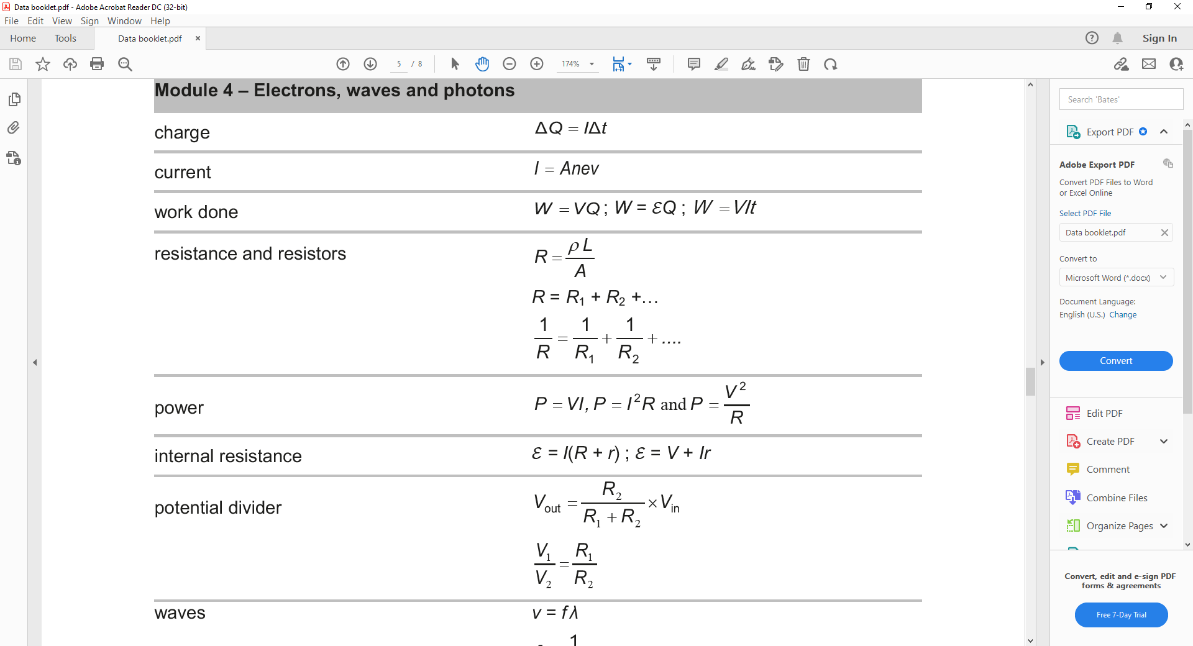**Equations given in exam- Complete the table with the definition of each variable symbol (5)**

|  |  |  |
| --- | --- | --- |
| **Variable symbol** | **Variable** | **Unit symbol** |
| **Q** |  |  |
| **I** |  |  |
| **t** |  |  |
| **A** |  |  |
| **n** |  |  |
| **e** |  |  |
| **v** |  |  |
| **W** |  |  |
| **V** |  |  |
| **R** |  |  |
| **ε** |  |  |
| **ρ** |  |  |
| **P** |  |  |

**Charge and Current**

1 (a) A lamp has a current of 3.5 A for a time of 45 minutes. How much charge has flowed through the lamp in this time ? (1)

(b) Calculate the current through a component if 2400 C of charge passes through it in 32 minutes. (1)

2 A wire forms part of a circuit. Calculate :

(a) The steady current through the wire if a charge of 400 μC passes a point in the wire in 8 ms. (1)

(b) The number of electrons which pass through the wire in 8 ms. (charge on an electron, e = 1.6 x10-19 C). (1)

3 A rechargeable battery can supply a current of 0.25 A for 5000 s, before its voltage drops and it needs to be recharged.

Calculate : (a) The total charge which the battery can deliver before it needs to be recharged. (1)

(b) The maximum amount of time it could be used for without being recharged, if the current through it

were : (i) 0.40 A, (ii) 0.10 A. (2)

4 (a) A charge of 4900 μC flows past each point in a wire in a time interval of 70 s. Calculate :

(i) The current in the wire (1)

(ii) The number of electrons per second passing each point in the wire (electron charge, e = 1.6 x 10-19 C). (1)

(b) A cathode-ray tube produces a beam of fast-moving electrons which strike a fluorescent screen. When the beam current is 250 μA, calculate the number of electrons which strike the screen in 2.5 s. (electron charge, e = 1.6 x 10-19 C). (1)

**Electron drift velocity**

**1** The length of a copper track on a printed circuit board has a cross-sectional area of **5.0 x 10-8 m 2.** The current in the track is **3.5 mA.** You are provided with the following useful information about copper.

- **1 m3 of copper has a mass of 8.9 x 10 3 kg.**

- **54 kg of copper contains 6.0 x 10 26 atoms.**

In copper there is roughly one electron liberated from each atom.

1. Show that the **electron number density (n)** for copper is about **1028 m-3.**
2. Calculate the **mean drift velocity** of the free electrons.

**Electromotive force**

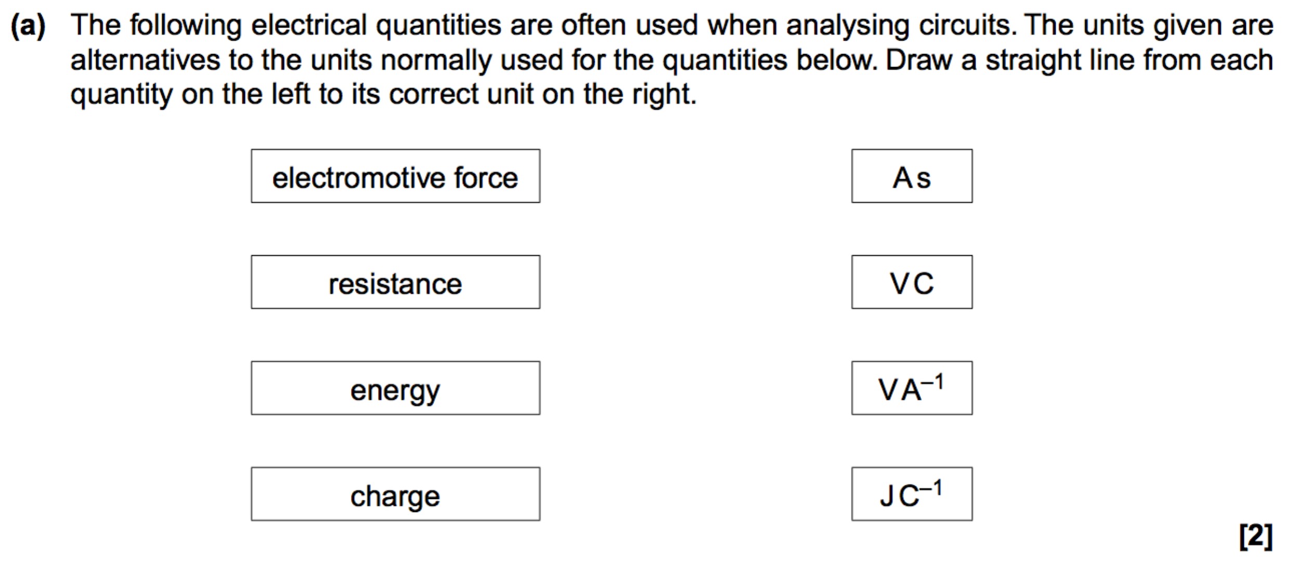

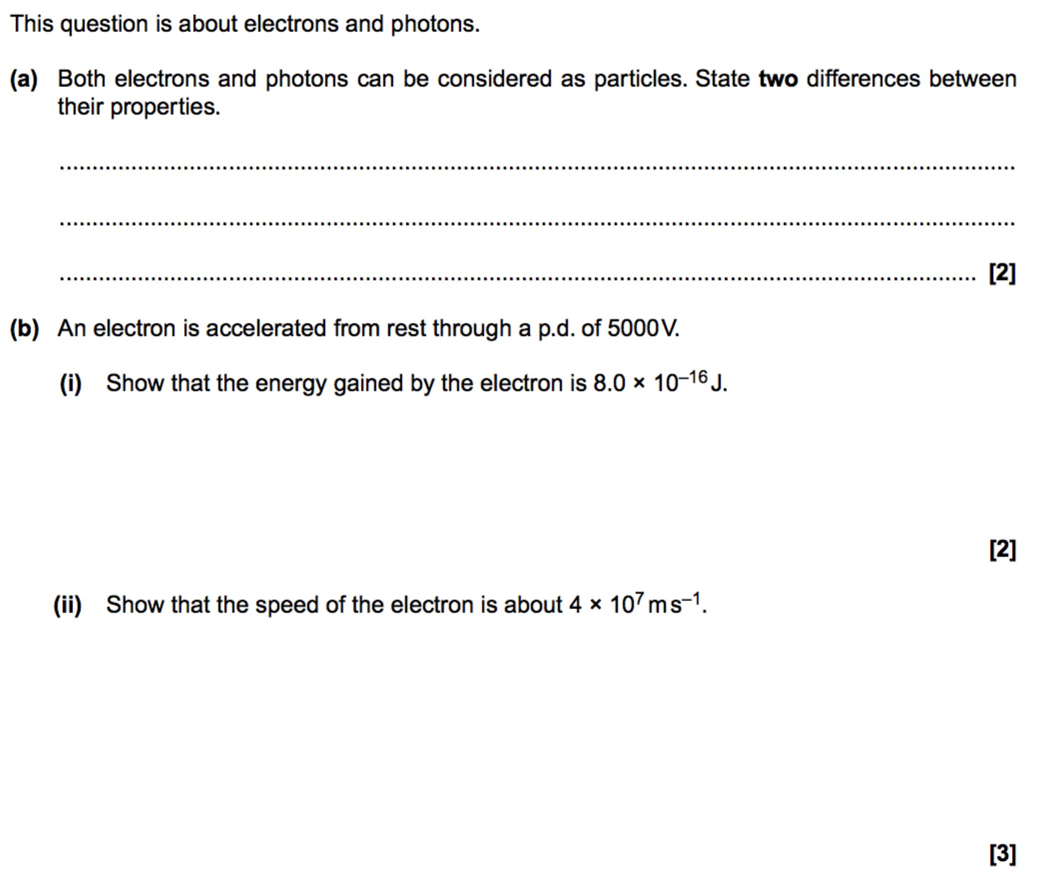

**Resistance and Ohm’s Law**

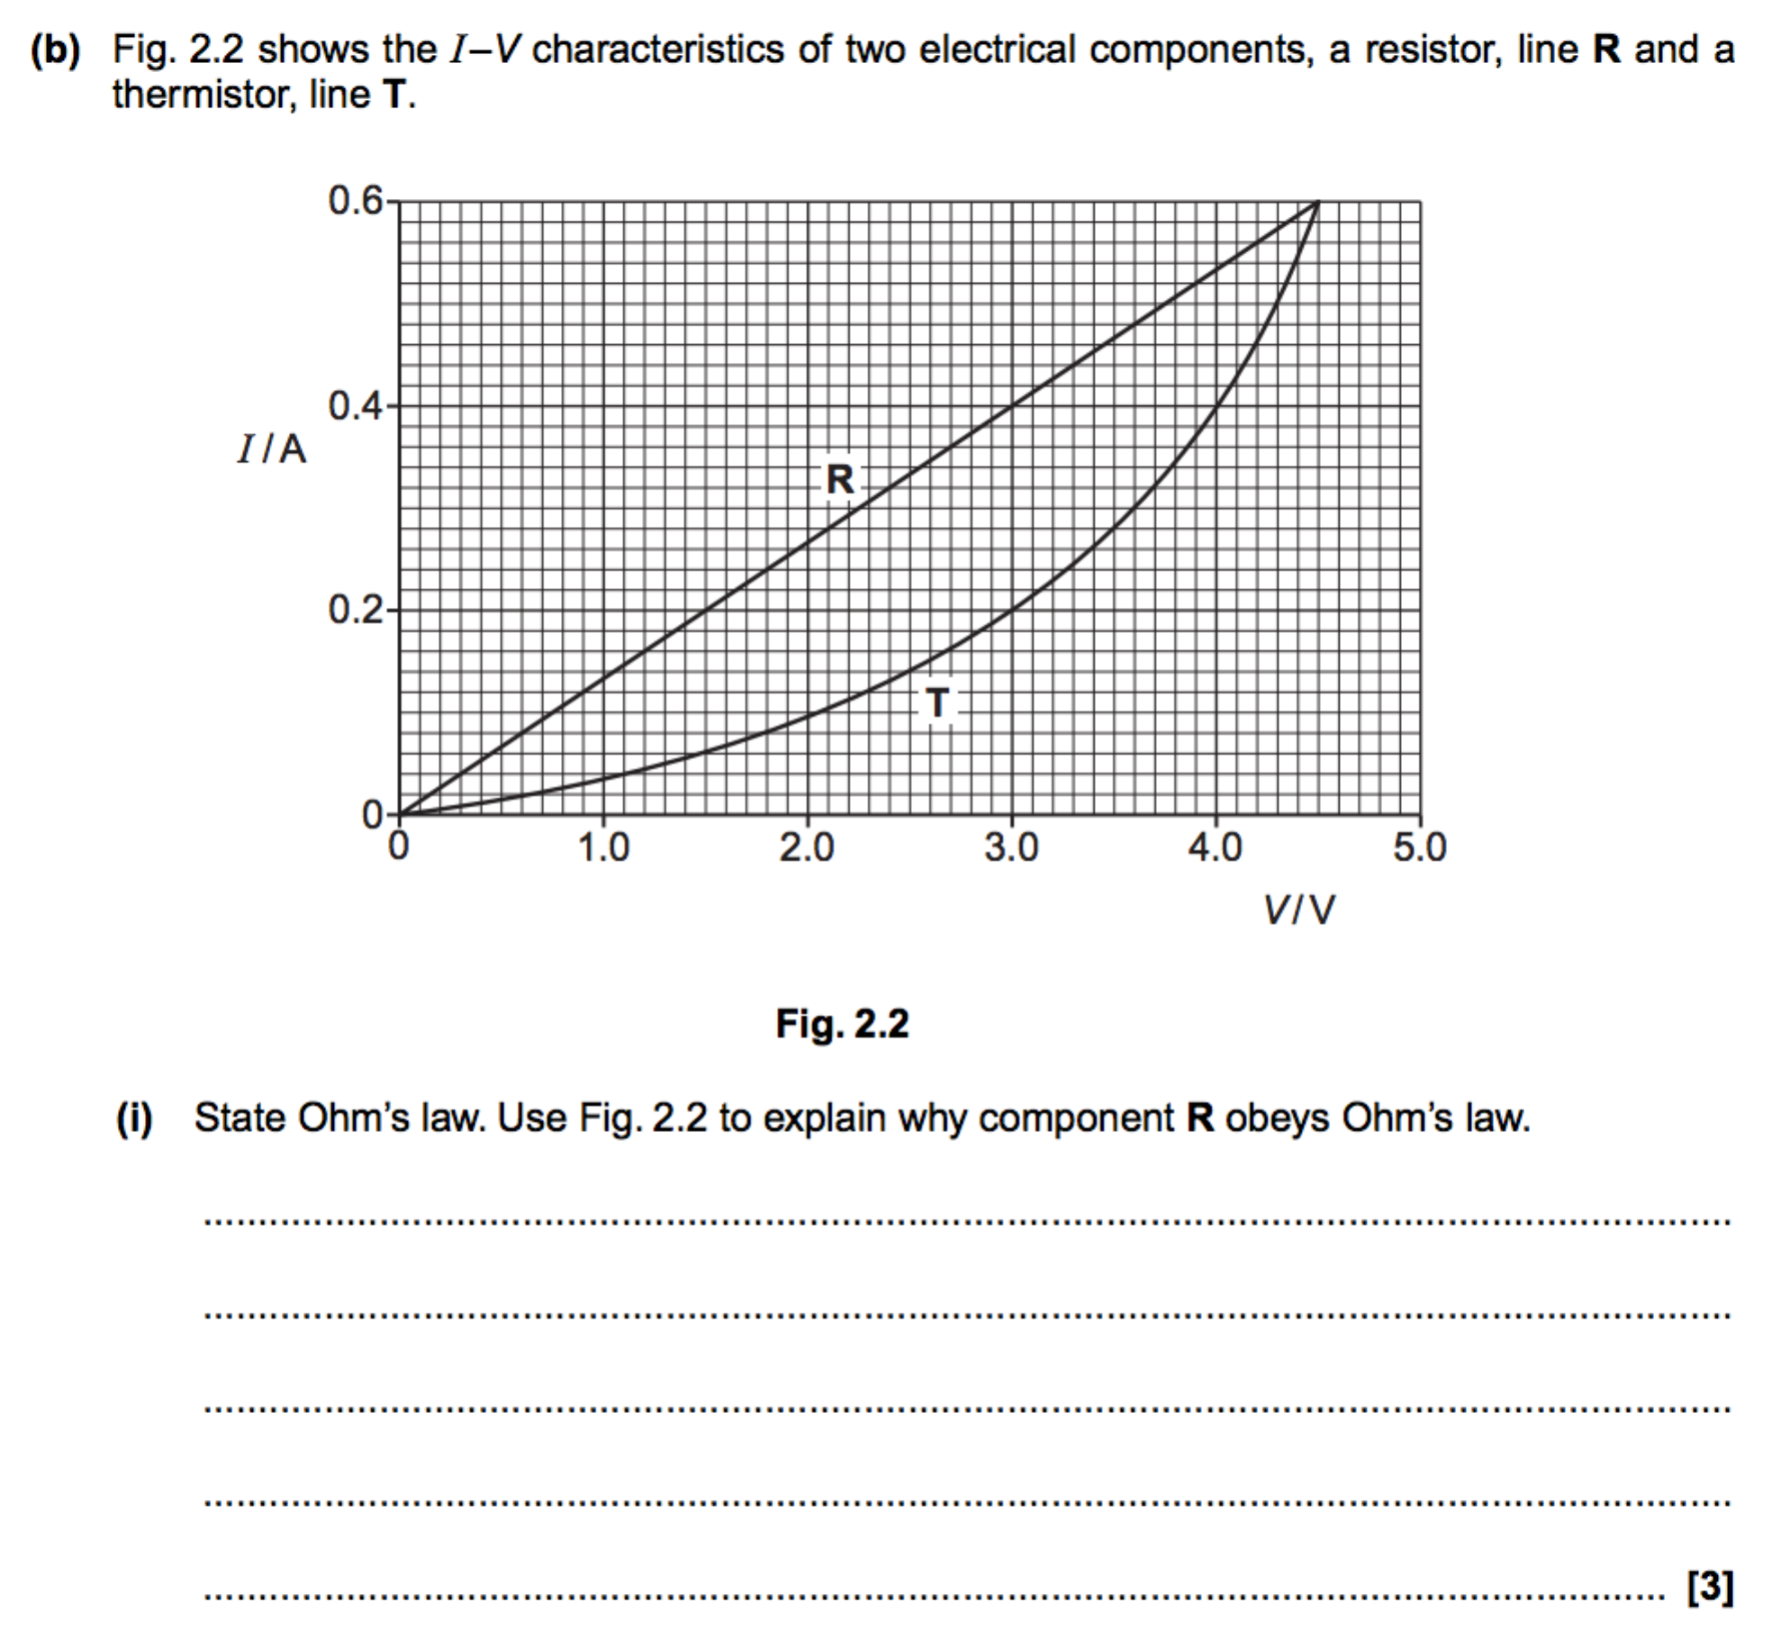

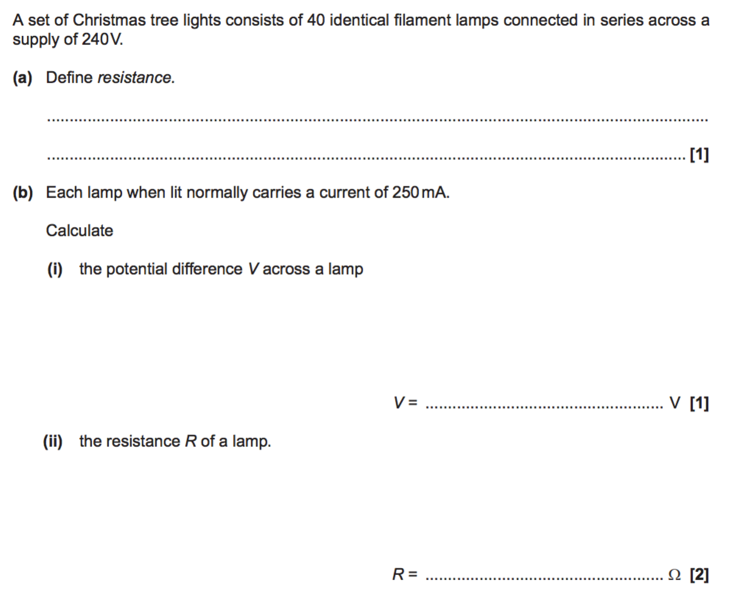



**I-V characteristics of circuit components**

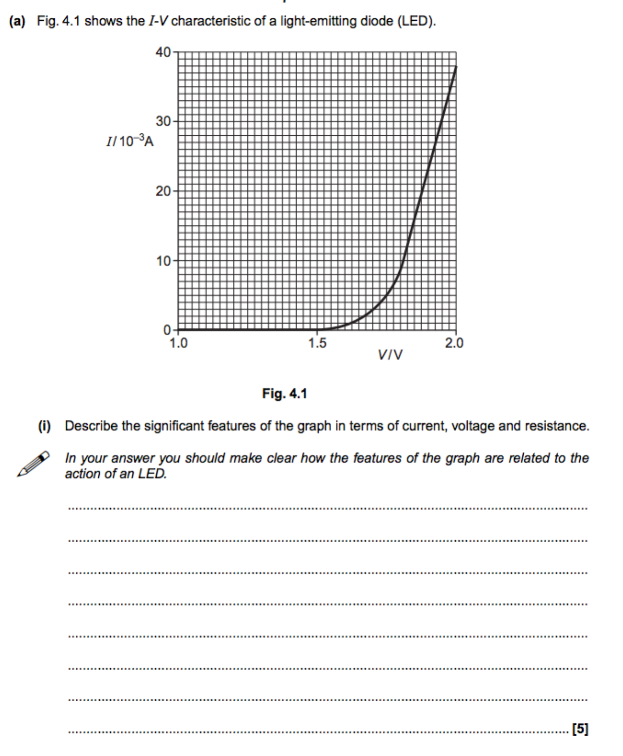



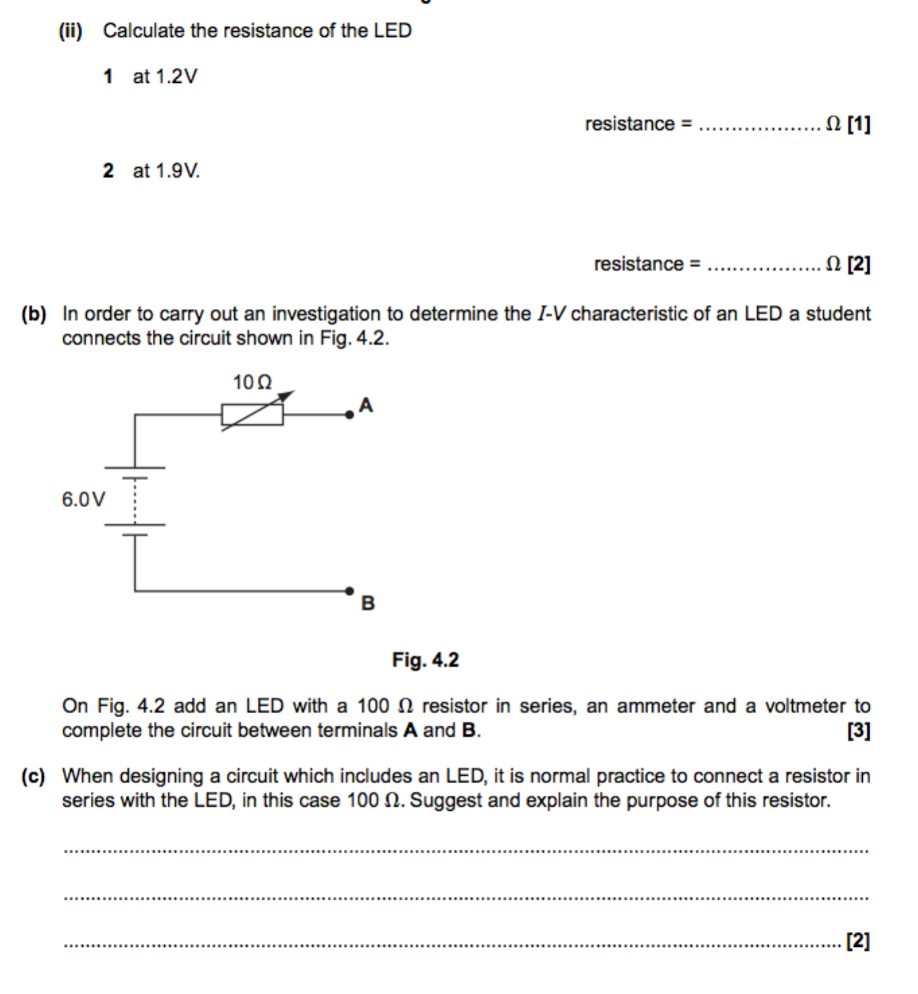

**Resistivity**

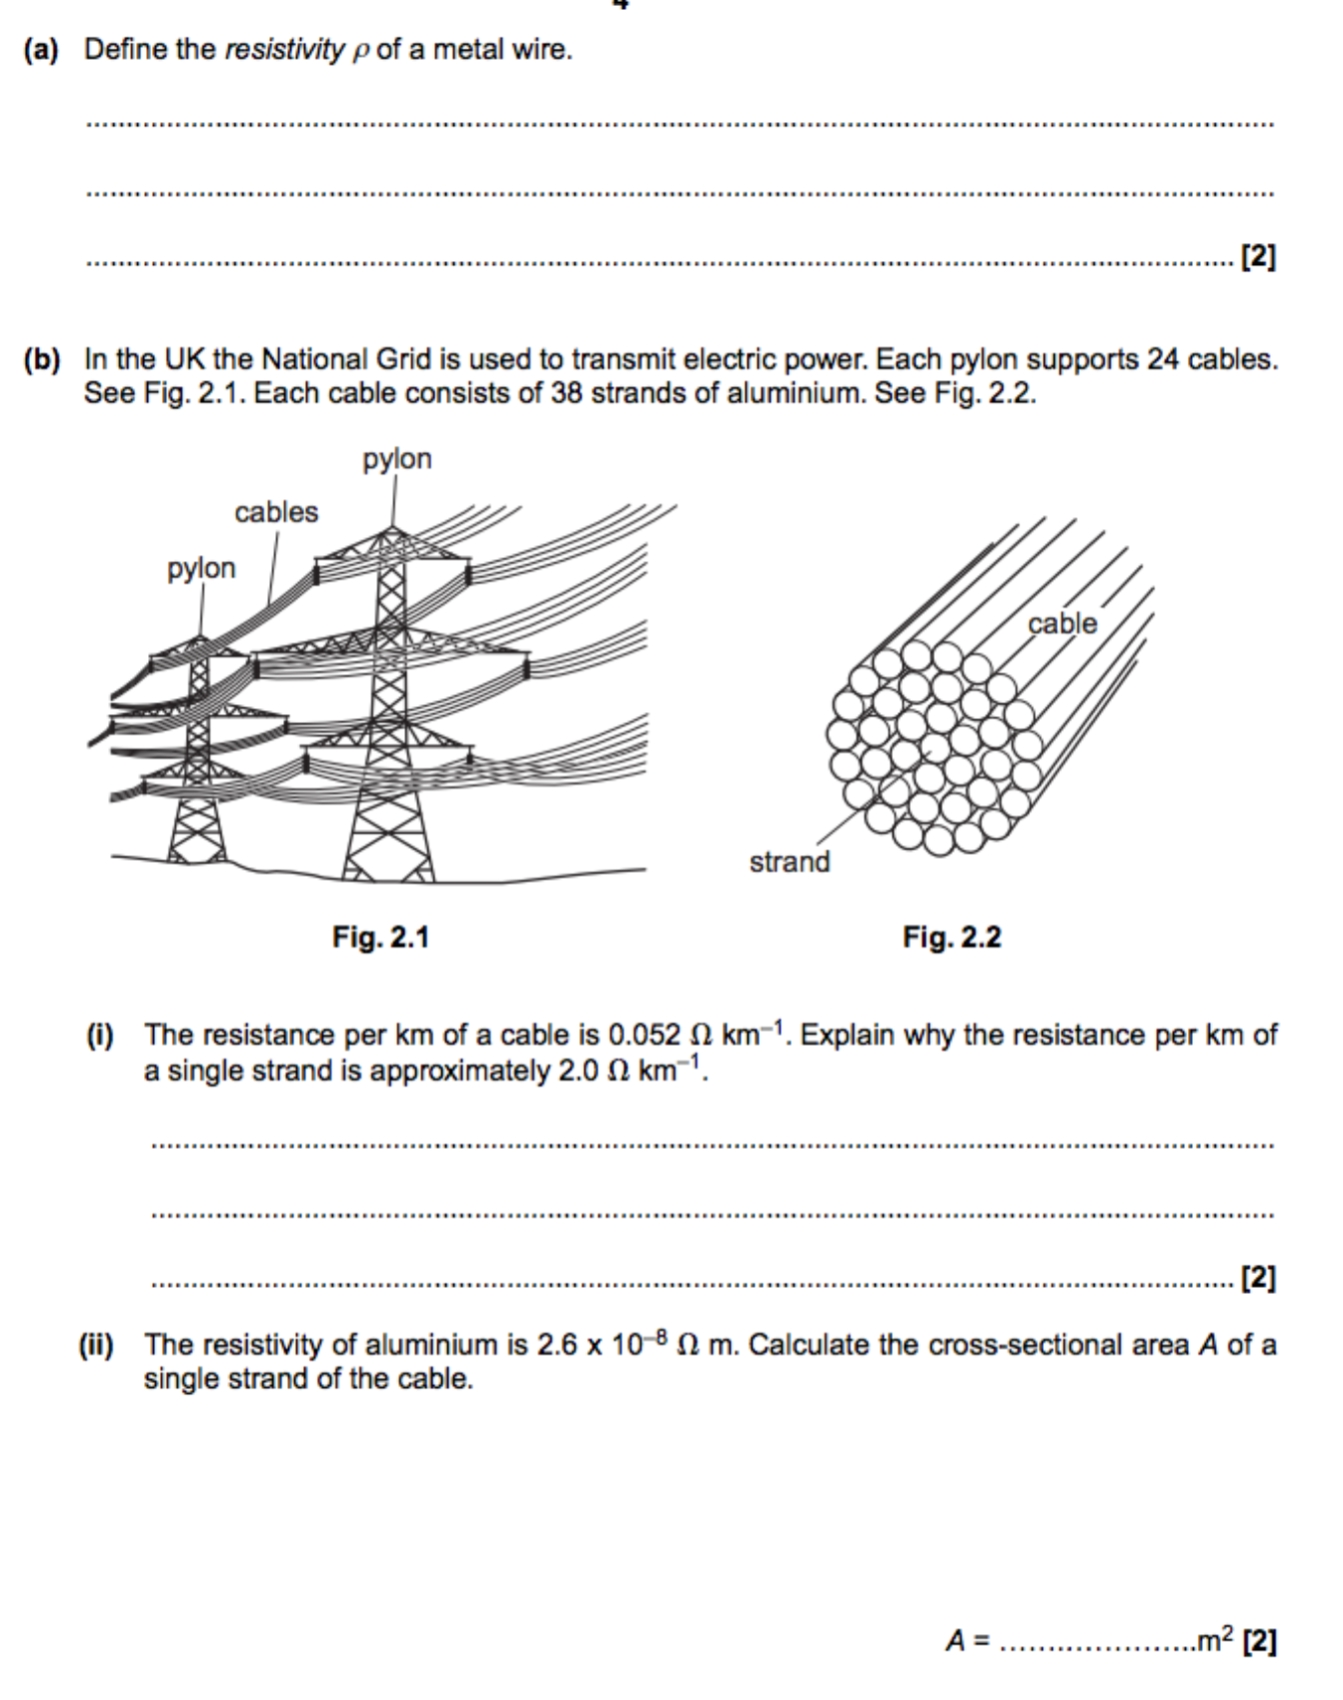



**Thermistors and LDRs**

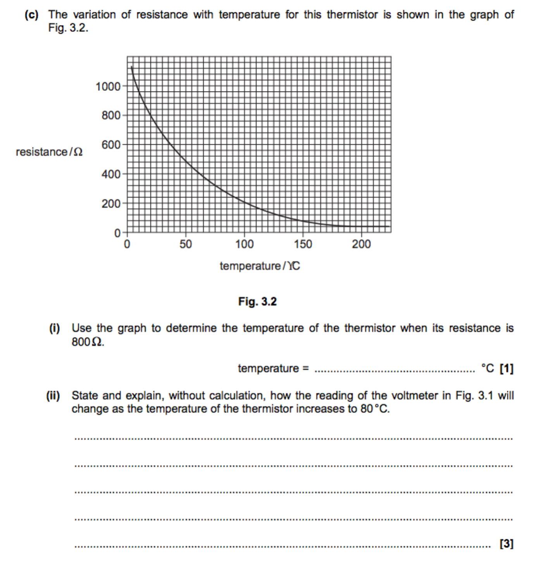

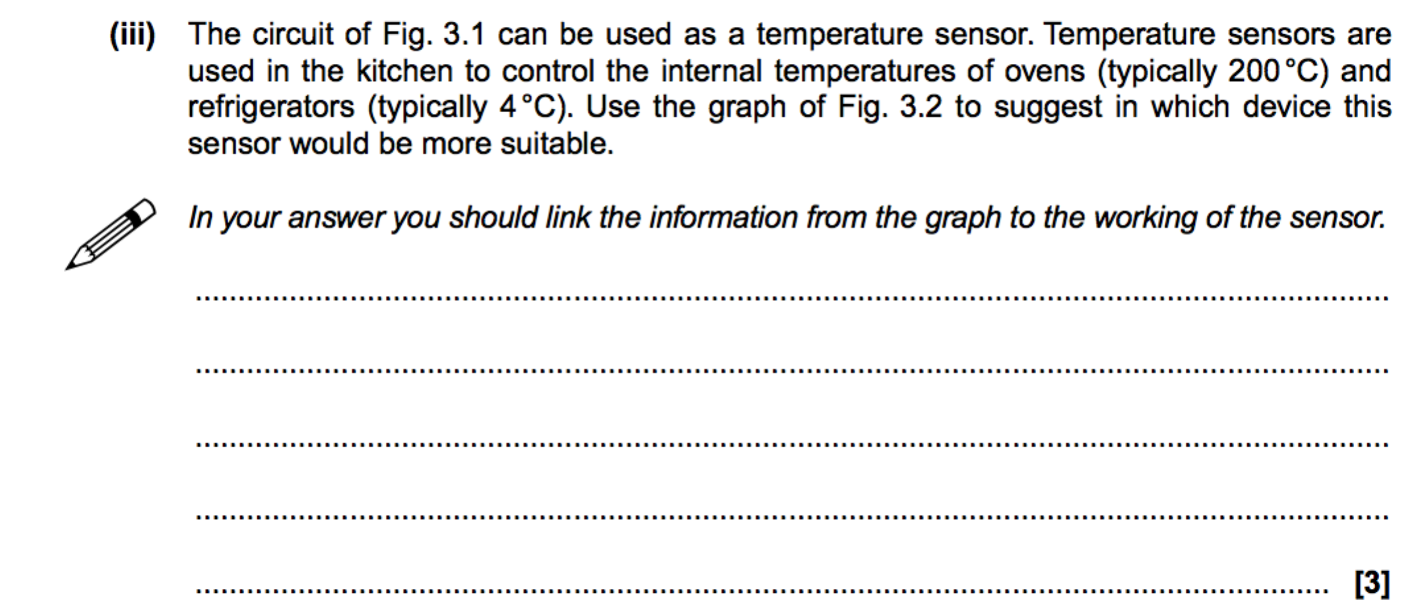

**Energy and power**

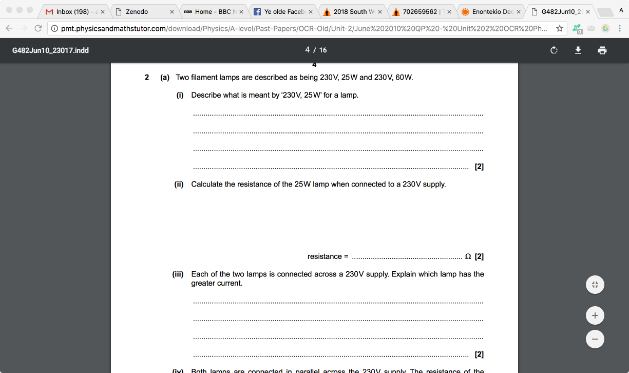

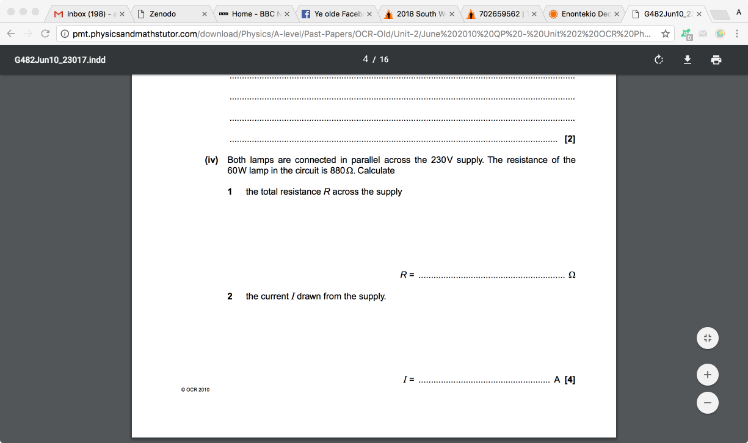

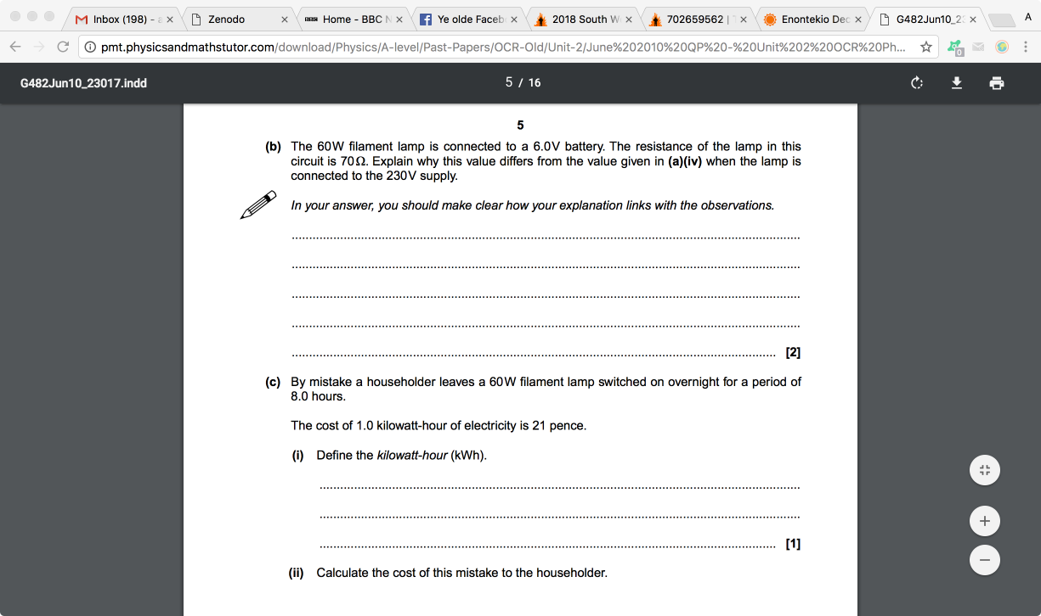

**Paying for electricity**

