Module 6.5 Medical Physics

|  |  |  |  |  |
| --- | --- | --- | --- | --- |
| **Topic area** | **Text book pre-reading** | **Syllabus ref** | **Max possible score in exam questions** | **Your score in exam questions** |
| X-ray generation |  | 6.5.1 | 13 |  |
| X-ray attenuation |  | 6.5.1 | 16 |  |
| Gamma camera |  | 6.5.2 | 7 |  |
| PET and CAT scans |  | 6.5.1 & 2 | 9 |  |
| Ultrasound |  | 6.5.3 | 4 |  |
| Acoustic impedance |  | 6.5.3 | 10 |  |
| The Doppler effect |  | 6.5.3 | 6 |  |
| **Total** | | | 65 |  |

**By the end of this topic you should be able to….**

* Describe the generation of X-rays using an X-ray tube
* Explain the four methods of x-ray attenuation and calculate the reduction in intensity of x-rays
* Describe how a CAT scan works and the advantages of this over an x-ray image
* Describe the use of radioactive tracers in medicine and the components and use of a gamma camera as part of this
* Describe how a PET scan works
* Describe the properties of ultrasound and how this is generated and detected using the piezoelectric effect
* Describe the similarities and differences between an ultrasound A and B scan
* Calculate acoustic impedance of a medium and use this to determine the ratio of reflected ultrasound at a boundary. Using this phenomena describe why a gel is used in an ultrasound for impedance matching
* Describe the Doppler effect in ultrasound to determine the speed of blood and calculate this.

**By the end of module 6.5 you need to be able to define the following key terms:**

Attenuation coefficient

Compton effect

Pair production

Scintillator

Collimator

Ultrasound

Piezoelectric effect

Acoustic impedance

Doppler effect

**Equations given in exam**

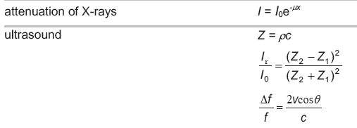

**X-ray generation**

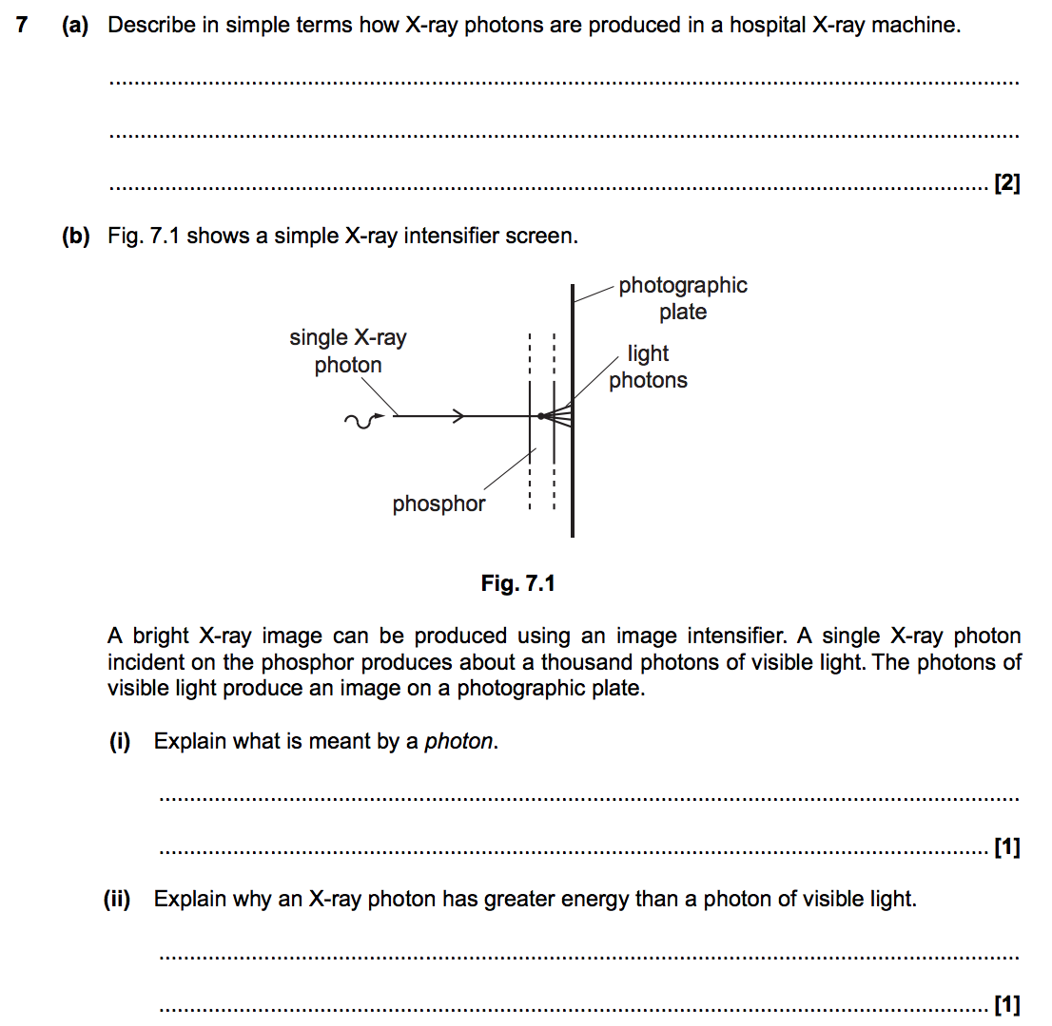

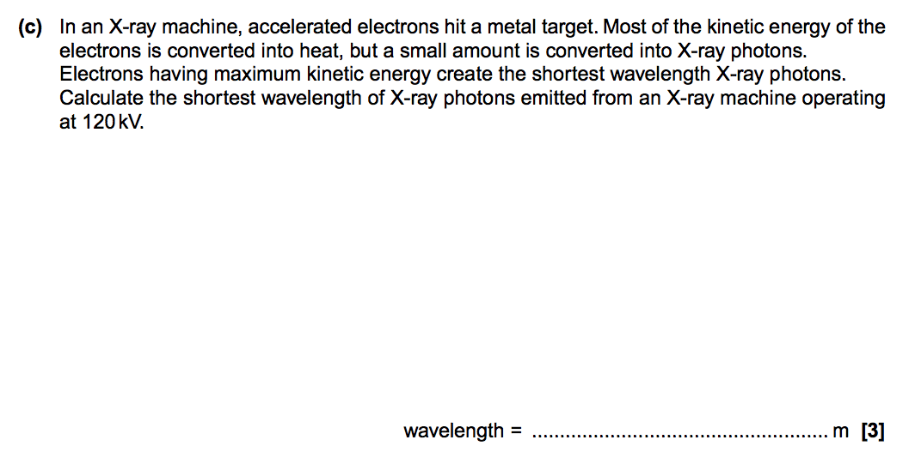

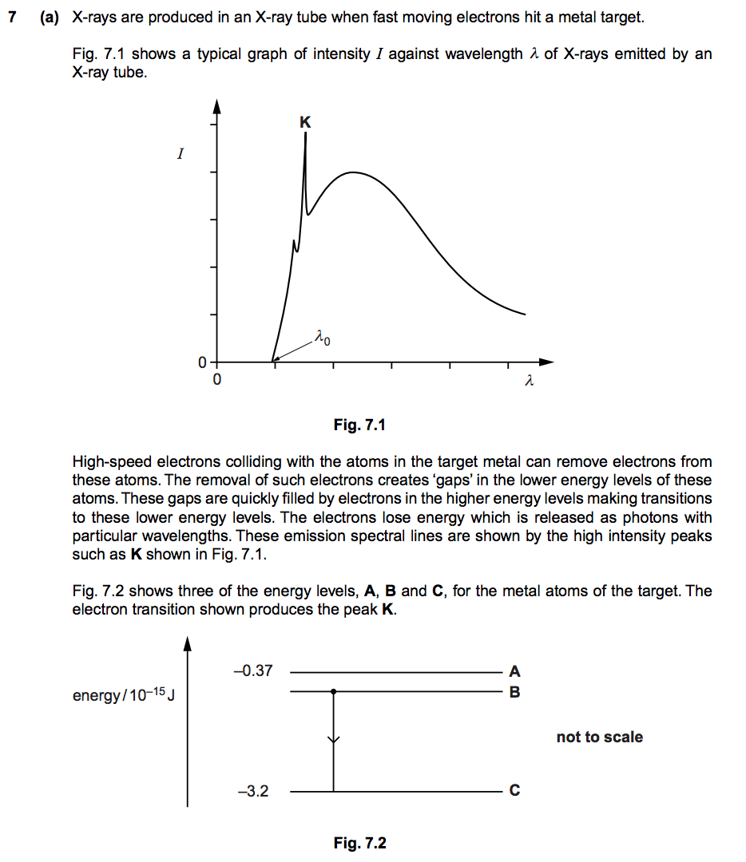

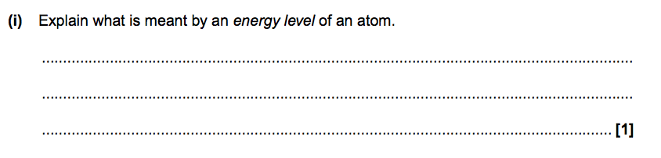

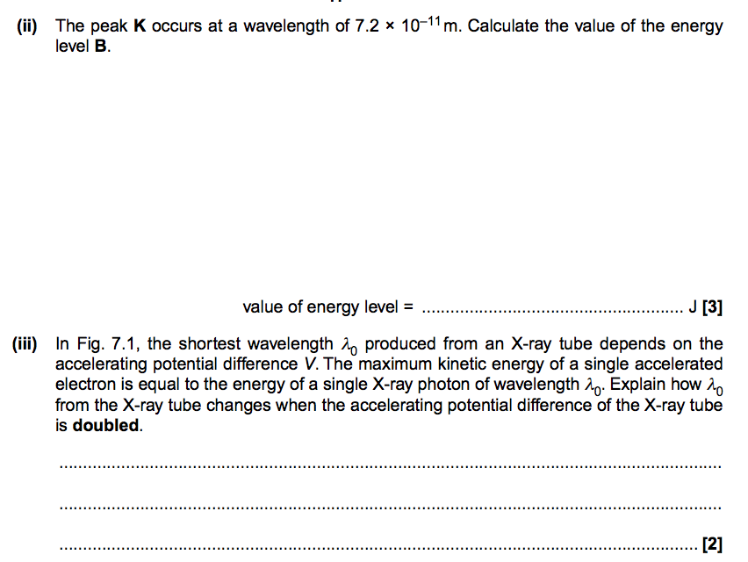

**X-ray attenuation**

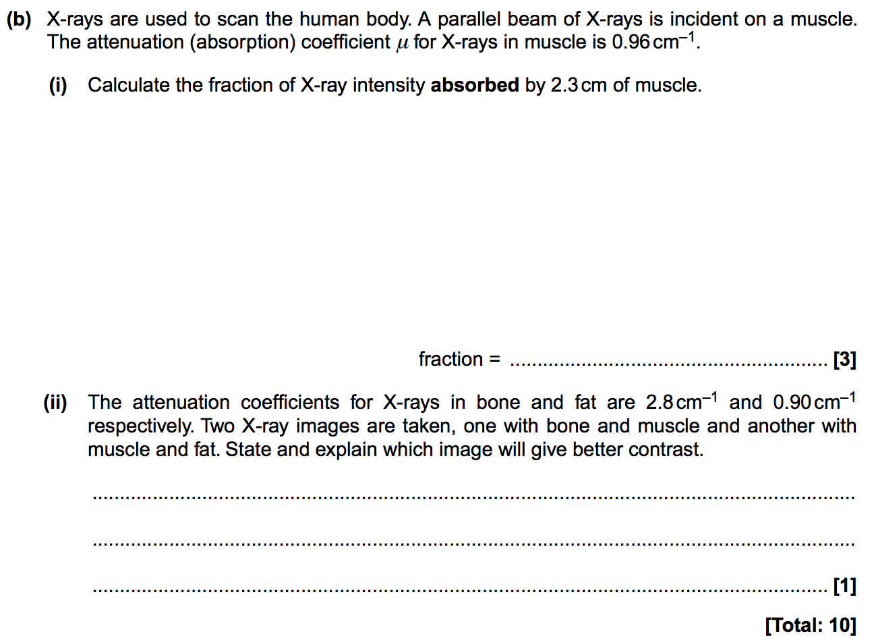

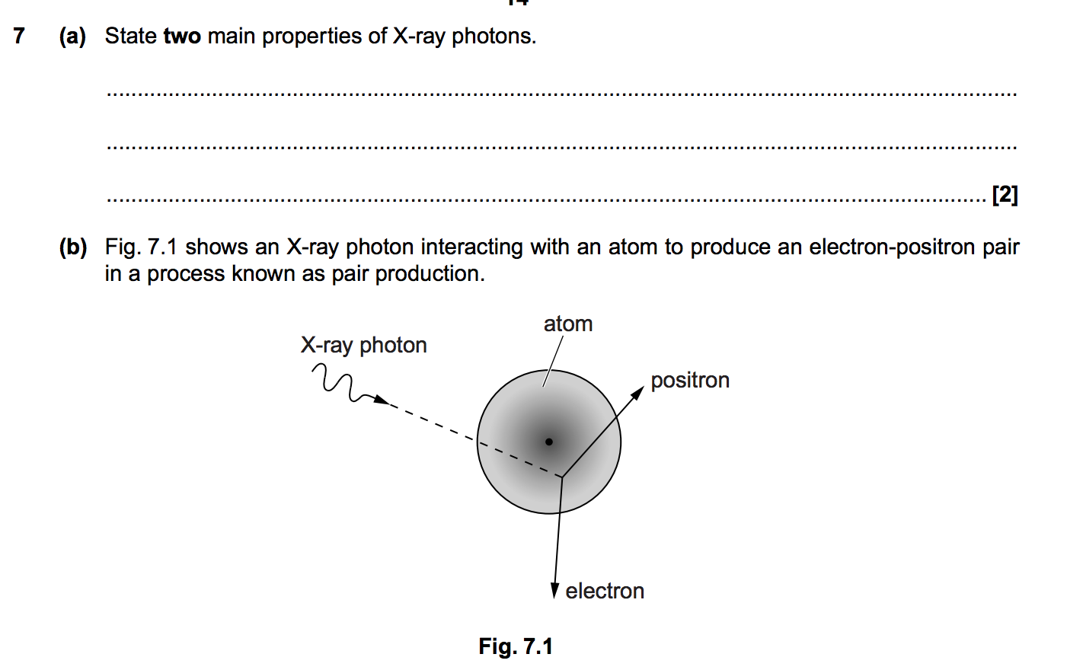

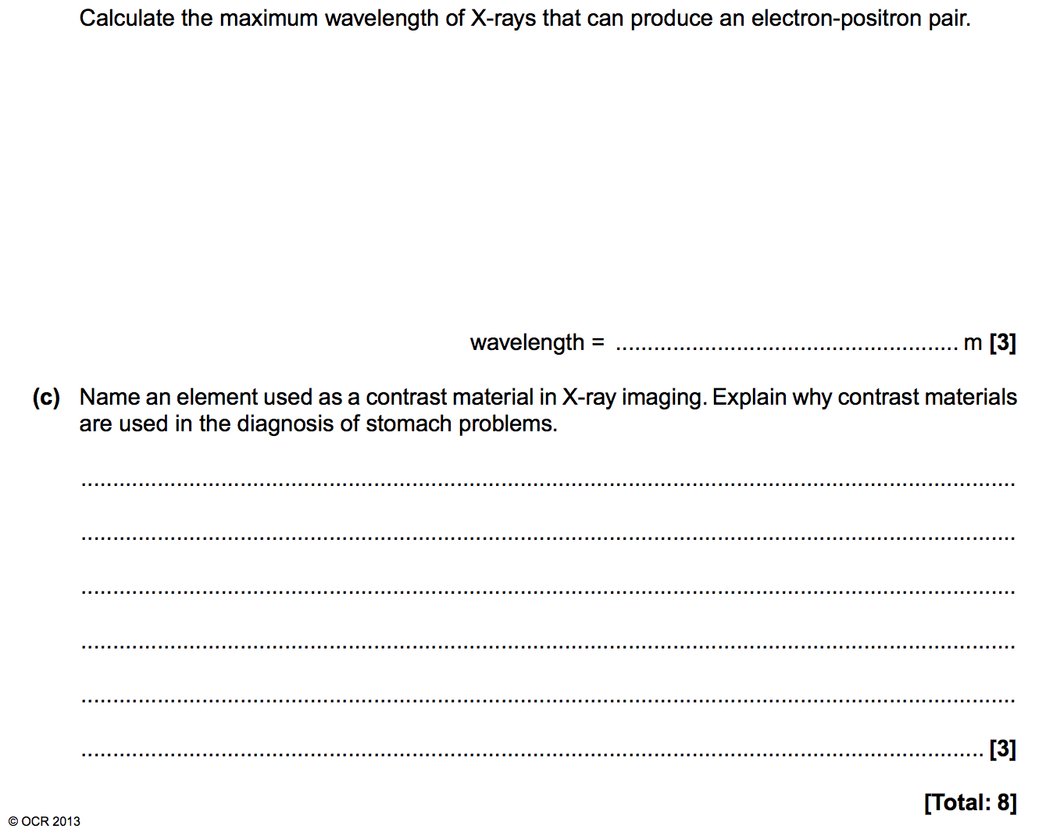

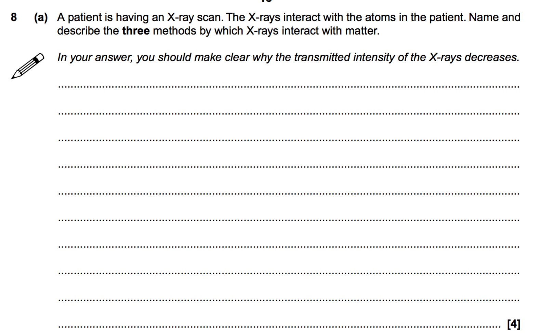

**The gamma camera**

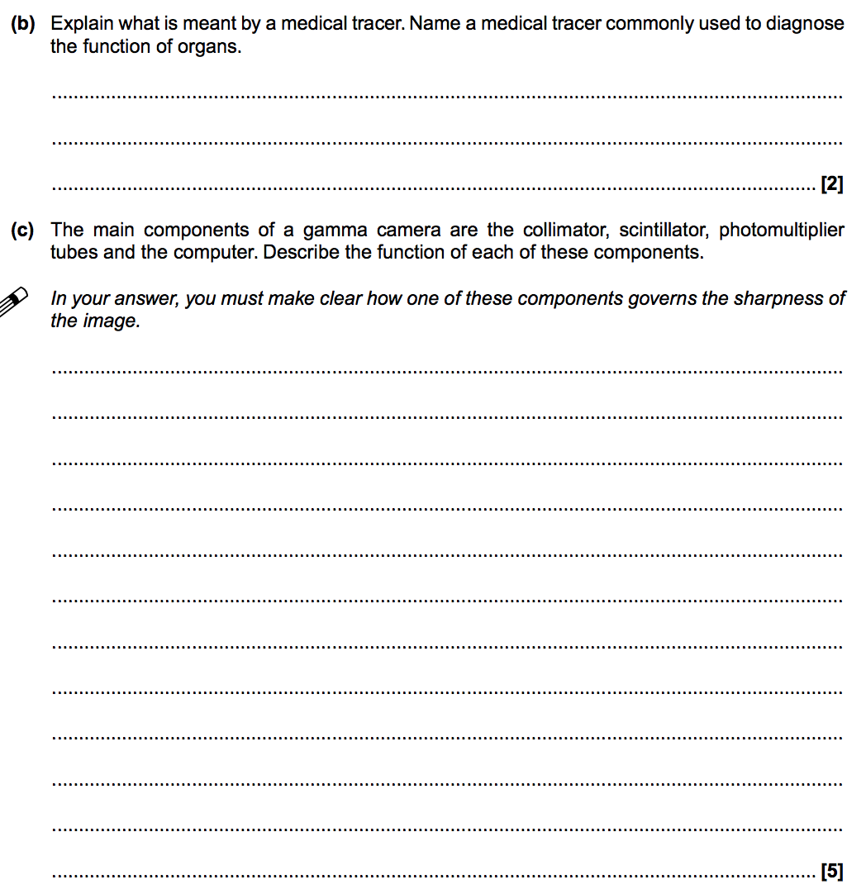

**PET versus CAT scans**

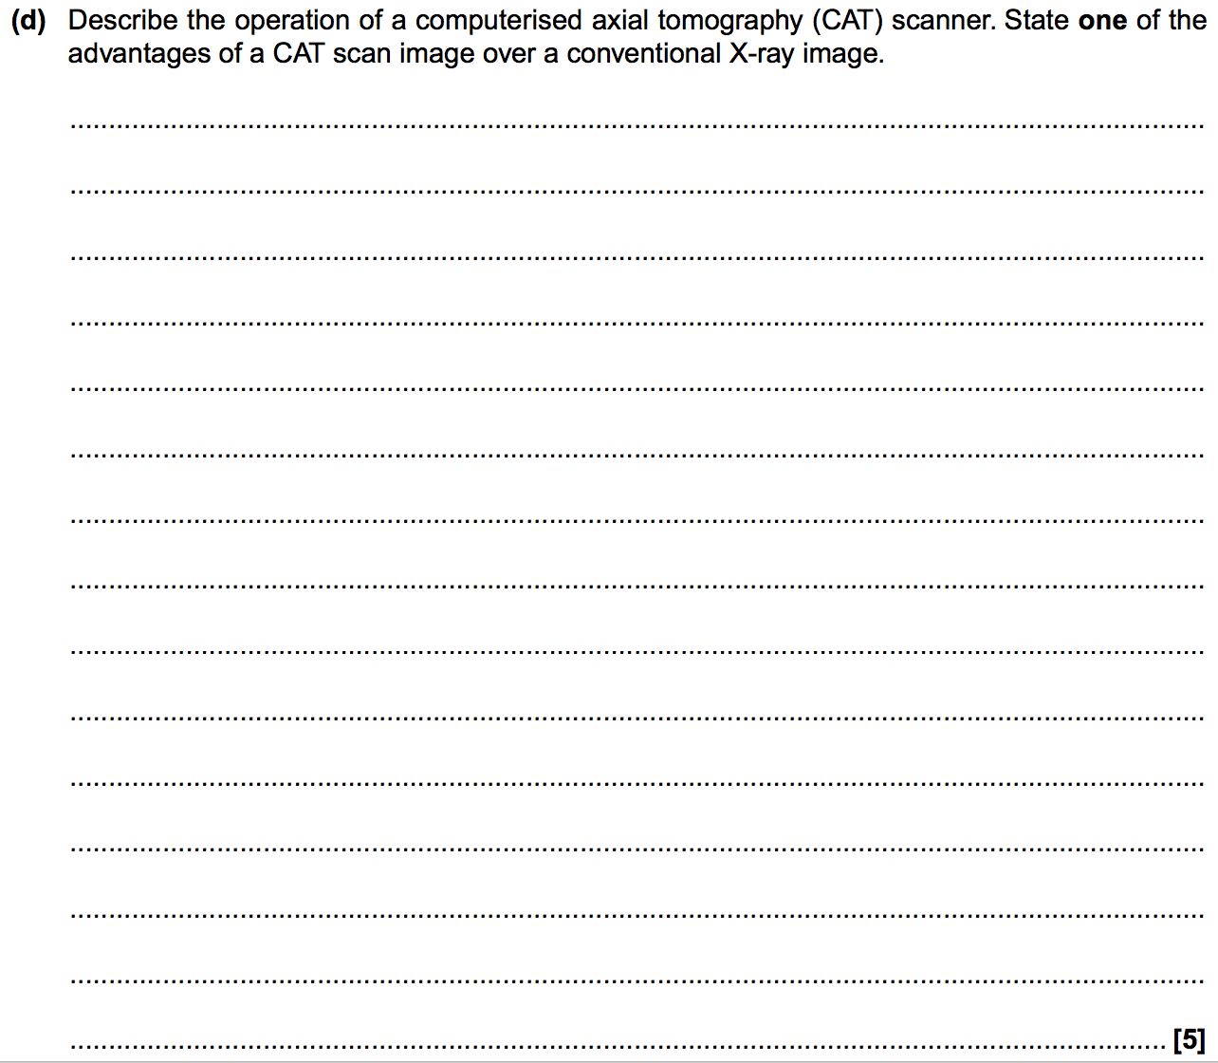

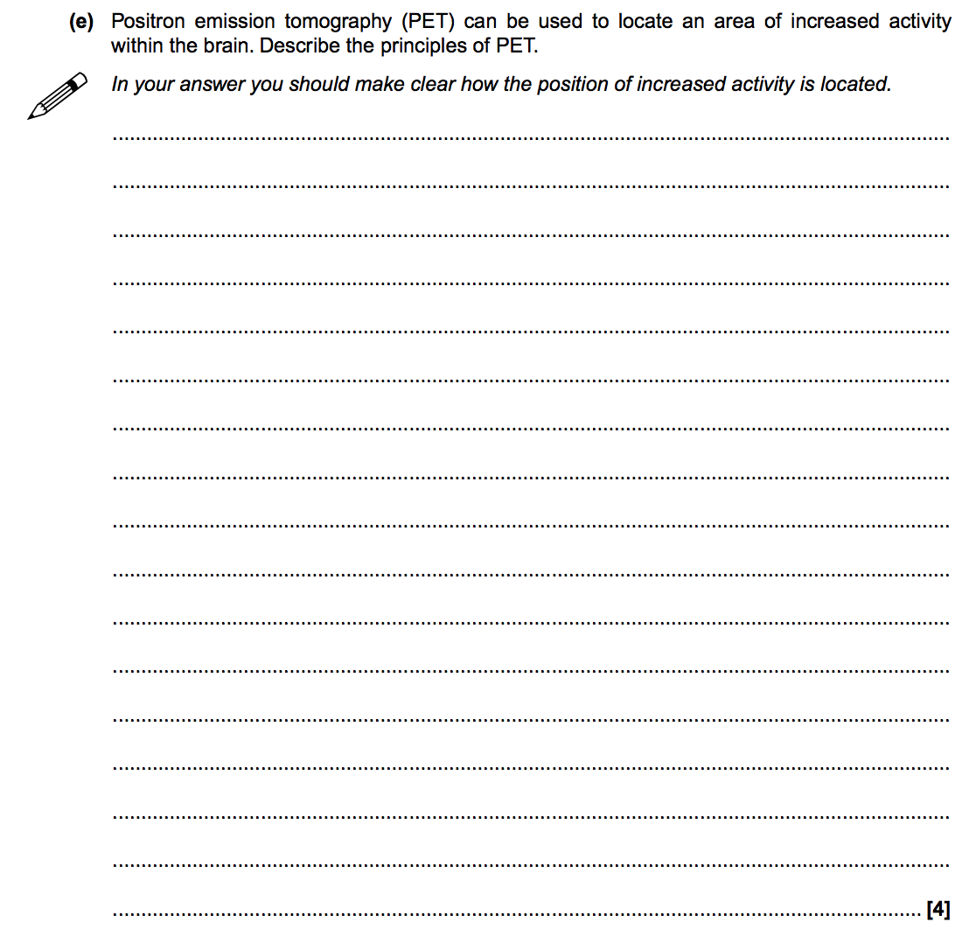

**Ultrasound**

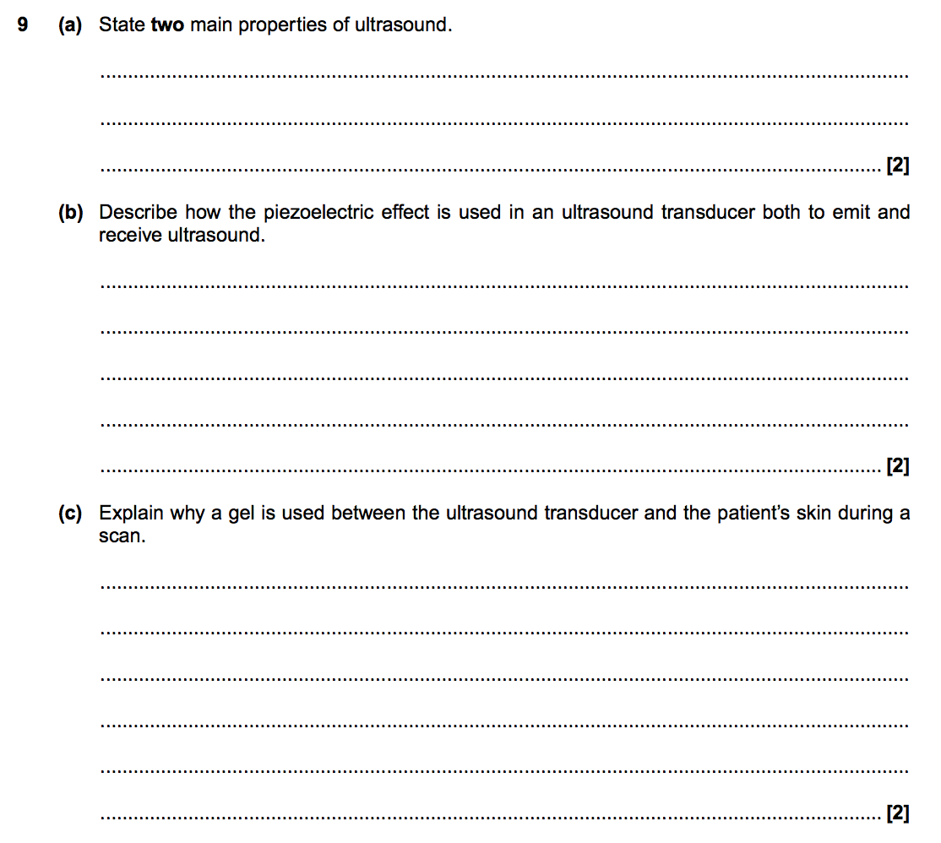

**Acoustic impedance**

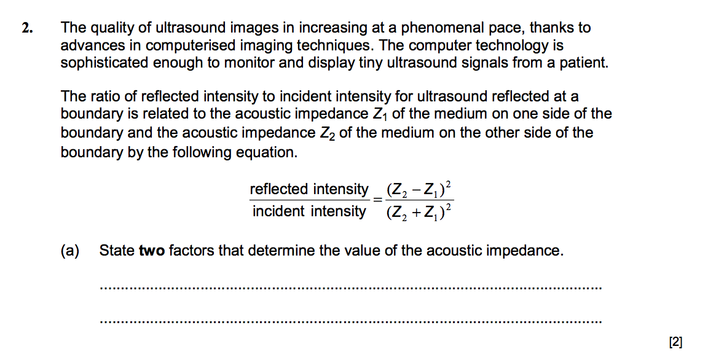

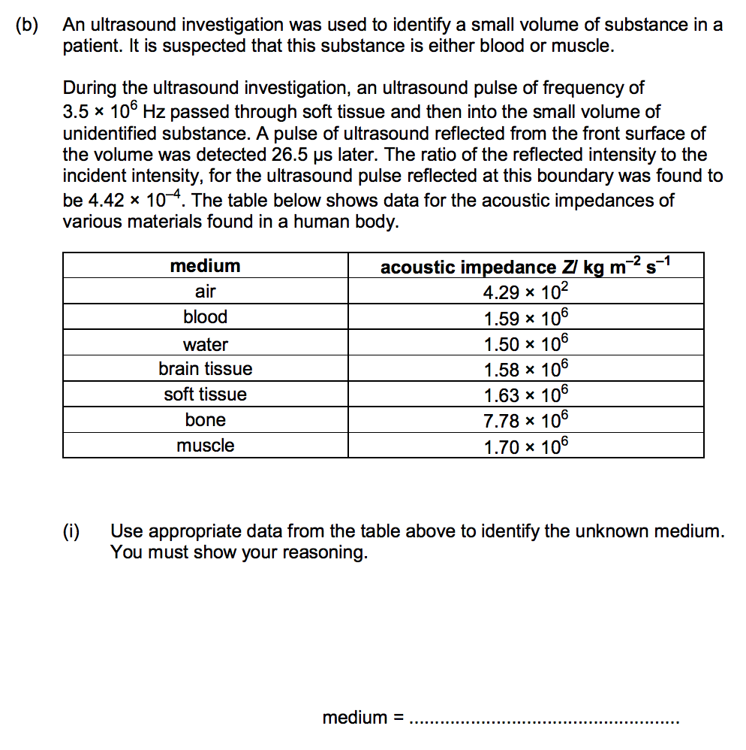**4**

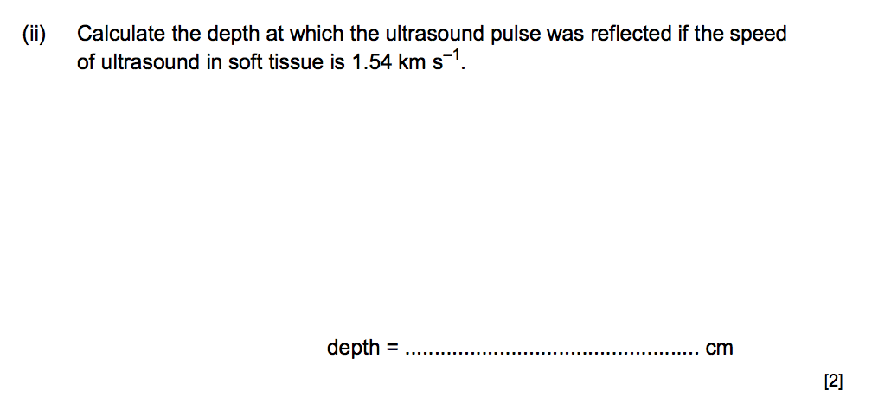

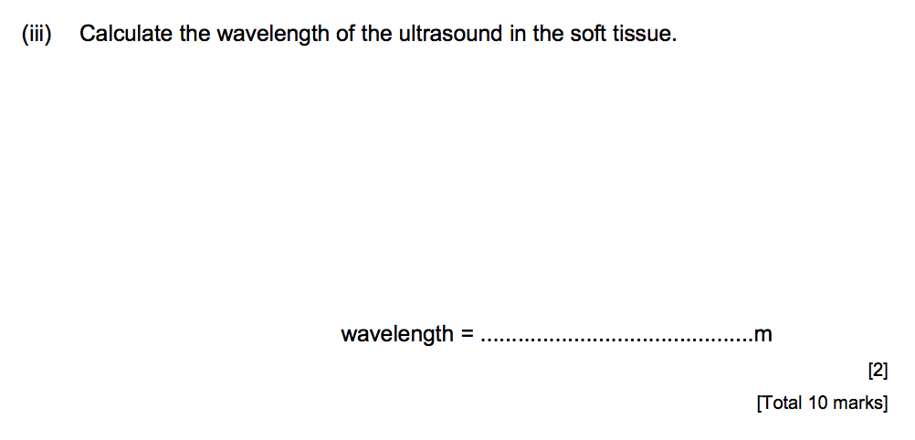

**The doppler effect**

