Module 6.4 Nuclear and Particle Physics

|  |  |  |  |  |
| --- | --- | --- | --- | --- |
| **Topic area** | **Text book pre-reading** | **Syllabus ref** | **Max possible score in exam questions** | **Your score in exam questions** |
| Radioactive decay | p 192 | 6.4.3 | 12 |  |
| Properties of radiation | p 192-195 | 6.4.3 | 6 |  |
| Nuclear decay equations | p 196-197 | 6.4.3 | 3 |  |
| Half lives | p 202-204 | 6.4.3 | 10 |  |
| Radioactive decay calculations | p 198-201 | 6.4.3 | 7 |  |
| Radioactive dating | p 205 | 6.4.3 | 21 |  |
| Mass-energy | p 207 | 6.4.4 | 10 |  |
| Binding energy | p 208-209 | 6.4.4 | 6 |  |
| Fission and fusion | p 210-216 | 6.4.4 | 7 |  |
| **Total** | | | 82 |  |

**By the end of this topic you should be able to….**

* Describe why radioactive decay occurs
* Describe the properties of different types of radiation and how these are investigated
* Complete nuclear decay equations for different types of radiation
* Describe what is meant by a half life and describe an experiment to investigate this
* Use radioactive decay equations to solve problems with radioactive decay
* Describe how radioactivity is used to date materials
* Describe what is meant by Einstein’s mass-energy equation
* Describe what is meant by binding energy and perform calculations to find this per nucleon
* Describe the process of fission and fusion, including the components of a fission reactor

**By the end of module 6.4 you need to be able to define the following key terms:**

Ionising radiation

Alpha decay

Beta decay

Gamma decay

Binding energy

Nucleon

Fission

Fusion

**Equations given in exam**

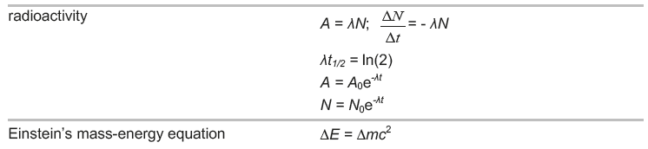

**Radioactive decay**

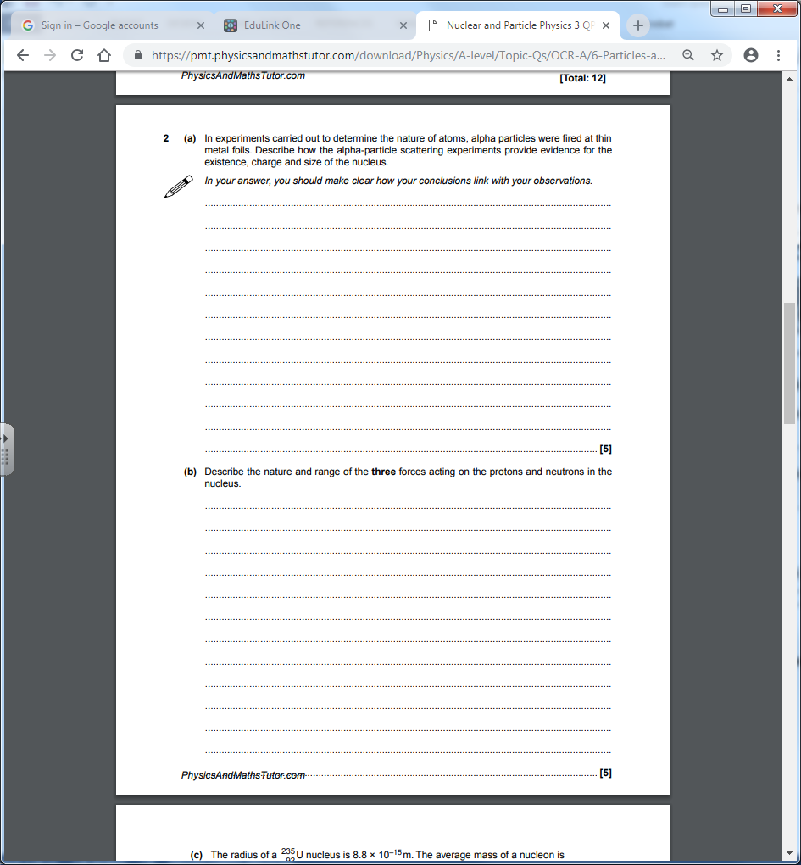

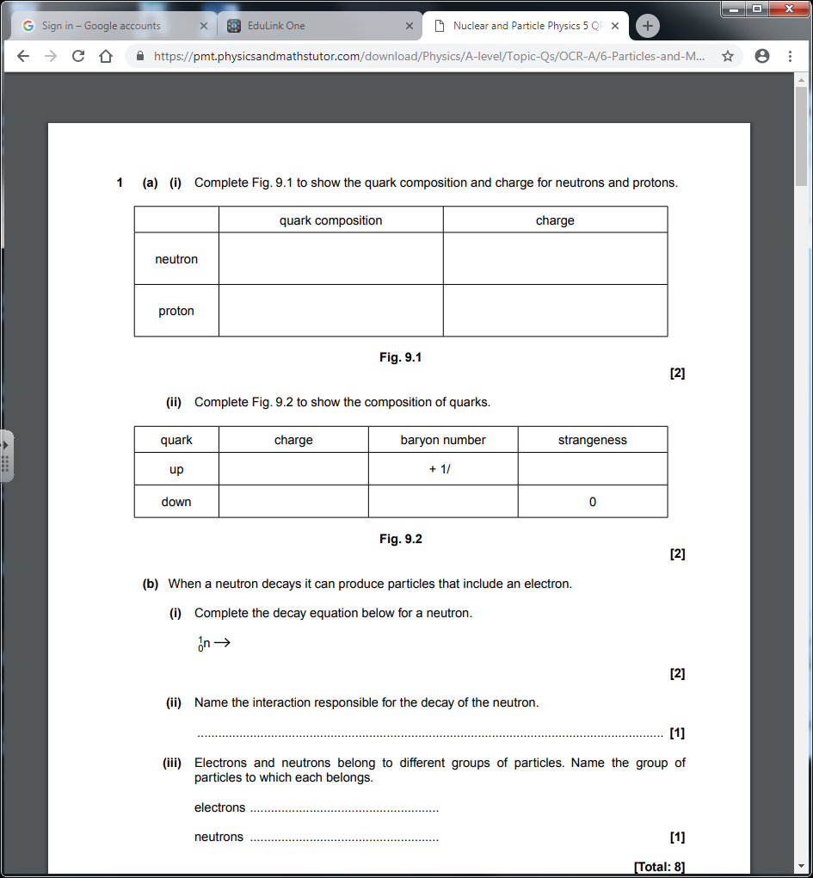

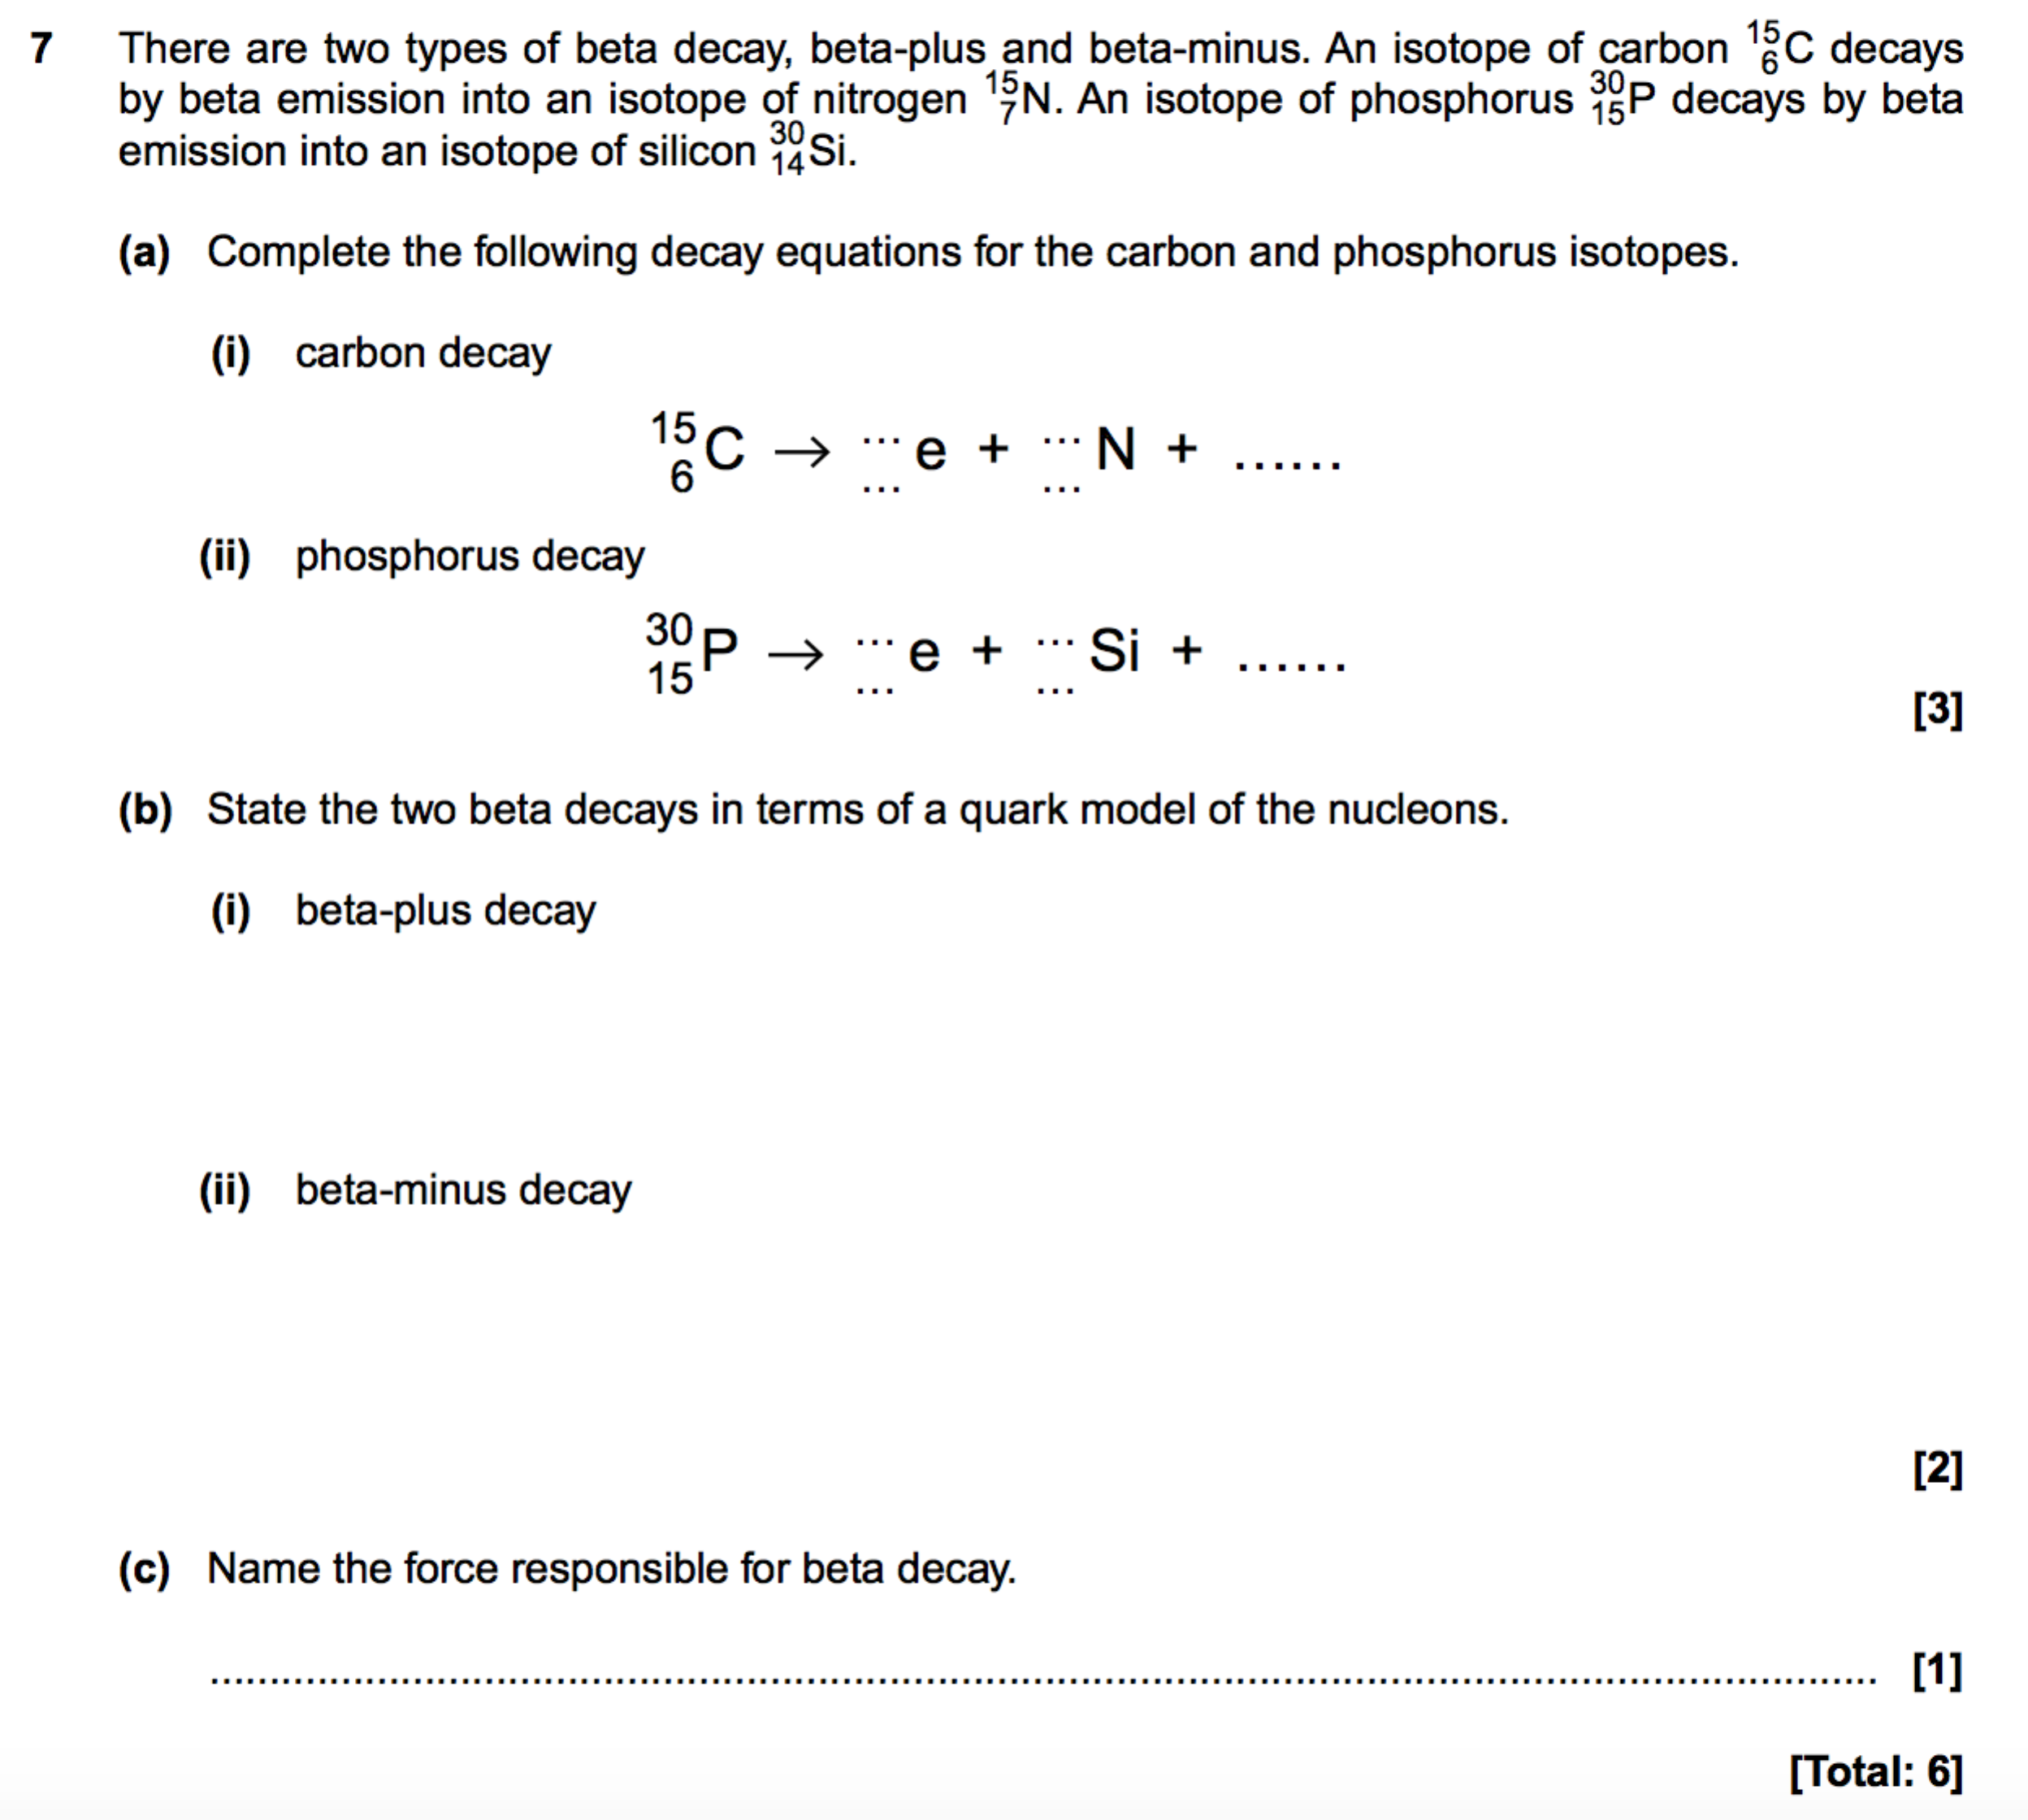

**Properties of radiation**

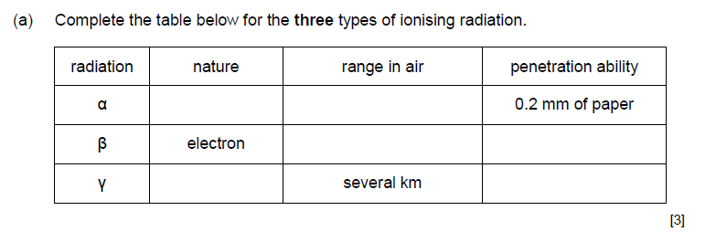

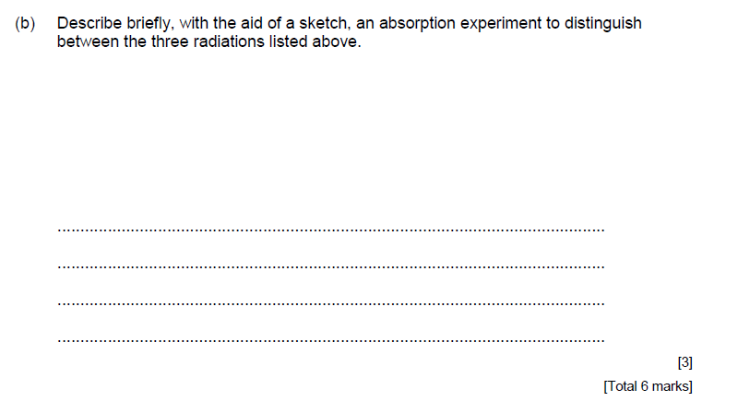

**Decay equations**

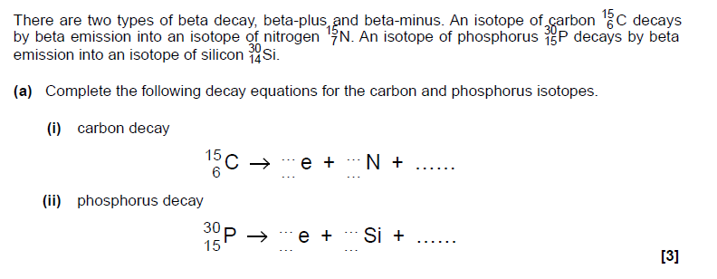

**Half-lives**

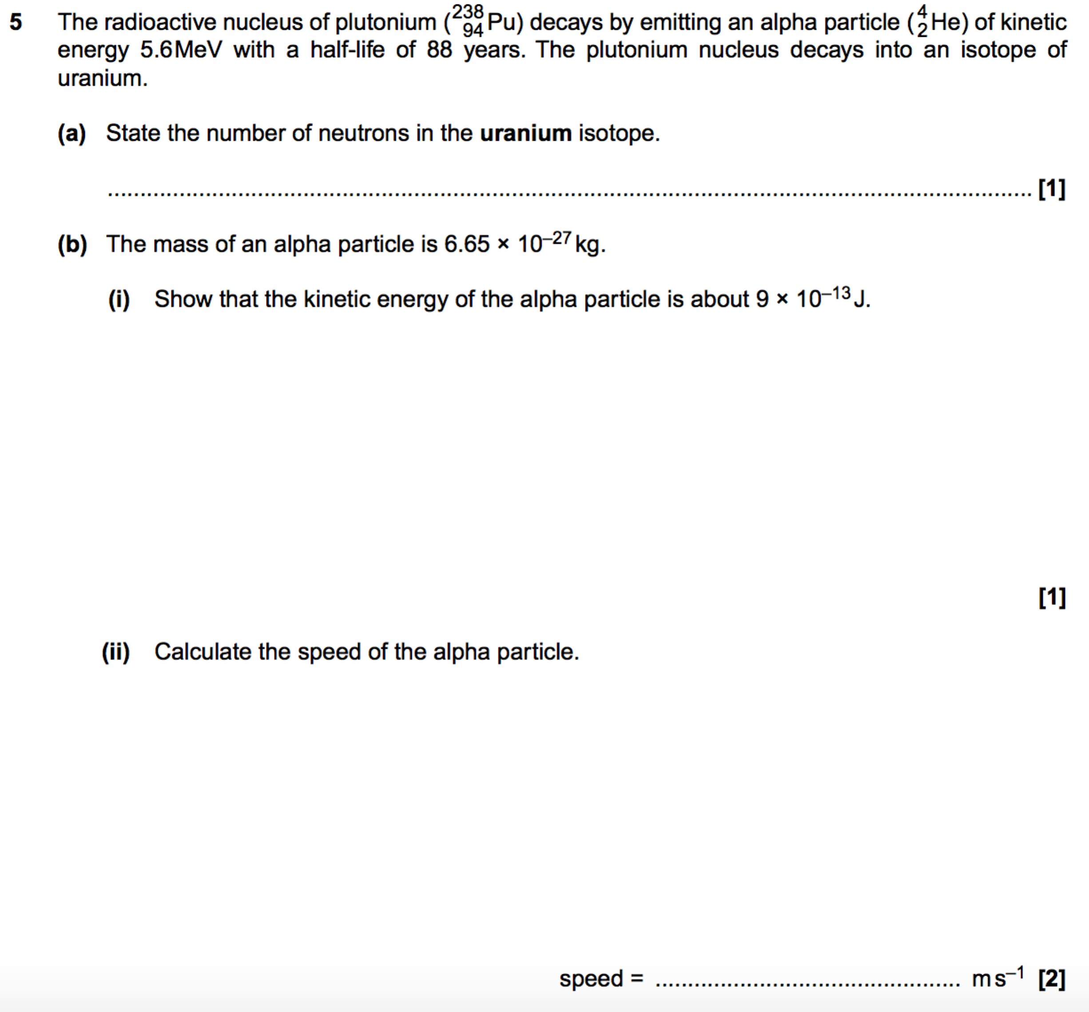



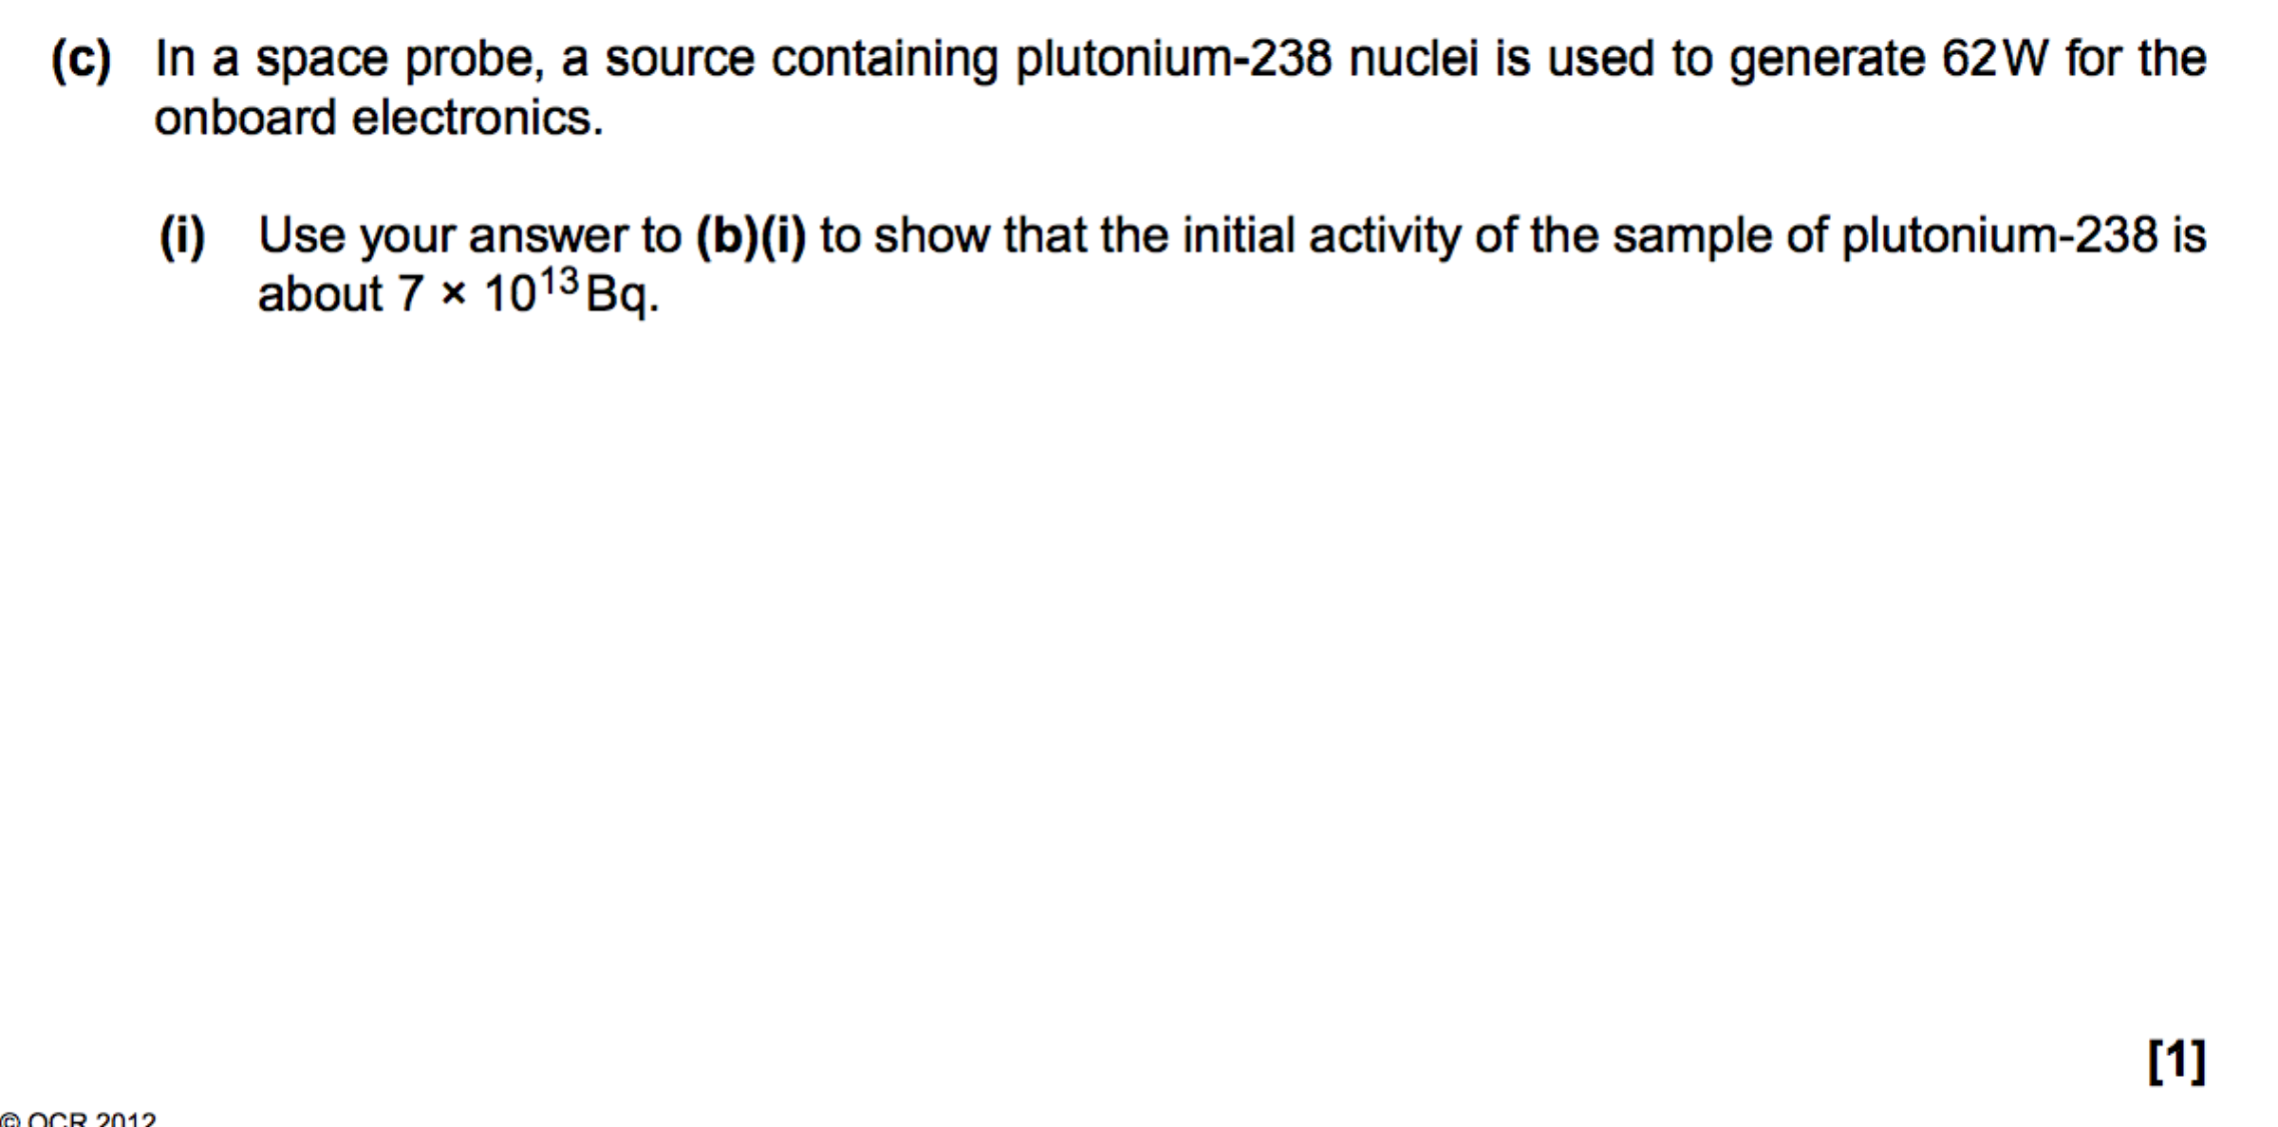

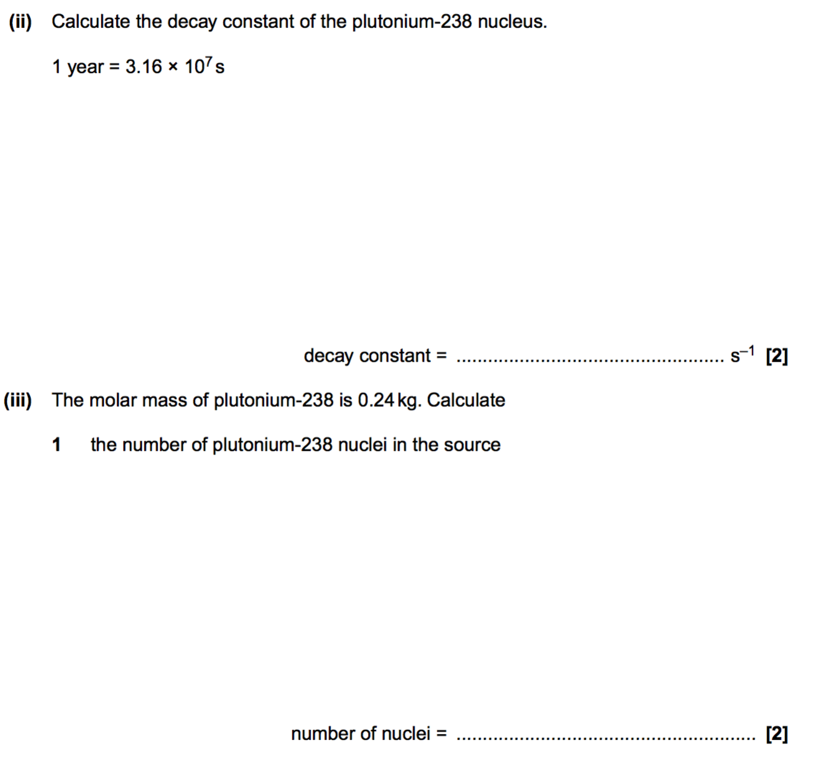

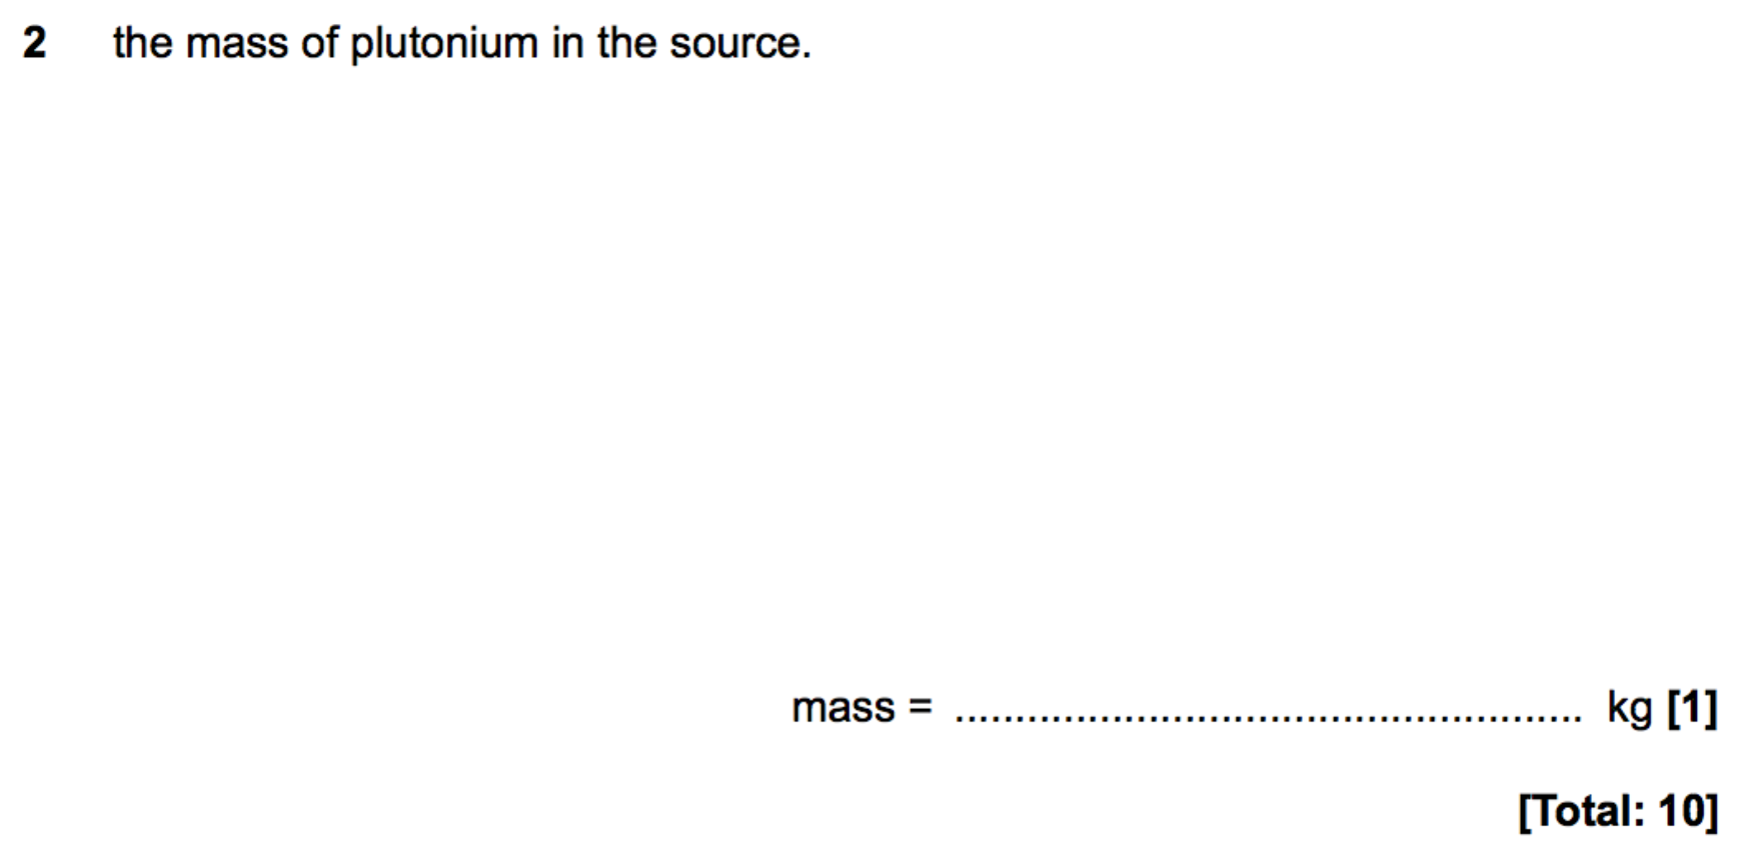

**Radioactive decay calculations**

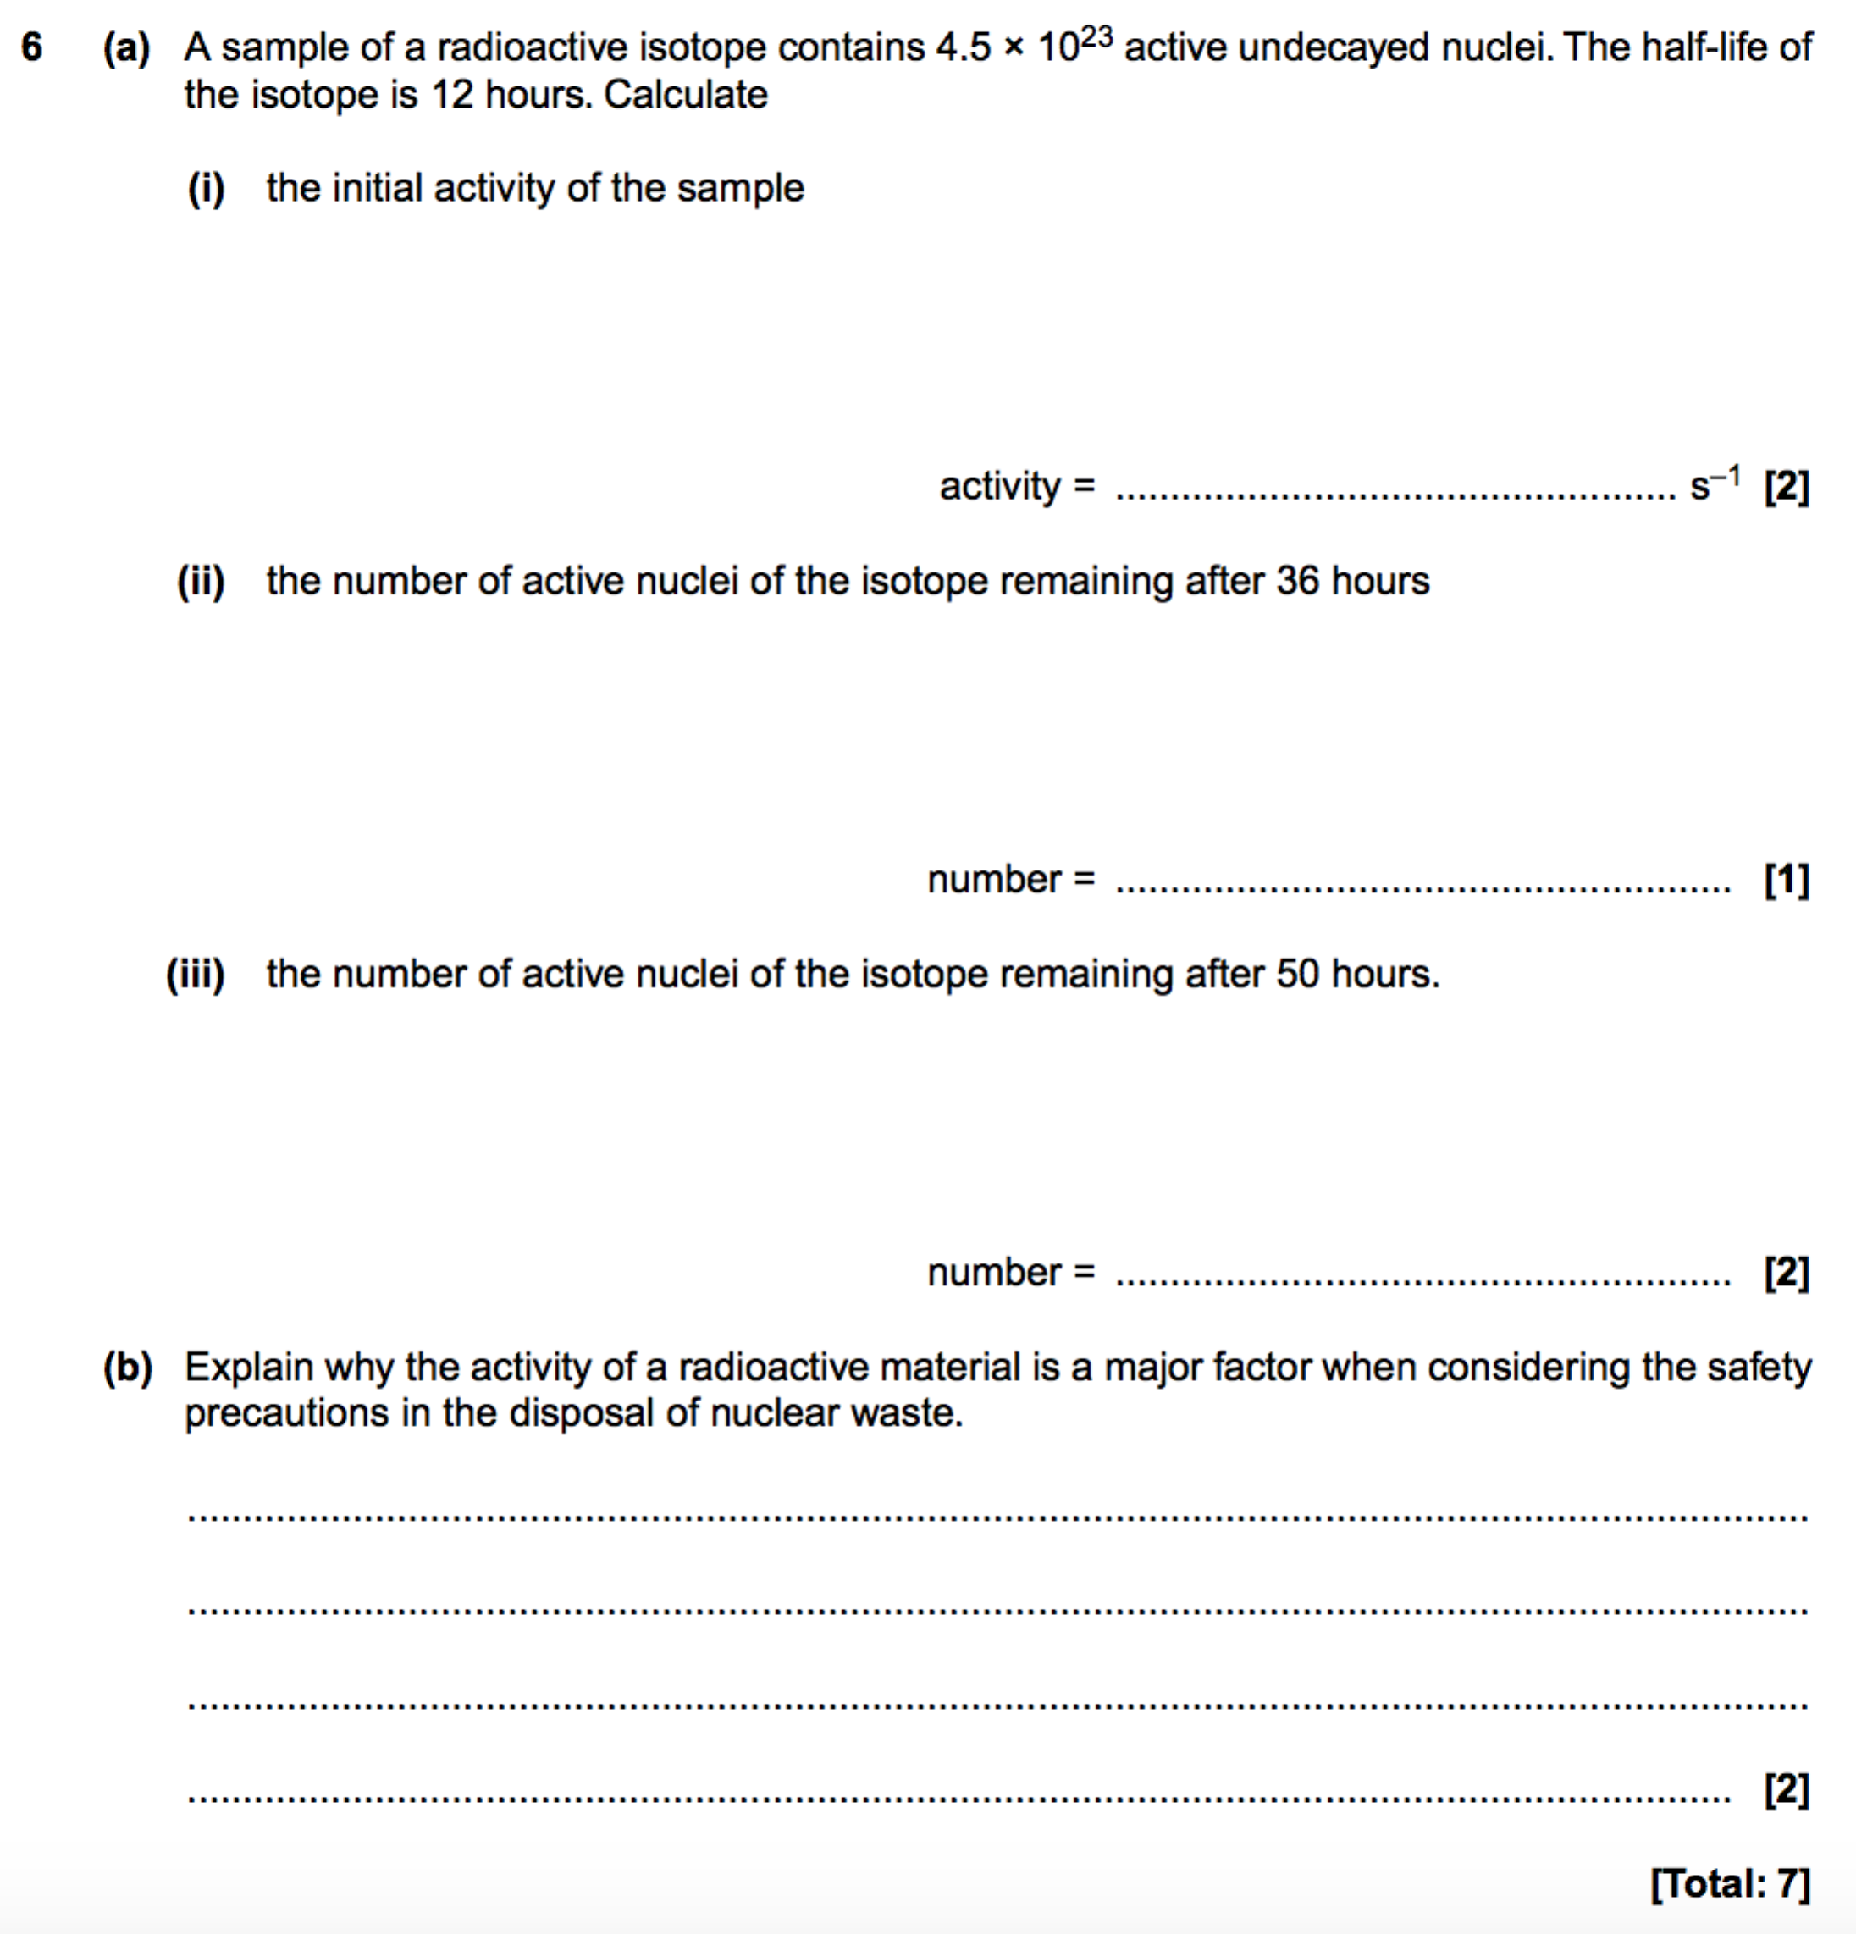

**Radioactive dating**

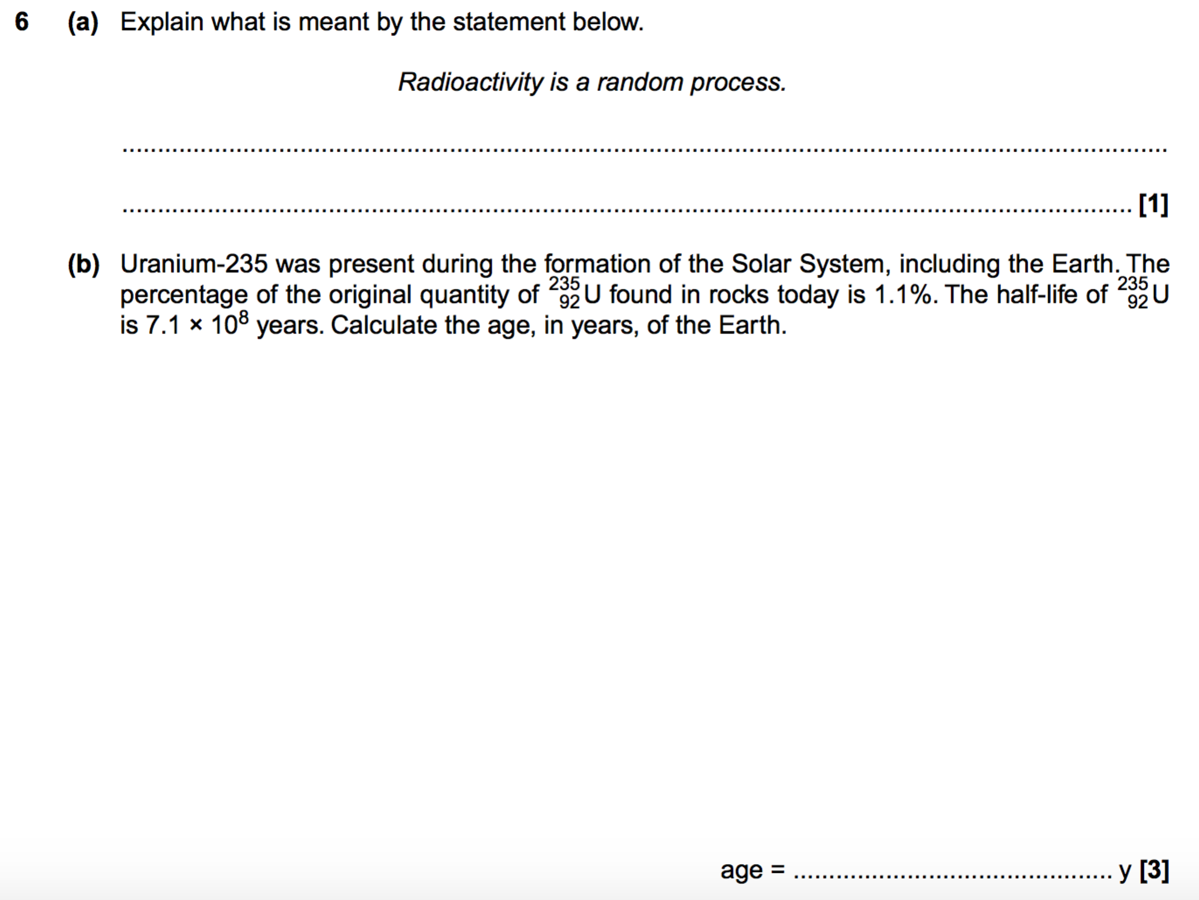

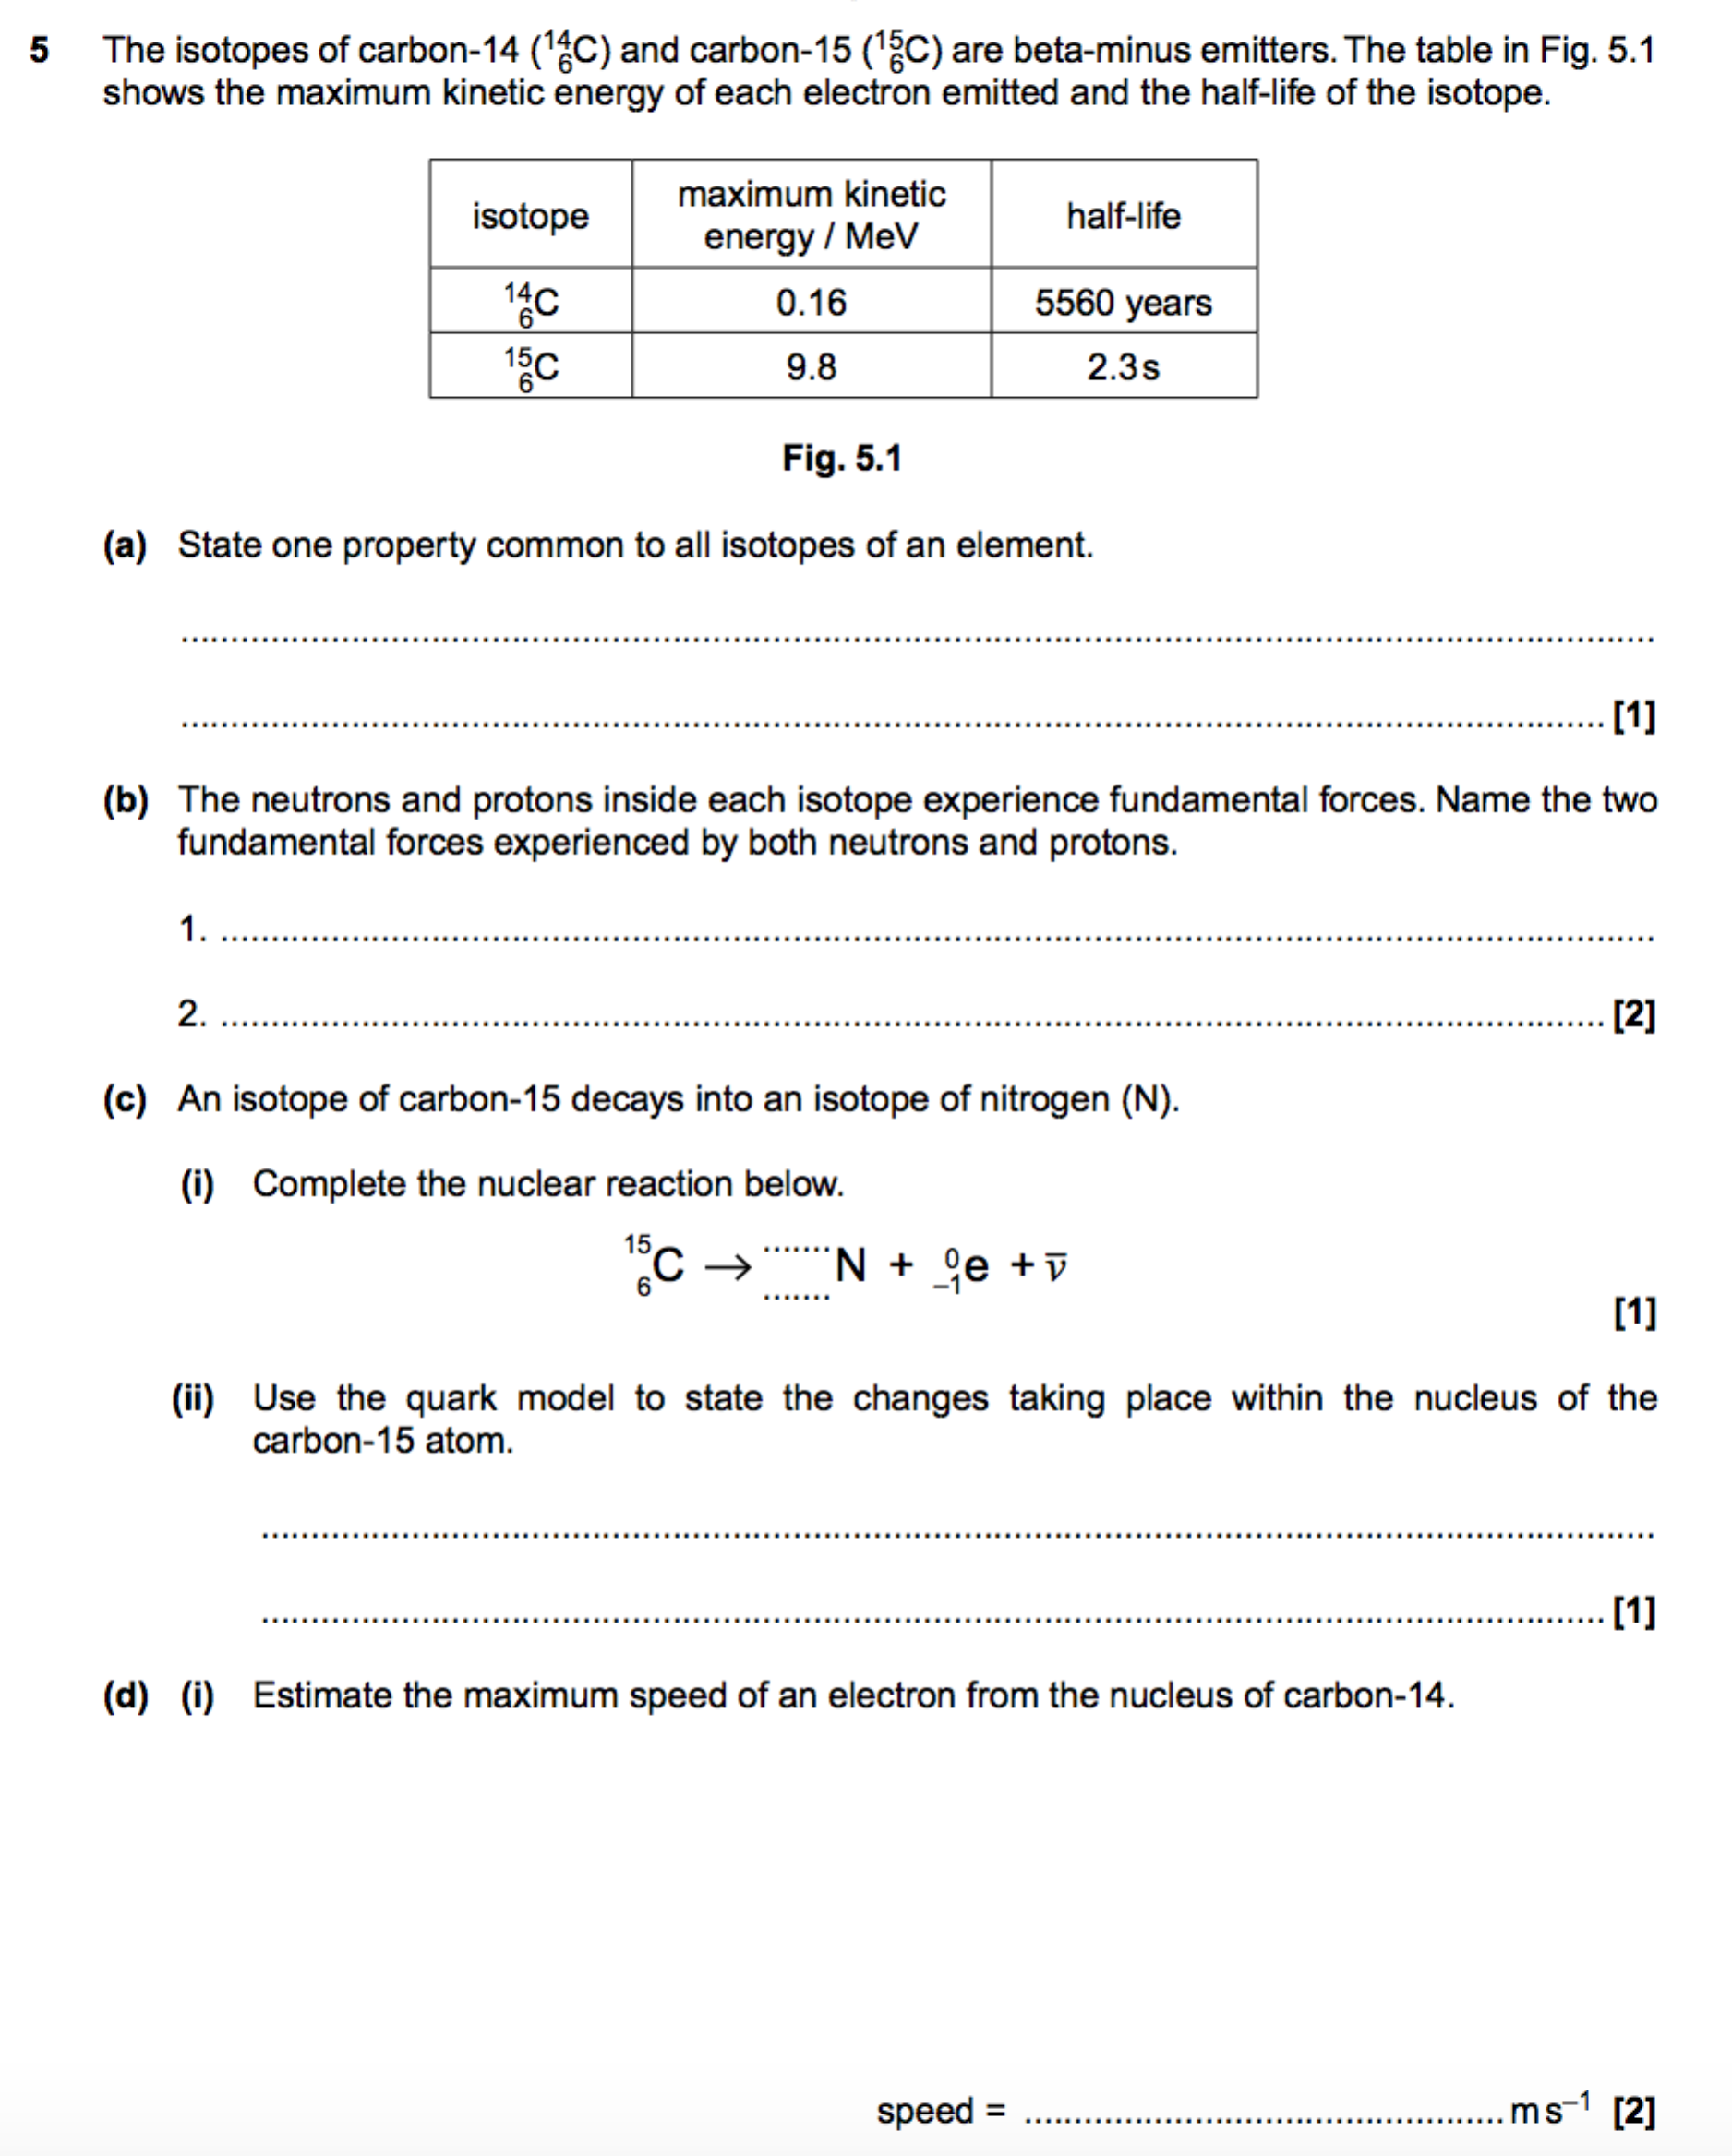

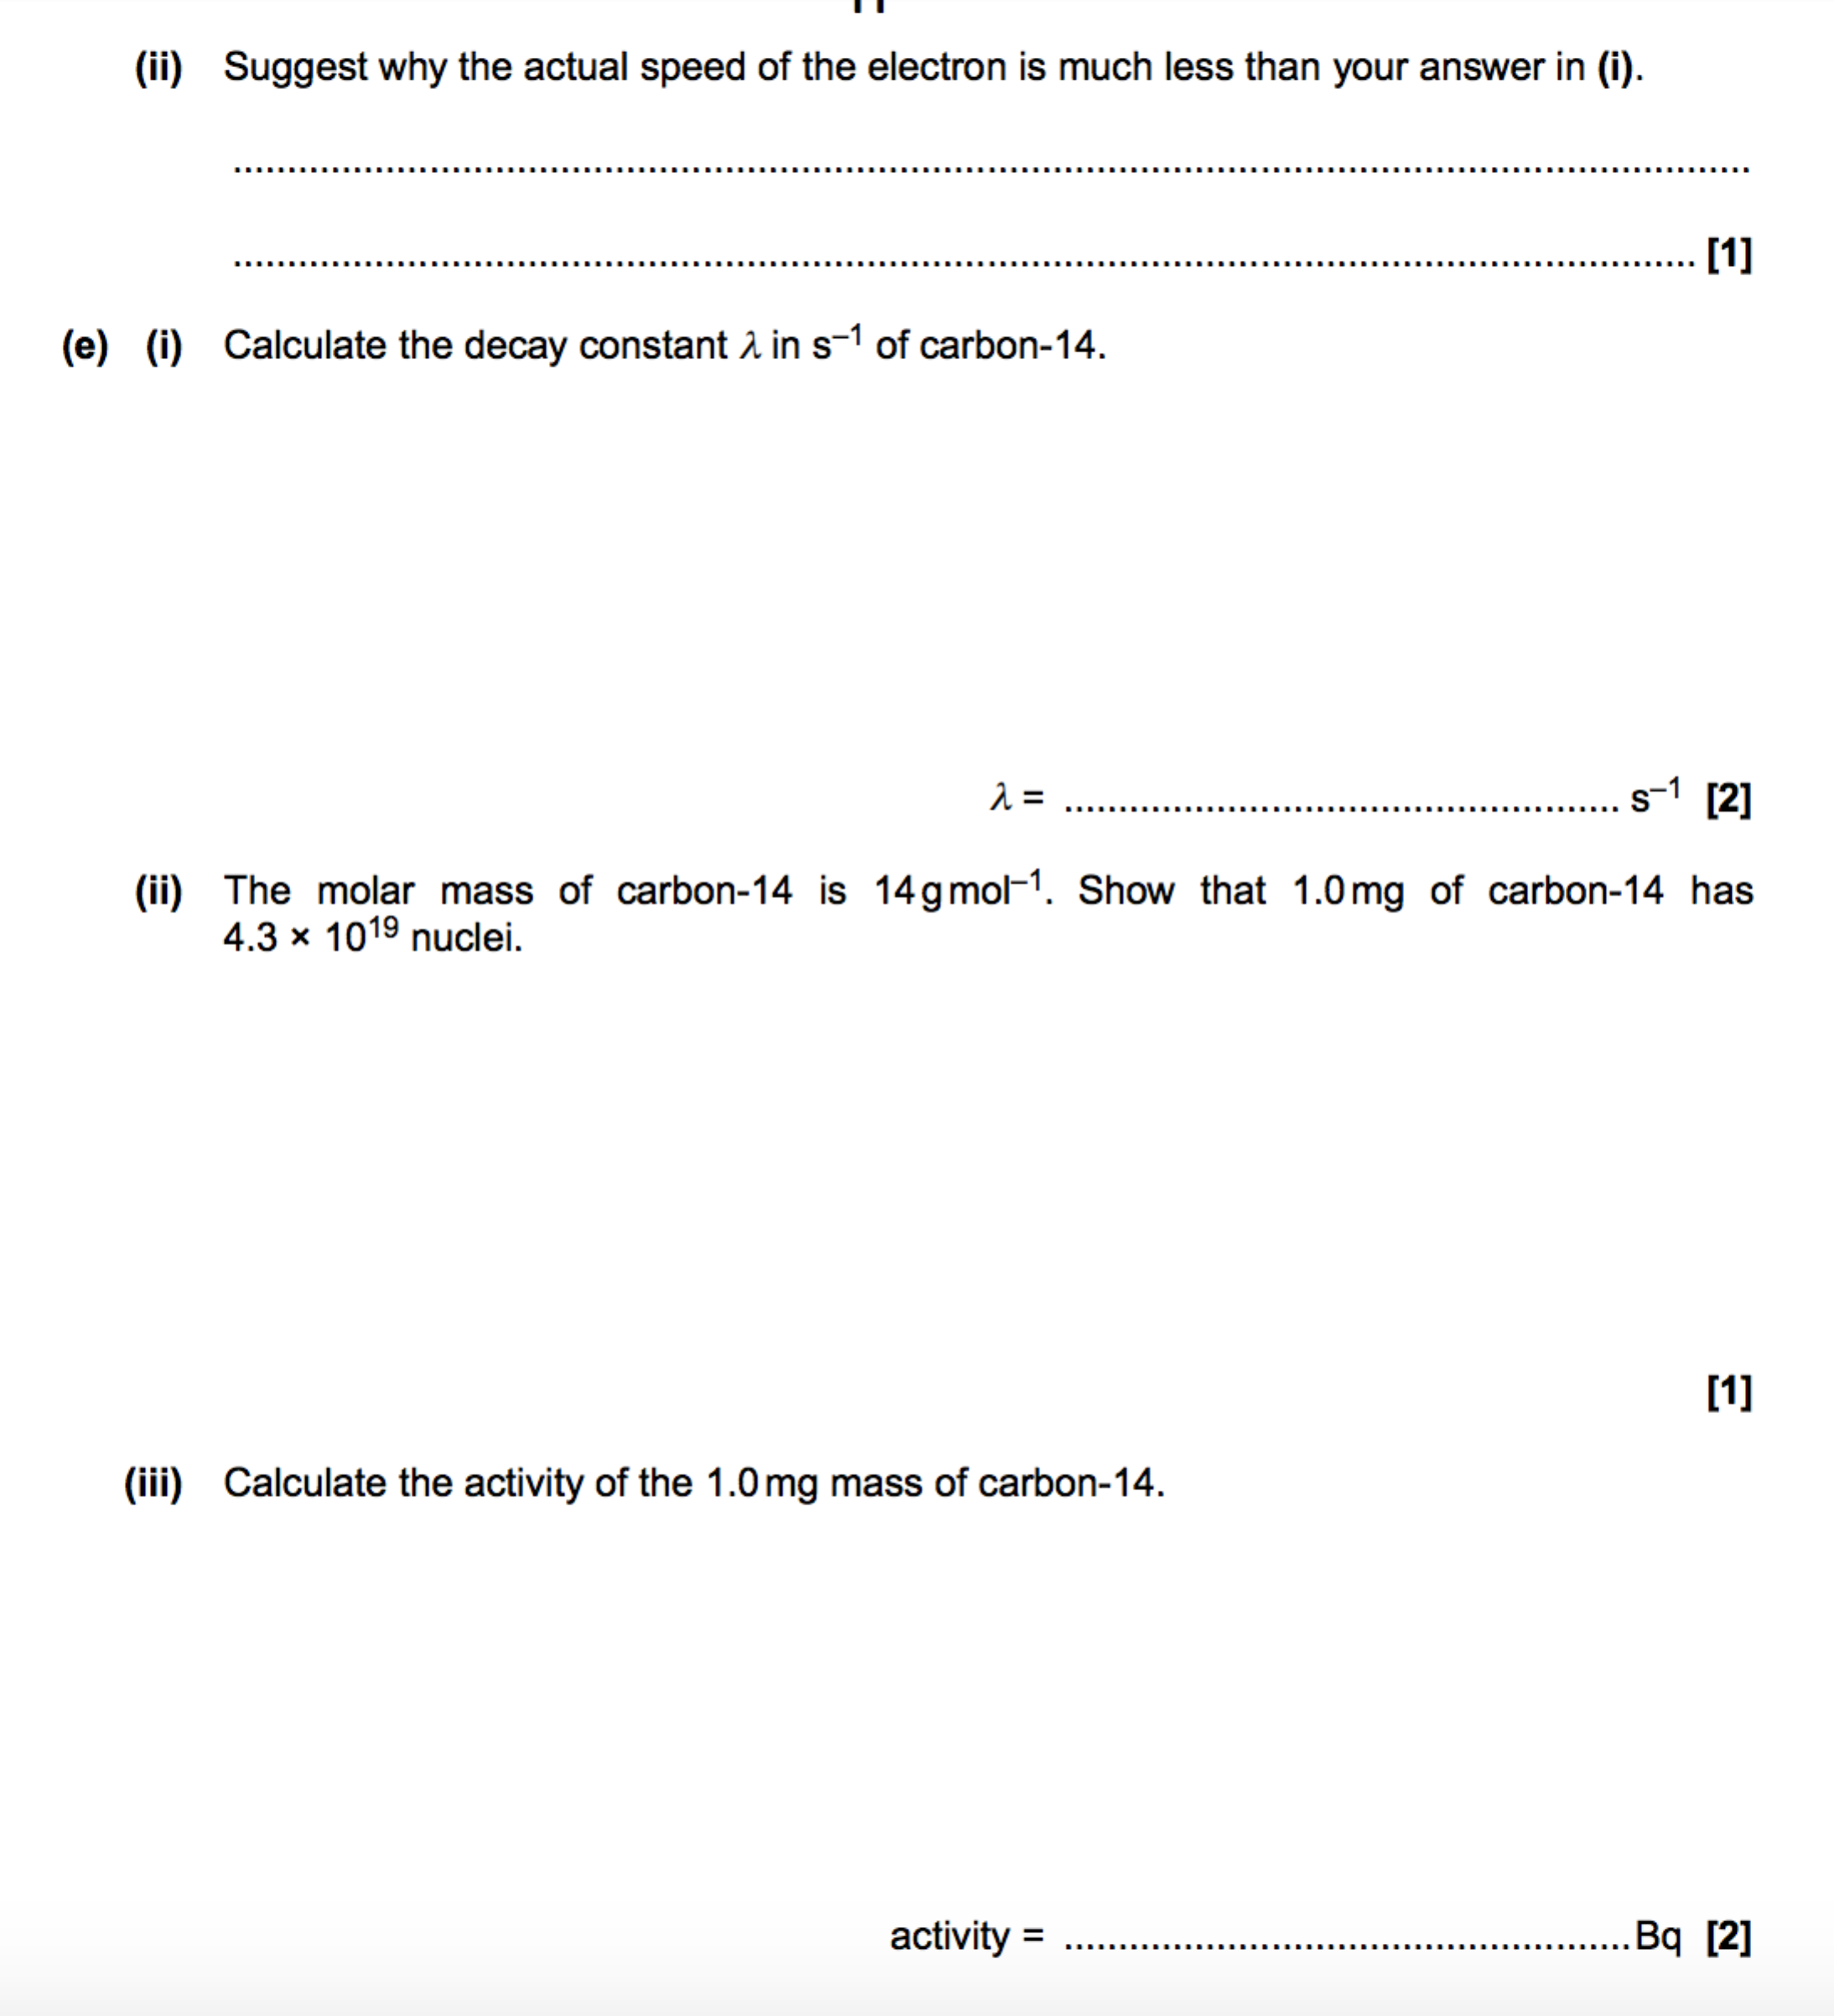

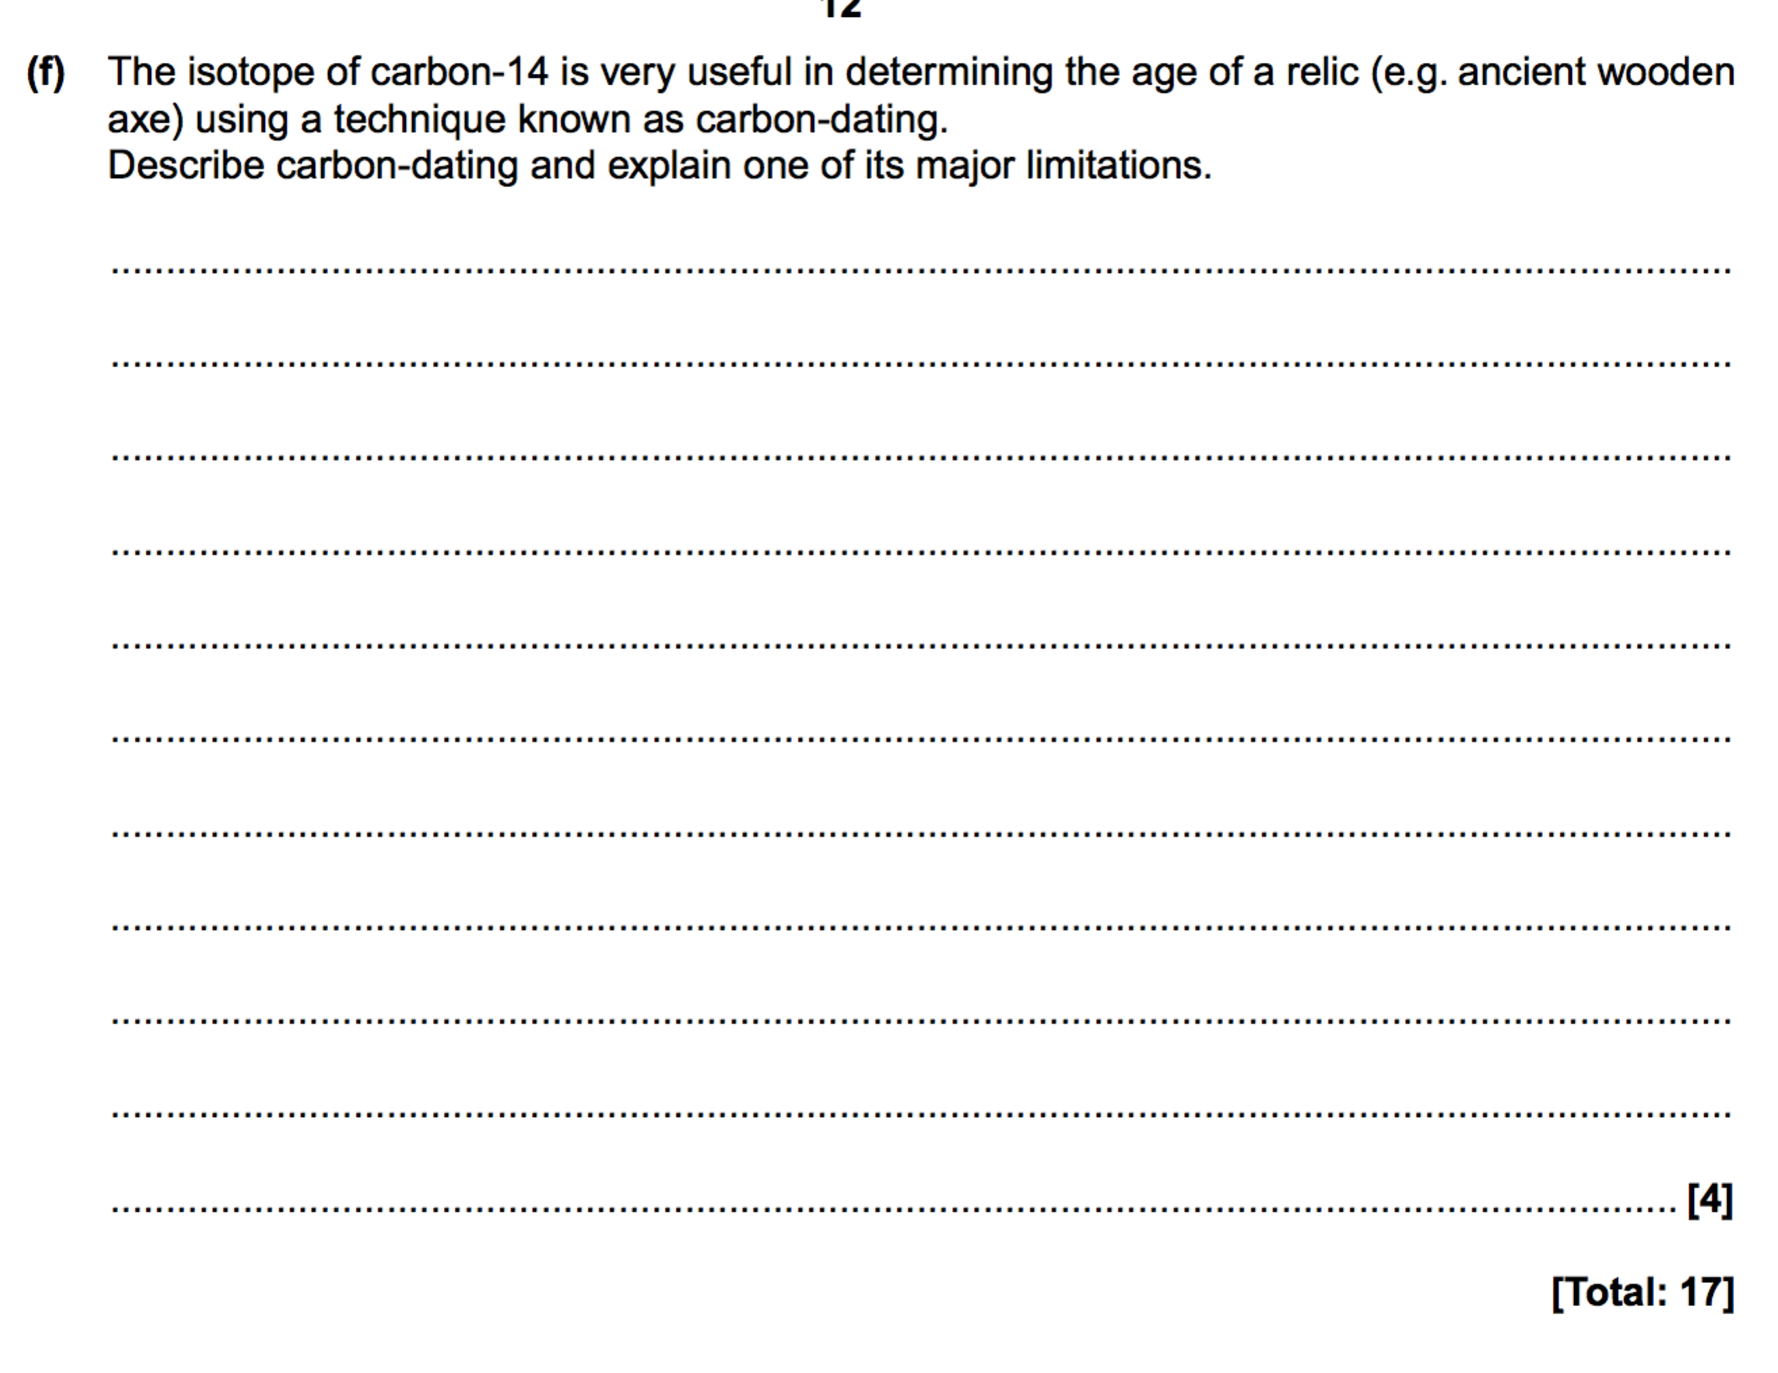

**Einstein’s mass-energy equation**

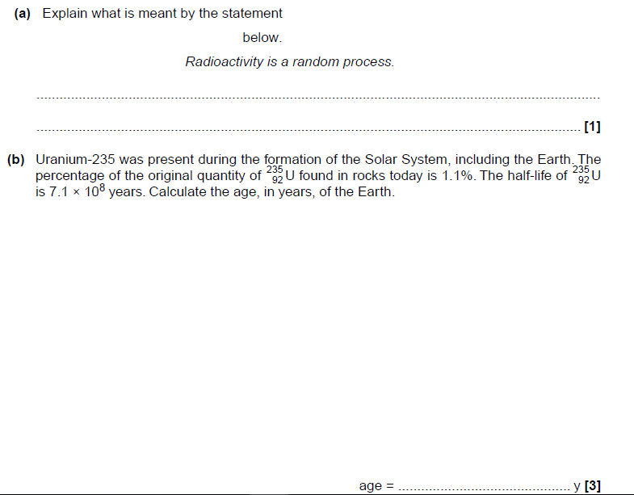

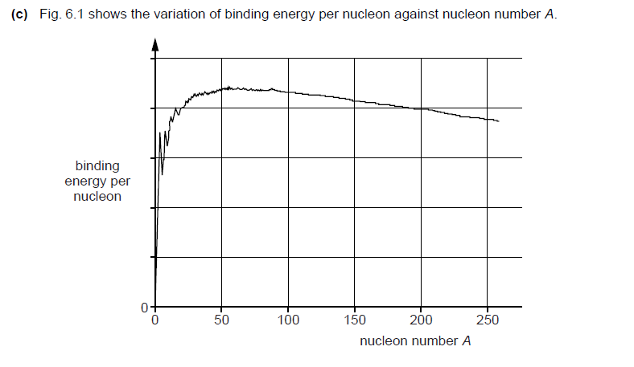

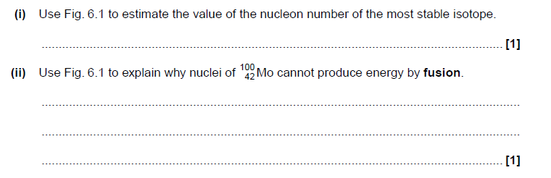

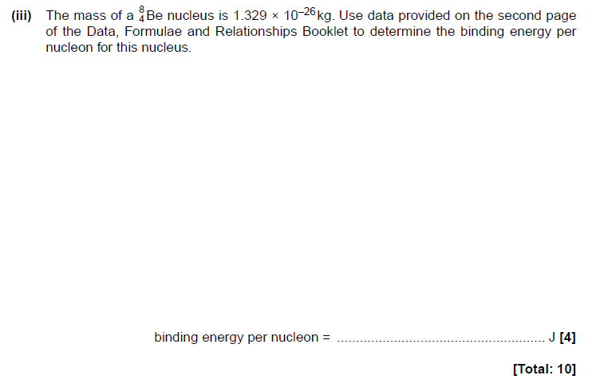

**Binding energy**

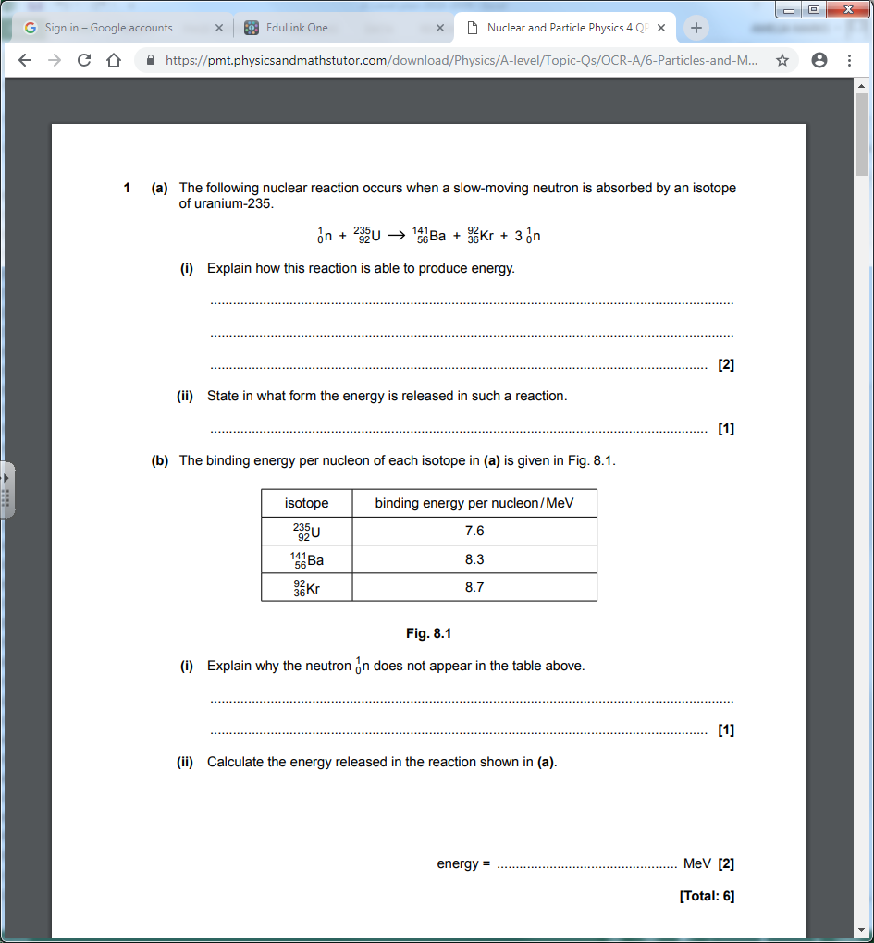

**Nuclear fission and fusion**

