**Particle and Quantum Physics**

| **Topic area** | **Text book pre-reading** | **Syllabus ref** | **Max possible score in exam questions** | **Your score in exam questions** |
| --- | --- | --- | --- | --- |
| Key terms, equations and units |  |  | 10 |  |
| Development of the atomic model | p 176-177 (Y2) | 6.4.1 | 5 |  |
| The nucleus | p178- 182 (Y2) | 6.4.1 | 9 |  |
| Fundamental particles | p184-191 (Y2) | 6.4.2 | 6 |  |
| Matter versus antimatter | p184-191 (Y2) | 6.4.2 | 2 |  |
| The photon model | p 225-226 | 4.5.1 | 7 |  |
| Calculating the Plank constant | p 227-228 | 4.5.1 | 13 |  |
| The Photoelectric Effect | p 230-231 | 4.5.2 | 4 |  |
| Einstein’s photoelectric equation | p 232-233 | 4.5.2 | 9 |  |
| Wave-particle duality | p 234-237 | 4.5.3 | 25 |  |
| **Total** | | | **90** |  |

| **By the end of this topic you should be able to…..** | **Check** |
| --- | --- |
| Describe the stages in the history of the development of the atomic model with a focus on Rutherford’s discovery of the nucleus using alpha particles |  |
| Define the terms; proton number, nucleon number and isotopes |  |
| Describe the features of the nucleus including calculating the radius and densities of nuclei and the forces acting on the nucleus |  |
| Describe and give examples and properties of hadrons and leptons, including the quark model of hadrons including up, down and strange quarks and the arrangements in protons and neutrons |  |
| Describe the difference between particles and antiparticles and name examples of these |  |
| Describe the photon model of electromagnetic radiation |  |
| Calculate the energy of a photon using Planck constant and frequency or the speed of light and wavelength. Describe how the Planck constant can be found experimentally using different colour LEDs |  |
| Describe the photoelectric effect and how this can be shown experimentally using a gold-leaf electroscope. |  |
| Use and explain Einstein's photoelectric equation to help explain the photoelectric effect, including the terms work function and threshold frequency. Use this to find the maximum kinetic energy of a photoelectron |  |
| Explain and give evidence to support why waves and particles can behave both as waves and particles (wave-particle duality), link this to the de Broglie equation |  |

**Glossary of key terms- Match the term to the definition (5)**

Proton number, Nucleon number, Isotope, Lepton, Quark, Hadron, Boson, Anti-particle, Photon, Meson, Baryon

|  | The number of protons and neutrons in a nucleus |
| --- | --- |
|  | An elementary particle which is affected by the strong nuclear force, is affected by the electromagnetic force if charged and decays by the weak nuclear force |
|  | A field or force carrying particle |
|  | The number of protons in a nucleus |
|  | A group of quarks |
|  | An atom of the same element with a different number of neutrons |
|  | A particle which is identical to a “normal” particle but has the opposite charge |
|  | A quanta of electromagnetic radiation energy |
|  | An elementary particle that is not affected by the strong nuclear force |
|  | 2 quarks- a quark and an anti-quark |
|  | A group of 3 quarks (neutron and protons are these) |

**Equations given in exam- Complete the table with the definition of each variable symbol (5)**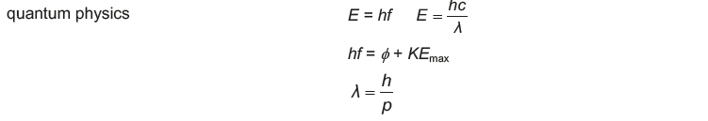

| **Variable symbol** | **Variable** | **Unit symbol** |
| --- | --- | --- |
| **R** |  |  |
| **r0** |  |  |
| **A** |  |  |
| **E** |  |  |
| **h** |  |  |
| **f** |  |  |
| **ф** |  |  |
| **KEmax** |  |  |

**Development of the atomic model**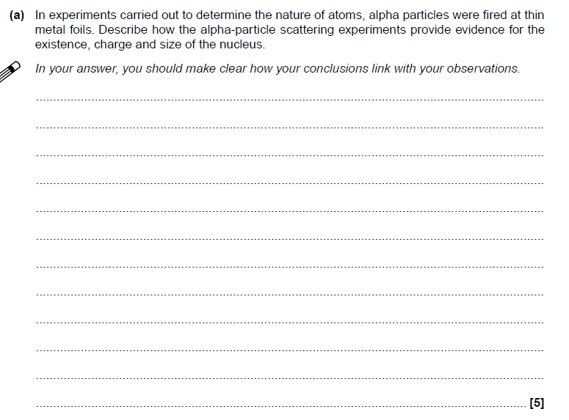

**The nucleus**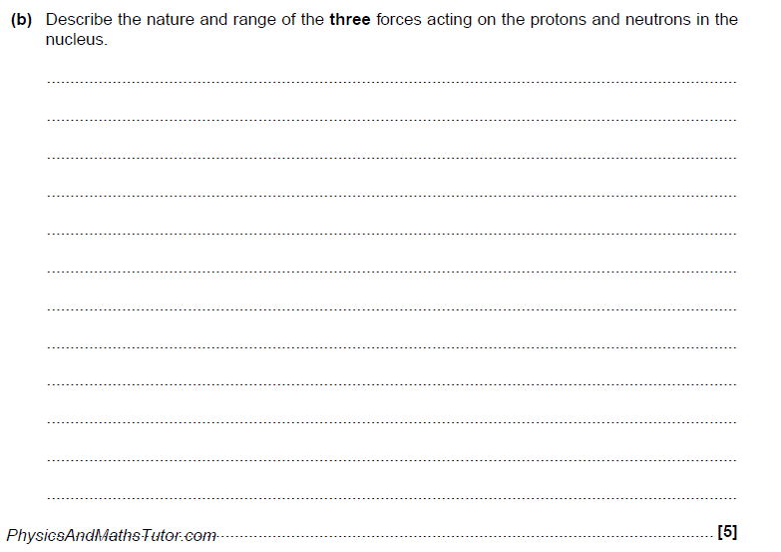

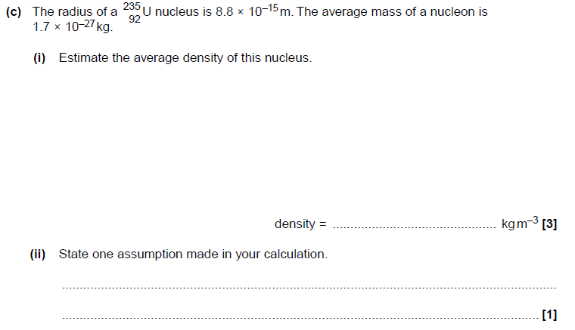

**Fundamental particles**

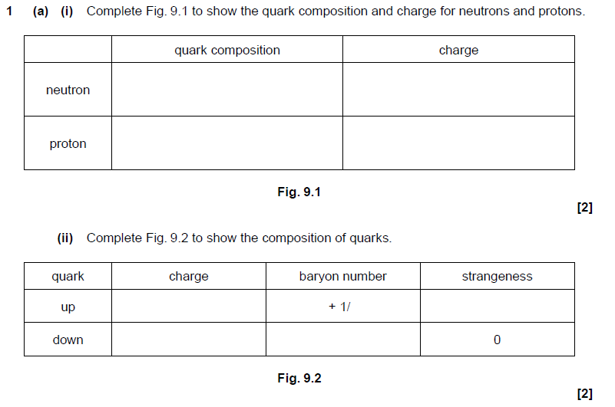



**2.**

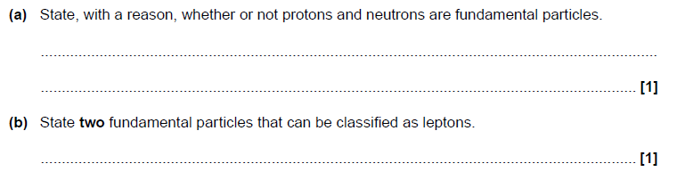

**Matter versus antimatter**

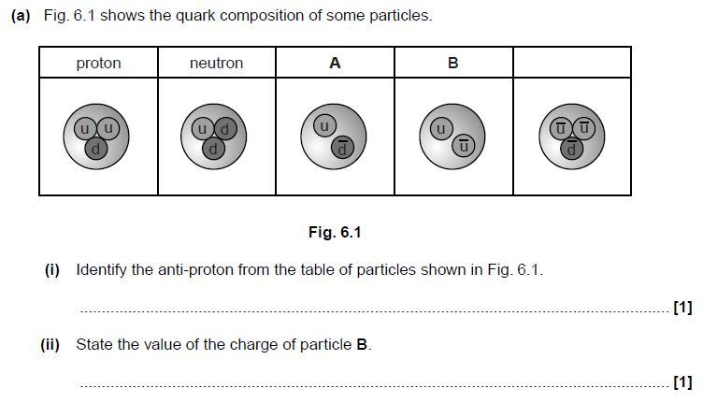

**The photon**

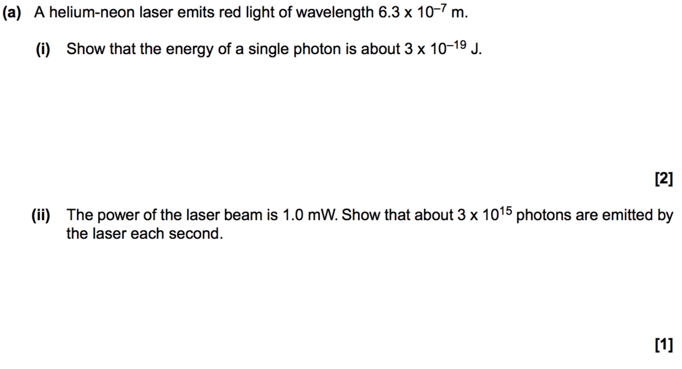

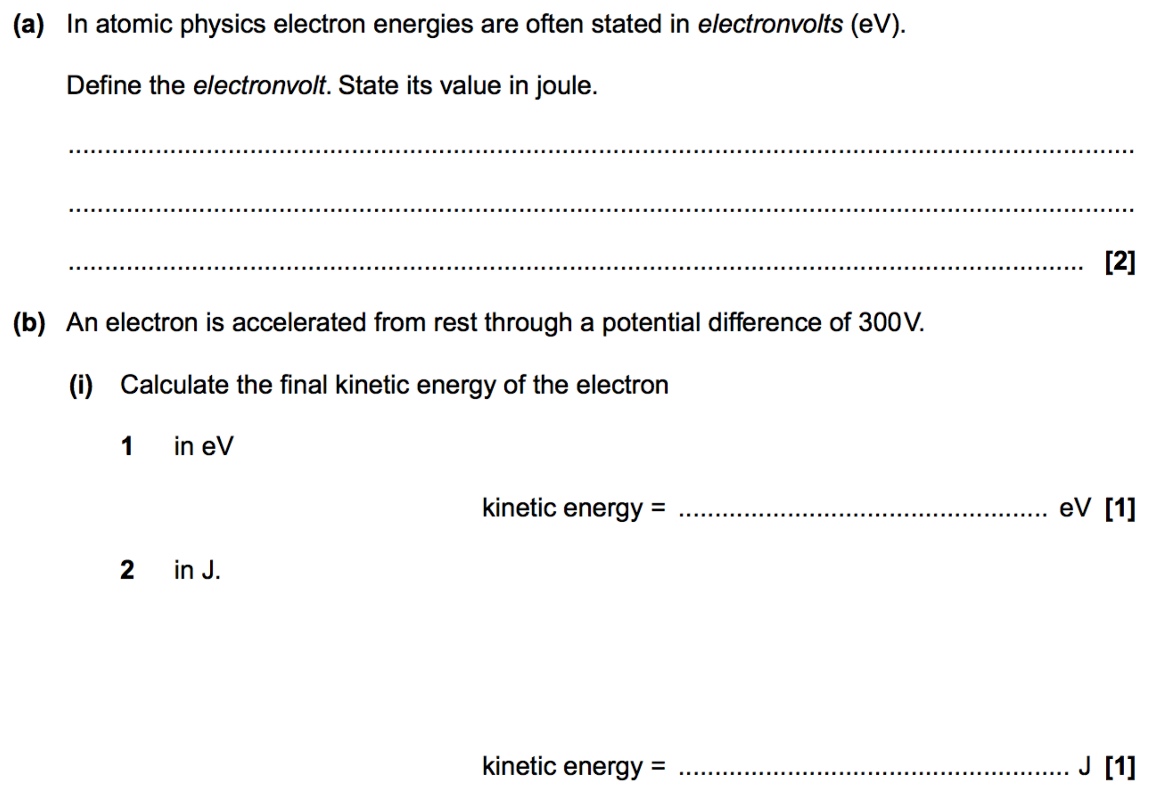

**Calculating Planck’s constant**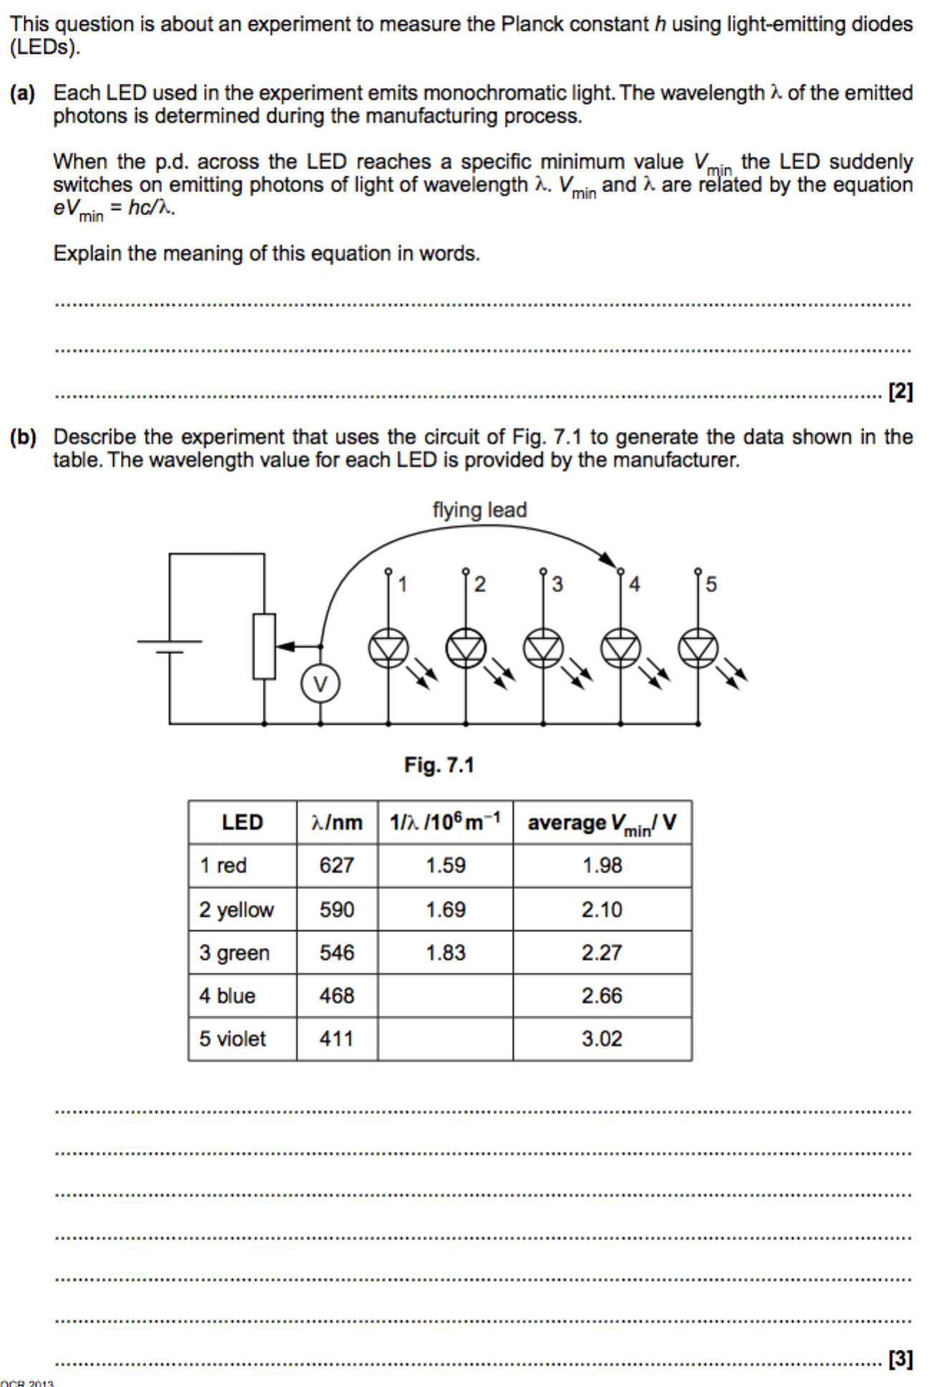

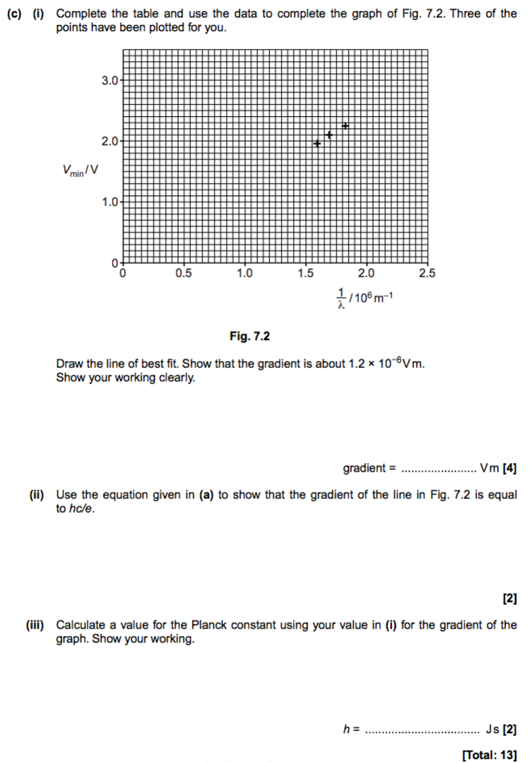

**The photoelectric effect**

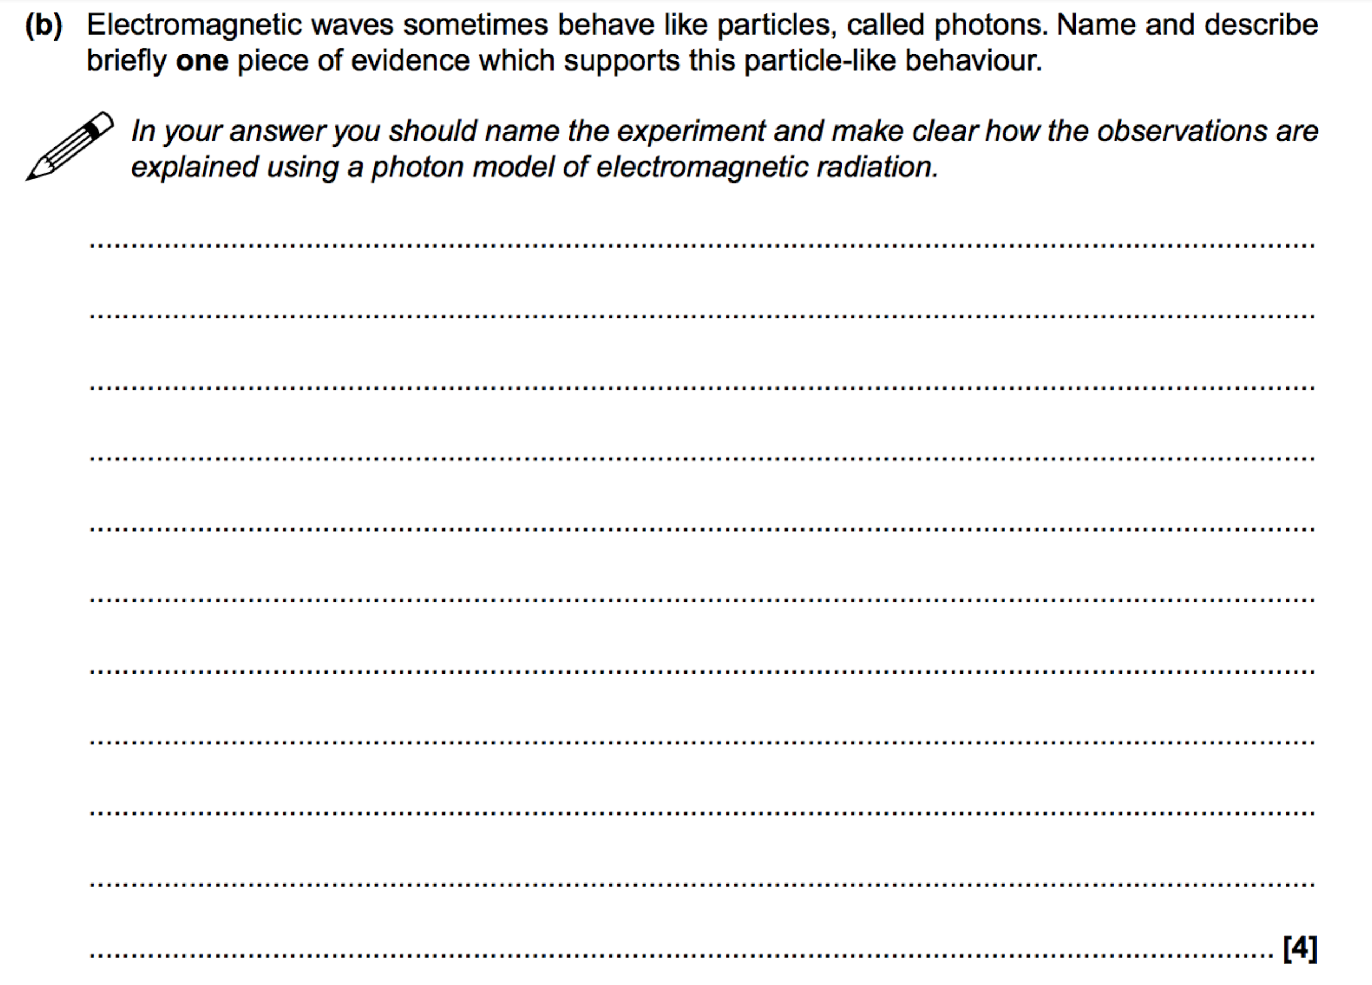

**Einstein’s photoelectric effect equation**

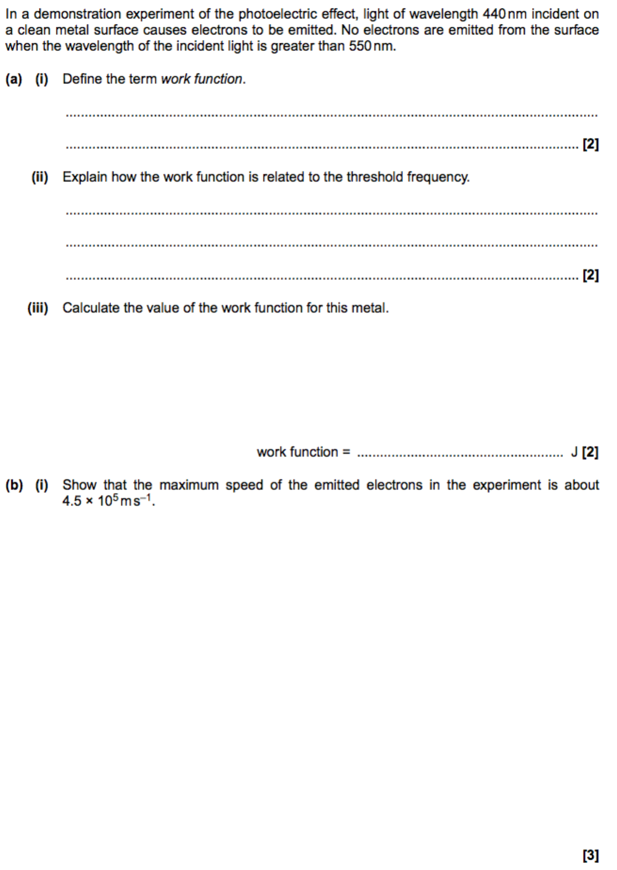



**Wave-particle duality**

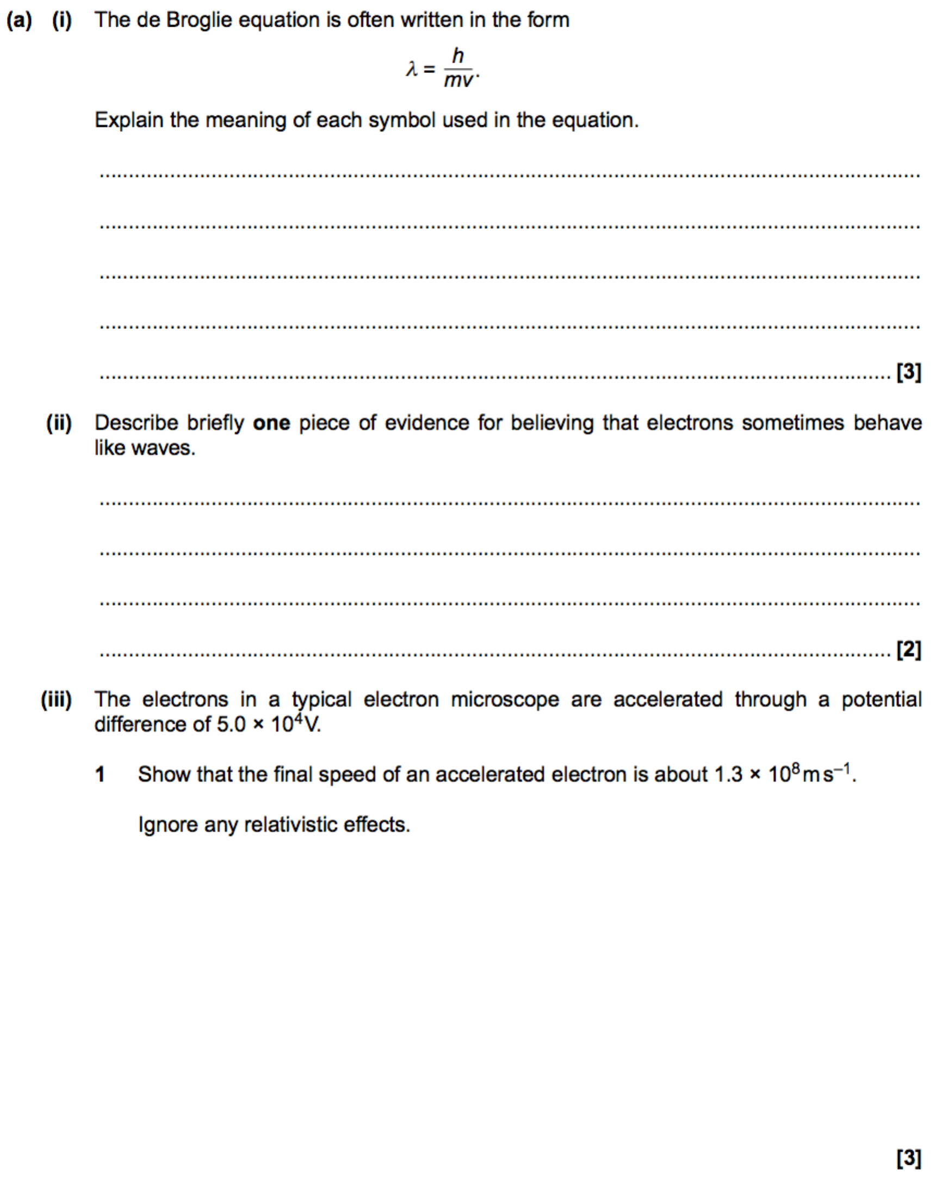

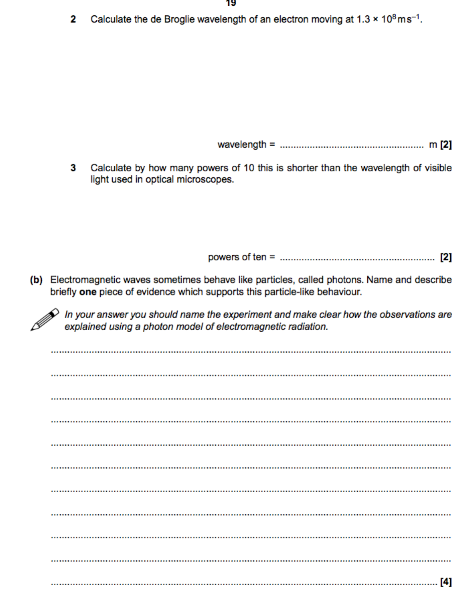

A researcher is investigating the de Broglie wavelength of charged particles.  
  
 The charged particles are accelerated through a potential difference *V*. The de Broglie wavelength *λ* of these particles is then determined by the researcher.  
  
 Each particle has mass *m* and charge *q*.

i. Show that the de Broglie wavelength *λ* is given by the expression .

| [2] |
| --- |

ii. The researcher plots data points on a *λ*2 against grid, as shown below.

|  |
| --- |

|  | 1 | Calculate the percentage uncertainty in *λ* for the data point circled on the grid. | |
| --- | --- | --- | --- |
|  |  | percentage uncertainty = ..................................................... % [2] | |
|  | 2 | Draw a straight line of best fit through the data points. | [1] |
|  | 3 | The charge *q* on the particle is 2*e*, where *e* is the elementary charge.   Use your best fit straight line to show that the mass *m* of the particle is about 10−26 kg. | |
|  |  | [4] | |