Motion and Uncertainty analysis

Topic area | Text book pre-reading | Syllabus ref | Max possible score in exam questions | Your score in exam questions
Key terms, equation and units |  |  | 10
Displacement, velocity and acceleration | p 41 | 3.1.1 | 8
Velocity, acceleration and displacement graphs | p 48-58 | 3.1.1 | 9
Analysing experimental uncertainty and error | p 29-33 | 2.2.1 | 15
Equations of motion (SUVAT) | p 41-42 | 3.1.2 | 8
Acceleration of free-fall (g) | p 43-45 | 3.1.2 | 4
Vehicle stopping distances | p 63- 64 | 3.1.2 | 5
Investigating motion and collisions in objects | p 59-62 | 3.1.2 | 3
Projectile motion | p 46-47 | 3.1.3 | 12
Synoptic question |  |  | 10
Total |  |  | 85

By the end of this topic you should be able to….. | Check
Describe the difference between accuracy and precision and random and systematic error

Calculate and combine percentage and absolute uncertainties

Construct error bars and lines of worst fit to establish uncertainty in a gradient

Define and calculate displacement, instantaneous speed, average speed, velocity and acceleration

Describe features of distance-time and displacement-time graphs and calculate the gradient to find velocity (including for non-linear graphs)
Describe features of speed-time and velocity-time graphs and calculate the gradient to find acceleration and area underneath to find total distance/displacement (including for non-linear graphs)
Use the equations of motion in calculations
Describe methods to measure acceleration of free-fall (g)
Define and explain factors that affect stopping distance, thinking distance and braking distance
Calculate variables in projectile motion by splitting into horizontal and vertical components of motion
Glossary of key terms- Match the term to the definition (5)
Accuracy, Precision, Resolution, Random error, Systematic error, Zero error, Absolute uncertainty, Percentage uncertainty, Scalar quantity, Vector quantity, Distance, Displacement, Speed, Velocity, Acceleration
How close a measured value is to a true value
These cause readings to differ from the true value by a consistent amount each time a measurement is made
The interval within which the true value can be expected to lie given as a percentage of the measured value
Displacement per unit time
The complete length travelled
How close each measured value is to another measured value
These cause readings to be spread about the true value, due to results varying in an unpredictable way from one measurement to the next
Any indication that a measuring system gives a false reading when the true value of a measured quantity is zero
The interval within which the true value can be expected to lie.
Has only magnitude
Has magnitude and direction
Distance travelled in a particular direction
Change in velocity per unit time
Distance travelled per unit time
The smallest change in the quantity being measured (input) of a measuring instrument that gives a perceptible change in the reading.

Equations given in exam- Complete the table with the definition of each variable symbol (5)
Variable symbol | Variable | Unit symbol
s

u

v

a

t

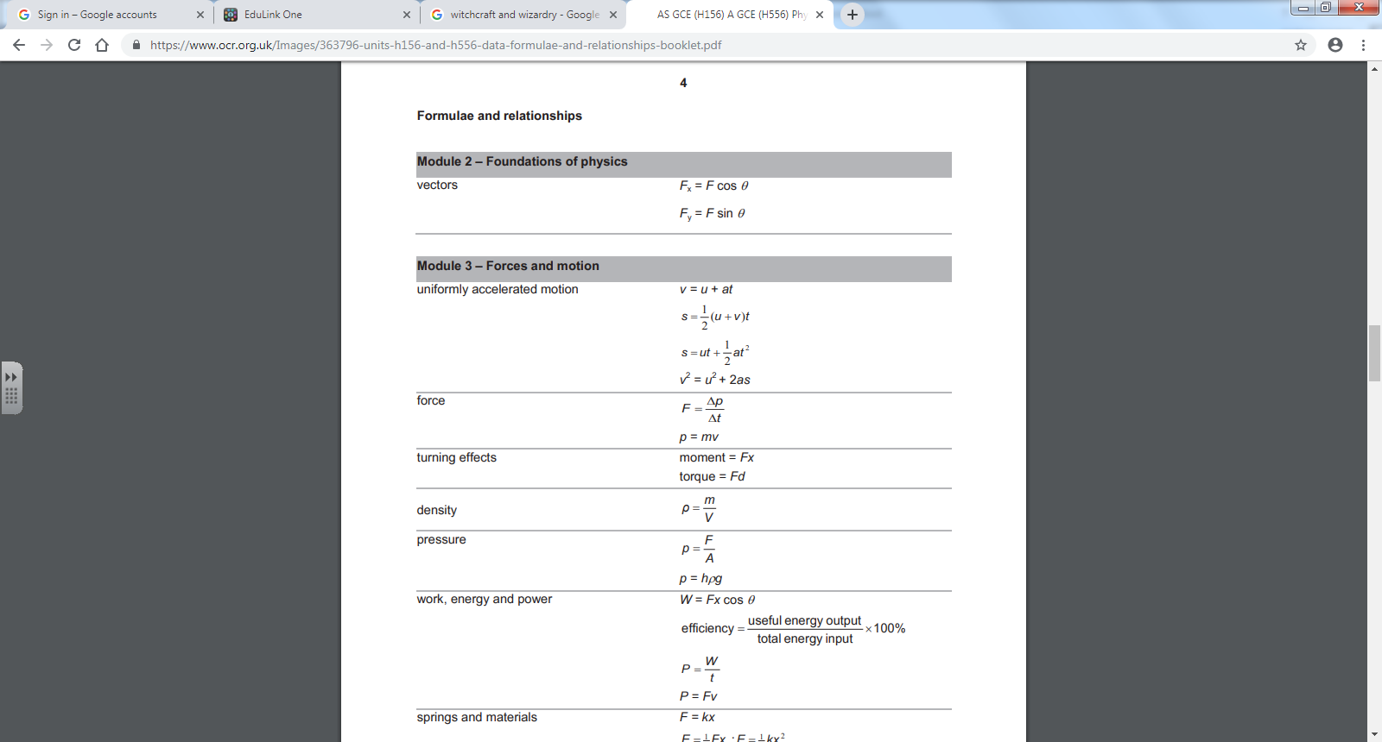

Displacement, velocity and acceleration
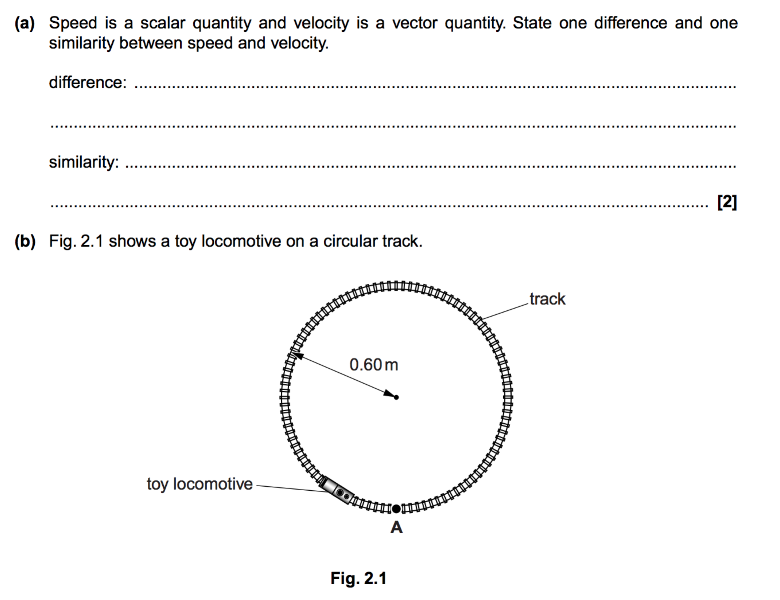
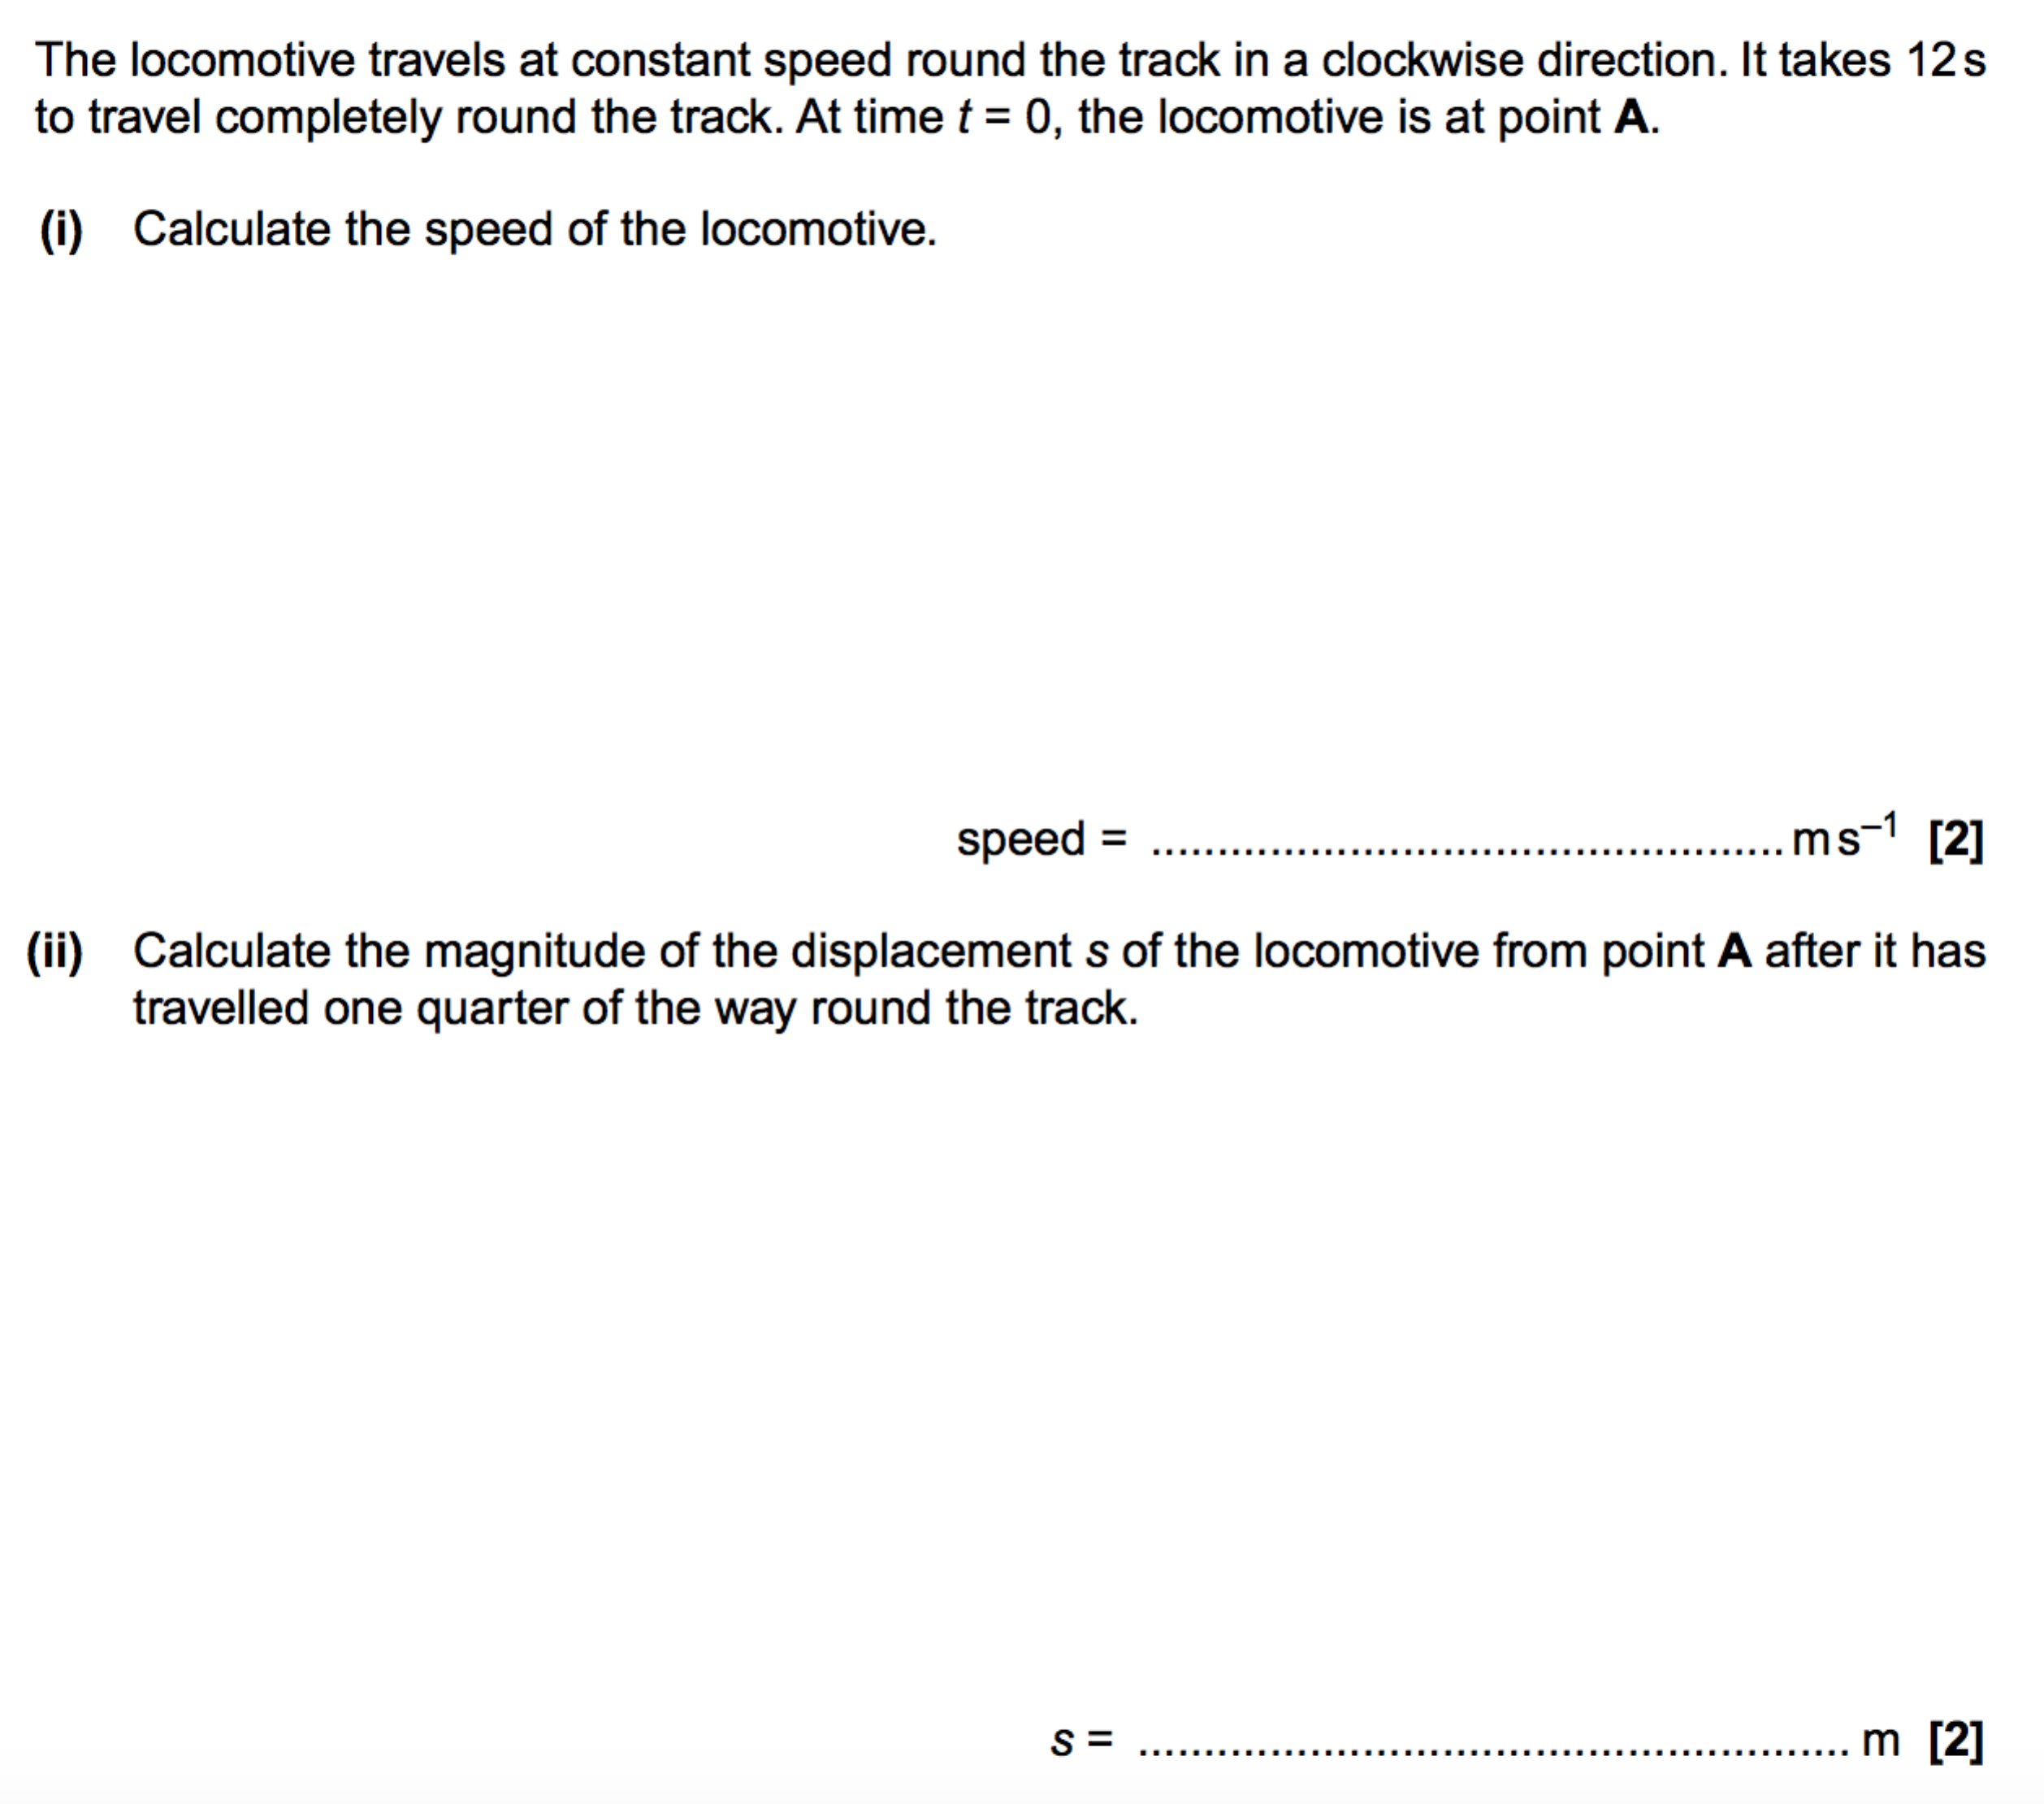
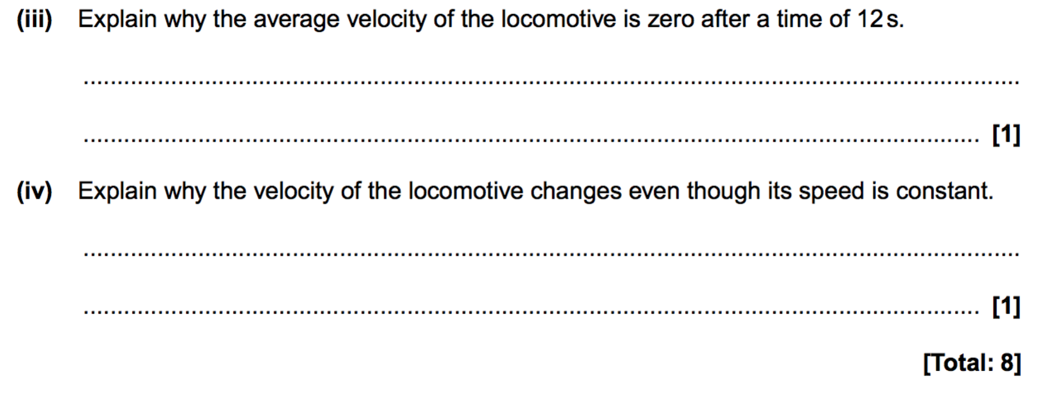

Velocity, acceleration and displacement graphs
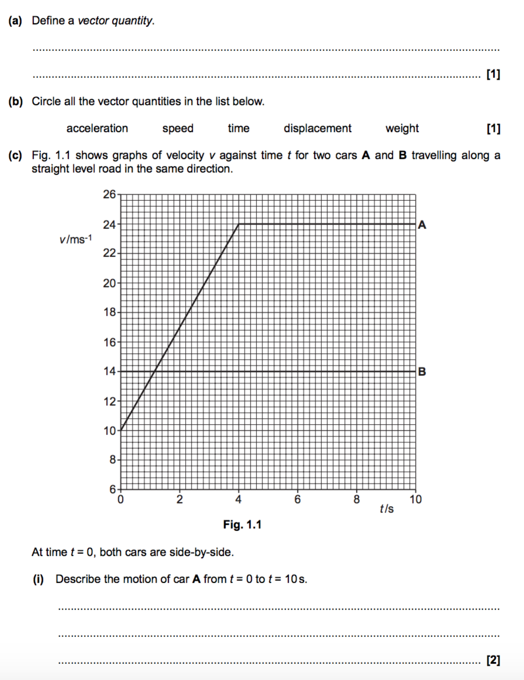
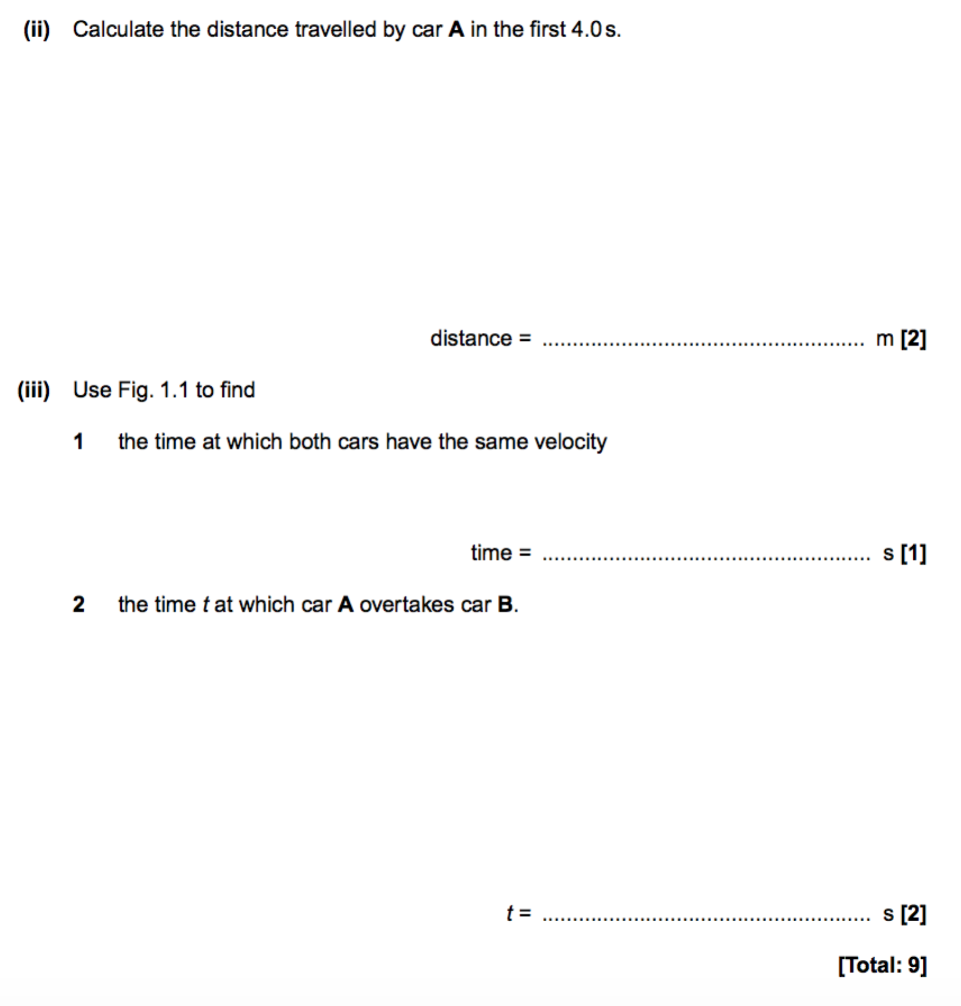

Analysing error and uncertainty in experiments
1. | A metal strip has thickness t, as shown below.  Five measurements of the thickness t at different positions along the length of the strip are shown below.  1.86 mm 1.88 mm 1.85 mm 1.89 mm 1.88 mm  Determine the percentage uncertainty in the thickness t.  percentage uncertainty = ..................................................... % [3]

2. | A toy parachute is falling through air.  The air resistance F acting on the parachute is given by the expression  F = kv ²  where v is the speed of the parachute and k is a constant.  The following items of data are collected for the parachute.  • v = 1.20 ± 0.12 m s⁻¹  • F = 4.00 ± 0.24 N  Calculate the absolute uncertainty in k. Write your answer to 2 significant figures.  absolute uncertainty in k = ..................................................... kg m⁻¹ [3]

3(a). | A student measures the diameter of a ball in different directions.  The student’s results are:  2.43 cm 2.54 cm 2.59 cm  - State the name of a suitable measuring instrument to measure the diameter of the ball.  [1]  - Calculate the mean diameter d of the ball.  Include the absolute uncertainty in d.  d = ................... ± ................... cm [2]  - Show that the volume of the ball is about 8.4 × 10^{–6} m³.  [1]  - The mass of the ball is 23 ± 1 g.  Determine the density ρ of the ball.  Give your answer to an appropriate number of significant figures.  ρ = ............................................. kg m^{-–3} [2]  - Determine the percentage uncertainty in ρ.  percentage uncertainty = ..................................................... % [2]

Equations of motion
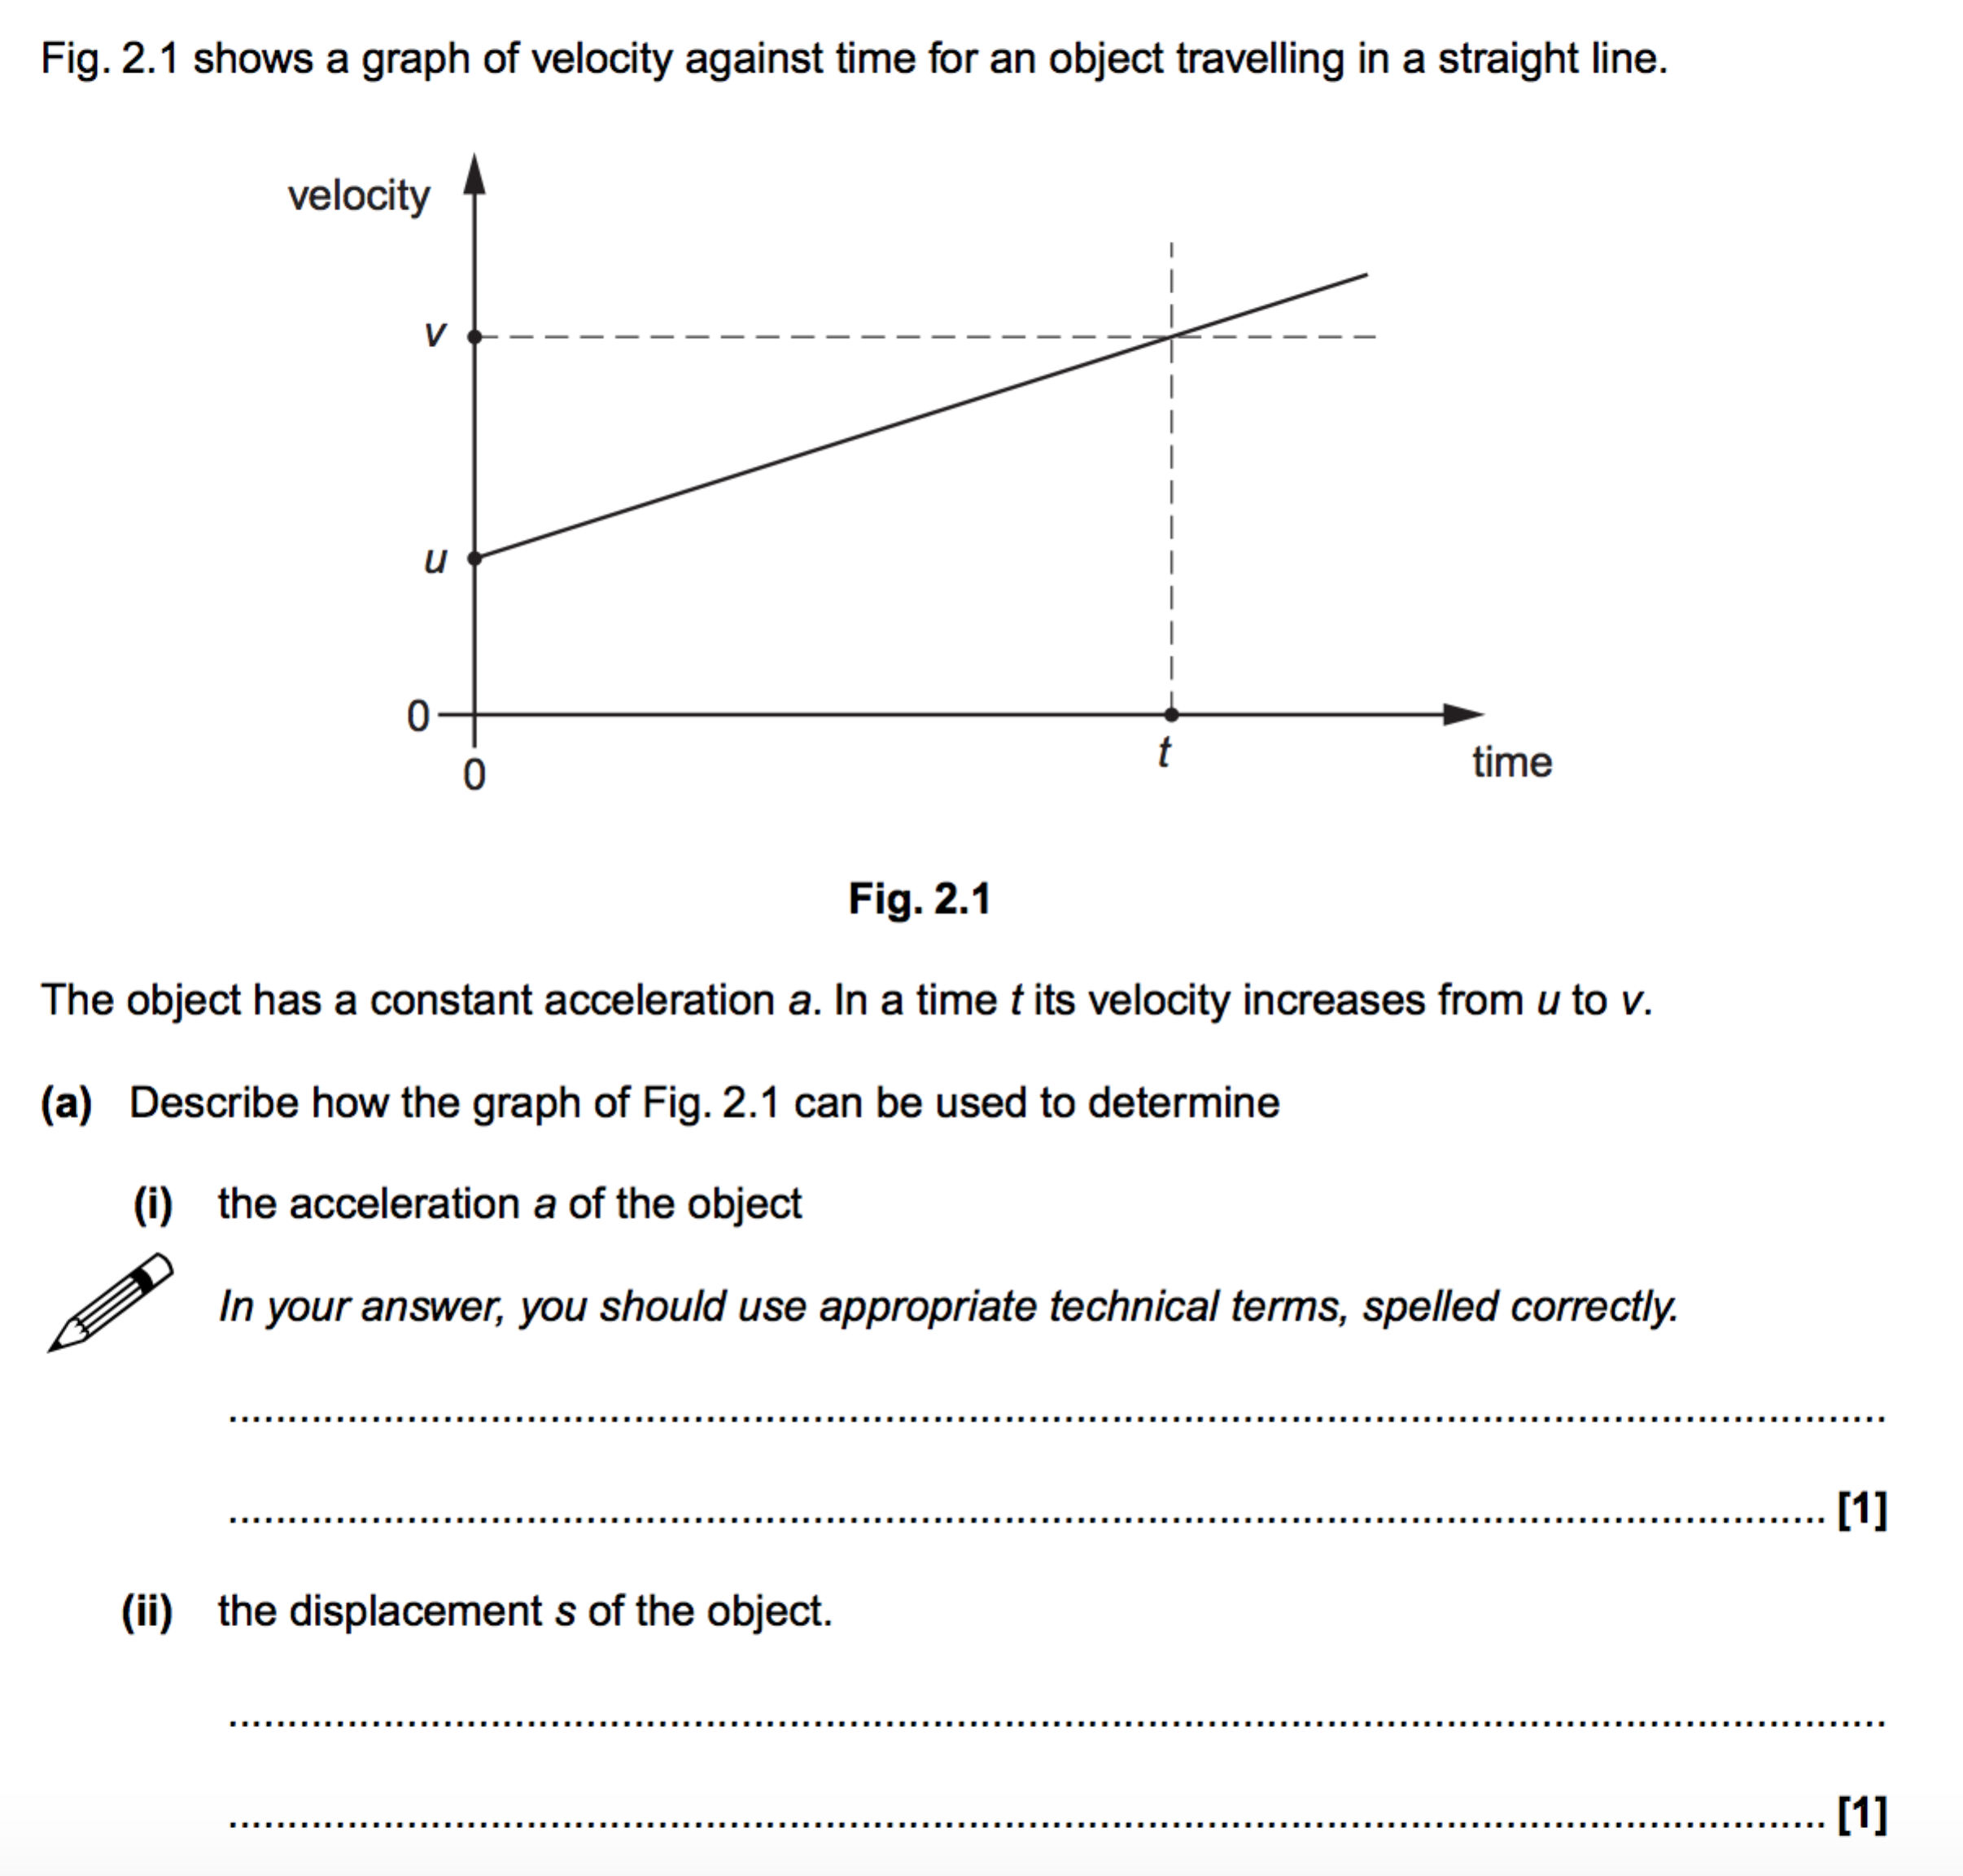
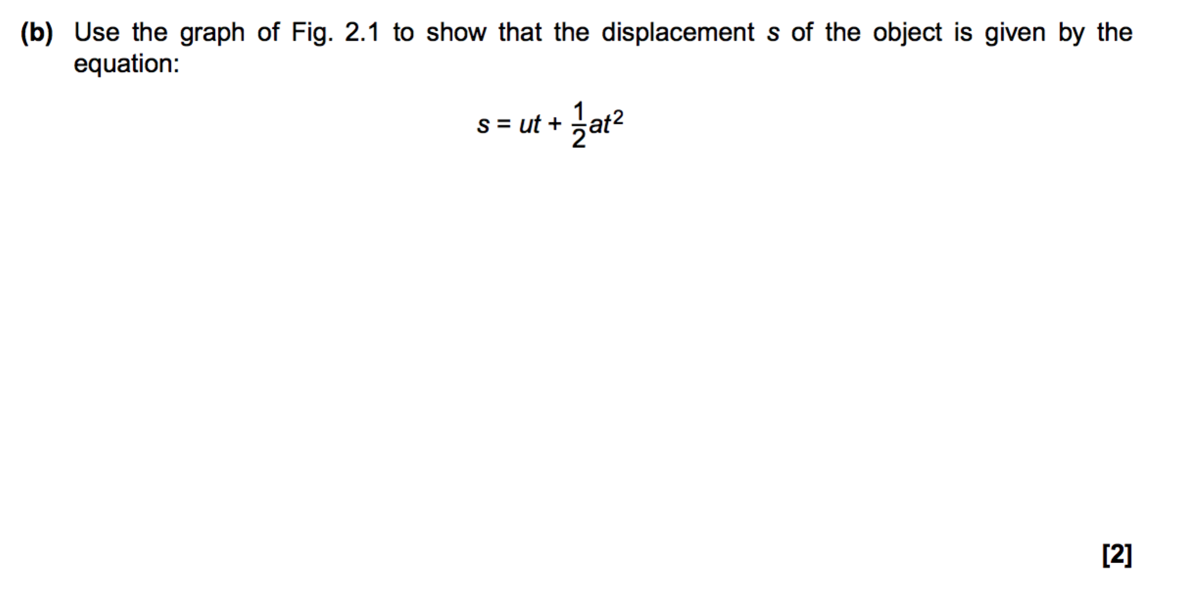
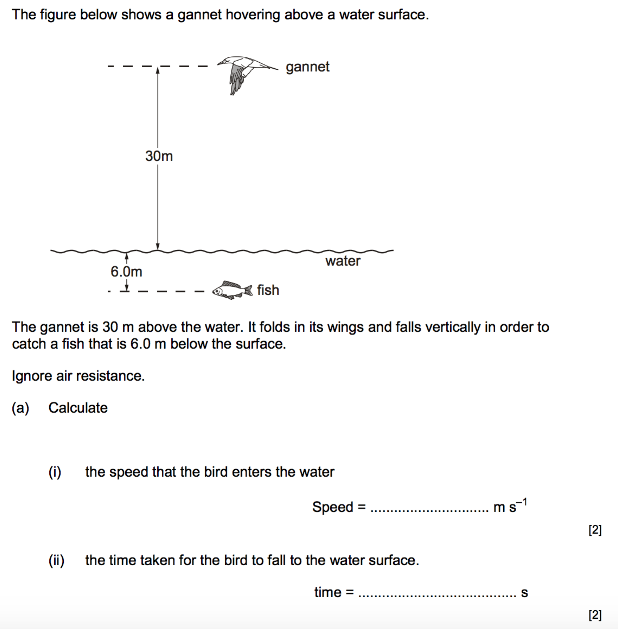
Acceleration due to gravity = 9.81 ms⁻²

Acceleration of free fall
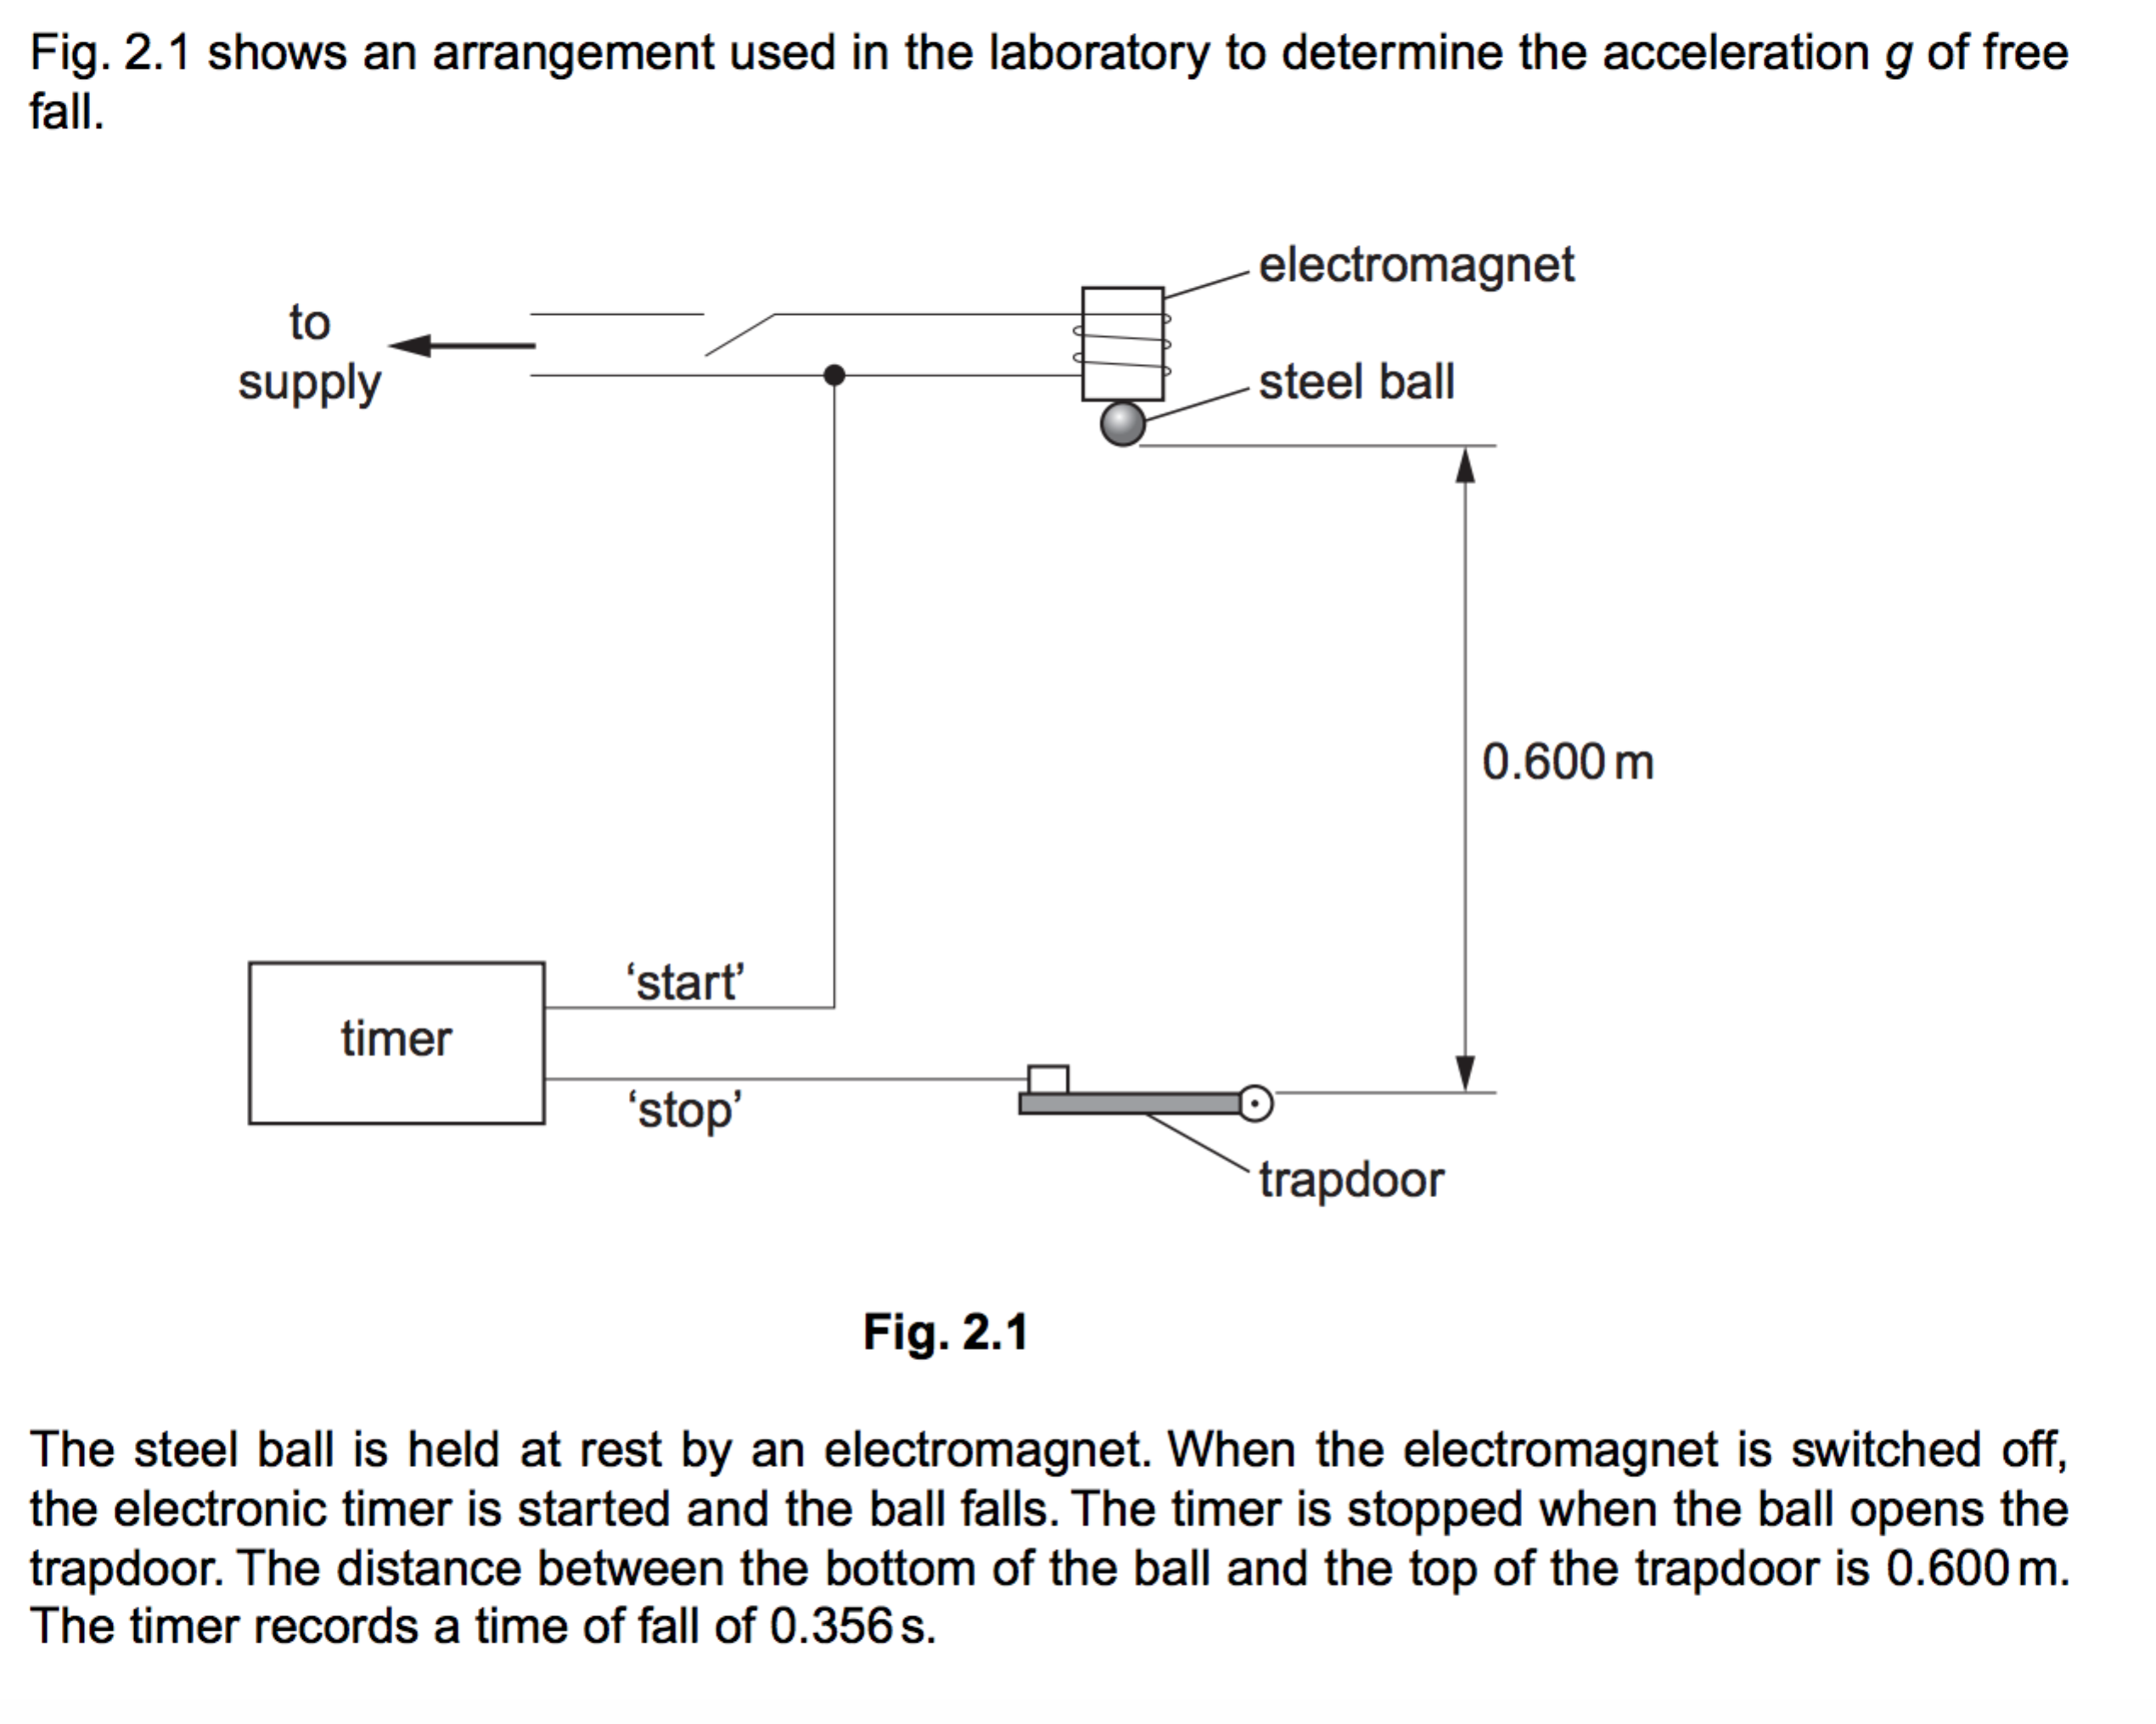
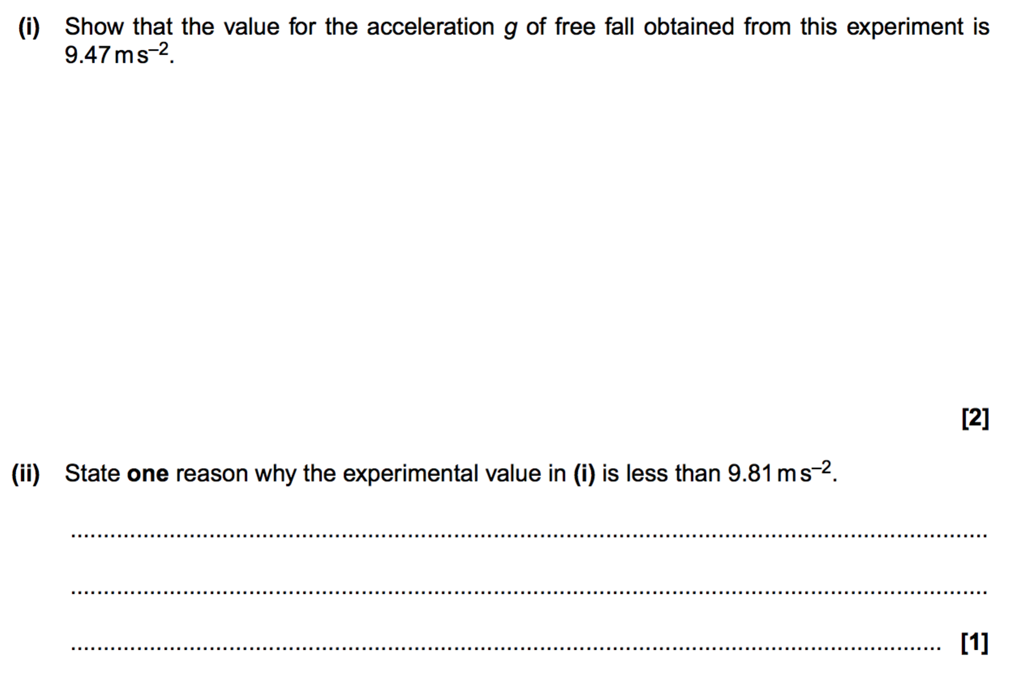
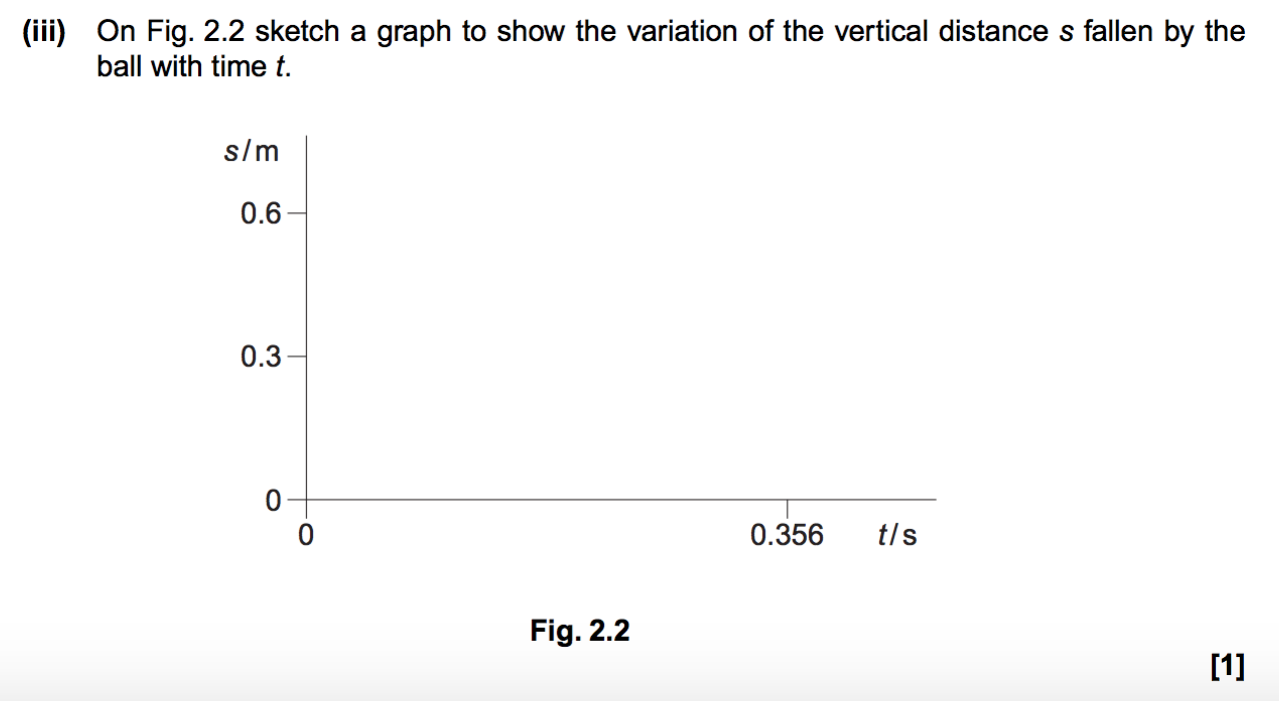

Vehicle stopping distances
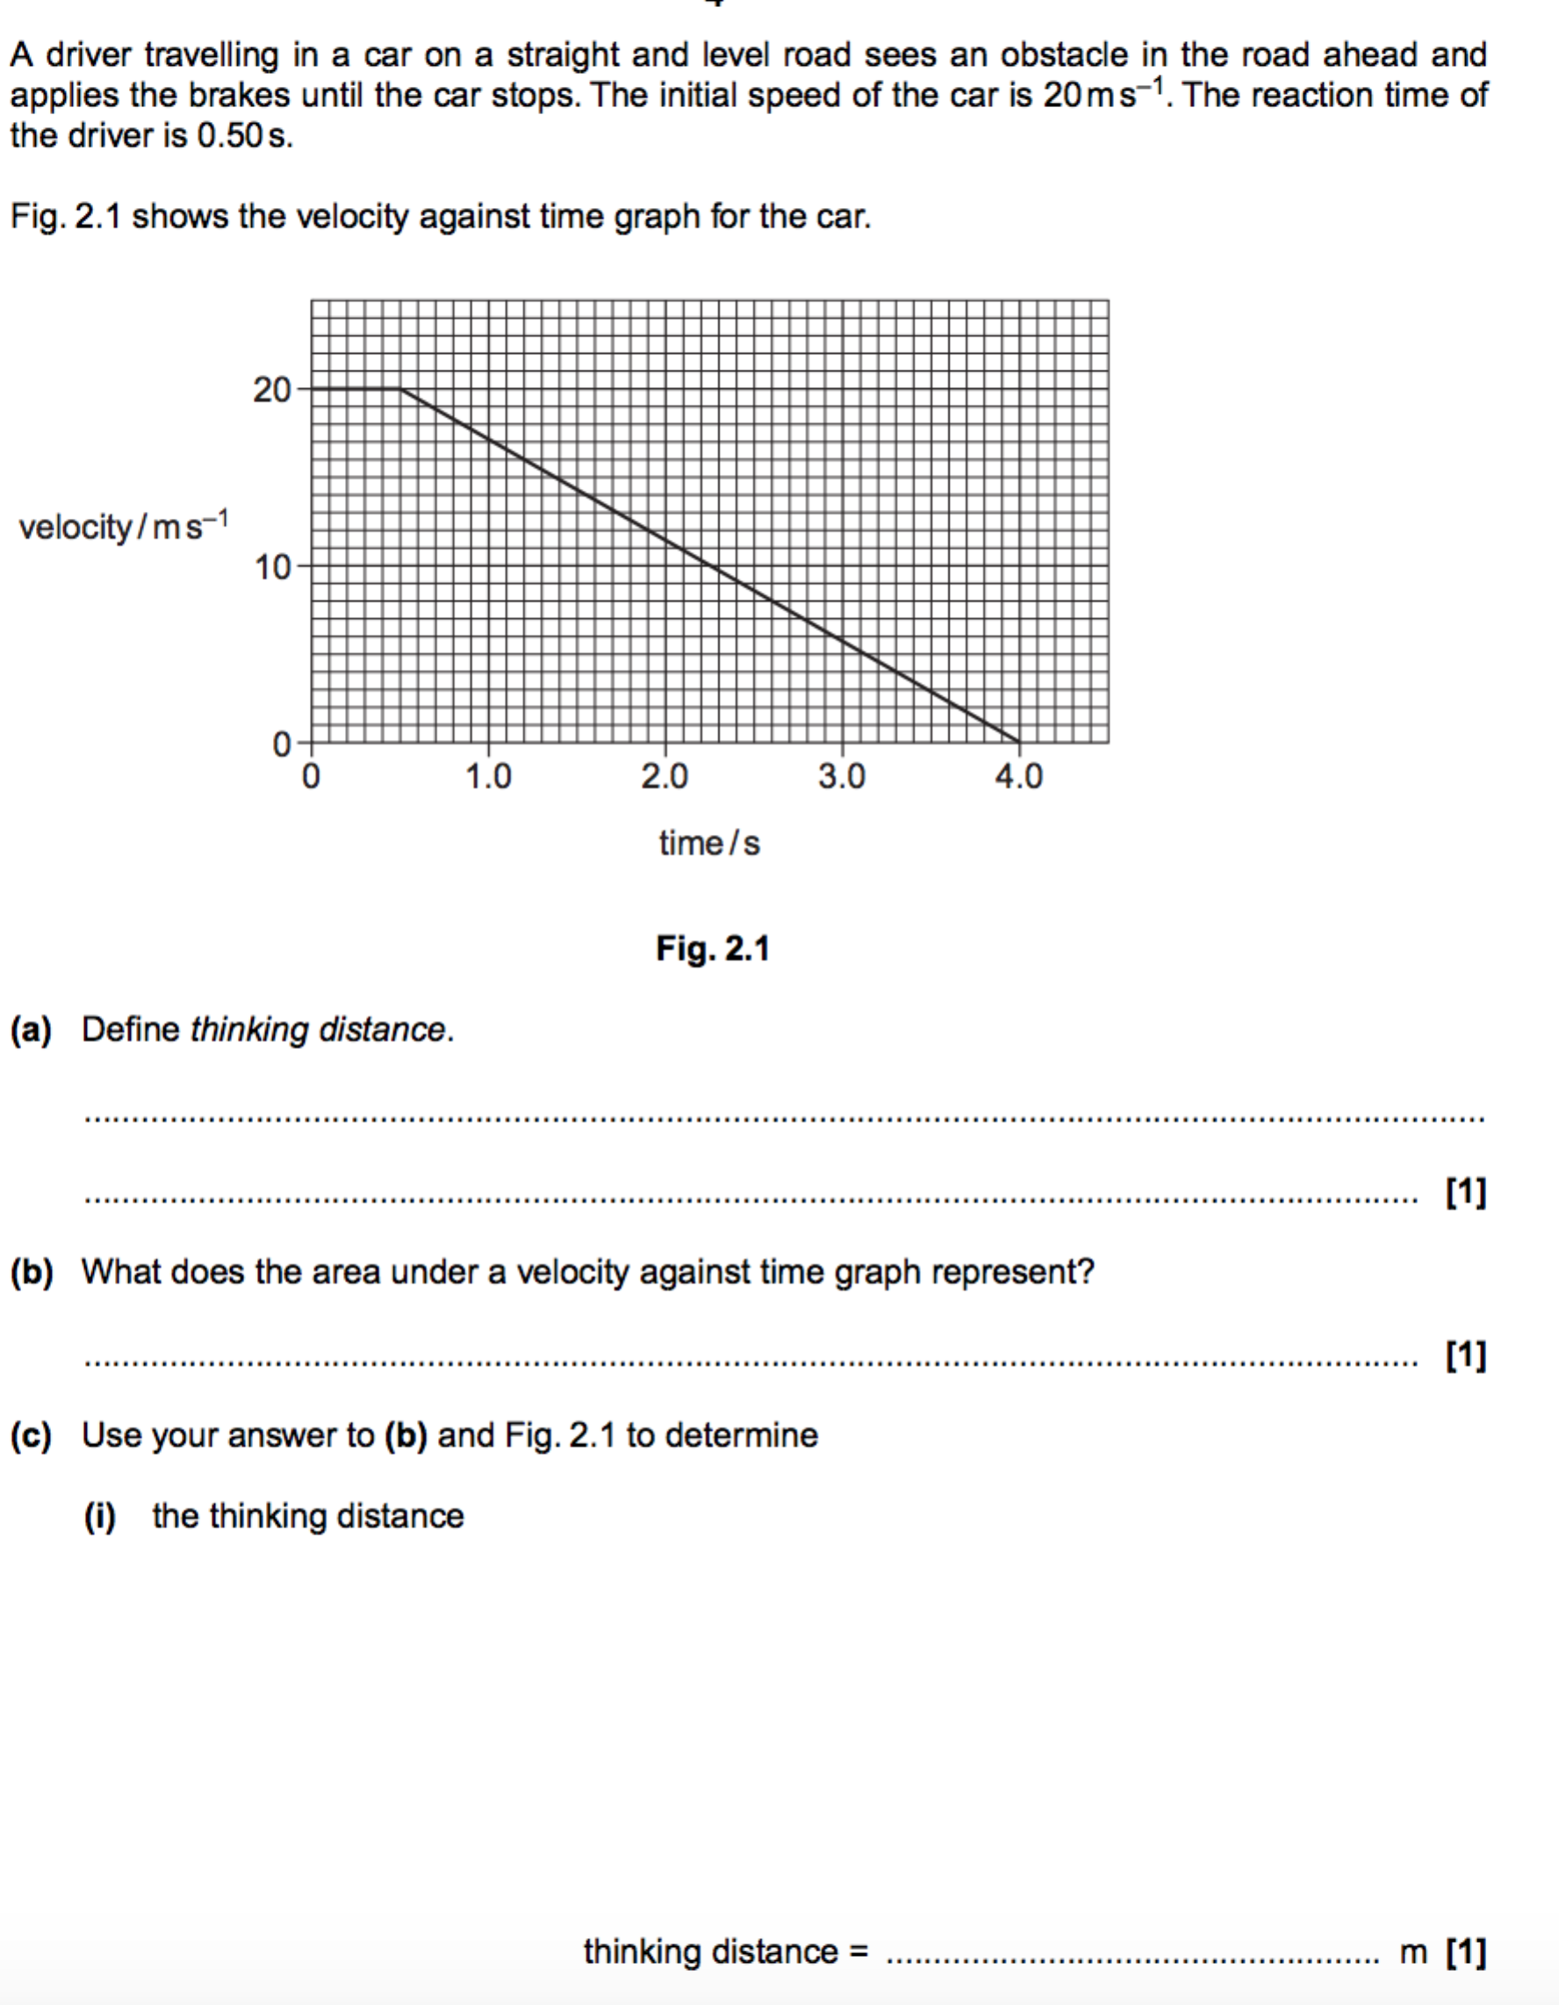
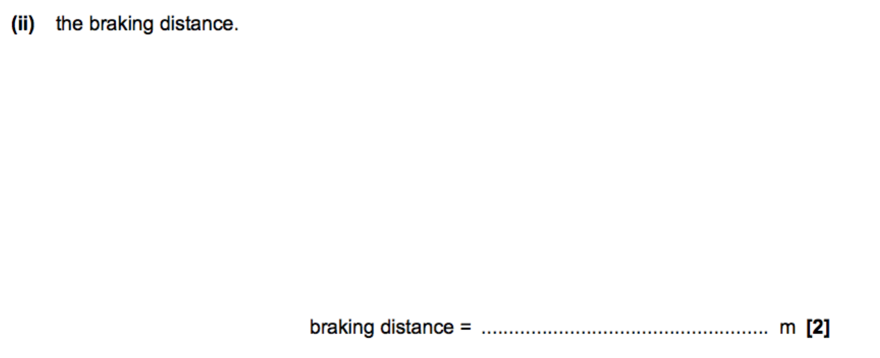
Investigating motion and collisions of objects
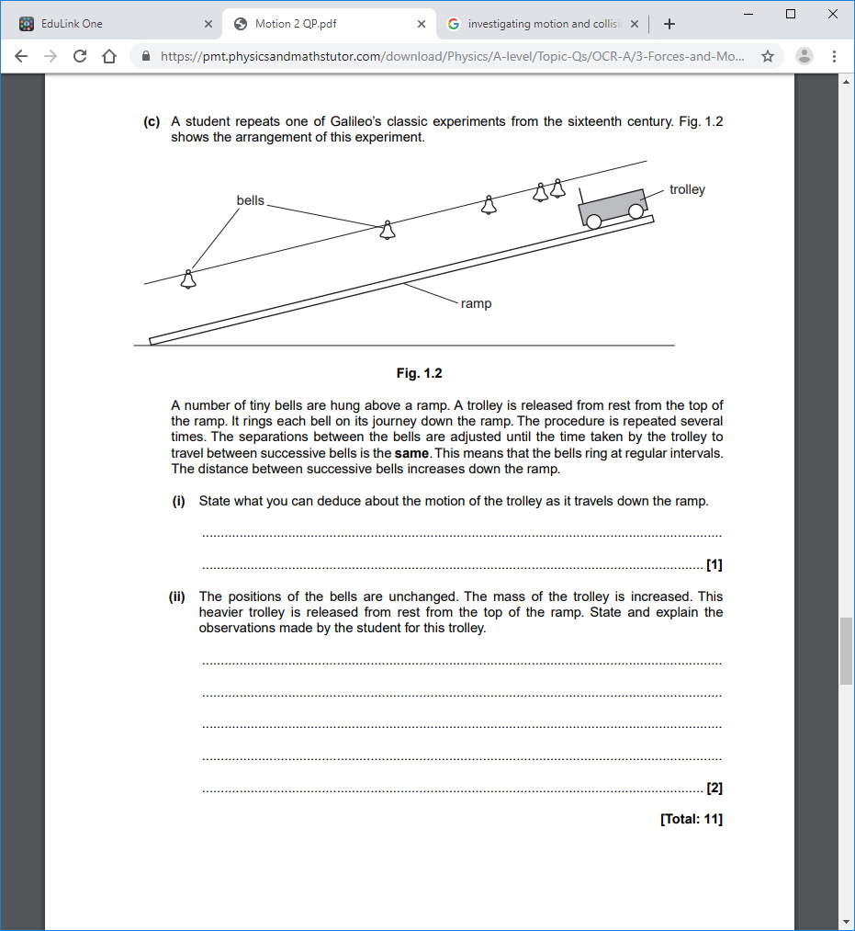Total: 3
Projectile motion
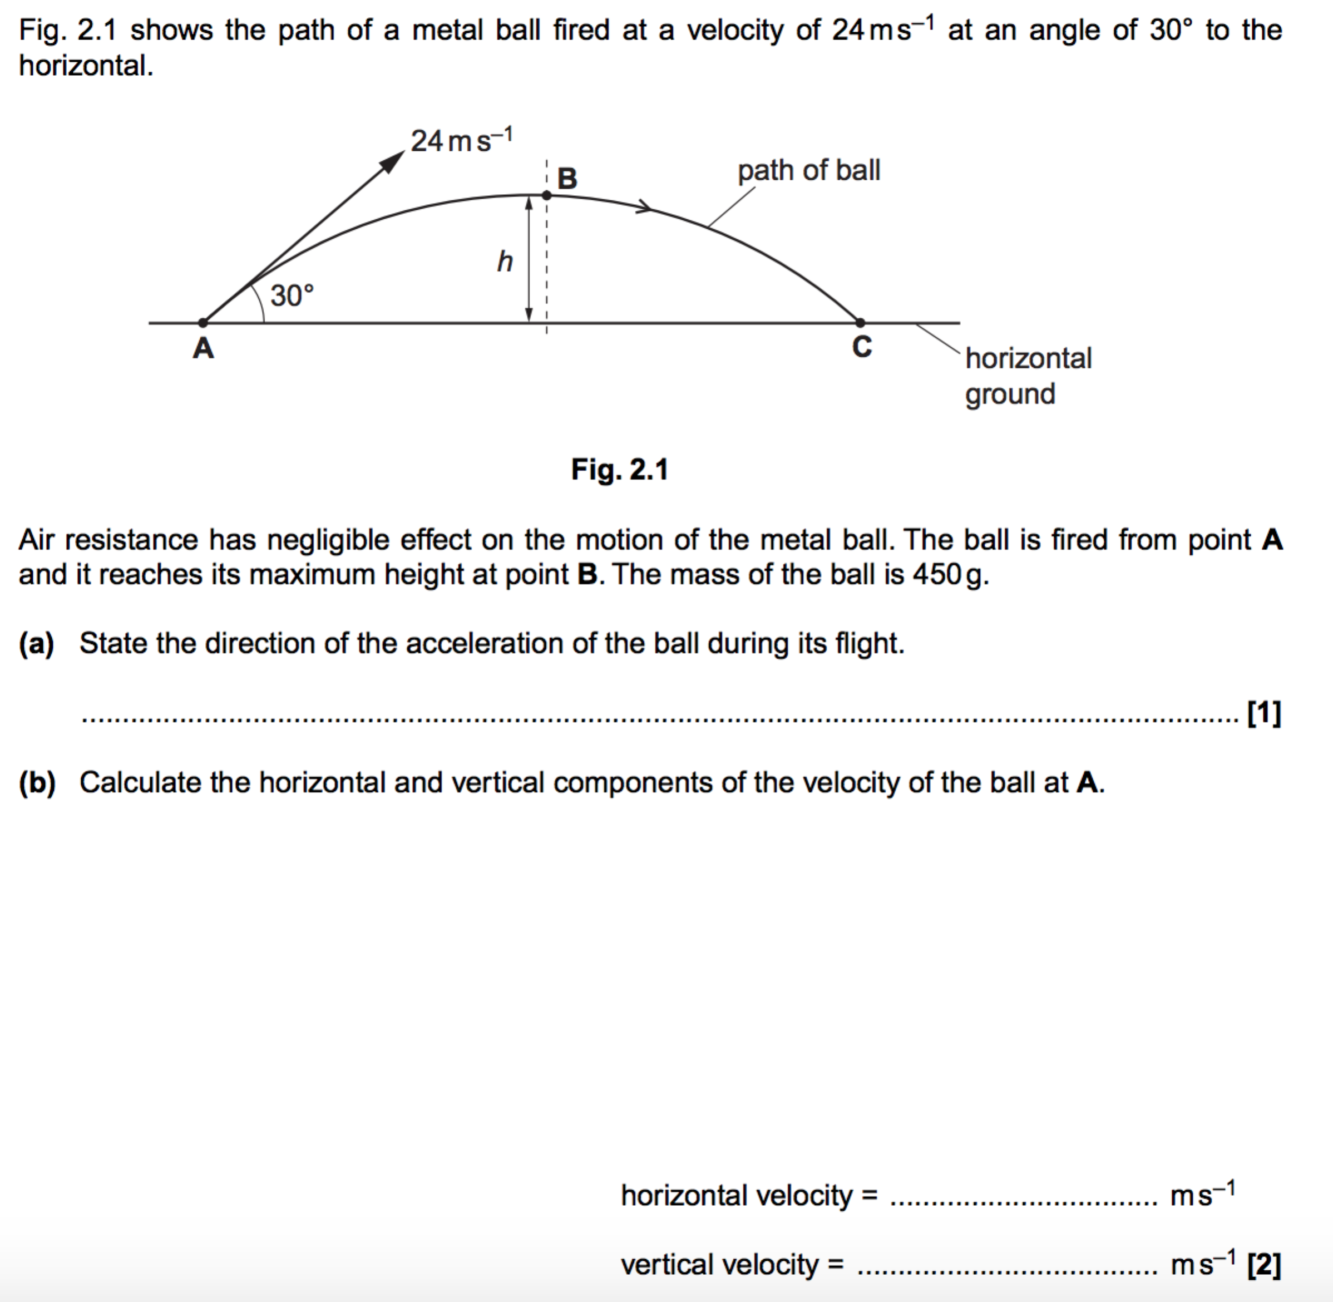
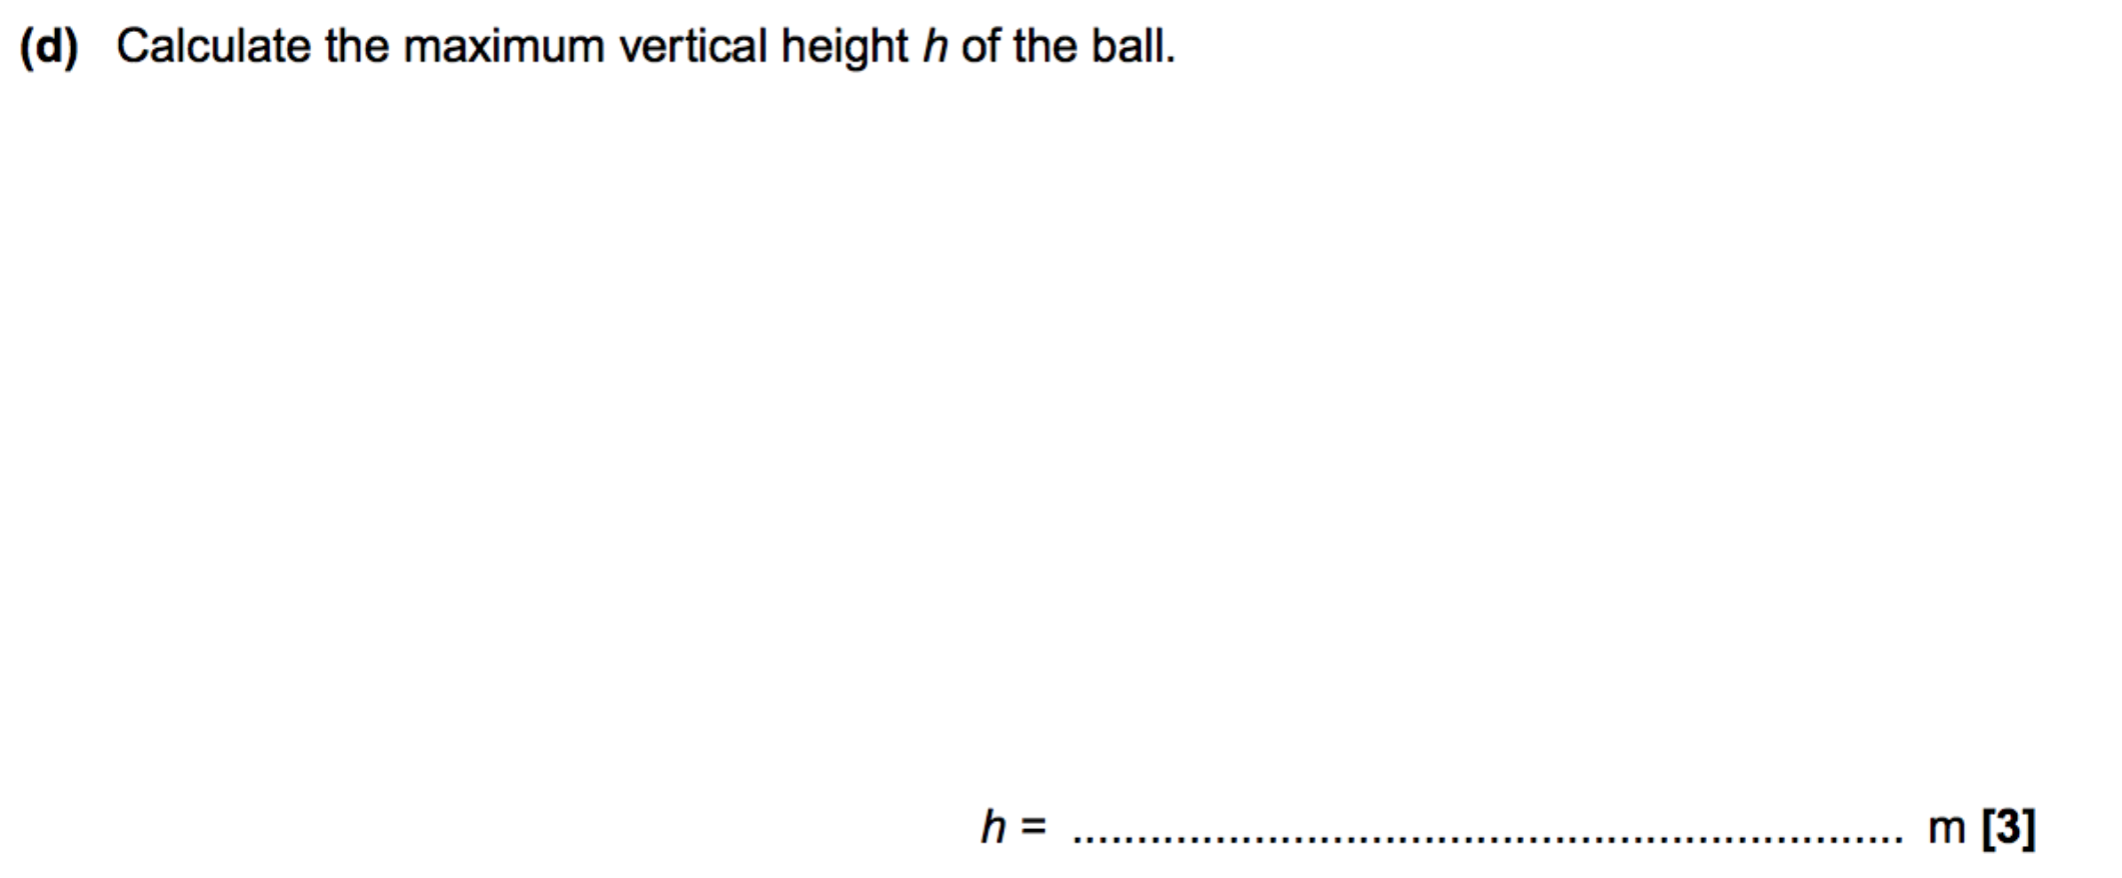
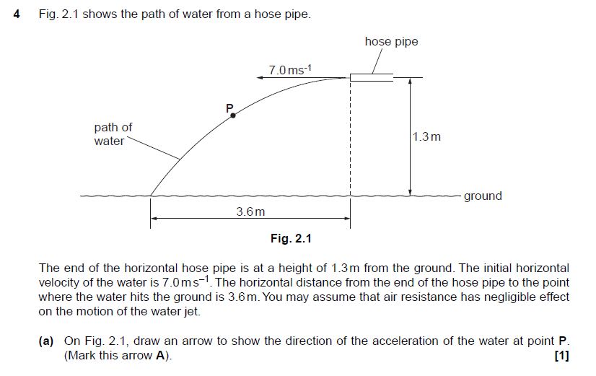

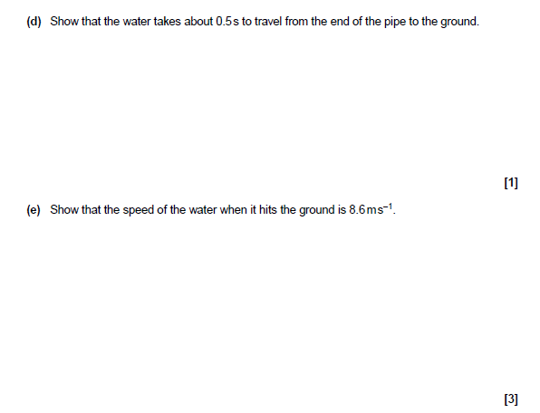
Synoptic question
1 (a). | A student is carrying out an experiment in the laboratory to determine the acceleration of free fall g. The student drops a small steel ball from rest and records the time t taken for the ball to fall through a vertical distance h.  The results for different vertical distances are shown in the table below.  h / m t / s t² / s²  0.660 0.365 0.133  0.720 0.385 0.148  0.780 0.400 0.160  0.840 0.415 0.172  0.900 0.430  0.960 0.445 0.198  Complete the table for the missing value of t². [1]

(b). | Fig. 3 shows the graph of t² (y-axis) against h (x-axis).  (i) Plot the missing data point and draw the straight line of best fit. [2]  Fig. 3  (ii) Determine the gradient of the straight line of best fit.  gradient = s² m⁻¹ [1]

(c). | - Use the equations of motion for constant acceleration to show that the relationship between t and h is  where g is the acceleration of free fall.  [1]  - Use your answer to (b)(ii) to determine the experimental value for g.  g = m s⁻² [1]

(d). | Describe and explain how the student could use standard laboratory equipment to make accurate measurements of h and t.  __________________________________________________________________________  __________________________________________________________________________  __________________________________________________________________________  __________________________________________________________________________  __________________________________________________________________________  __________________________________________________________________________  __________________________________________________________________________  __________________________________________________________________________  __________________________________________________________________________  [4]

