Module 5.1 Thermal Physics

|  |  |  |  |  |
| --- | --- | --- | --- | --- |
| **Topic area** | **Text book pre-reading** | **Syllabus ref** | **Max possible score in exam questions** | **Your score in exam questions** |
| States of matter and Brownian motion | p13-14 | 5.1.2 | 3 |  |
| Specific heat capacity and temperature | p15-18 | 5.1.3 & 5.1.1 | 18 |  |
| Specific latent heat and internal energy | p19-21 | 5.1.3 | 24 |  |
| Kinetic theory and gas pressure | p29-31 | 5.1.4 | 9 |  |
| Investigating gases | p22-25 | 5.1.4 | 18 |  |
| The ideal gas equation | p27-28 | 5.1.4 | 13 |  |
| The Boltzmann constant | p32-34 | 5.1.4 | 20 |  |
| **Total** | | | 105 |  |

**By the end of this topic you should be able to….**

* Define what is meant by temperature and how this is measured (Celsius versus Kelvin)
* Describe the properties of solids, liquids and gases
* Describe what is meant by Brownian motion and experiments that demonstrate this
* Describe how internal energy comprises of the total kinetic and potential energy and how this varies in solids, liquids and gases
* Define specific heat capacity, perform calculations involving this and describe experiments to measure this
* Define specific latent heat, perform calculations involving this and describe experiments to measure this
* Calculate the number of moles in a substance using Avogadro constant
* Describe the kinetic theory of gases
* Describe the relationships between temperature, volume and pressure on a gas.
* Define absolute zero and describe a method to estimate this
* Use the equation pV = 1/3 Nmc2
* Describe the Maxwell-Boltzmann distribution and root mean speed
* Derive the equation 1/2mc2 = 3/2kT from pV = 1/3 Nmc2 and pV = NkT, where k is the Boltzmann constant

**By the end of module 5.1 you need to be able to define the following key terms:**

Absolute zero

Absolute scale of temperature

Avogadro’s constant

Boltzmann constant

Boyle’s law

Brownian motion

Charles’ law

Ideal gas

Ideal gas equation

Internal energy

Kinetic theory model of a gas

Mean square speed

Mole

Pressure-temperature law

Specific heat capacity

Specific latent heat

Temperature

Thermal equilibrium

**Equations given in exam**

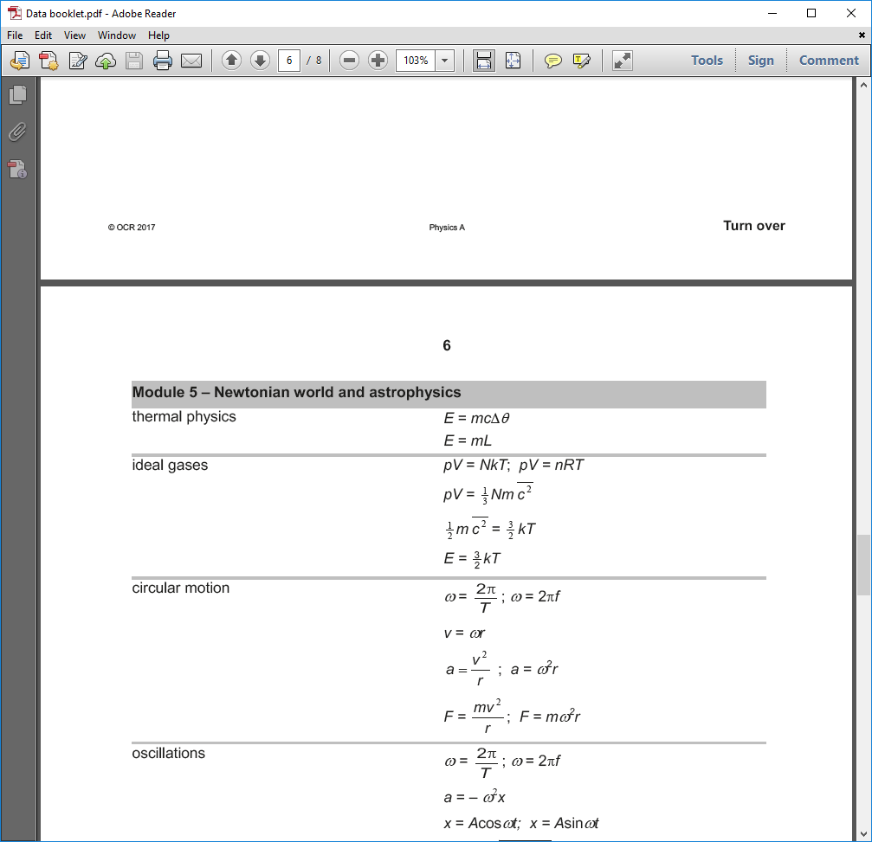

**States of Matter and Brownian motion**

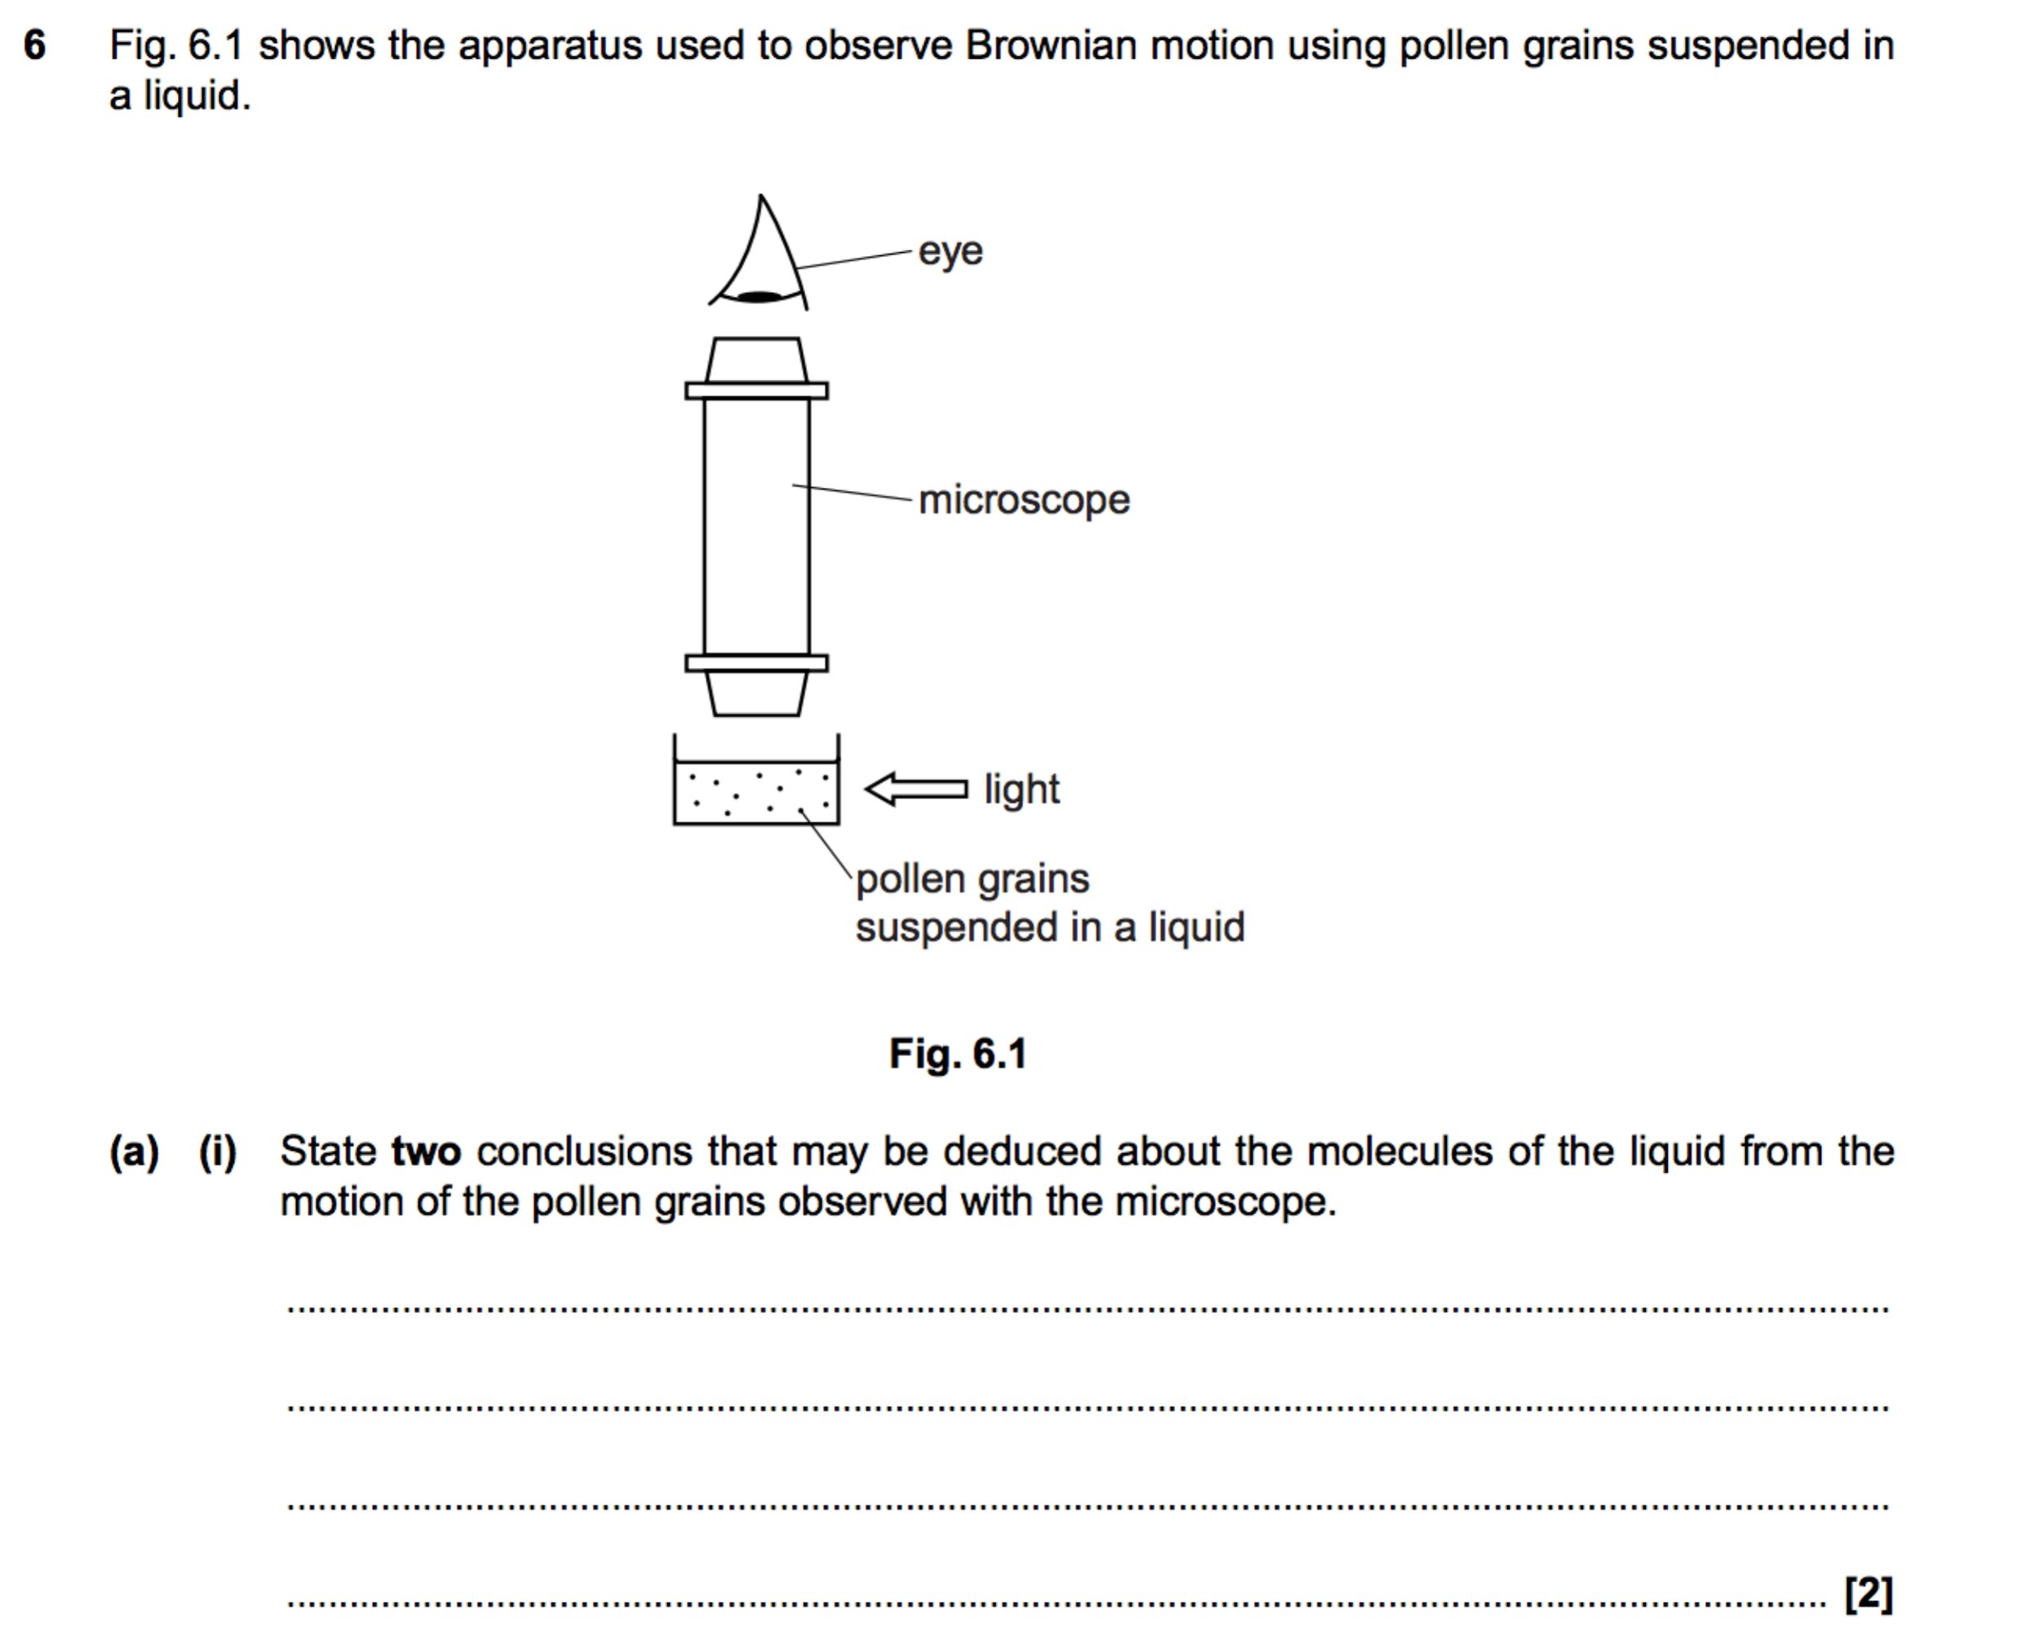

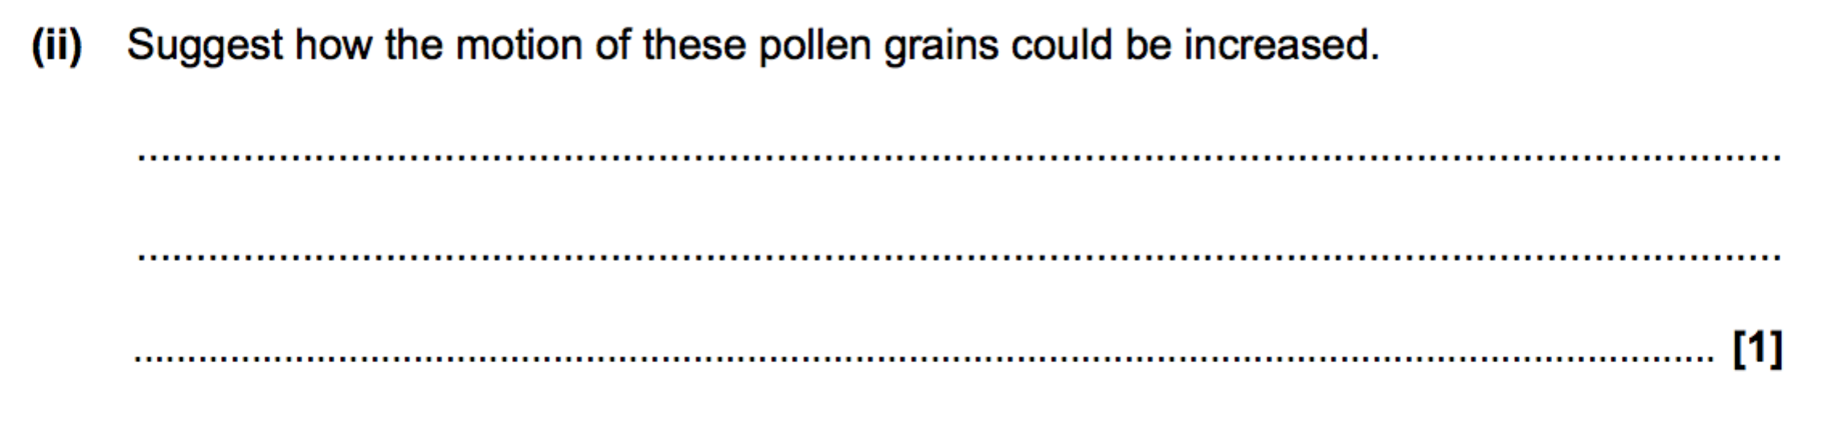

**Specific heat capacity and temperature**

|  |  |  |  |  |  |  |  |
| --- | --- | --- | --- | --- | --- | --- | --- |
|  | |  |  | | --- | --- | |  |  | | **1(a).** | A substance can exist as a crystalline solid, a liquid or a gas. A solid sample of the substance is placed in a sealed container and heated at a constant rate until it changes into a gas.  Fig. 21 shows the variation with time t of the temperature θ for the substance.   |  | | --- | | **Fig. 21** |   Use Fig. 21 to explain how the specific heat capacity of the liquid compares with the specific heat capacity of the solid.        **[2]** | | |
|  | | |  |  | | --- | --- | |  |  | | **(b).** | Use the kinetic theory of matter to describe the solid phase (section **AB**) and the liquid phase (section **CD**) in terms of the motion and arrangement of the molecules of the substance.     |  |  | | --- | --- | | Section **AB**: |  | |  | | |  | | |  | | |  | | |  | | | Section **CD**: |  | |  | | |  | | |  | | |  | | | **[4]** | | | |
|  | | |  |  | | --- | --- | |  |  | | **2(a).** | Fig. 6.1 shows a tube containing small pellets of lead. When the tube is inverted the pellets of lead fall freely through a vertical height equal to the length of the tube. The pellets are warm after the tube has been inverted many times.    The tube is used in an experiment to determine the specific heat capacity of lead. The following results are obtained. total mass of lead pellets = 0.025 kg number of inversions = 50 length of tube = 1.2 m change in temperature of the lead = 4.5 °C  Use this information to calculate the specific heat capacity of the lead.  specific heat capacity ........................................................... J kg−1 K−1**[4]** | |
|  | | |  |  | | --- | --- | |  |  | | **(b).** | State **two** assumptions you have made in your calculation of the specific heat capacity.        **[2]** | |

|  |  |  |  |  |  |
| --- | --- | --- | --- | --- | --- |
|  | |  |  | | --- | --- | |  |  | | **(c).** | State and explain the change, if any, you would expect to see in the temperature rise if the mass of the lead pellets is doubled.        **[2]**  3. | |

……………………………………………………………………………………………………………………………………………………………………………………..

……………………………………………………………………………………………………………………………………………………………………………………..

……………………………………………………………………………………………………………………………………………………………………………………..

…………………………………………………………………………………………………………………………………………………………………………………(2)

**Specific latent heat and internal energy**

|  |  |  |  |  |  |  |  |
| --- | --- | --- | --- | --- | --- | --- | --- |
|  | |  |  |  |  | | --- | --- | --- | --- | | **1.** | A plastic kettle is filled with 0.60 kg of water at a temperature of 20°C. A 2.2 kW electric heater is used to heat the water for a time of 4.0 minutes.  The specific heat capacity of water is 4200 J kg−1 K−1 and the specific latent heat of vaporisation of water is 2.3 × 106 J kg−1. The boiling point of water is 100°C.  Calculate the mass of water **remaining** in the kettle after 4.0 minutes. Assume that all the thermal energy from the heater is transferred to the water.     |  |  | | --- | --- | |  | mass of water remaining = ......................................... kg **[4]** | | | | |
|  | | | |  |  | | --- | --- | |  |  | | **2(a).** | Define the internal energy of a substance.      **[1]** | |
|  | | |  |  | | --- | --- | |  |  | | **(b).** | A block of paraffin wax is melting at a constant temperature of 52 °C. Use the behaviour of paraffin molecules to describe and explain the changes to the internal energy of the molecules of the paraffin wax as it melts.  ___________________________________________________________________________________  ___________________________________________________________________________________  ___________________________________________________________________________________  ___________________________________________________________________________________  ___________________________________________________________________________________  ___________________________________________________________________________________  ___________________________________________________________________________________**[4]** | | |

|  |  |  |  |  |  |  |  |  |  |  |
| --- | --- | --- | --- | --- | --- | --- | --- | --- | --- | --- |
|  | |  |  |  |  |  |  |  |  |  | | --- | --- | --- | --- | --- | --- | --- | --- | --- | | **3.** | * A student is carrying out an experiment to determine the specific latent heat of fusion L f of ice. The student has two sets of apparatus next to each other on the laboratory bench, as shown in **Fig. 17.1** and **Fig. 17.2**.     |  | | --- | |  |      |  |  |  |  | | --- | --- | --- | --- | |  | **Fig. 17.1** | **Fig. 17.2** |  |   Both funnels are identical and have the same mass of crushed ice at 0 °C.  The current in the heater is 5.0A and the potential difference across it is 12 V.  **Fig. 17.3** shows the variation of mass of water m collected in each beaker with time t.     |  | | --- | | **Fig. 17.3** |      |  | | --- | | Describe and explain the shape of the two graphs in **Fig. 17.3** and use them to determine the specific latent heat of fusion L f of ice. |       ___________________________________________________________________________________  ___________________________________________________________________________________  ___________________________________________________________________________________  ___________________________________________________________________________________  ___________________________________________________________________________________  ___________________________________________________________________________________  ___________________________________________________________________________________  ___________________________________________________________________________________  ___________________________________________________________________________________  ___________________________________________________________________________________  ___________________________________________________________________________________  ___________________________________________________________________________________  ___________________________________________________________________________________  ___________________________________________________________________________________  ___________________________________________________________________________________  ___________________________________________________________________________________  ___________________________________________________________________________________  ___________________________________________________________________________________  ___________________________________________________________________________________  ___________________________________________________________________________________  ___________________________________________________________________________________  ___________________________________________________________________________________  ___________________________________________________________________________________  ___________________________________________________________________________________  ___________________________________________________________________________________  __________________________________________________________________________________[**6]** | |

**4.** (a) (i) State whatis meantby *thermal equilibrium***.**

...........................................................................................................................

...........................................................................................................................

...........................................................................................................................

(ii) Explain thermal equilibrium by reference to the behaviour of the molecules when a sample of hot gas is mixed with a sample of cooler gas and thermal equilibrium is reached.

...........................................................................................................................

...........................................................................................................................

...........................................................................................................................

(3)

**5.** (a) A sample of solid material, which has a mass of 0.15 kg, is supplied with energy at a constant rate. The specific heat capacity of the material is 1200 J kg–1 K–1 when in the solid state. During heating, its temperature is recorded at various times and the following graph is plotted.

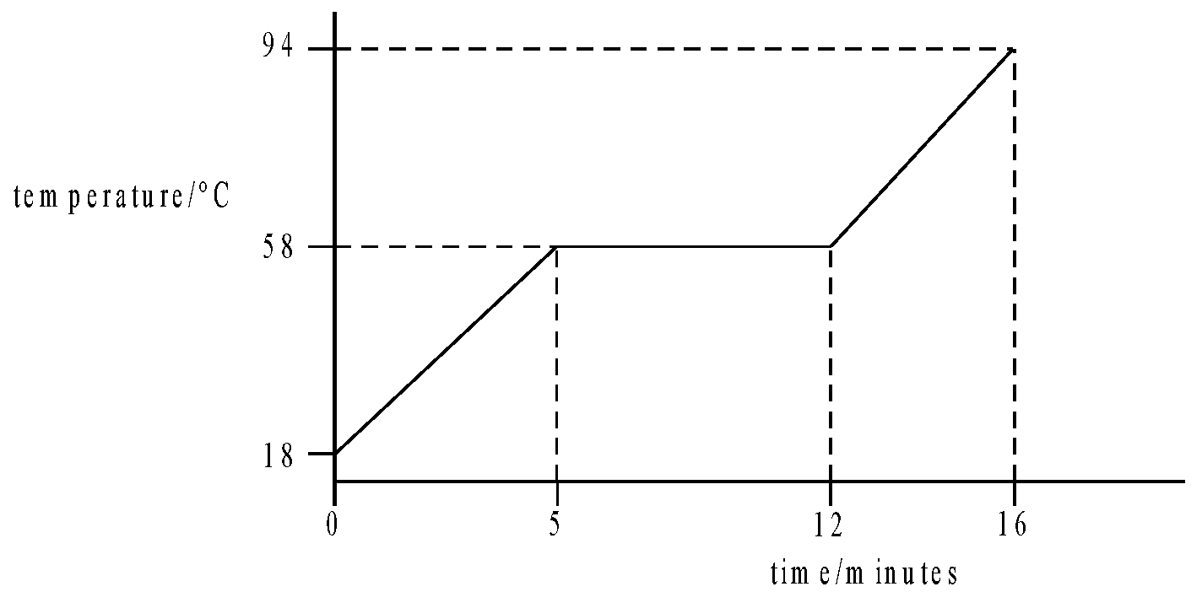

Assume there is no heat exchange with the surroundings.

(i) Show that energy is supplied to the material at a rate of 24W.

............................................................................................................................

............................................................................................................................

............................................................................................................................

(ii) Calculate the specific latent heat of fusion of the material.

............................................................................................................................

............................................................................................................................

............................................................................................................................

............................................................................................................................

(iii) Calculate the specific heat capacity of the material when in the liquid state.

............................................................................................................................

............................................................................................................................

............................................................................................................................

............................................................................................................................

(6)

(Total 10 marks)

**Kinetic theory and gas pressure**

1 (a) (i) State what is meant by a perfectly elastic collision …………………………………………………………………………………………………………………………………………………………………………………….

……………………………………………………………………………………………………………………………………………………………………………..…(1)

(ii) Explain in terms of the behaviour of molecules, how a gas exerts a pressure on the walls of its container. …………………………………………………………………………………………………………………………………………………………………………………….

……………………………………………………………………………………………………………………………………………………………………………………..

……………………………………………………………………………………………………………………………………………………………………………………..

……………………………………………………………………………………………………………………………………………………………………………………..

……………………………………………………………………………………………………………………………………………………………………………..…(4)

(iii) Explain, in terms of the behaviour of molecules, why the pressure of a gas in a container of constant volume increases when the temperature of the gas is increased.

……………………………………………………………………………………………………………………………………………………………………………………..

……………………………………………………………………………………………………………………………………………………………………………………..

……………………………………………………………………………………………………………………………………………………………………………………..

……………………………………………………………………………………………………………………………………………………………………………..…(2)

5 (a) A gas molecule of mass m travelling perpendicular to the wall of a container hits the wall with speed v. Explain why the molecule rebounds with speed v and undergoes a change of momentum of 2mv.

……………………………………………………………………………………………………………………………………………………………………………………..

……………………………………………………………………………………………………………………………………………………………………………………..

……………………………………………………………………………………………………………………………………………………………………………………..

……………………………………………………………………………………………………………………………………………………………………………..…(2)

**Investigating gases**

|  |  |  |  |  |  |  |  |  |  |  |  |  |  |  |  |  |  |  |  |  |  |  |  |  |  |  |  |  |  |  |  |  |  |  |  |  |  |  |  |  |  |  |  |  |
| --- | --- | --- | --- | --- | --- | --- | --- | --- | --- | --- | --- | --- | --- | --- | --- | --- | --- | --- | --- | --- | --- | --- | --- | --- | --- | --- | --- | --- | --- | --- | --- | --- | --- | --- | --- | --- | --- | --- | --- | --- | --- | --- | --- | --- |
|  | |  |  | | --- | --- | |  |  | | **1(a).** | A group of students are conducting an experiment in the laboratory to determine the value of absolute zero by heating a fixed mass of gas. The volume of the gas is kept constant. Fig. 17.1 shows the arrangement used by the students.  **Fig. 17.1**  The gas is heated using a water bath. The temperature θ of the water is increased from 5 °C to 70 °C. The temperature of the water bath is assumed to be the same as the temperature of the gas. The pressure p of the gas is measured using a pressure gauge.  The results from the students are shown in a table   |  |  |  |  |  |  |  |  |  |  |  |  |  |  |  |  |  |  |  |  |  |  |  |  |  |  |  |  |  |  |  |  |  |  |  |  |  |  |  | | --- | --- | --- | --- | --- | --- | --- | --- | --- | --- | --- | --- | --- | --- | --- | --- | --- | --- | --- | --- | --- | --- | --- | --- | --- | --- | --- | --- | --- | --- | --- | --- | --- | --- | --- | --- | --- | --- | --- | |  | |  |  |  |  | | --- | --- | --- | --- | |  | θ **/ °C** | **p / kPa** |  | |  | 5 ± 1 | 224 ± 3 |  | |  | 13 ± 1 | 231 ± 3 |  | |  | 22 ± 1 | 238 ± 3 |  | |  | 35 ± 1 | 248 ± 3 |  | |  | 44 ± 1 |  |  | |  | 53 ± 1 | 262 ± 3 |  | |  | 62 ± 1 | 269 ± 3 |  | |  | 70 ± 1 | 276 ± 3 |  | |  |   Describe and explain how the students may have made accurate measurements of the temperature θ.  ___________________________________________________________________________________  ___________________________________________________________________________________  ___________________________________________________________________________________  __________________________________________________________________________________  **[2]** | |

|  |  |  |  |  |  |  |  |  |  |  |  |
| --- | --- | --- | --- | --- | --- | --- | --- | --- | --- | --- | --- |
|  | |  |  | | --- | --- | |  |  | | **(b).** | Fig. 17.2 shows the pressure gauge. Measurements of p can be made using the kPa scale or the psi (pounds per square inch) scale. The students used the psi scale to measure pressure and then converted the reading to pressure in kPa.  **Fig. 17.2**   * 1. Suggest why it was sensible to use the psi scale to measure p.       **[1]**   * 1. The students made a reading of p of 37.0 ± 0.5 psi when θ was 44 ± 1°C. Convert this value of p from psi to kPa. Complete the table for the missing value of p. Include the absolute uncertainty in p.      |  |  |  |  | | --- | --- | --- | --- | |  | |  | | --- | | 1 pound of force = 4.448 N | | 1 inch = 0.0254 m | |        |  |  | | --- | --- | |  | **[2]** | | |
|  | |  |  | | --- | --- | |  |  | | **(c).** | Fig. 17.3 shows the graph of p against θ.  **Fig. 17.3**   1. Plot the missing data point and the error bars on Fig. 17.3.  |  |  | | --- | --- | |  | **[1]** |  1. Explain what is meant by absolute zero. Describe how Fig. 17.3 can be used to determine the value of absolute zero. Determine the value of absolute zero. You may assume that the gas behaves as an ideal gas.     ___________________________________________________________________________________  ___________________________________________________________________________________  ___________________________________________________________________________________  ___________________________________________________________________________________  ___________________________________________________________________________________  ___________________________________________________________________________________  ___________________________________________________________________________________  ___________________________________________________________________________________  ___________________________________________________________________________________  ___________________________________________________________________________________  ___________________________________________________________________________________  ___________________________________________________________________________________  ___________________________________________________________________________________  ___________________________________________________________________________________  ___________________________________________________________________________________  ___________________________________________________________________________________  ___________________________________________________________________________________  __________________________________________________________________________________ [6] | |

|  |  |  |  |  |  |
| --- | --- | --- | --- | --- | --- |
|  | |  |  | | --- | --- | |  |  | | **(d).** | Describe, without doing any calculations, how you could use Fig. 17.3 to determine the actual uncertainty in the value of absolute zero in **(c)(ii)**.  ___________________________________________________________________________________  ___________________________________________________________________________________  ___________________________________________________________________________________  ___________________________________________________________________________________  ___________________________________________________________________________________  __________________________________________________________________________________**[2]** | |
|  | |  |  | | --- | --- | |  |  | | **(e).** | The experiment is repeated as the water bath quickly cools from 70 °C to 5 °C. Absolute zero was found to be −390°C.  Compare this value with your value from **(c)(ii)** and explain why the values may differ. Describe an experimental approach that could be taken to avoid systematic error in the determination of absolute zero.    ___________________________________________________________________________________  ___________________________________________________________________________________  ___________________________________________________________________________________  ___________________________________________________________________________________  ___________________________________________________________________________________  ___________________________________________________________________________________  ___________________________________________________________________________________  ___________________________________________________________________________________  ___________________________________________________________________________________  _______________________________________________________________________________ **[4]** | |

**The ideal gas equation**

1. (i) The pressure of the air in the tyres of a car before a journey is 2.2 × 105 Pa at 18 °C. After travelling some distance, the temperature of the air in the tyres rises to 54 °C. Calculate the new pressure of the air. Assume the volume of air in the tyre stays constant.

pressure = .................................................... Pa [2]

iii)Assuming that the total mass of the car in (i) stays constant at 1200kg, calculate the change in the total area of contact of the tyres with the road as a result of the rise in temperature.

change in area = .................................................... m2 [3]

2(a) The ideal gas equation is pV = nRT.

Show that the pressure p exerted by a fixed mass of gas is given by the equation p = ρRT

M

where ρ is the density of the gas and M is the mass of one mole of gas (3)

……………………………………………………………………………………………………………………………………………………………………………………..

……………………………………………………………………………………………………………………………………………………………………………………..

……………………………………………………………………………………………………………………………………………………………………………………..

……………………………………………………………………………………………………………………………………………………………………………………..

……………………………………………………………………………………………………………………………………………………………………………………..

……………………………………………………………………………………………………………………………………………………………………………………..

(b) The Earth’s atmosphere may be treated as an ideal gas whose density, pressure and temperature all decrease with height. In 1924, Howard Somervell and Edward Norton set a new altitude record when attempting to climb Mount Everest. They managed to climb to a vertical height of 8570 m above sea level by breathing in natural air. At this height, the air pressure was 0.35 times the pressure at sea level and the temperature was −33 °C. At sea level, air has a temperature 20°C and density 1.3 kg m−3.

(i) Calculate the density of the air at a height of 8570 m at the time the record was set. (3)

……………………………………………………………………………………………………………………………………………………………………………………..

……………………………………………………………………………………………………………………………………………………………………………………..

……………………………………………………………………………………………………………………………………………………………………………………..

……………………………………………………………………………………………………………………………………………………………………………………..

……………………………………………………………………………………………………………………………………………………………………………………..

……………………………………………………………………………………………………………………………………………………………………………………..

……………………………………………………………………………………………………………………………………………………………………………………..

……………………………………………………………………………………………………………………………………………………………………………………..

……………………………………………………………………………………………………………………………………………………………………………………..

(ii) Determine the ratio number of air molecules present in Somervell’s lungs at the top of his climb number of air molecules present in Somervell’s lungs at sea level . Assume that the volume of Somervell’s lungs remained constant throughout the climb. (2)

……………………………………………………………………………………………………………………………………………………………………………………..

……………………………………………………………………………………………………………………………………………………………………………………..

……………………………………………………………………………………………………………………………………………………………………………………..

……………………………………………………………………………………………………………………………………………………………………………………..

**The Boltzmann constant**

|  |  |  |  |  |  |
| --- | --- | --- | --- | --- | --- |
|  | |  |  | | --- | --- | |  |  | | **1(a).** | The equation of state of an ideal gas is pV = nRT. Explain why the temperature must be measured in kelvin.        **[2]** | |
|  | |  |  | | --- | --- | |  |  | | **(b).** | A meteorological balloon rises through the atmosphere until it expands to a volume of 1.0 × 106 m3, where the pressure is 1.0 × 103 Pa. The temperature also falls from 17 °C to − 43 °C.  The pressure of the atmosphere at the Earth’s surface = 1.0 × 105 Pa.  Show that the volume of the balloon at take off is about 1.3 × 104 m3.  **[3]** | |
|  | |  |  | | --- | --- | |  |  | | **(c).** | The balloon is filled with helium gas of molar mass 4.0 × 10−3 kg mol−1 at 17 °C at a pressure of 1.0 × 105 Pa.  Calculate   1. the number of moles of gas in the balloon   number of moles = .......................................... **[2]**   1. the mass of gas in the balloon.   mass = .......................................... kg **[1]** | |
|  | |  |  | | --- | --- | |  |  | | **(d).** | The internal energy of the helium gas is equal to the random kinetic energy of all of its molecules.  When the balloon is filled at ground level at a temperature of 17 °C, the internal energy is 1900 MJ.  Estimate the internal energy of the helium when the balloon has risen to a height where the temperature is −43 °C.  internal energy = ............................. MJ **[1]** | |

|  |  |  |  |  |  |
| --- | --- | --- | --- | --- | --- |
|  | |  |  | | --- | --- | |  |  | | **(e).** | The acceleration of the balloon and its instruments at the Earth’s surface as it is released is 27 m s−2.  The density of the air at the Earth's surface is 1.3 kg m−3.  Calculate the total mass M of the helium-filled balloon and its load.    M = ............................. kg **[3]** | |

2 (a) The molar mass of hydrogen gas is 2.02 × 10–3 kg mol–1. Calculate the mass of a hydrogen molecule.

mass = ..................................................... kg [2]

(b) The temperature of the Earth’s upper atmosphere is about 1100 K.

Show that at this temperature the mean kinetic energy of an air molecule is about 2 × 10–20 J. [2]

(c) Show that the speed of a helium atom of mass 6.6 × 10–27 kg at a temperature of 1100 K is about 2.5 km s–1. [2]

(d) The escape velocity from the Earth is 11 km s–1. The escape velocity is the minimum vertical velocity a particle must have in order to escape from the Earth’s gravitational field. Explain why helium atoms still escape from the Earth’s atmosphere. [2]

……………………………………………………………………………………………………………………………………………………………………………………..

……………………………………………………………………………………………………………………………………………………………………………………..

……………………………………………………………………………………………………………………………………………………………………………………..