**Module 5.5 Astrophysics and cosmology**

|  |  |  |  |  |
| --- | --- | --- | --- | --- |
| **Topic area** | **Text book pre-reading** | **Syllabus ref** | **Max possible score in exam questions** | **Your score in exam questions** |
| Structure of the Universe | p 80-81 | 5.5.1 | 7 |  |
| The life cycle of stars | p 85-88 | 5.5.1 |  |
| The H-R diagram and Wein and Stefan’s laws | p 89-92 | 5.5.1 & 2 | 11 |  |
| Line Spectra from stars | p 94-97 | 5.5.2 | 6 |  |
| Wavelength of star light | P 93-94 | 5.5.2 | 5 |  |
| Astronomical distances | p 82-84 | 5.5.3 | 4 |  |
| Doppler effect and red shift | p 98-100 | 5.5.3 | 3 |  |
| Hubble’s law and the expansion of the universe | P 100 |  | 5 |  |
| Cosmic microwave background radiation | p 101 | 5.5.3 | 7 |  |
| Early evolution of the universe | p 103-105 | 5.5.3 | 6 |  |
| **Total** | | | **54** |  |

|  |  |
| --- | --- |
| **By the end of this topic you should be able to…** | **Check** |
| Describe components of the universe: planets, comets, solar systems, galaxies and the universe |  |
| Describe the formation and evolution of stars |  |
| Describe features of the Hertzsprung-Russell diagram |  |
| Link energy levels in atoms to absorption and emission lines and be able to equate change in energy levels to a specific wavelength |  |
| Describe how diffraction gratings can be used to determine the wavelength of light and calculate the wavelength |  |
| Describe and use Wein’s law linking wavelength and temperature |  |
| Describe and use Stefan’s law linking temperature, size and luminosity |  |
| Describe the units used to measure astronomical distances including the Astronomical Unit (AU), light year (ly) and parsec (pc) |  |
| Define and describe the cosmological principle |  |
| Describe the Doppler effect and use this to measure the speed of recession of galaxies |  |
| Describe Hubble’s law and use this to be able to estimate the age of the universe including from graphical data |  |
| Explain evidence for the big bang theory including cosmic microwave background radiation |  |
| Describe the evolution of the universe |  |
| Describe theories of dark matter and dark energy |  |

**Glossary of key terms**

Planet

Planetary satellite

Comet

Solar system

Galaxy

The Universe

Planetary nebula

Red giant

Red super giant

Neutron star

Black hole

Supernova

White dwarf

Electron degeneracy pressure

Chadrasekhar limit

Emission spectra

Absorption spectra

Wein’s displacement law

Luminosity

Stefan’s law

Astronomical unit

Light year

Parsec

Parallax

Cosmological principle

Doppler effect

Hubble’s law

Big bang theory

Cosmic microwave background radiation

Dark energy

Dark matter

**Equations given in exam**

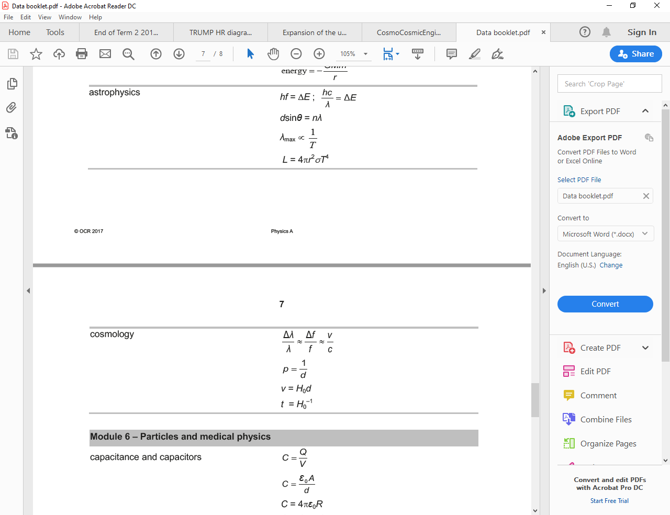



**The structure of the universe and the life cycle of stars**

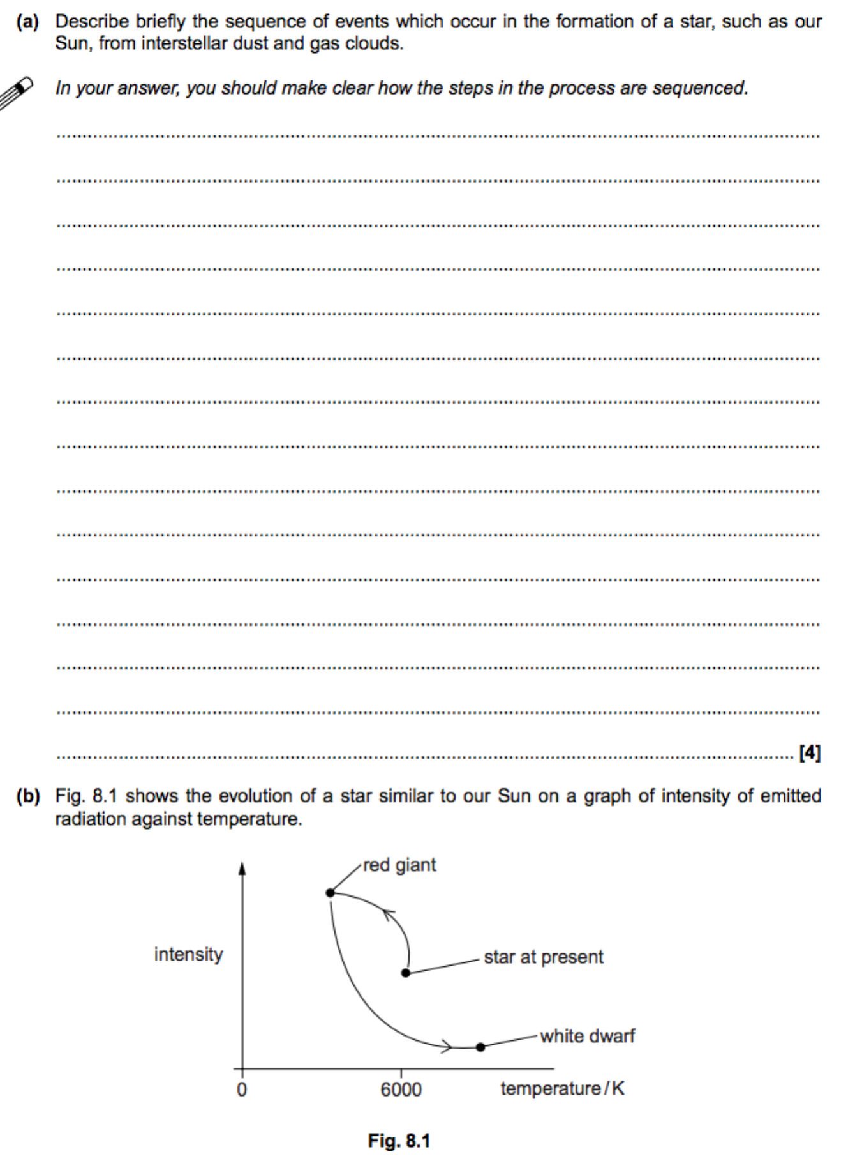

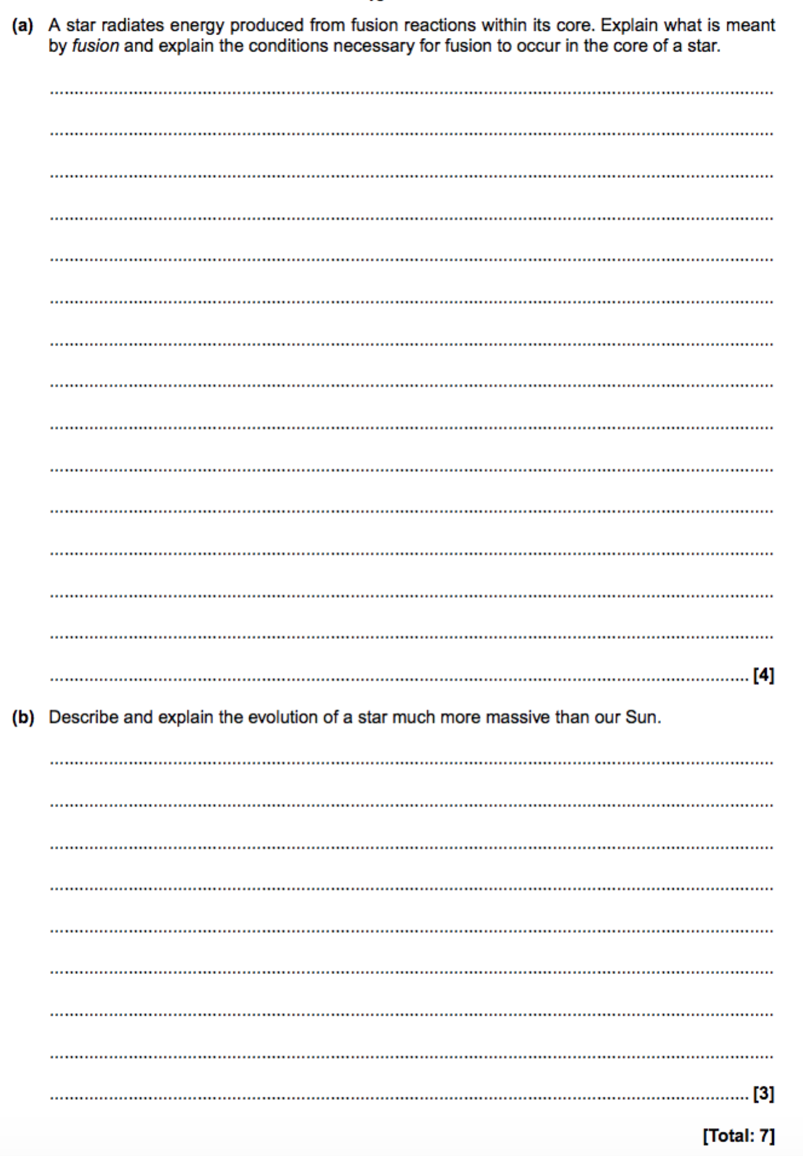

**The H-R diagram and Wein and Stephan’s laws**



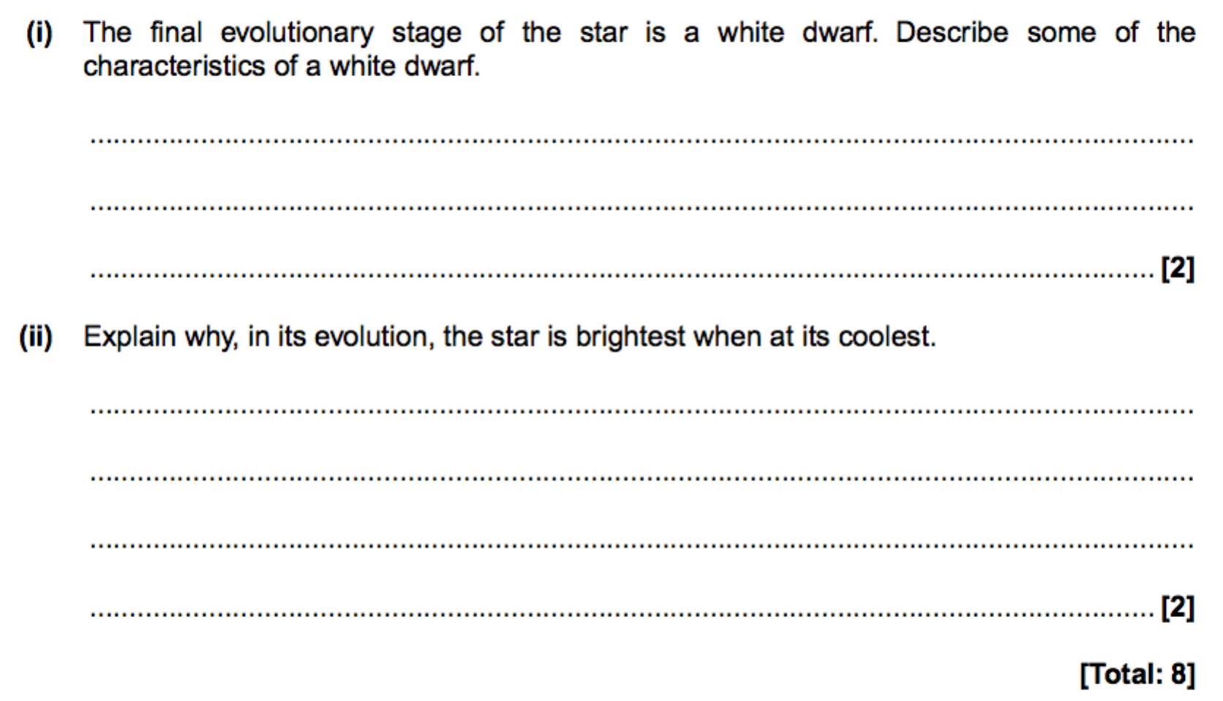

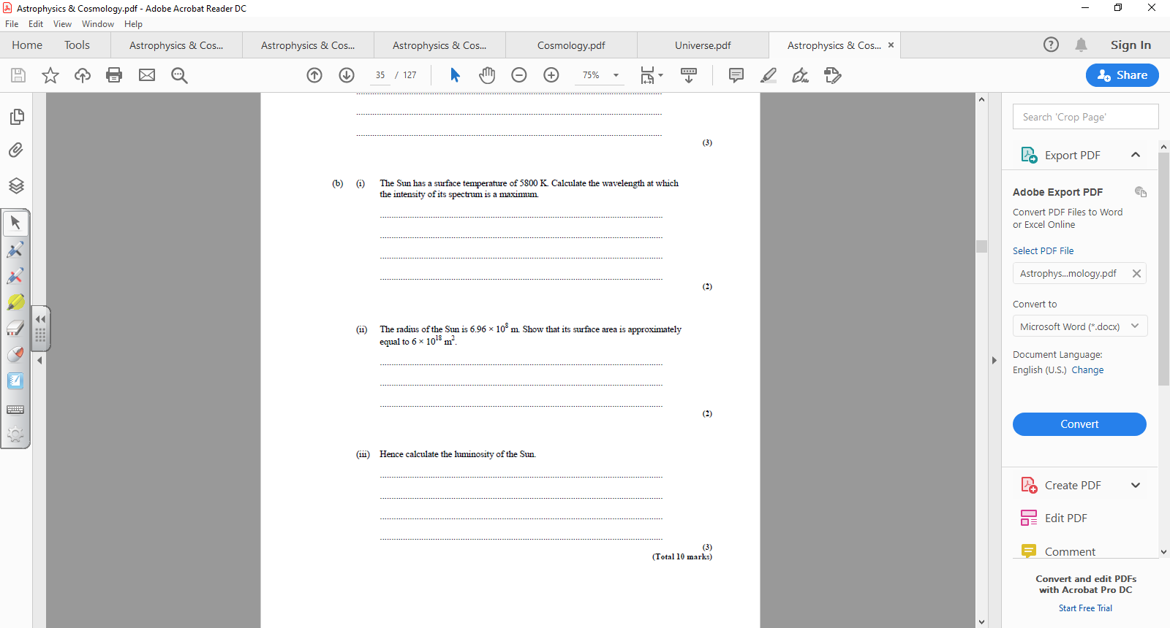

**Line spectra from stars**

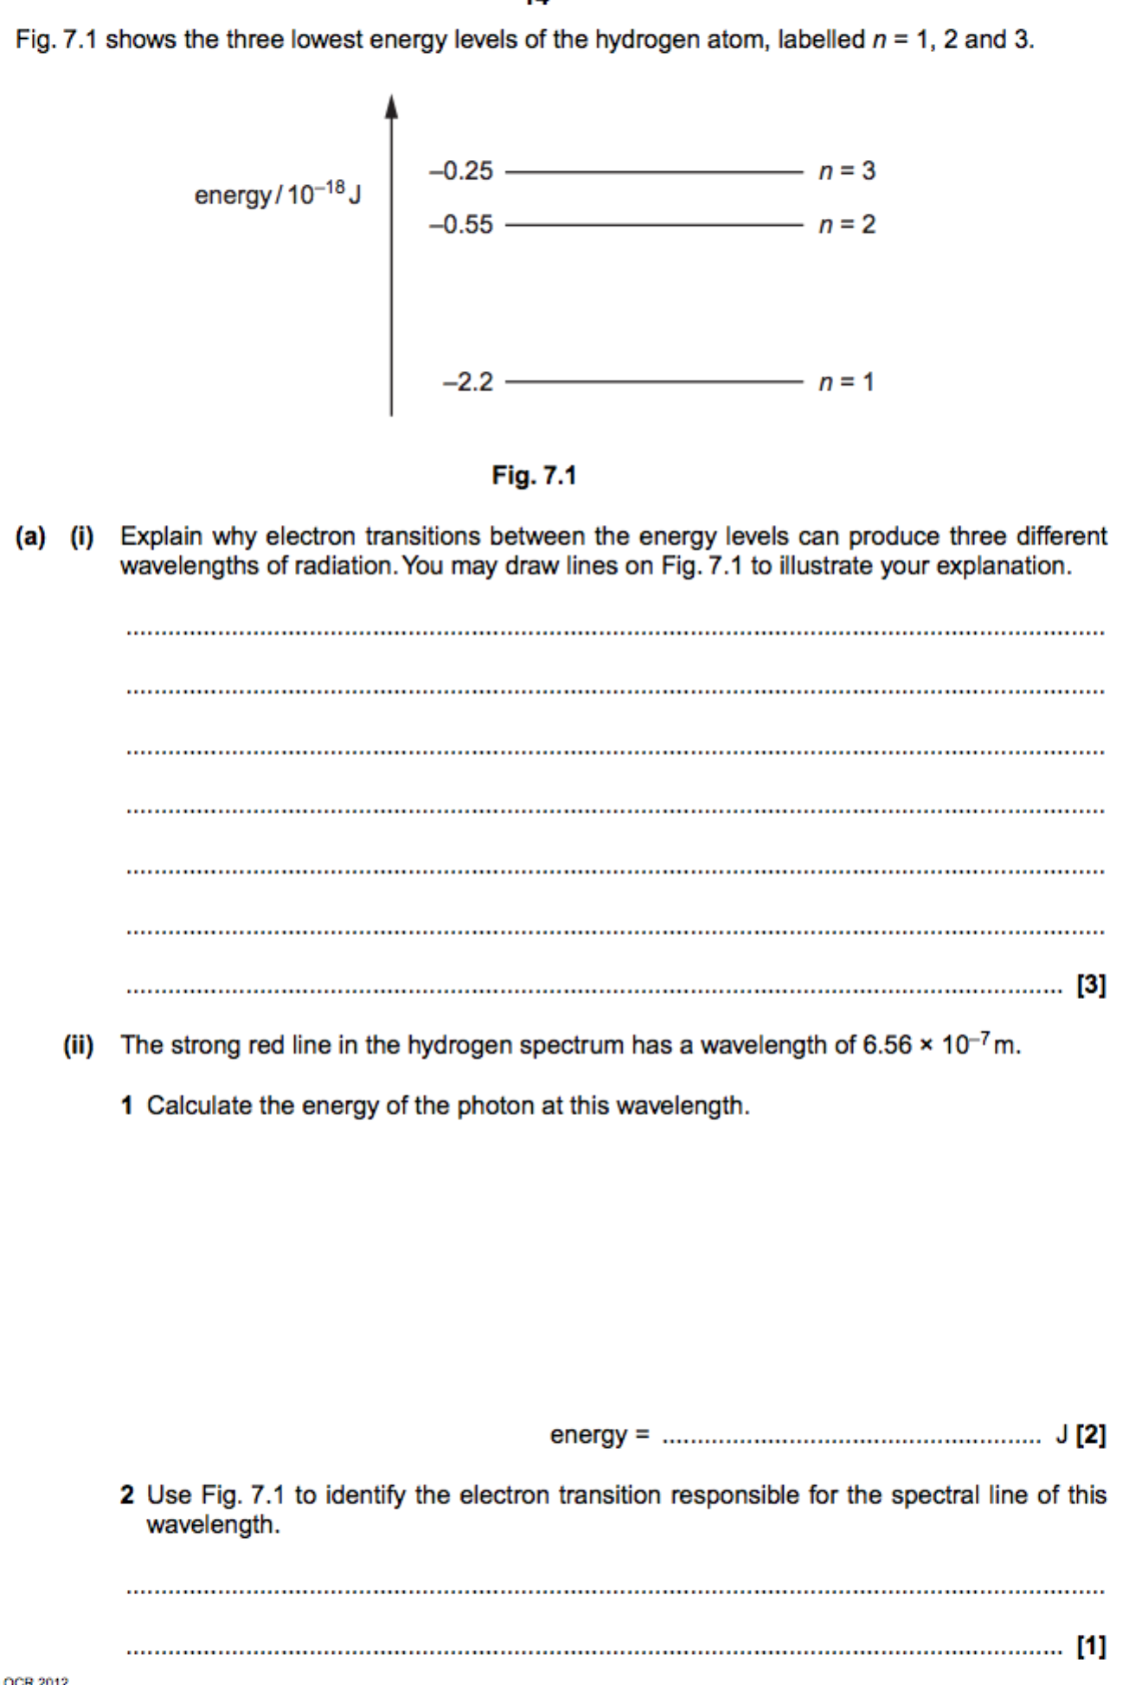



**Wavelength of starlight- diffraction gratings**

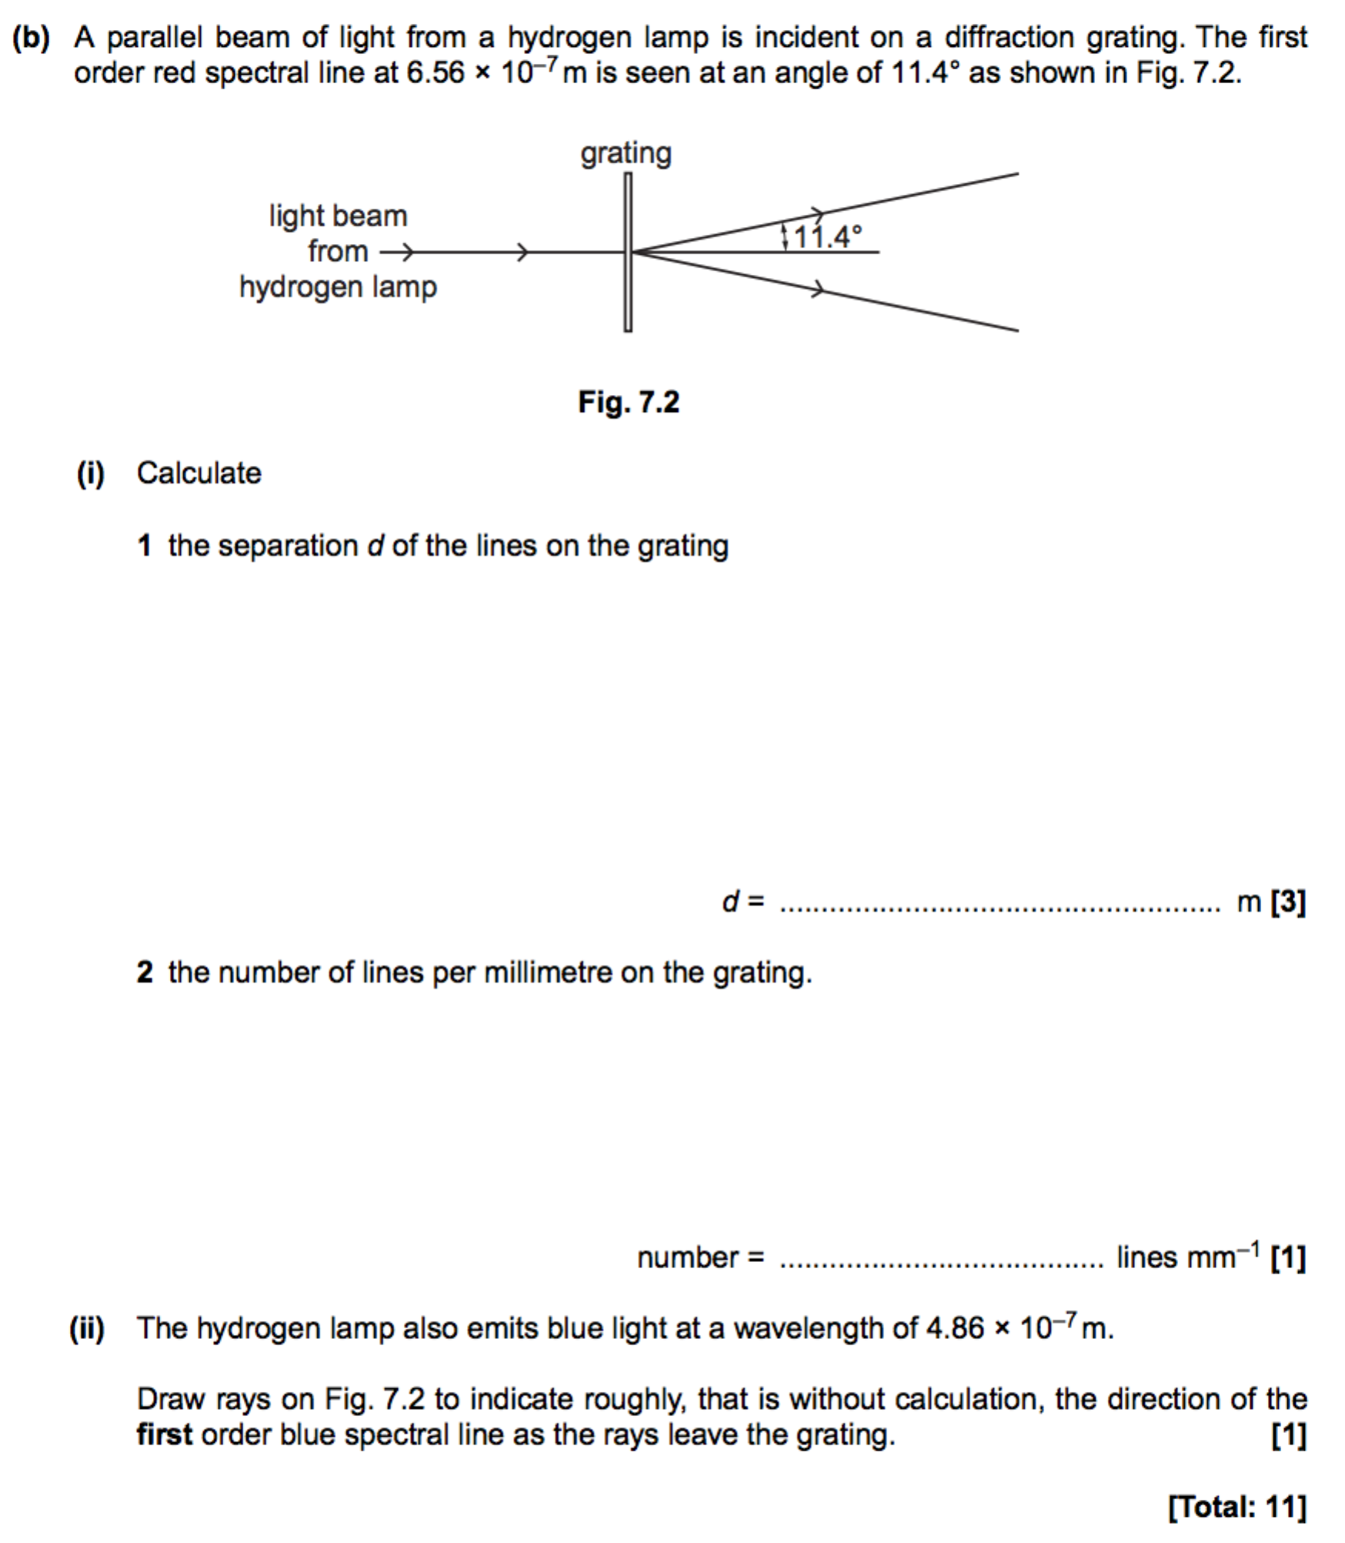



**Astronomical distances**

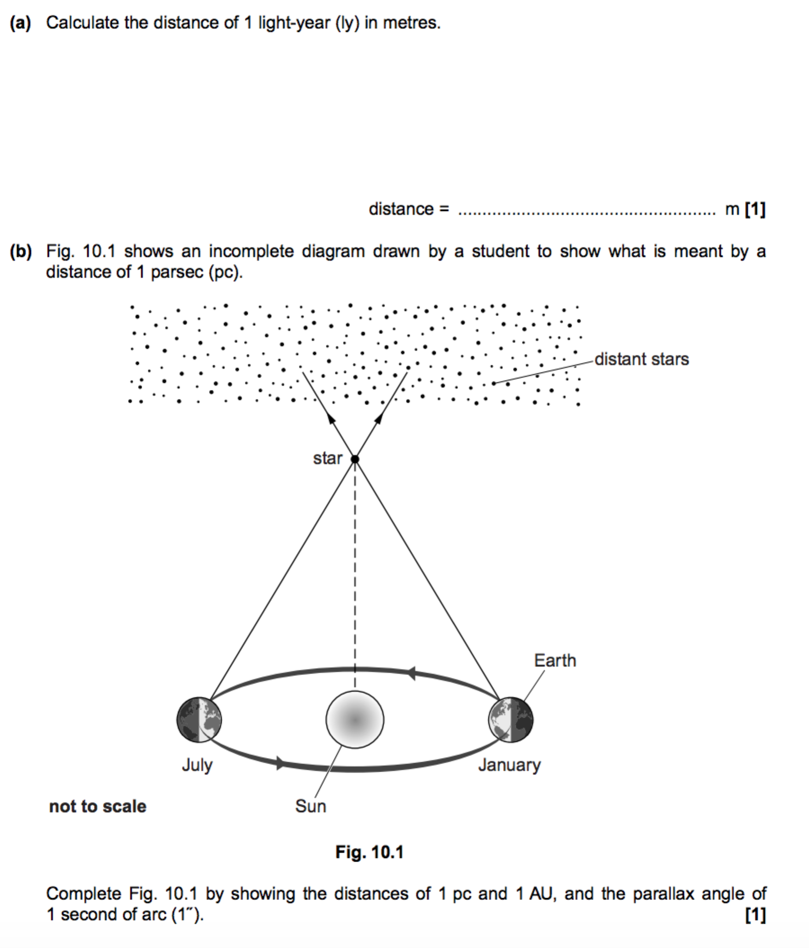





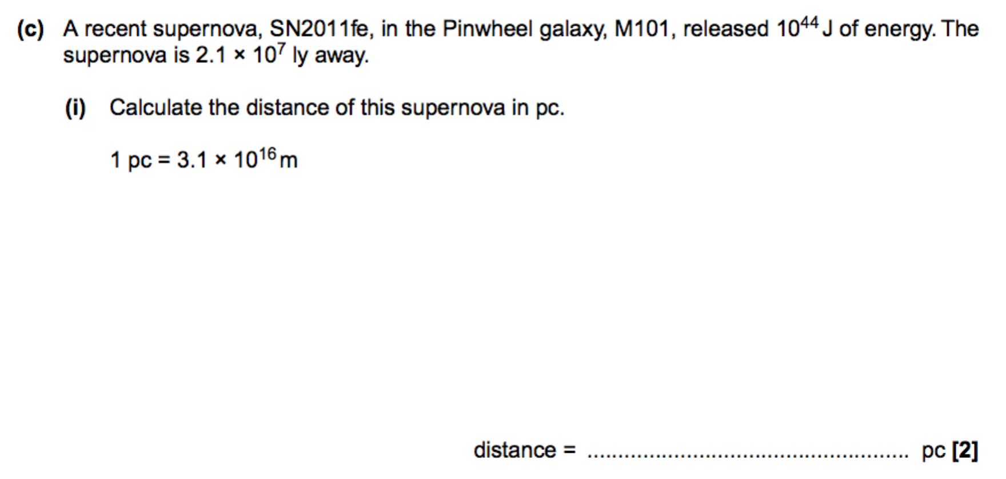

**The Doppler effect and red shift**

When measured from a stationary source in the laboratory, a spectral line has a wavelength λ of 656.3 nm. The light from star S is examined over a period of 74 hours. The change in wavelength ∆λ for the same spectral line is recorded. The velocity has been calculated and the data shown in Fig. 2.

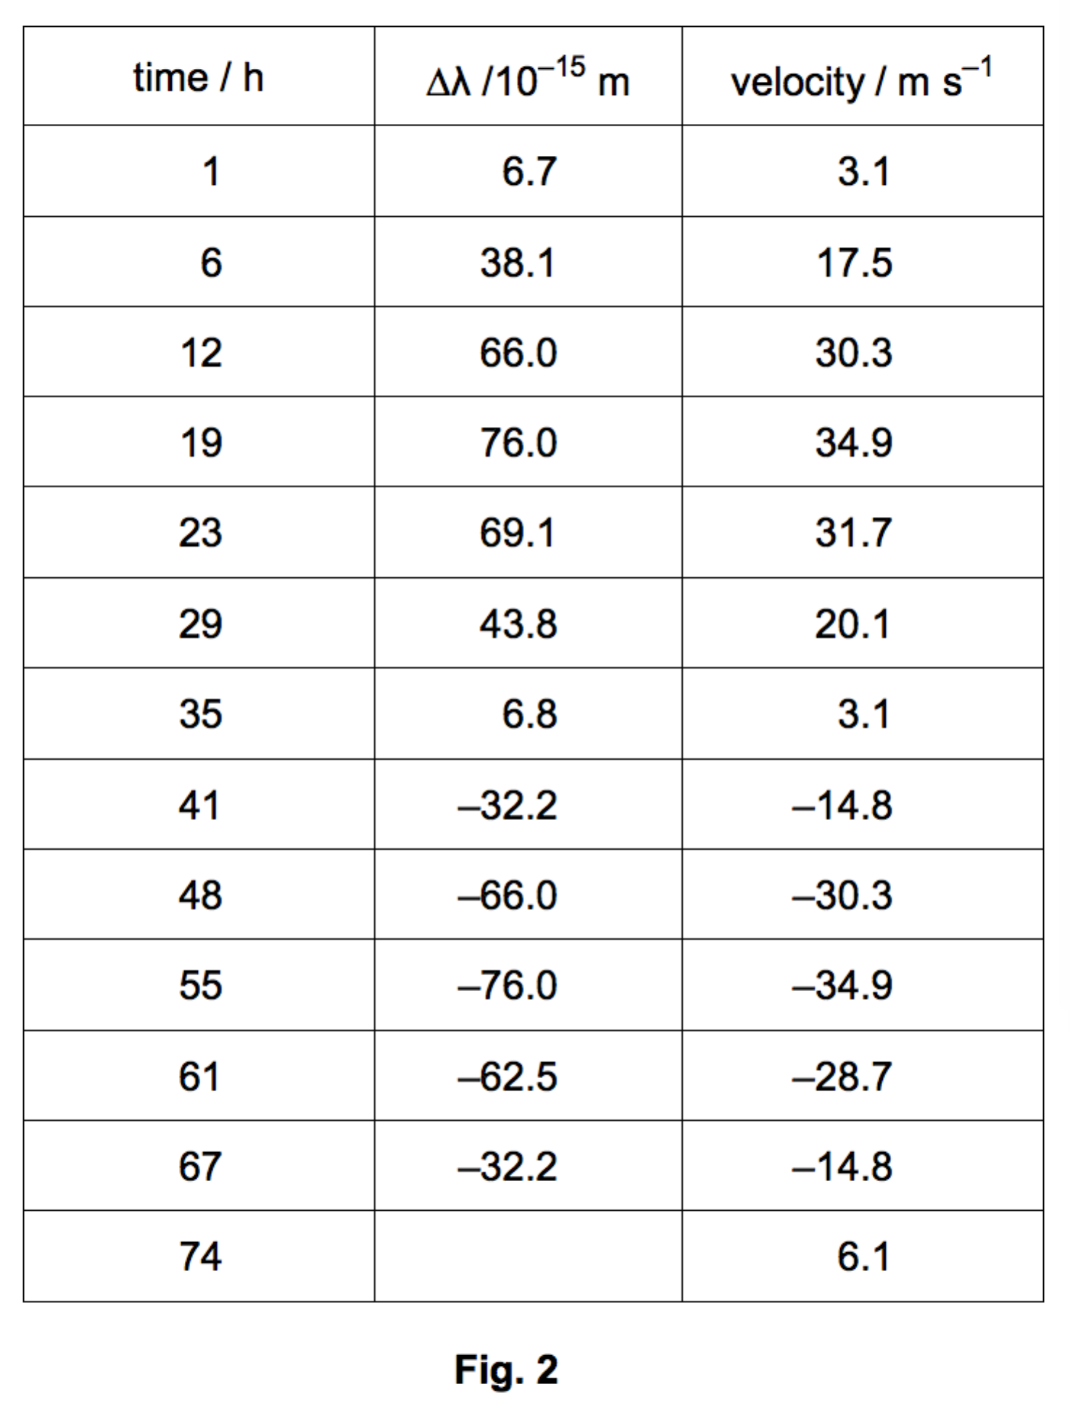

(i) Use the Doppler equation relating ∆λ with velocity v to calculate the change in wavelength for the final velocity of 6.1 m s–1

change in wavelength = ………….........m

**Hubble’s law**

In 1929 Edwin Hubble showed that the Universe was expanding by studying the light from stars and galaxies. Explain how.

...........................................................................................................................................................................

...........................................................................................................................................................................

...........................................................................................................................................................................

...........................................................................................................................................................................

...........................................................................................................................................................................

...........................................................................................................................................................................

...........................................................................................................................................................................

...........................................................................................................................................................................

................................................................................................................................................... [Total 5 marks]

**Cosmic microwave background and the cosmological principle**

1. State the Cosmological Principle.

............................................................................................................................................................................................ ..............................................................................................................................................................................................................................................................................................................................................................[Total 2 marks]

2. Describe the important properties of the cosmic microwave background radiation and how the standard model of the Universe explains these properties. Explain their significance as evidence for the past evolution of the Universe.

In your answer, you should make clear how your explanation links with the evidence.

...........................................................................................................................................................................

...........................................................................................................................................................................

...........................................................................................................................................................................

............................................................................................................................................................................................ ..................................................................................................................................................................................................................................................................................................................................................................................... ................................................................................................................................................................................................................................................................................................................................................................................... ................................................................................................................................................................................. [5]

**The evolution and expansion of the universe**

Some stages in the early evolution of the Universe are represented in the figure below.

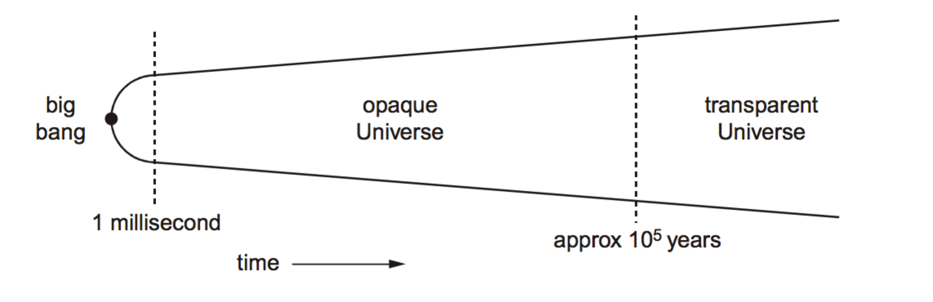

i. What limits our understanding of events in the first millisecond? (1)

……………………………………………………………………………………………………………………………………………………………………………………..

……………………………………………………………………………………………………………………………………………………………………………………..

……………………………………………………………………………………………………………………………………………………………………………………..

ii. State and explain how the temperature of the Universe has changed after the first millisecond. (2)

……………………………………………………………………………………………………………………………………………………………………………………..

……………………………………………………………………………………………………………………………………………………………………………………..

……………………………………………………………………………………………………………………………………………………………………………………..

……………………………………………………………………………………………………………………………………………………………………………………..

iii. Explain how the Universe became transparent. (3)

……………………………………………………………………………………………………………………………………………………………………………………..

……………………………………………………………………………………………………………………………………………………………………………………..

……………………………………………………………………………………………………………………………………………………………………………………..

……………………………………………………………………………………………………………………………………………………………………………………..

……………………………………………………………………………………………………………………………………………………………………………………..