Module 6.2 Electric Fields

|  |  |  |  |  |
| --- | --- | --- | --- | --- |
| **Topic area** | **Text book pre-reading** | **Syllabus ref** | **Max possible score in exam questions** | **Your score in exam questions** |
| Electric fields and field lines | p133-134 | 6.2.1 | 2 |  |
| Electric field strength | p133-136 | 6.2.1 & 2 | 6 |  |
| Coulomb’s law | p134 | 6.2.2 | 13 |  |
| Uniform electric fields | p137-138 | 6.2.3 | 16 |  |
| Capacitance | p137 & 141 | 6.2.3 & 4 | 9 |  |
| Electric potential and potential energy | p139-140 | 6.2.4 | 6 |  |
| Electric versus gravitational fields | p142 | 6.2.2 | - |  |
| **Total** | | | 52 |  |

**By the end of this topic you should be able to….**

* Describe what is meant by an electric field and draw the electric field lines around single point charge
* Calculate the electric field strength
* Use Coulomb's law to calculate the force between two point charges.
* Calculate the electric field strength
* Describe the similarities and differences between gravitational fields and electric fields
* Calculate electric field strength
* Calculate capacitance and permittivity for parallel plate capacitors and capacitance for isolated spheres
* Describe the motion of charged particles in a uniform electric field
* Define and calculate electric potential and electric potential energy
* Draw force-distance graphs for point and spherical charges and link this to work done

**By the end of module 6.2 you need to be able to define the following key terms:**

Electric field strength

Coulombs law

Capacitance

Permittivity of free space

Electric potential

Electric potential energy

**Equations given in exam**

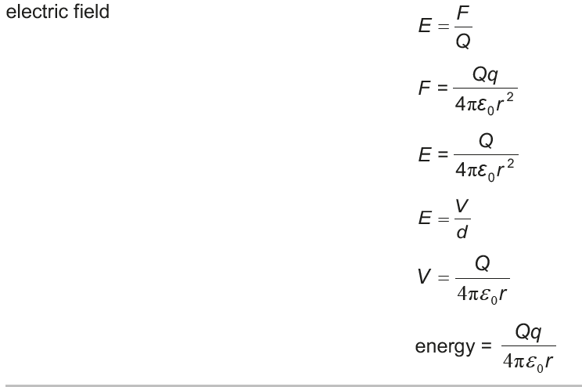

**Electric fields and field lines**

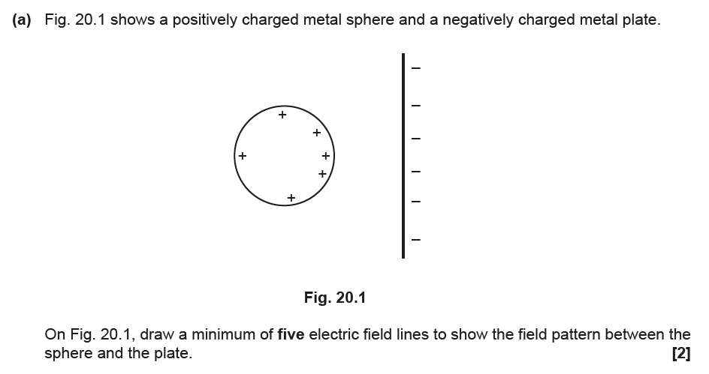

**Electric field strength**

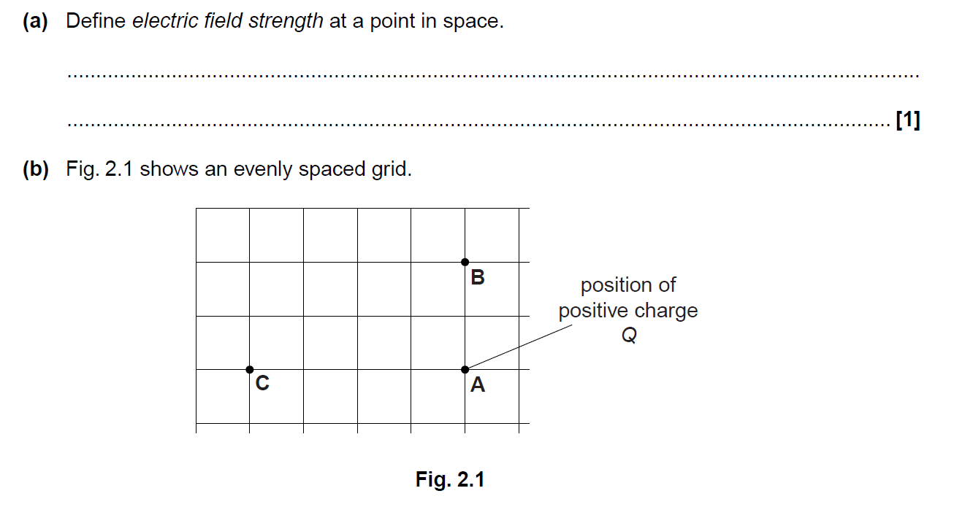

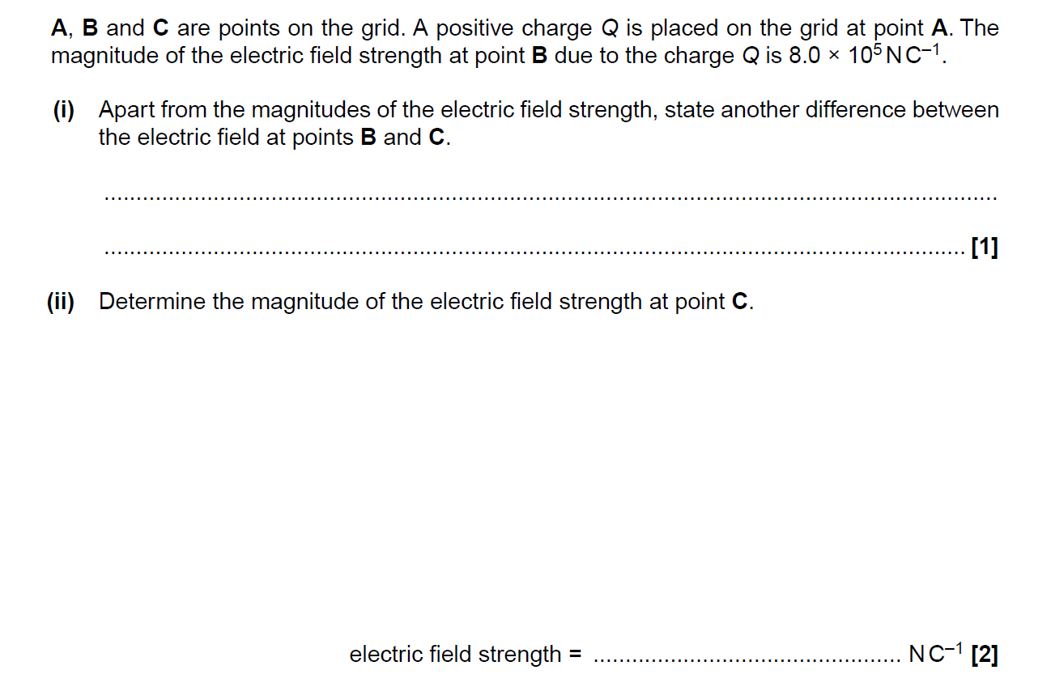

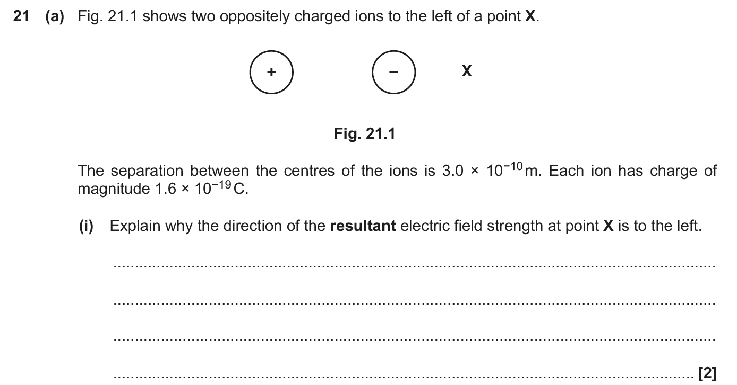

**Coulomb’s law**

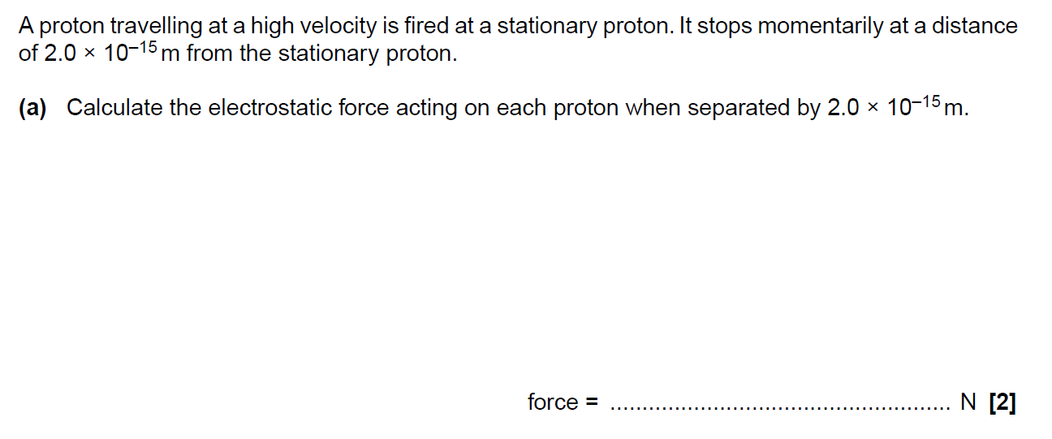

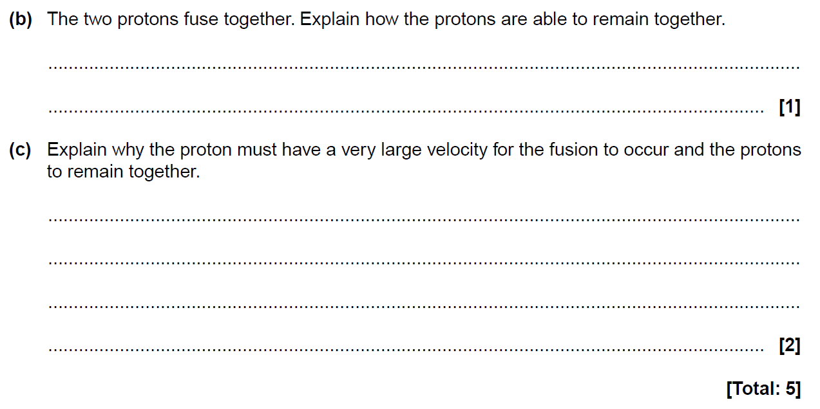

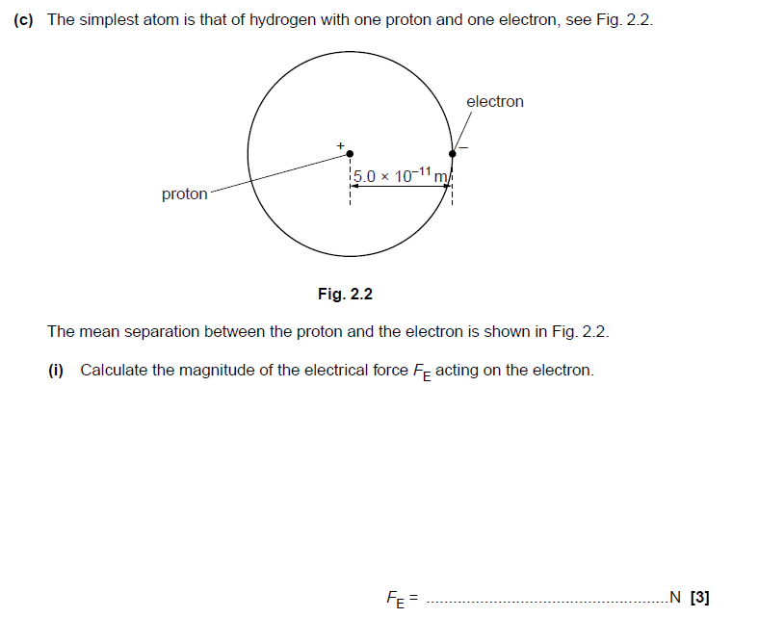

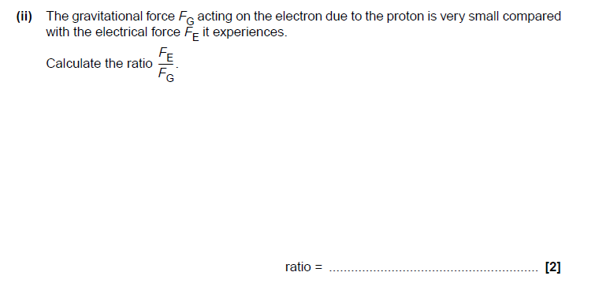

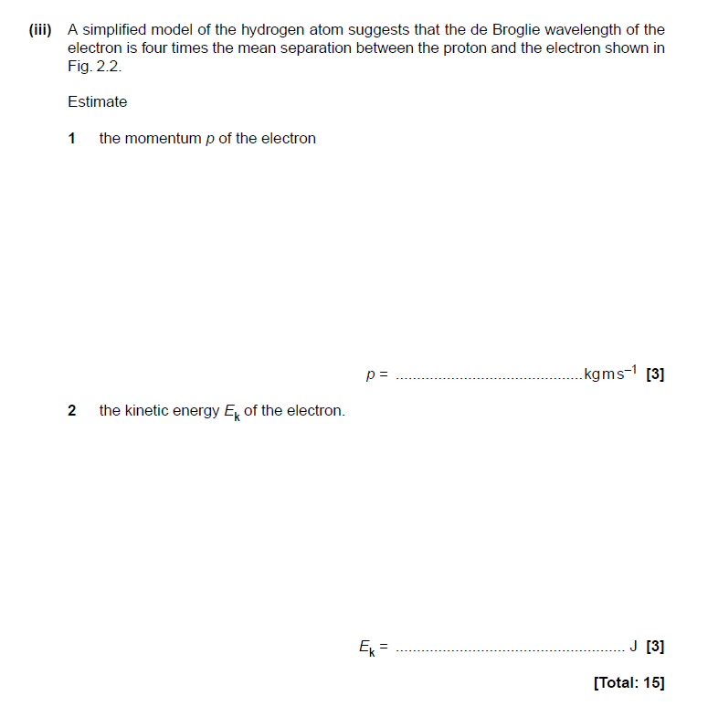

**Uniform Electric fields**

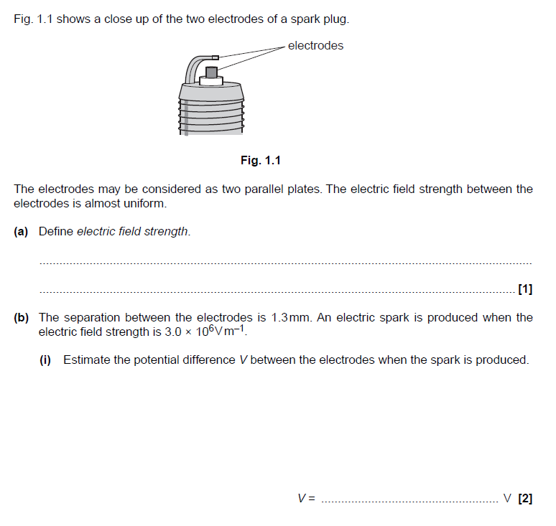

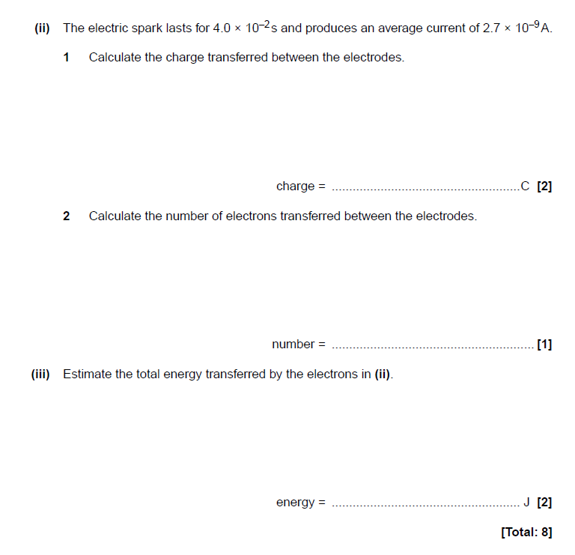

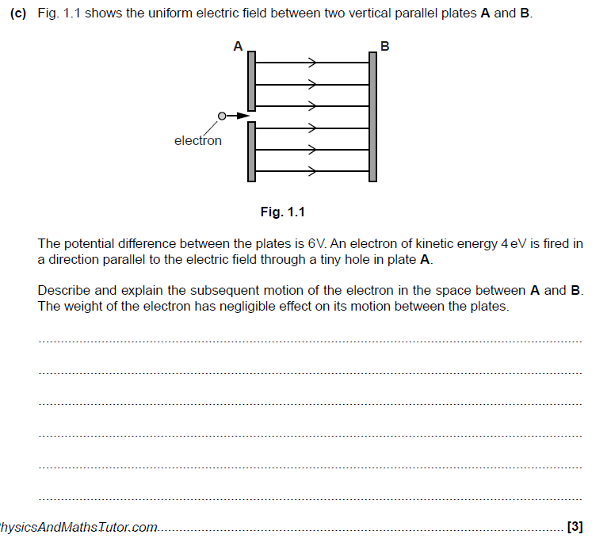

(3)

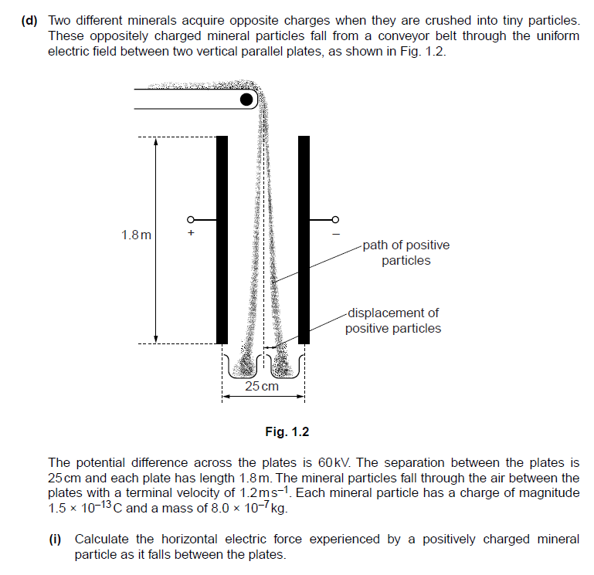

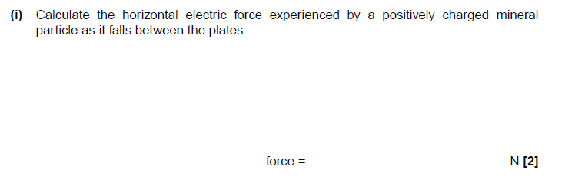

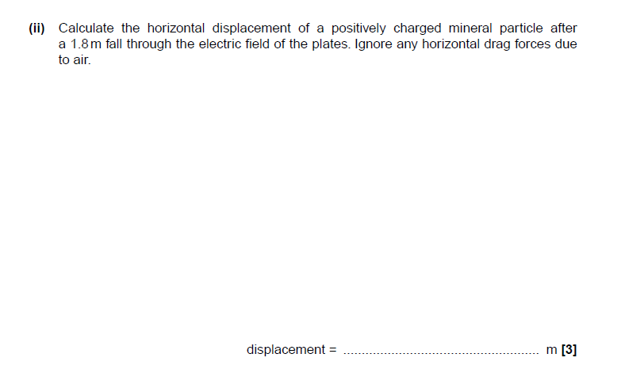

**Capacitance**

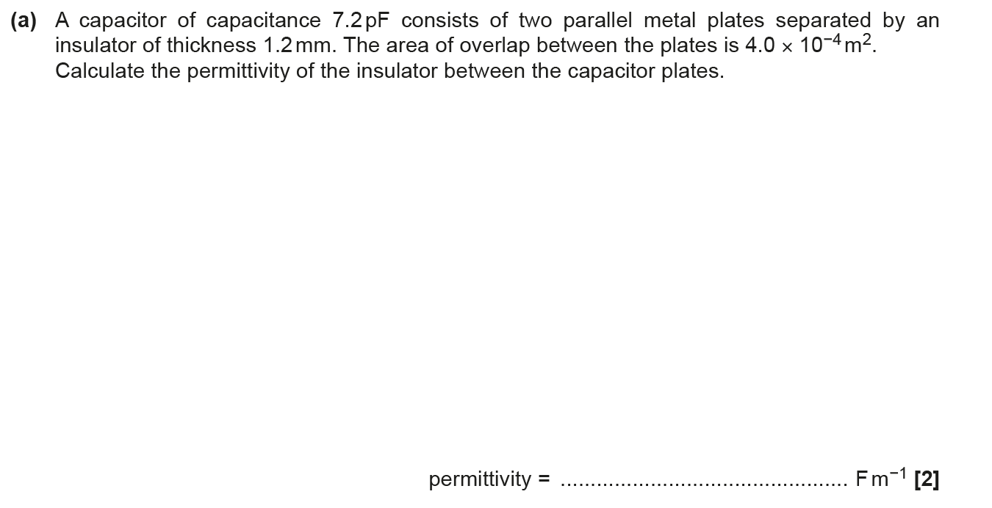

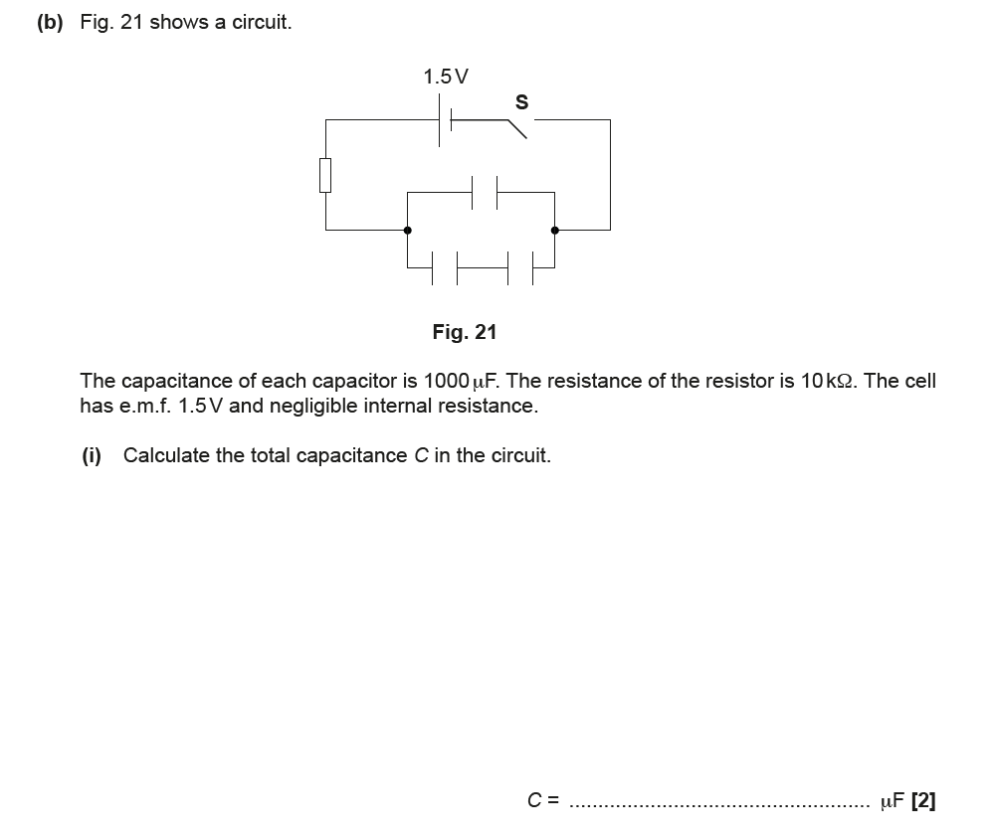

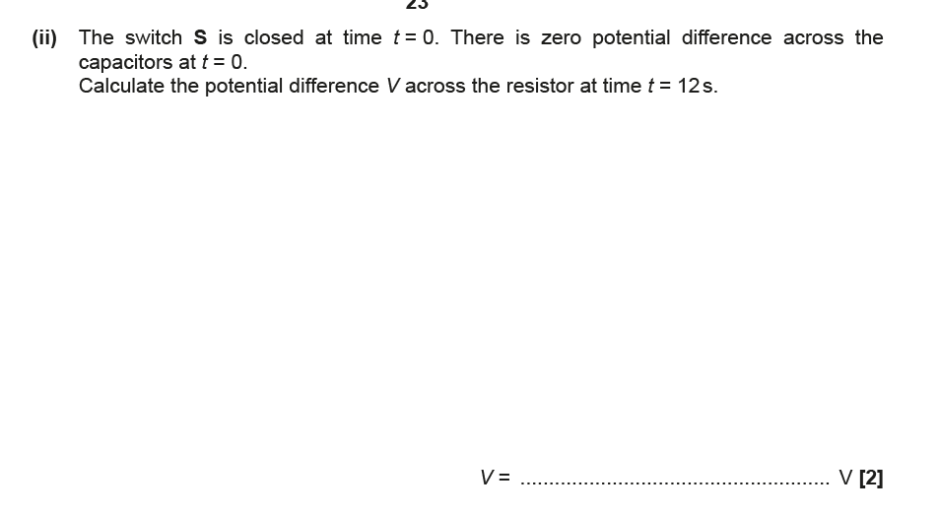

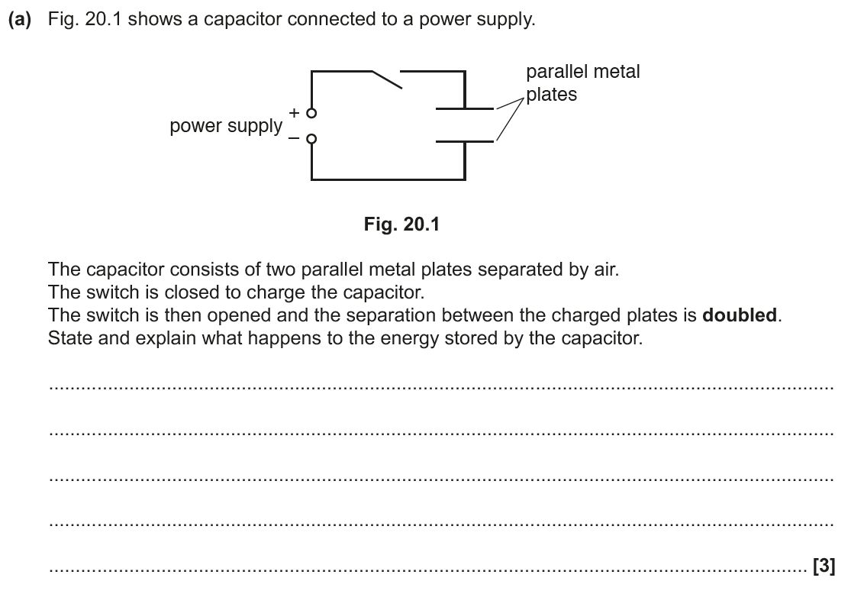

**Electric potential and potential energy**

