Module 5.4 Gravitational Fields

|  |  |  |  |  |
| --- | --- | --- | --- | --- |
| **Topic area** | **Text book pre-reading** | **Syllabus ref** | **Max possible score in exam questions** | **Your score in exam questions** |
| Newton’s law of gravitation | P62-64 | 5.4.1 & 2 | 5 |  |
| Gravity of point masses | P65-66 | 5.4.2 | 9 |  |
| Kepler’s laws | P75-76 | 5.4.3 | 9 |  |
| Satellites | P73-74 | 5.4.3 | 10 |  |
| Gravitational potential and gravitational potential energy | P68-71 | 5.4.4 | 8 |  |
| **Total** | | | 41 |  |

**By the end of this topic you should be able to….**

* Draw gravitational fields around point masses and on a flat surface
* Define what is meant by gravitational field strength
* Define and use Newton’s law of gravitation between two point masses
* Describe Kepler’s three laws of planetary motion
* Derive the equation form of Kepler’s third law relating period and radius of an orbit
* Describe different types of satellite orbit
* Describe what is meant by gravitational potential and calculate this
* Describe what is meant by gravitational potential energy and calculate this
* Define escape velocity and be able to calculate this

**By the end of module 5.4 you need to be able to define the following key terms:**

Gravitational field strength

Newton’s law of gravitation

Kepler’s 1st law

Kepler’s 2nd law

Kepler’s 3rd law

Geostationary orbit

Polar orbit

Gravitational potential

Gravitational potential energy

**Equations given in exam**

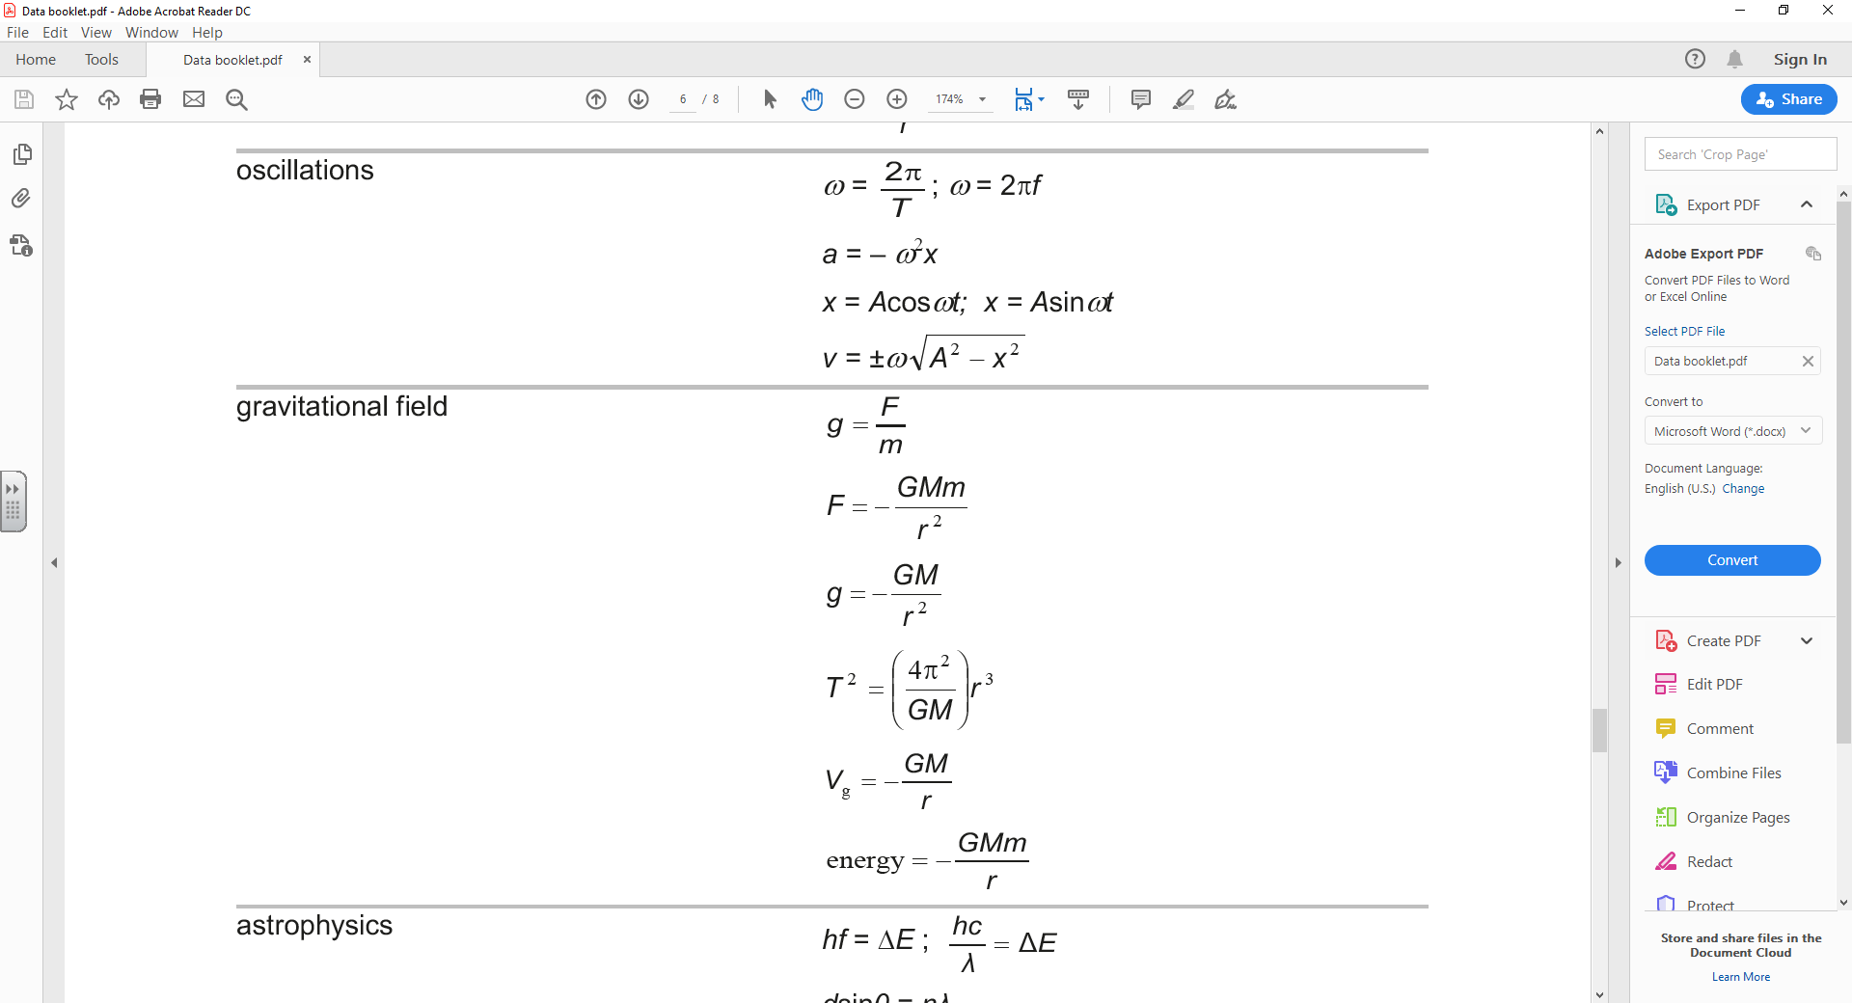

**Newton’s law of gravitation**

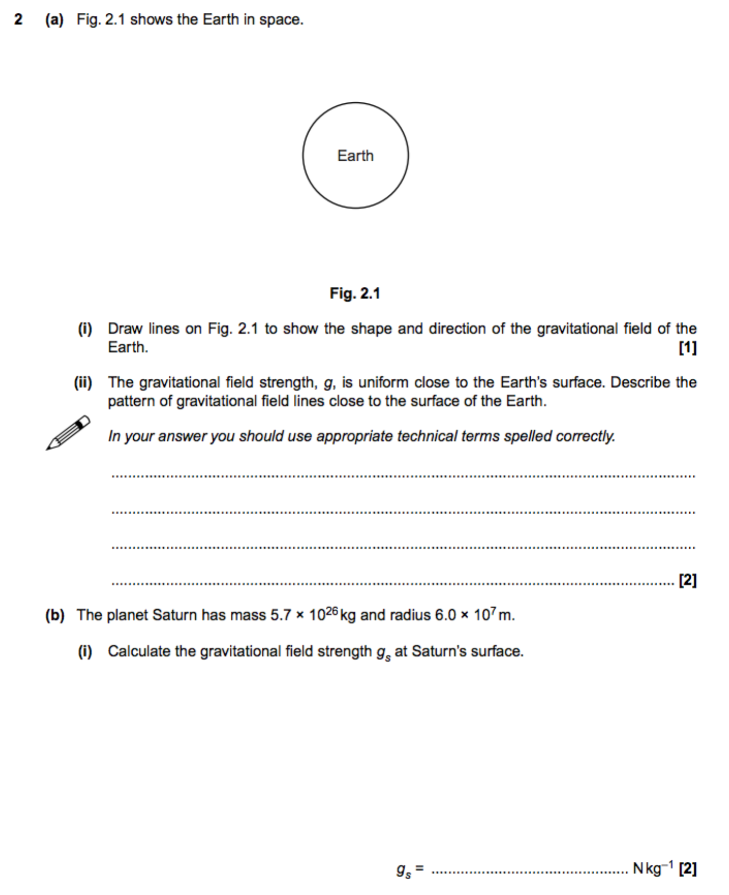

**Gravity of point masses**

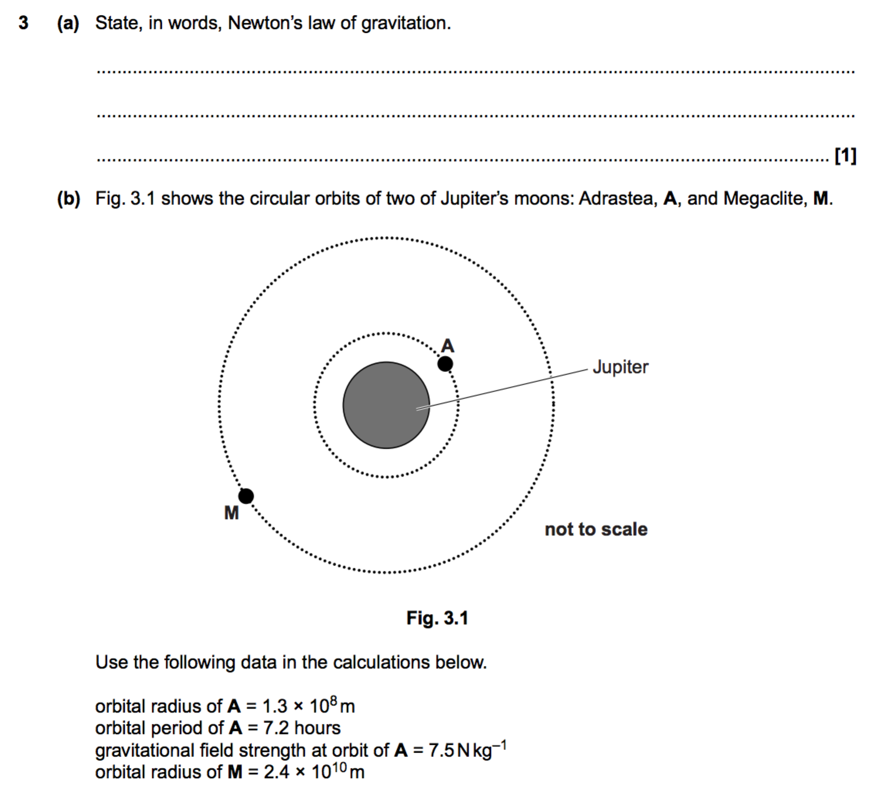

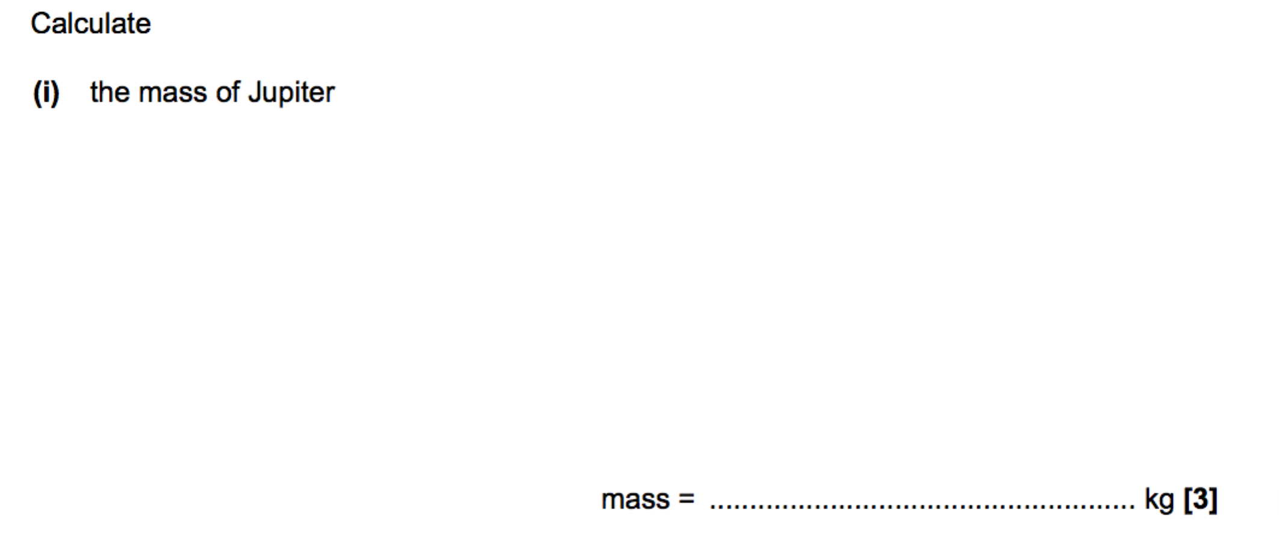

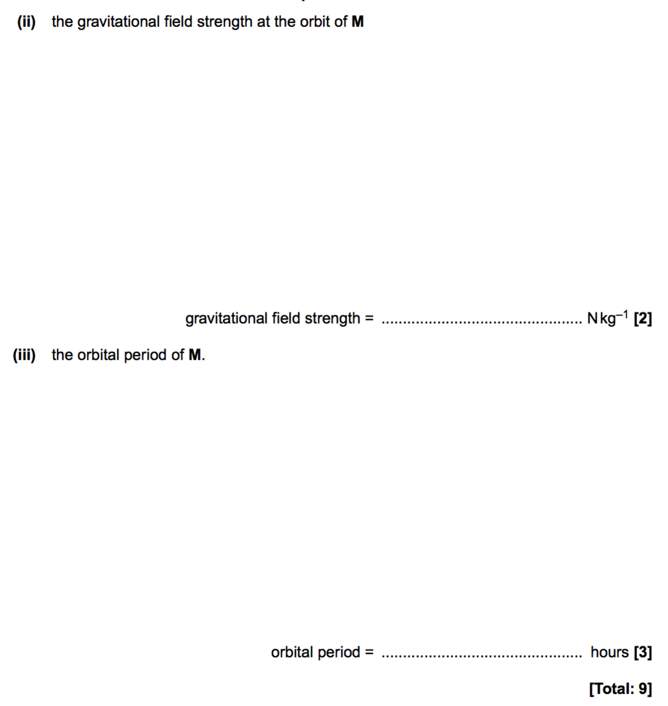

**Kepler’s laws**

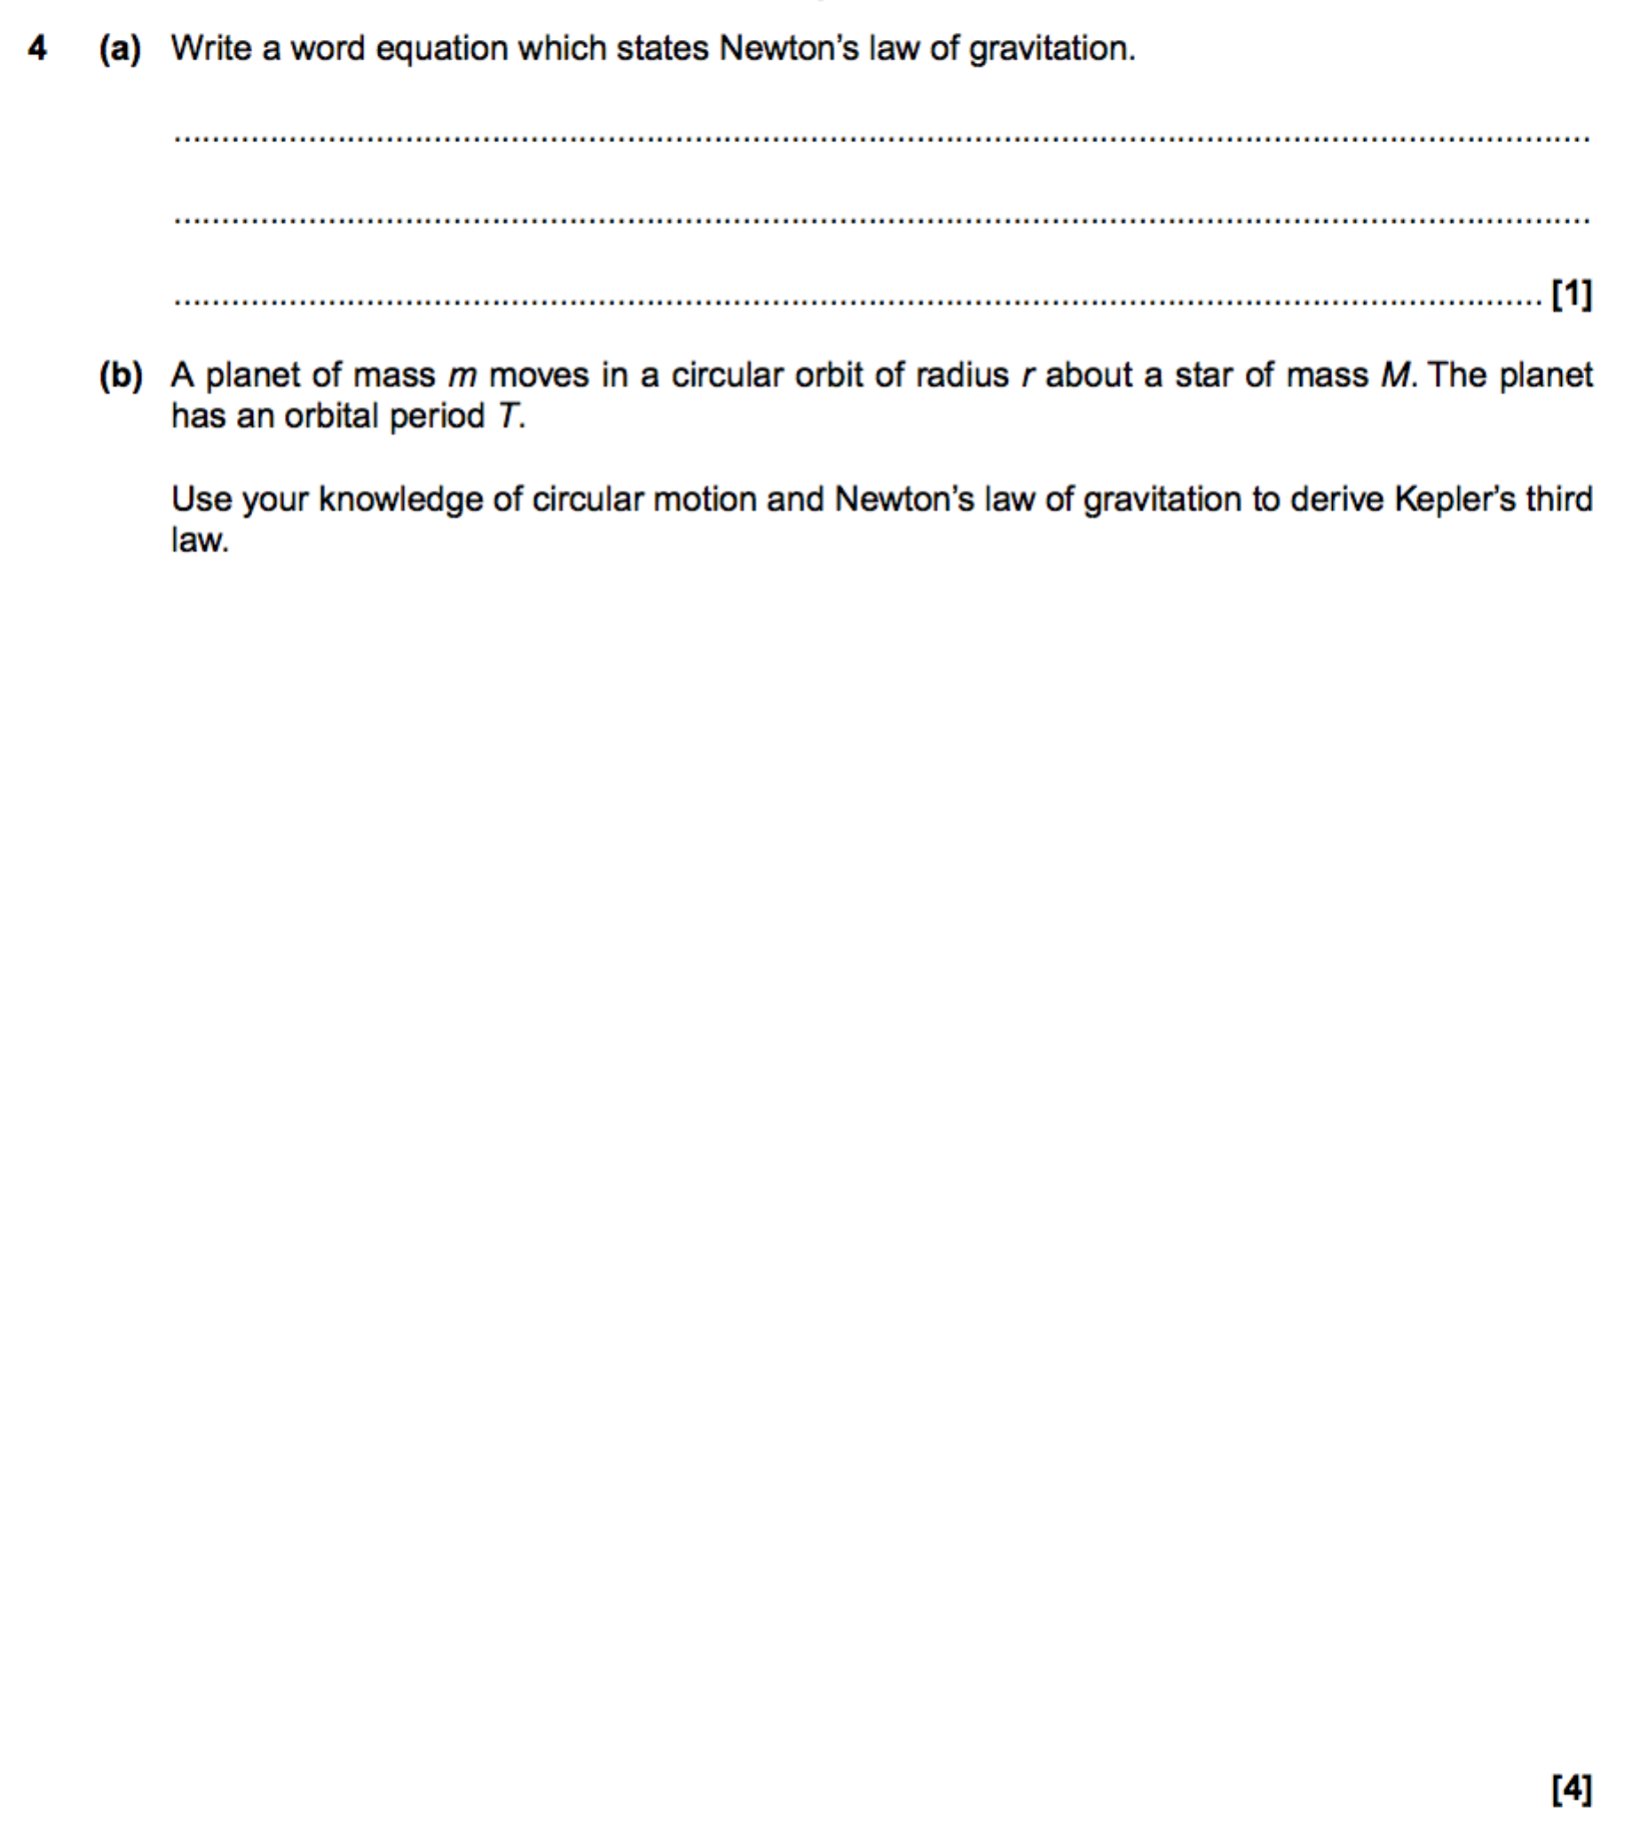

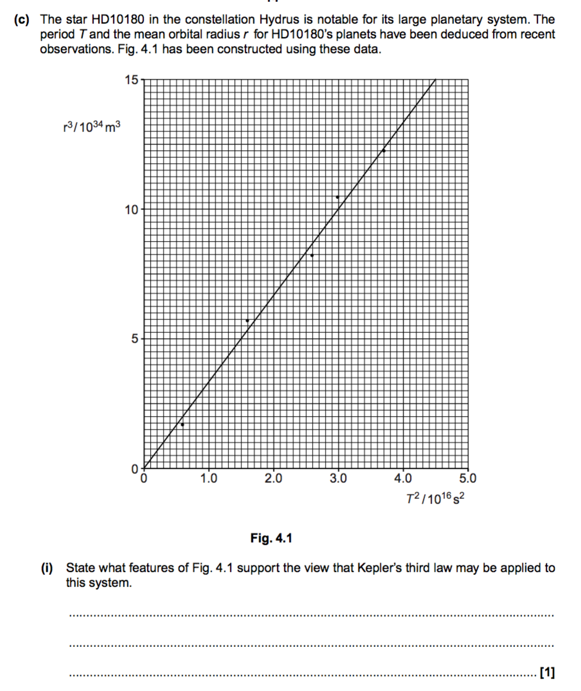

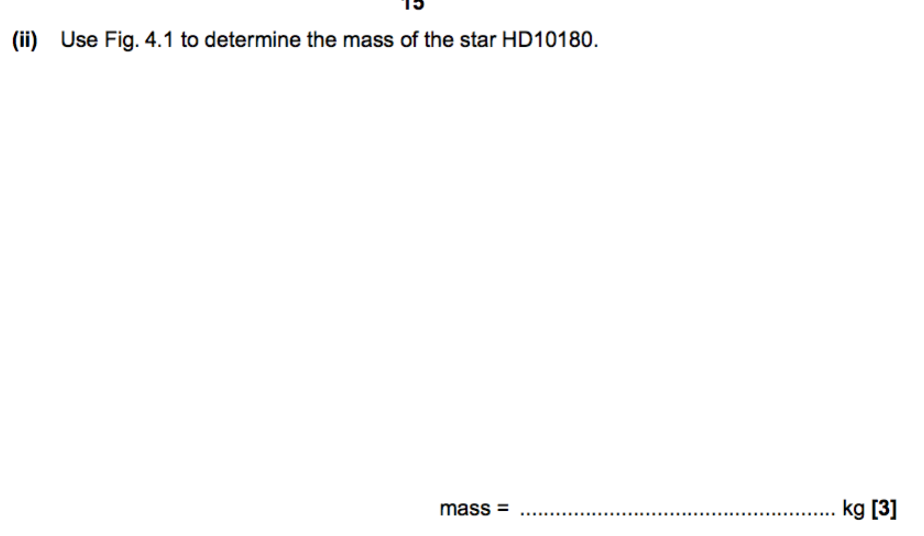**Satellites**

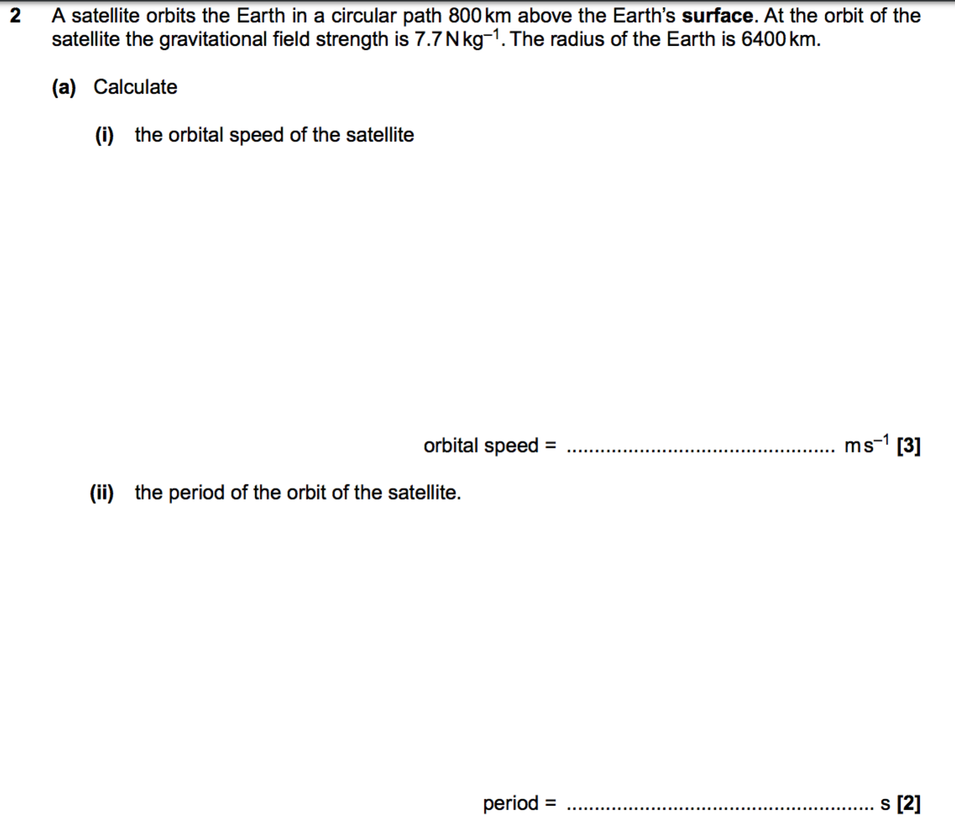

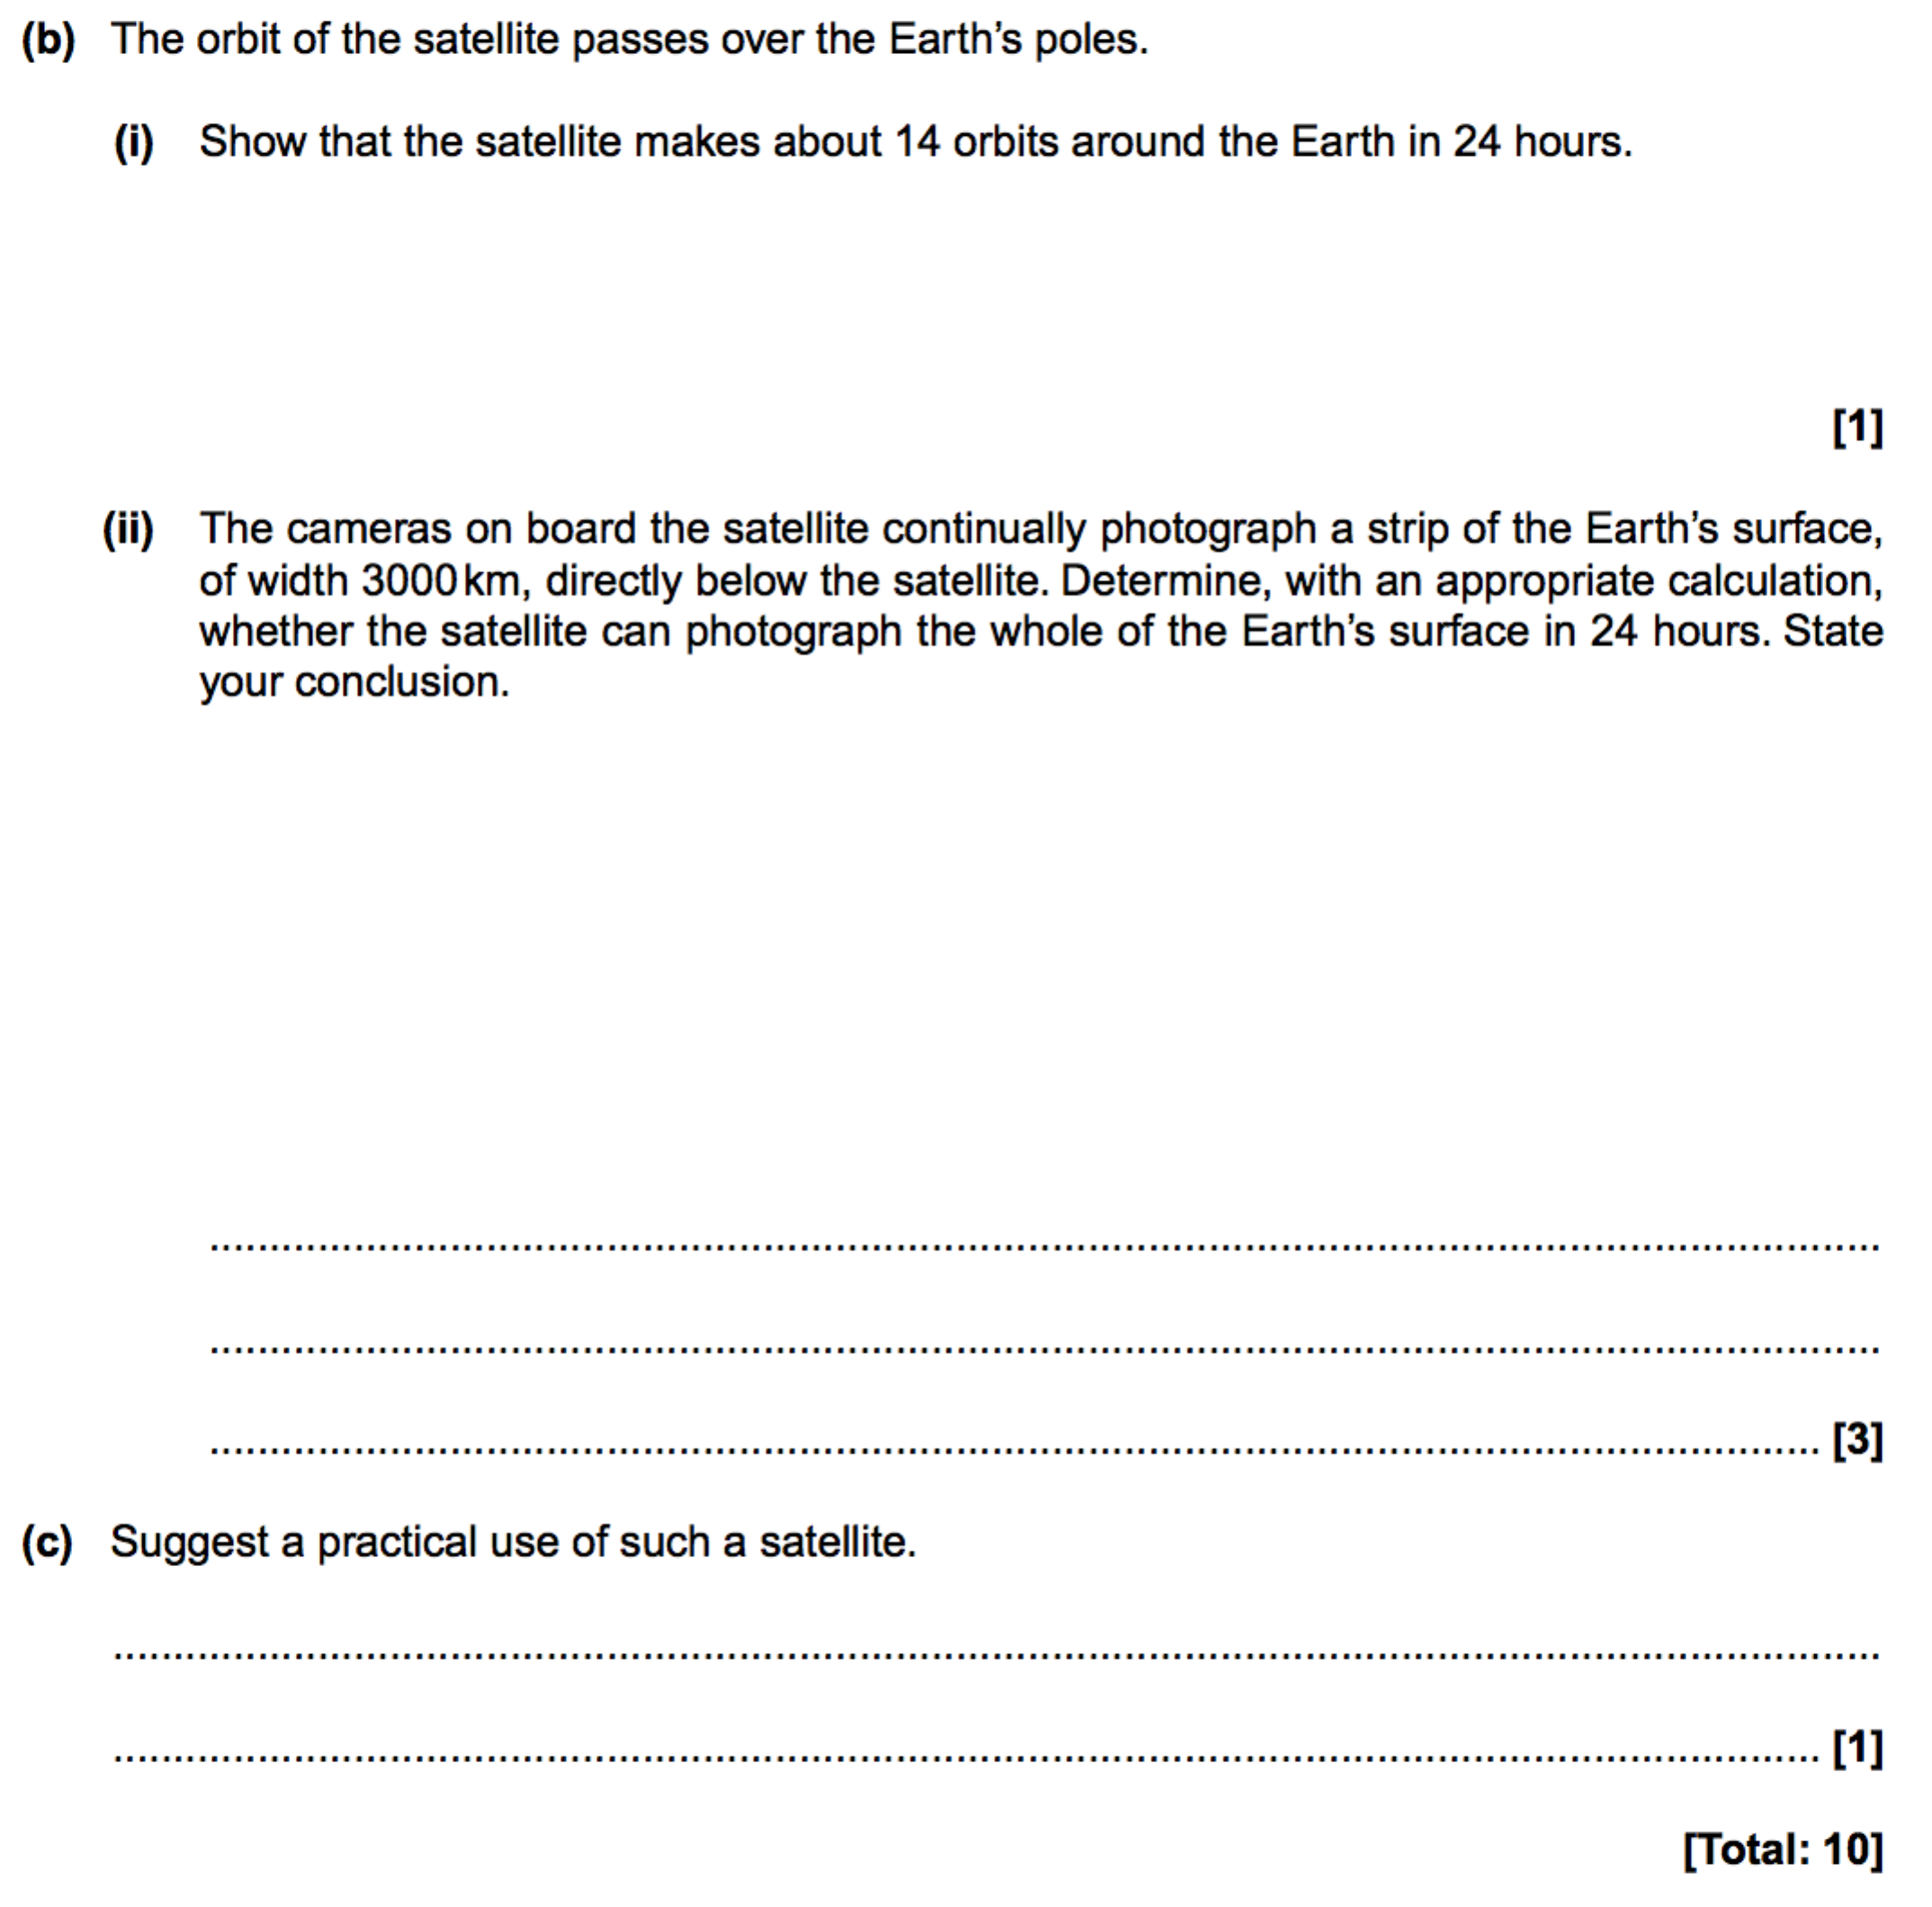

**Gravitational potential and Gravitational potential energy**

