Module 6.1 Capacitors

|  |  |  |  |  |
| --- | --- | --- | --- | --- |
| **Topic area** | **Text book pre-reading** | **Syllabus ref** | **Max possible score in exam questions** | **Your score in exam questions** |
| Charging capacitors and capacitance |  | 6.1.1 | 10 |  |
| Capacitors in series and parallel |  | 6.1.1 | 15 |  |
| Energy stored in a capacitor |  | 6.1.2 | 16 |  |
| Charging and discharging capacitors |  | 6.1.3 | 11 |  |
| **Total** | | | 52 |  |

**By the end of this topic you should be able to….**

* Define and calculate capacitance for individual capacitors and capacitors in series and parallel
* Describe charging and discharging of capacitors in terms of flow of electrons, and describe techniques to investigate this
* Describe a graph showing the relationship between p.d. and charge for a capacitor and use this and other equations to find the energy stored in a capacitor
* Describe graphically the exponential changes in the voltage, energy and charge as a capacitor charges and discharges and use equations to calculate these variables using the time constant for a capacitor-resistor circuit

**By the end of module 6.1 you need to be able to define the following key terms:**

Capacitor

Capacitance

Time constant

**Equations given in exam**

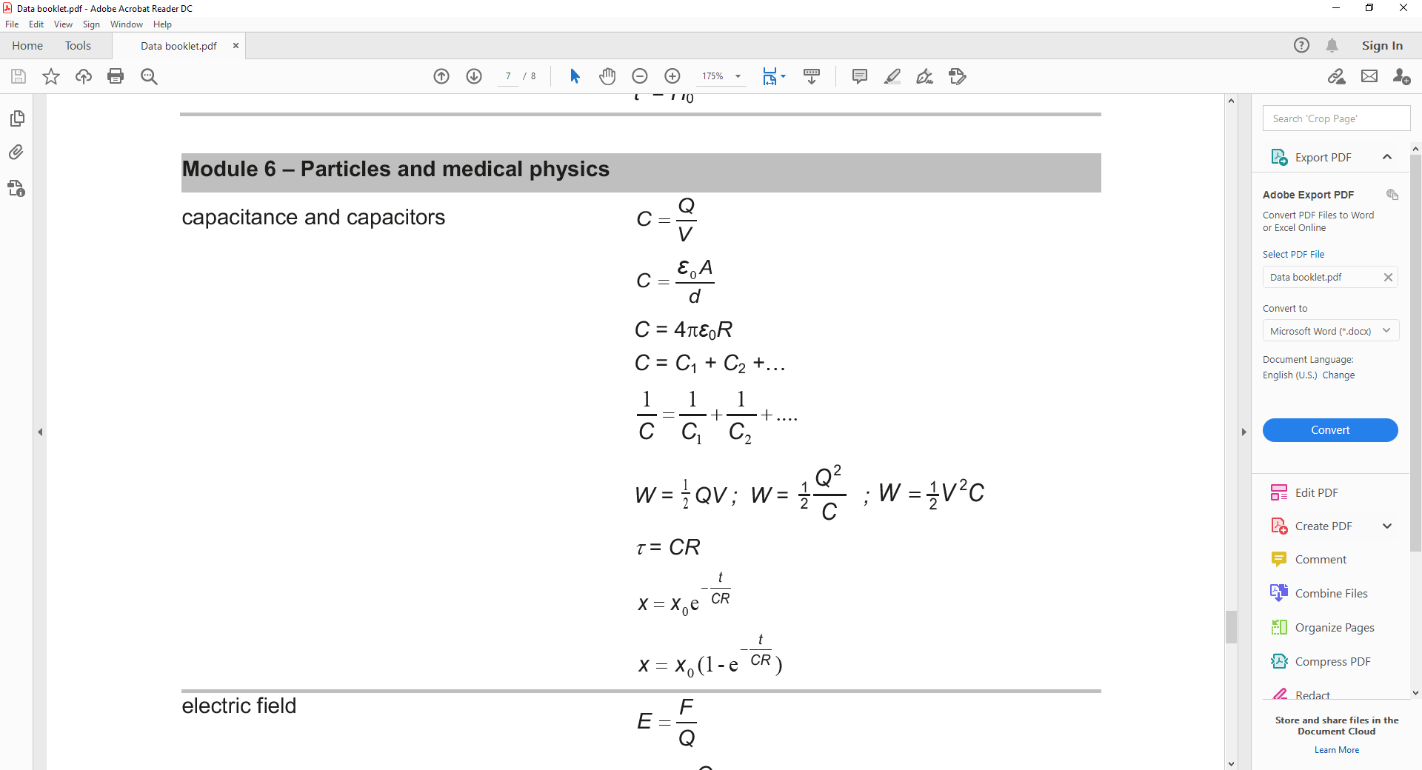

**Charging capacitors and capacitance**

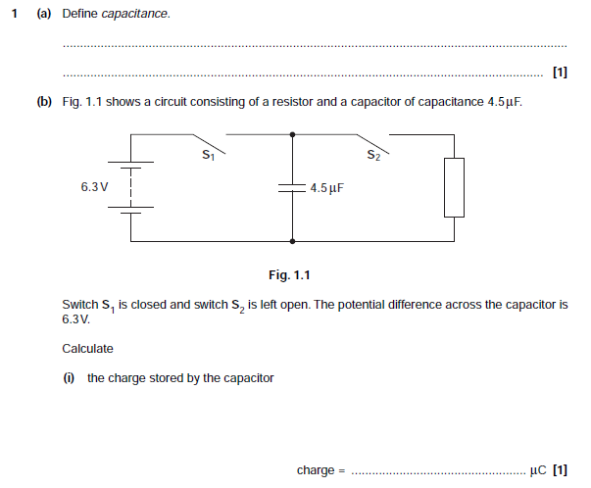

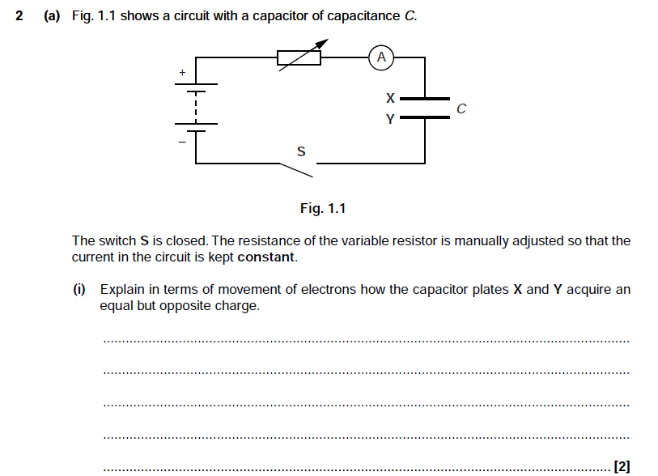



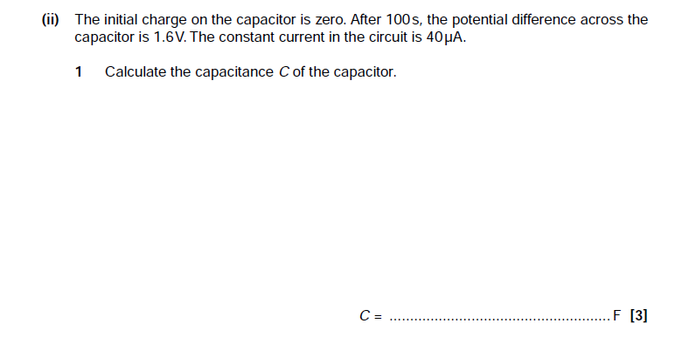

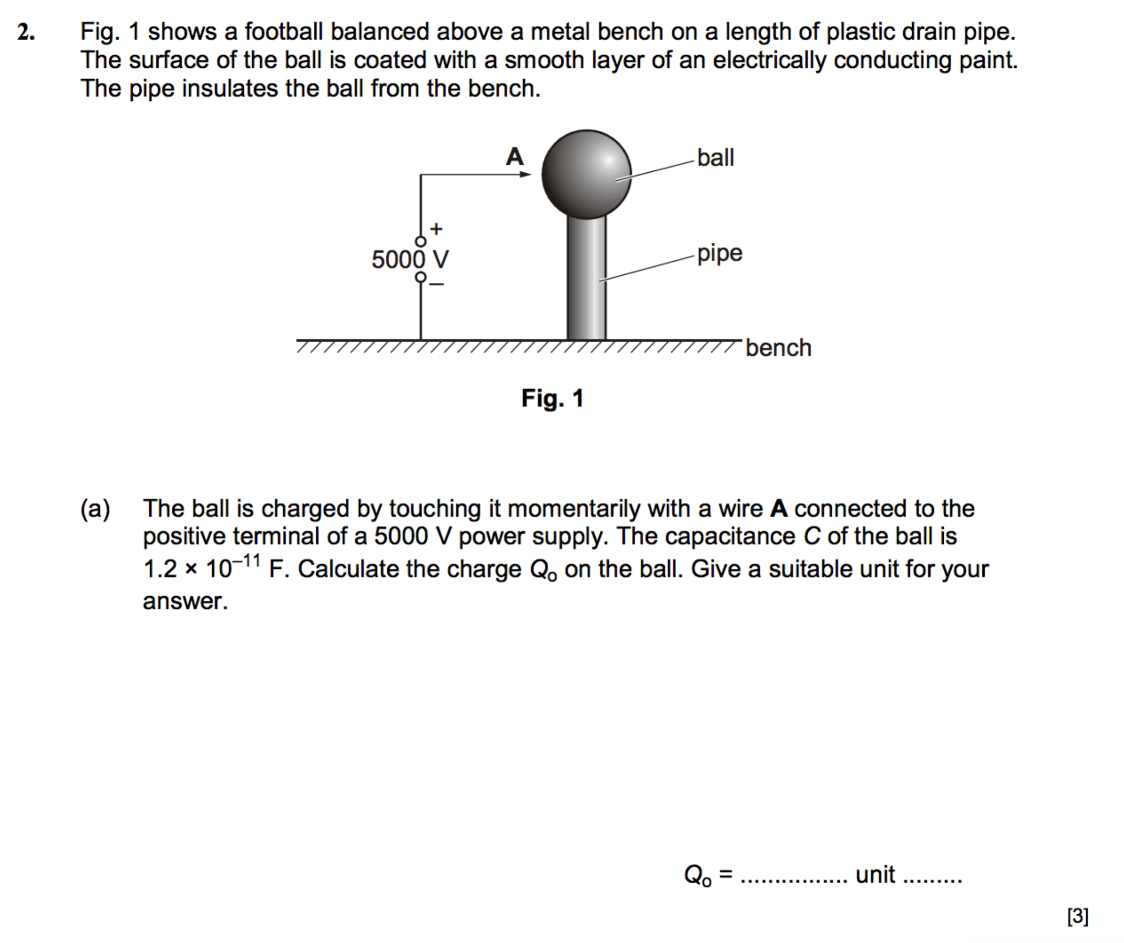

**Capacitors in series and parallel**

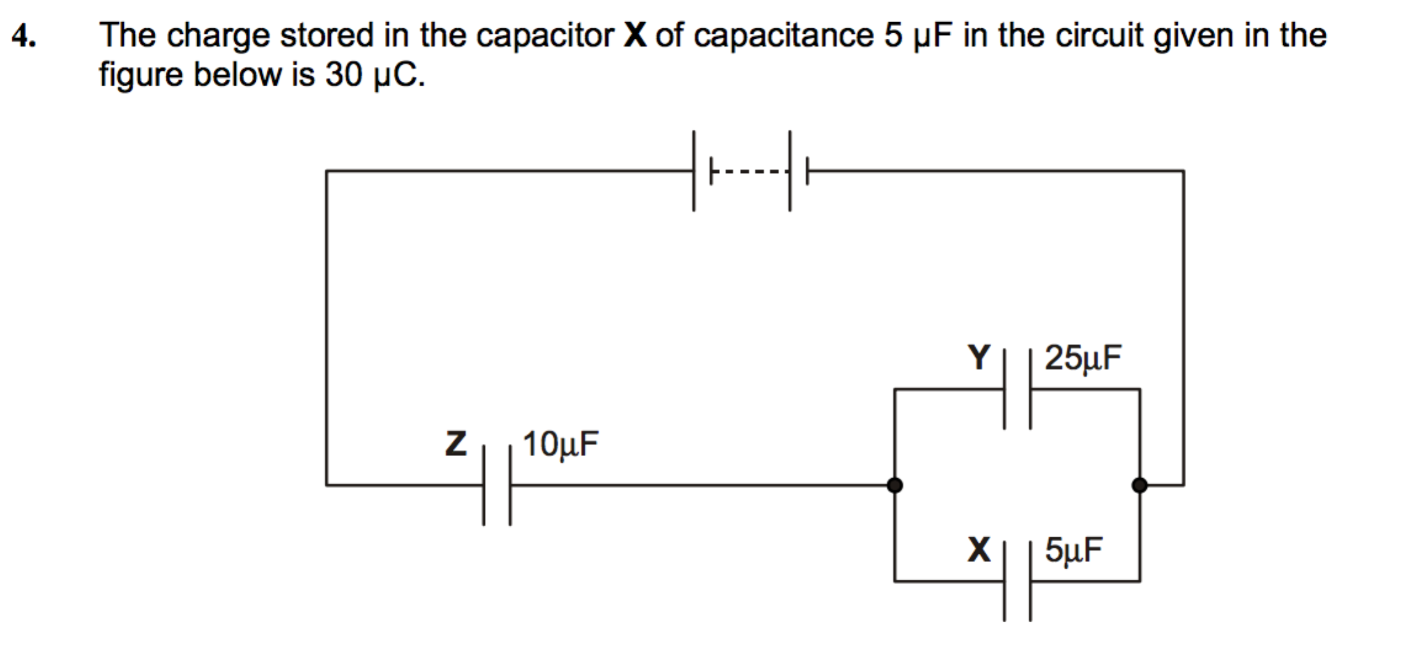

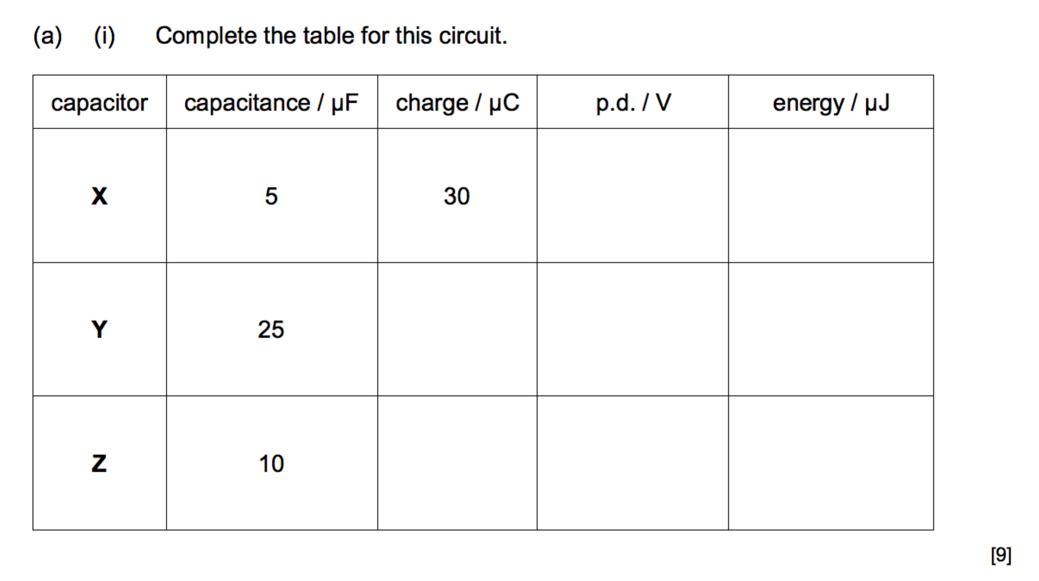

**5**

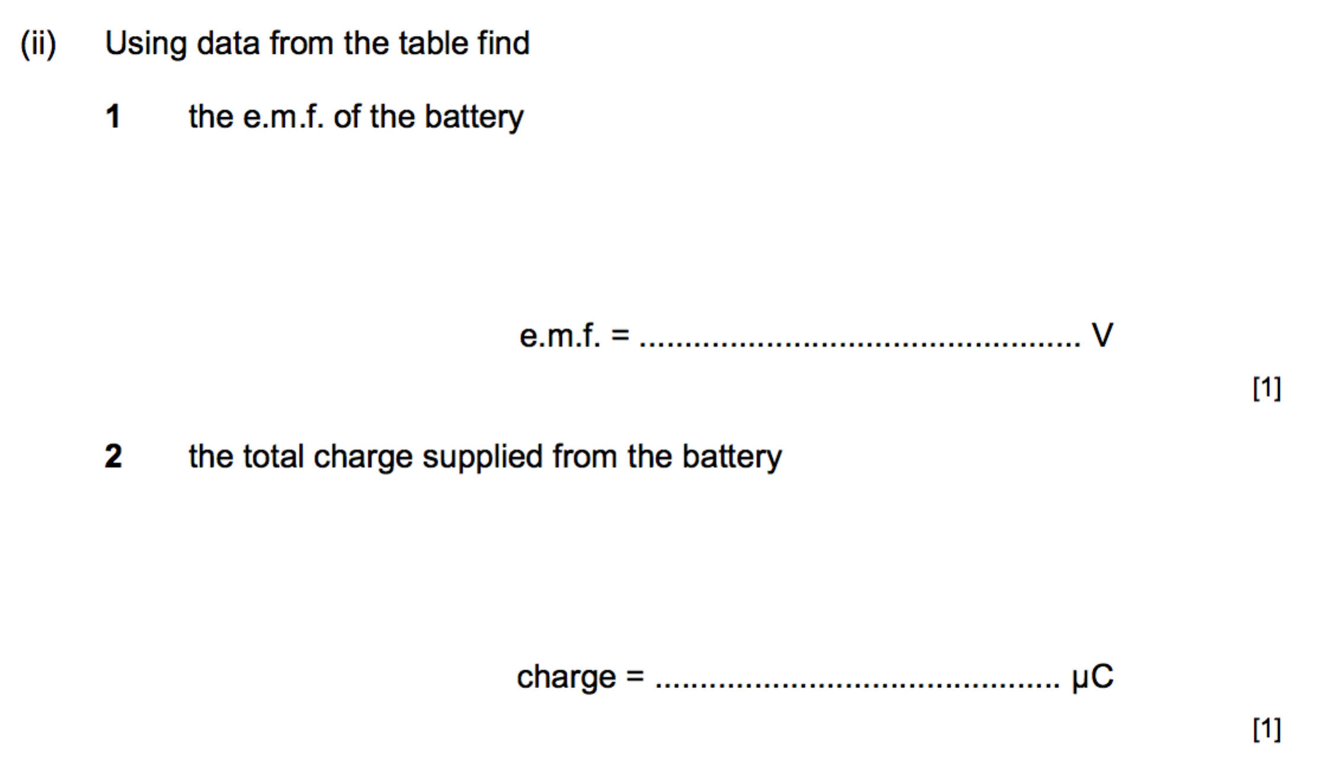

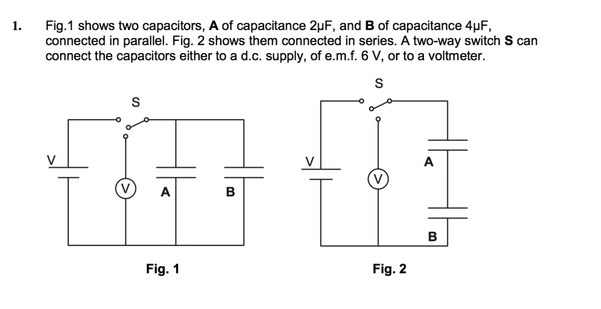

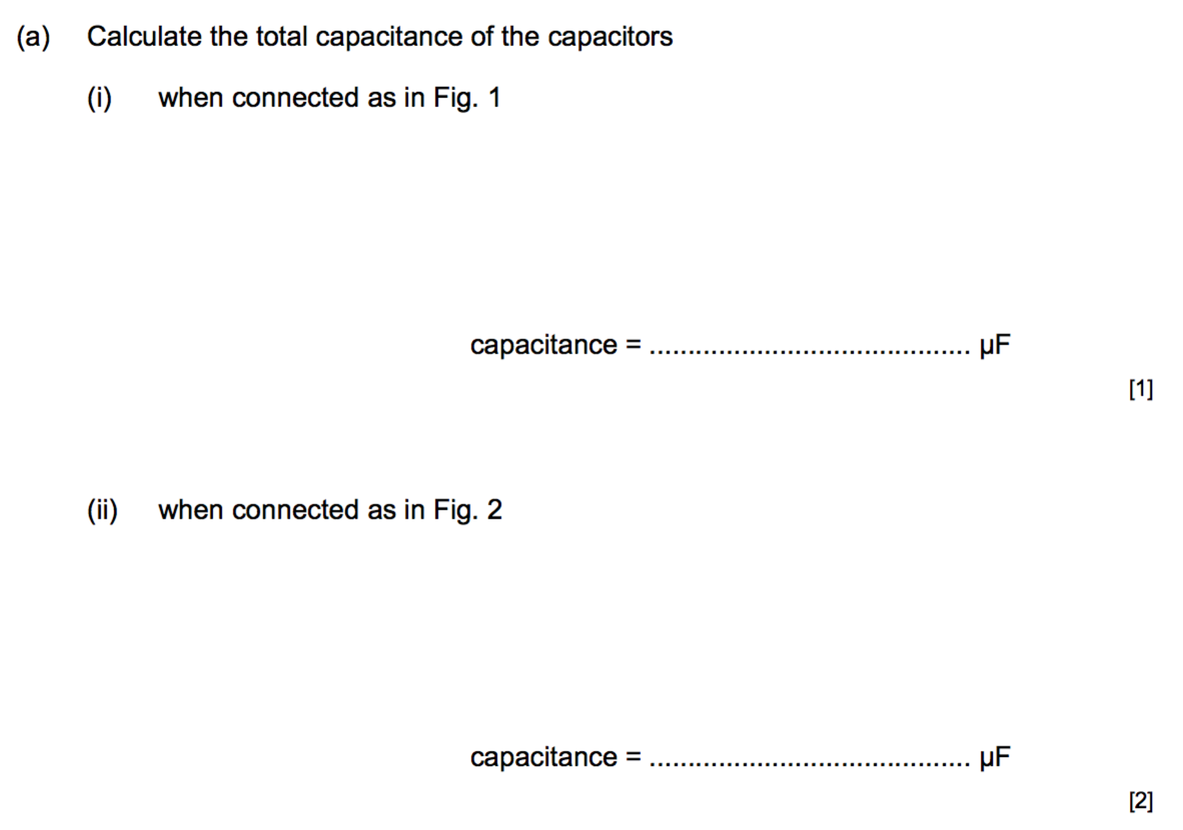

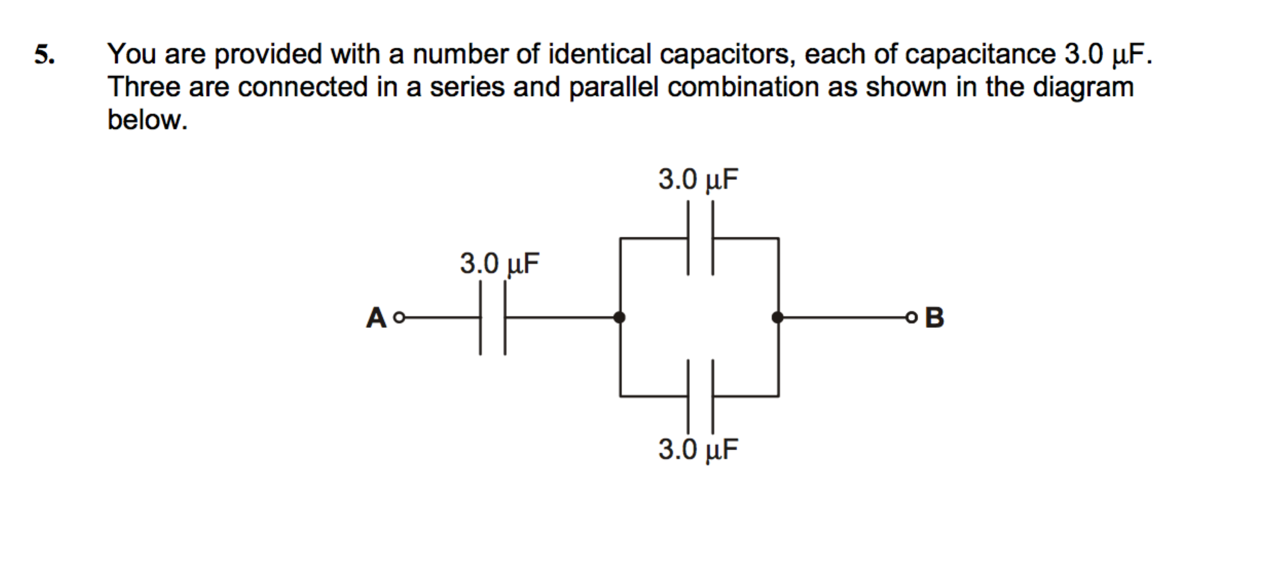

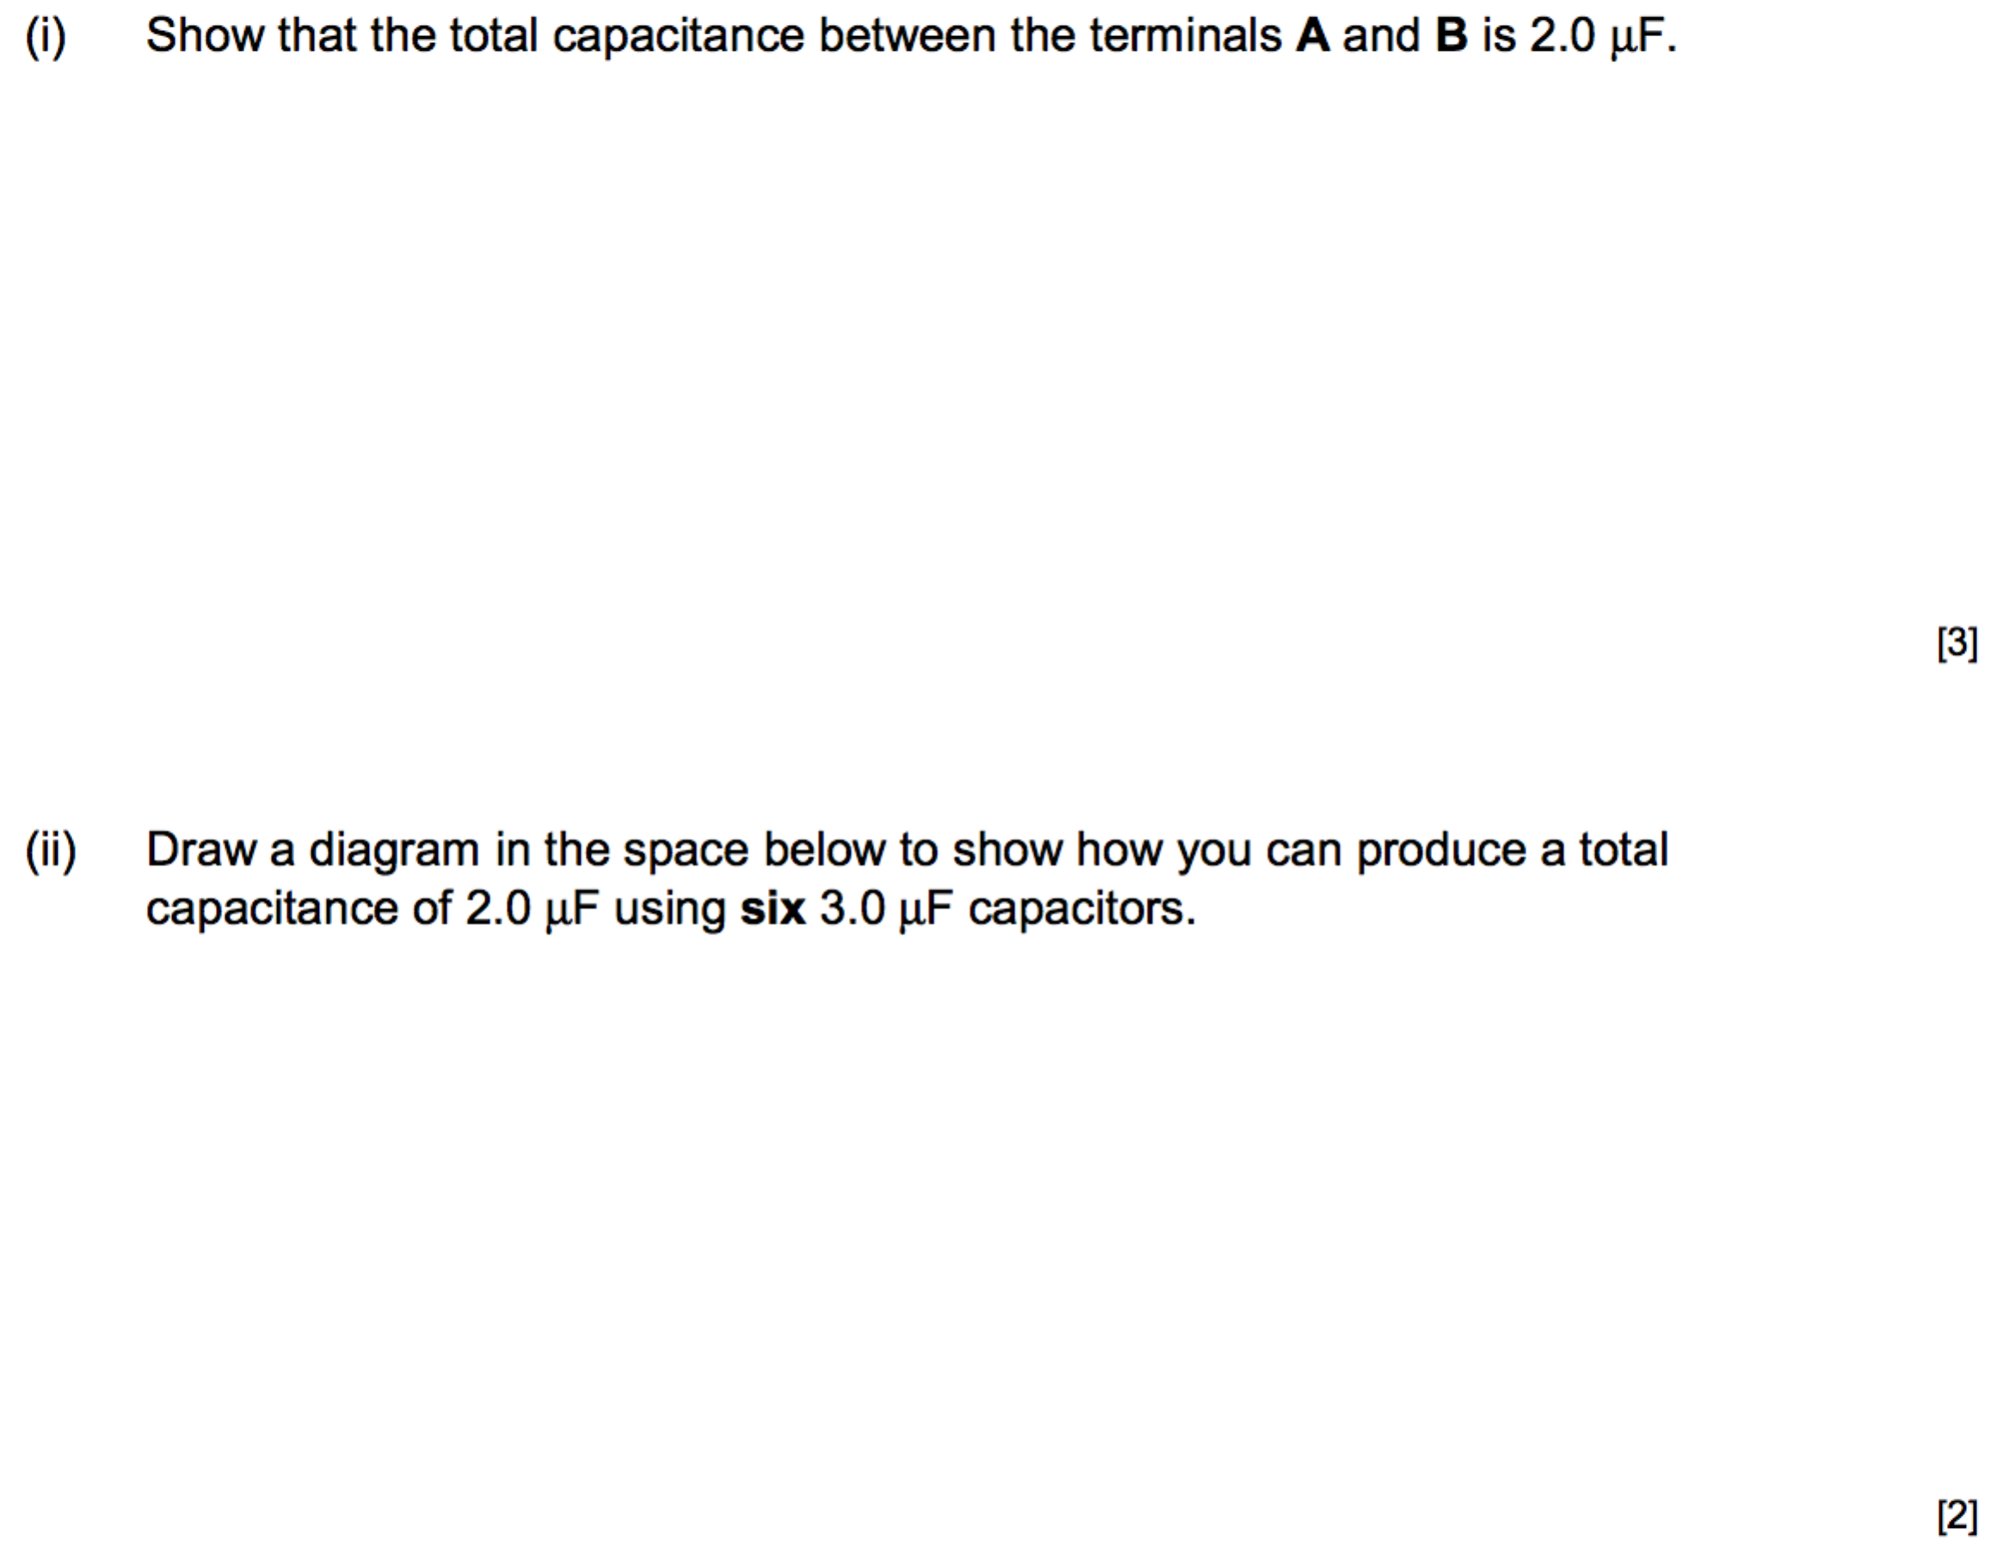

**Energy stored in a capacitor**

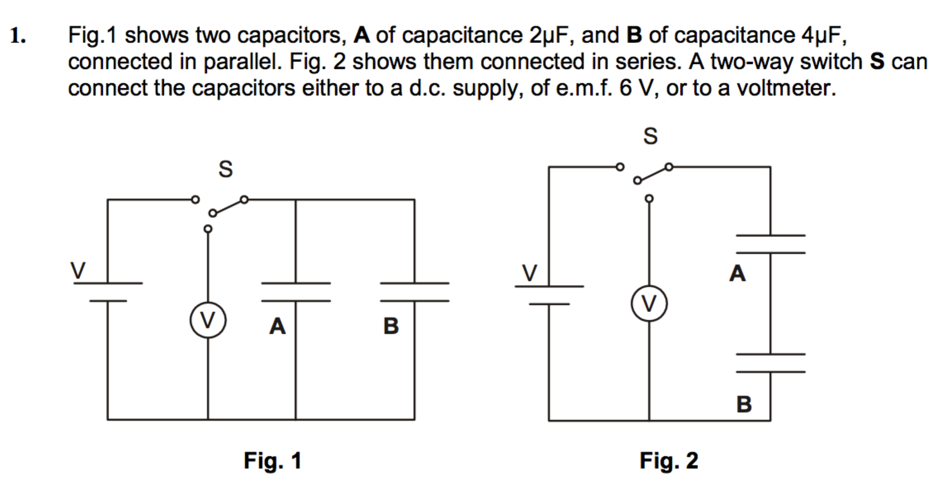

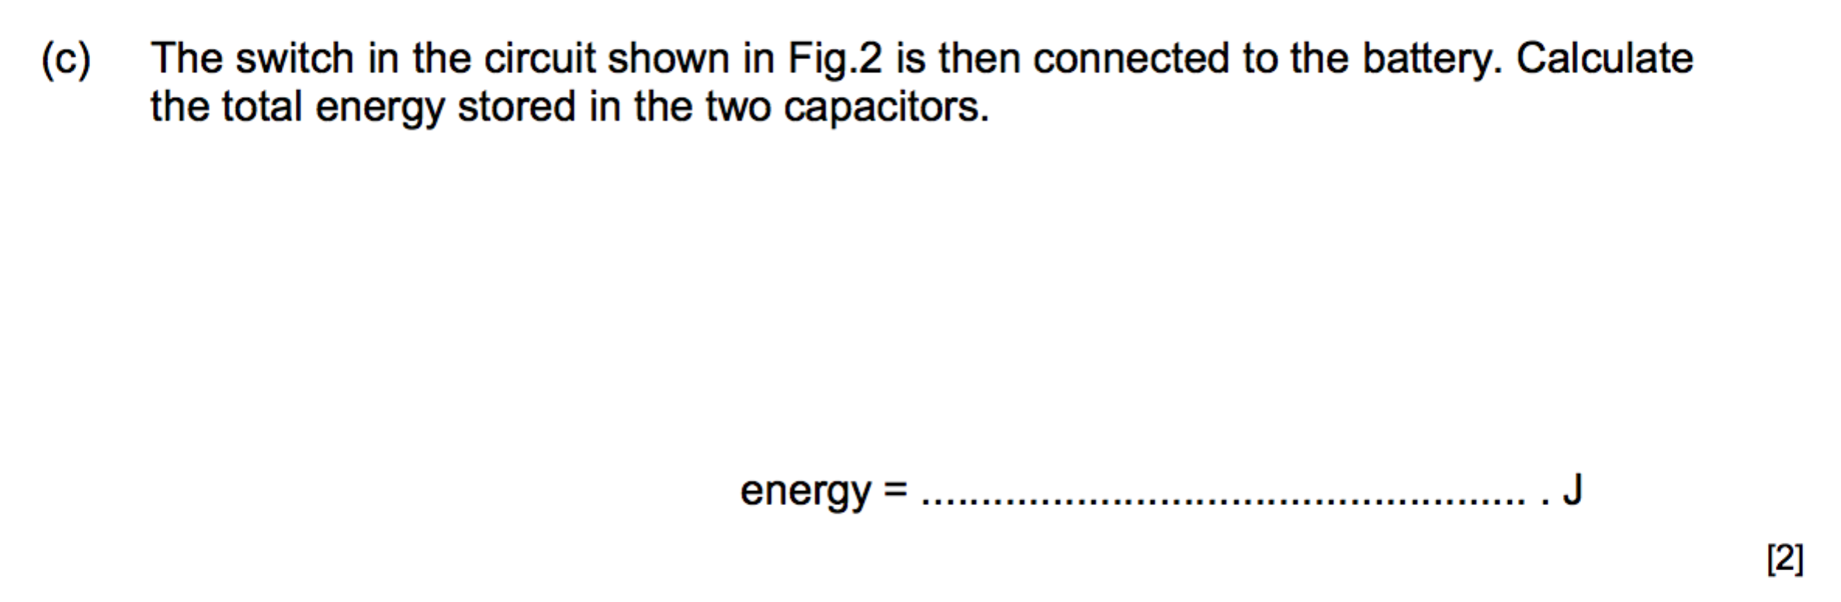

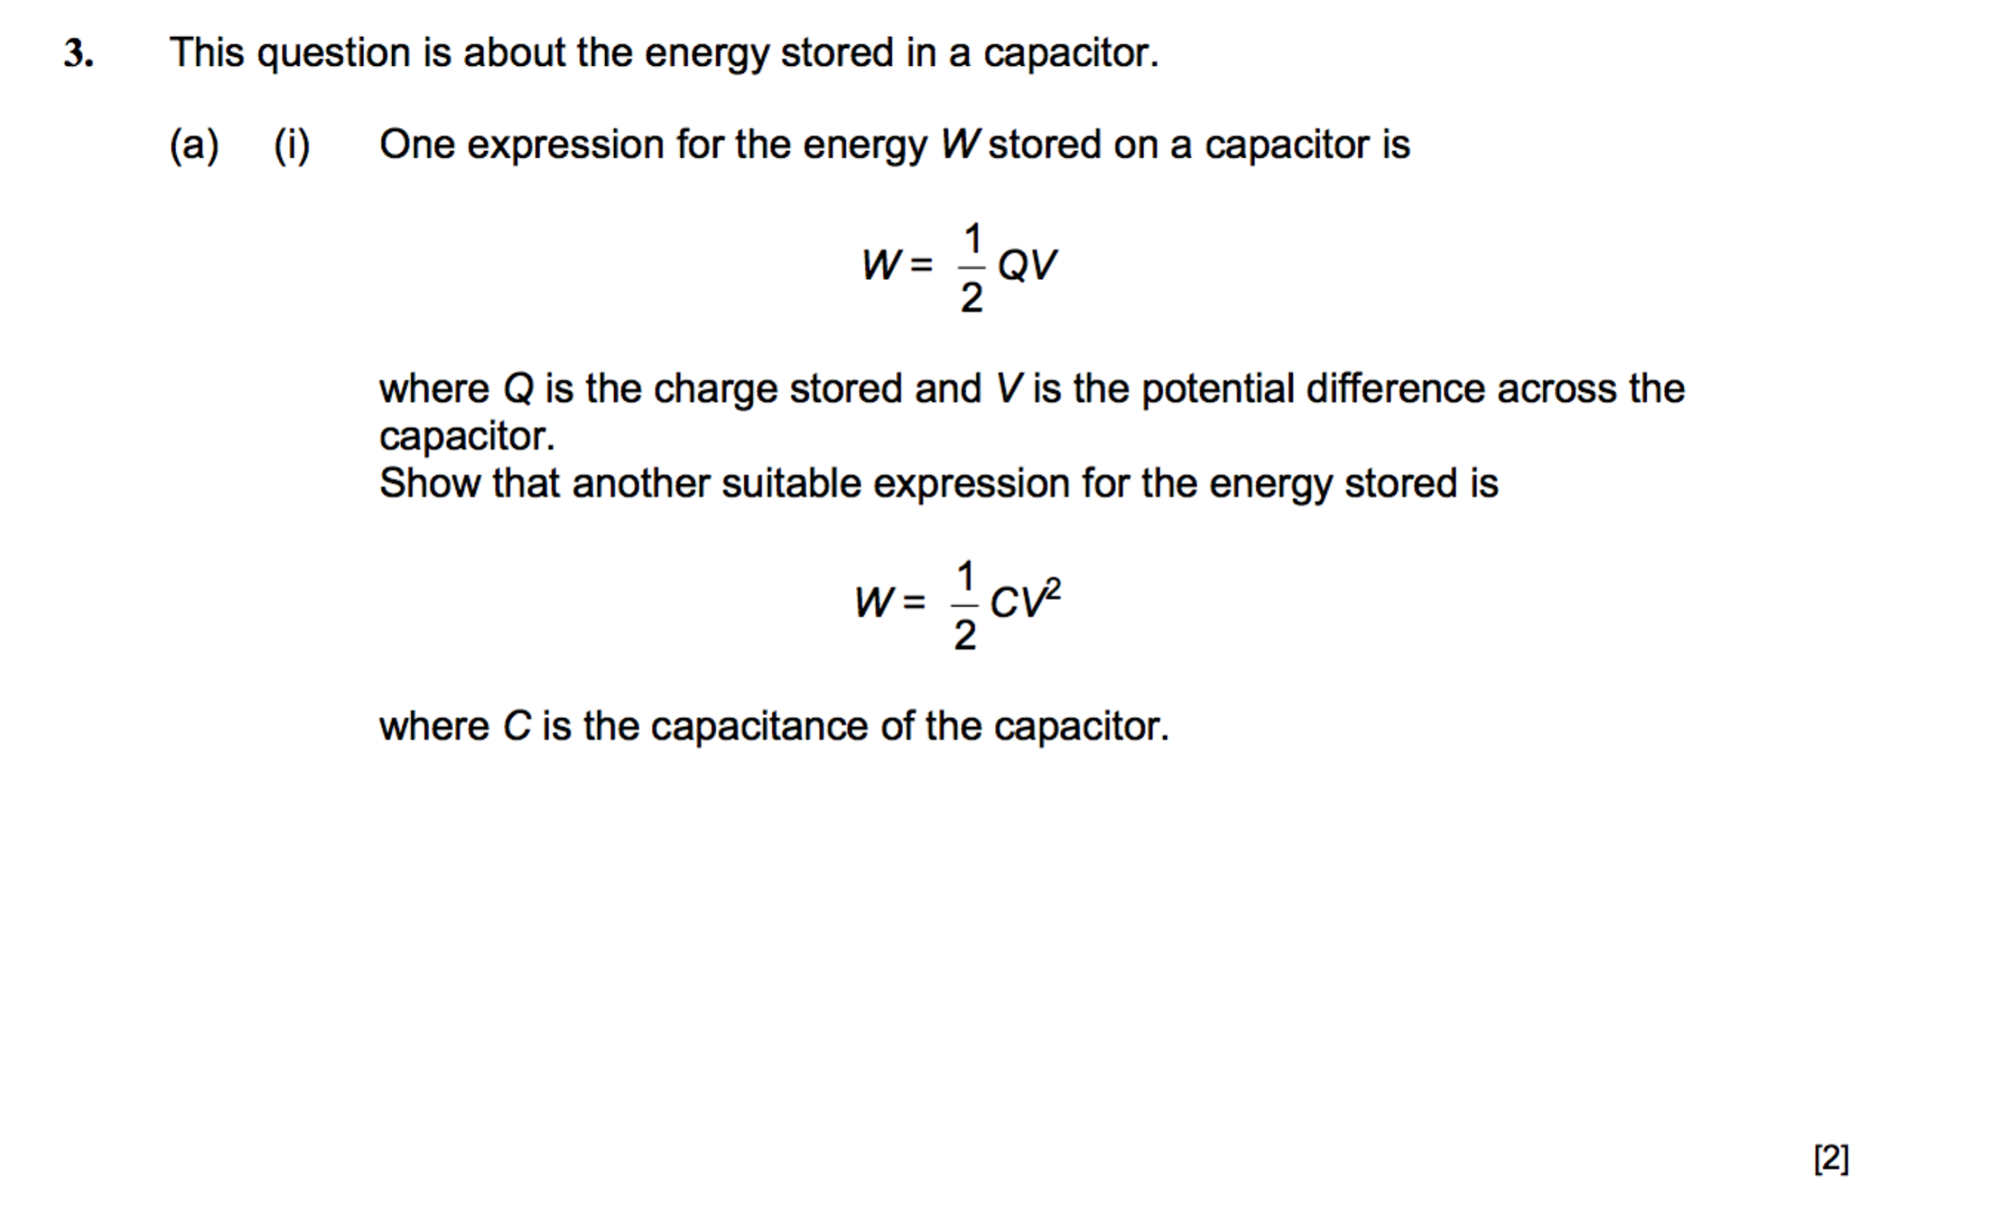

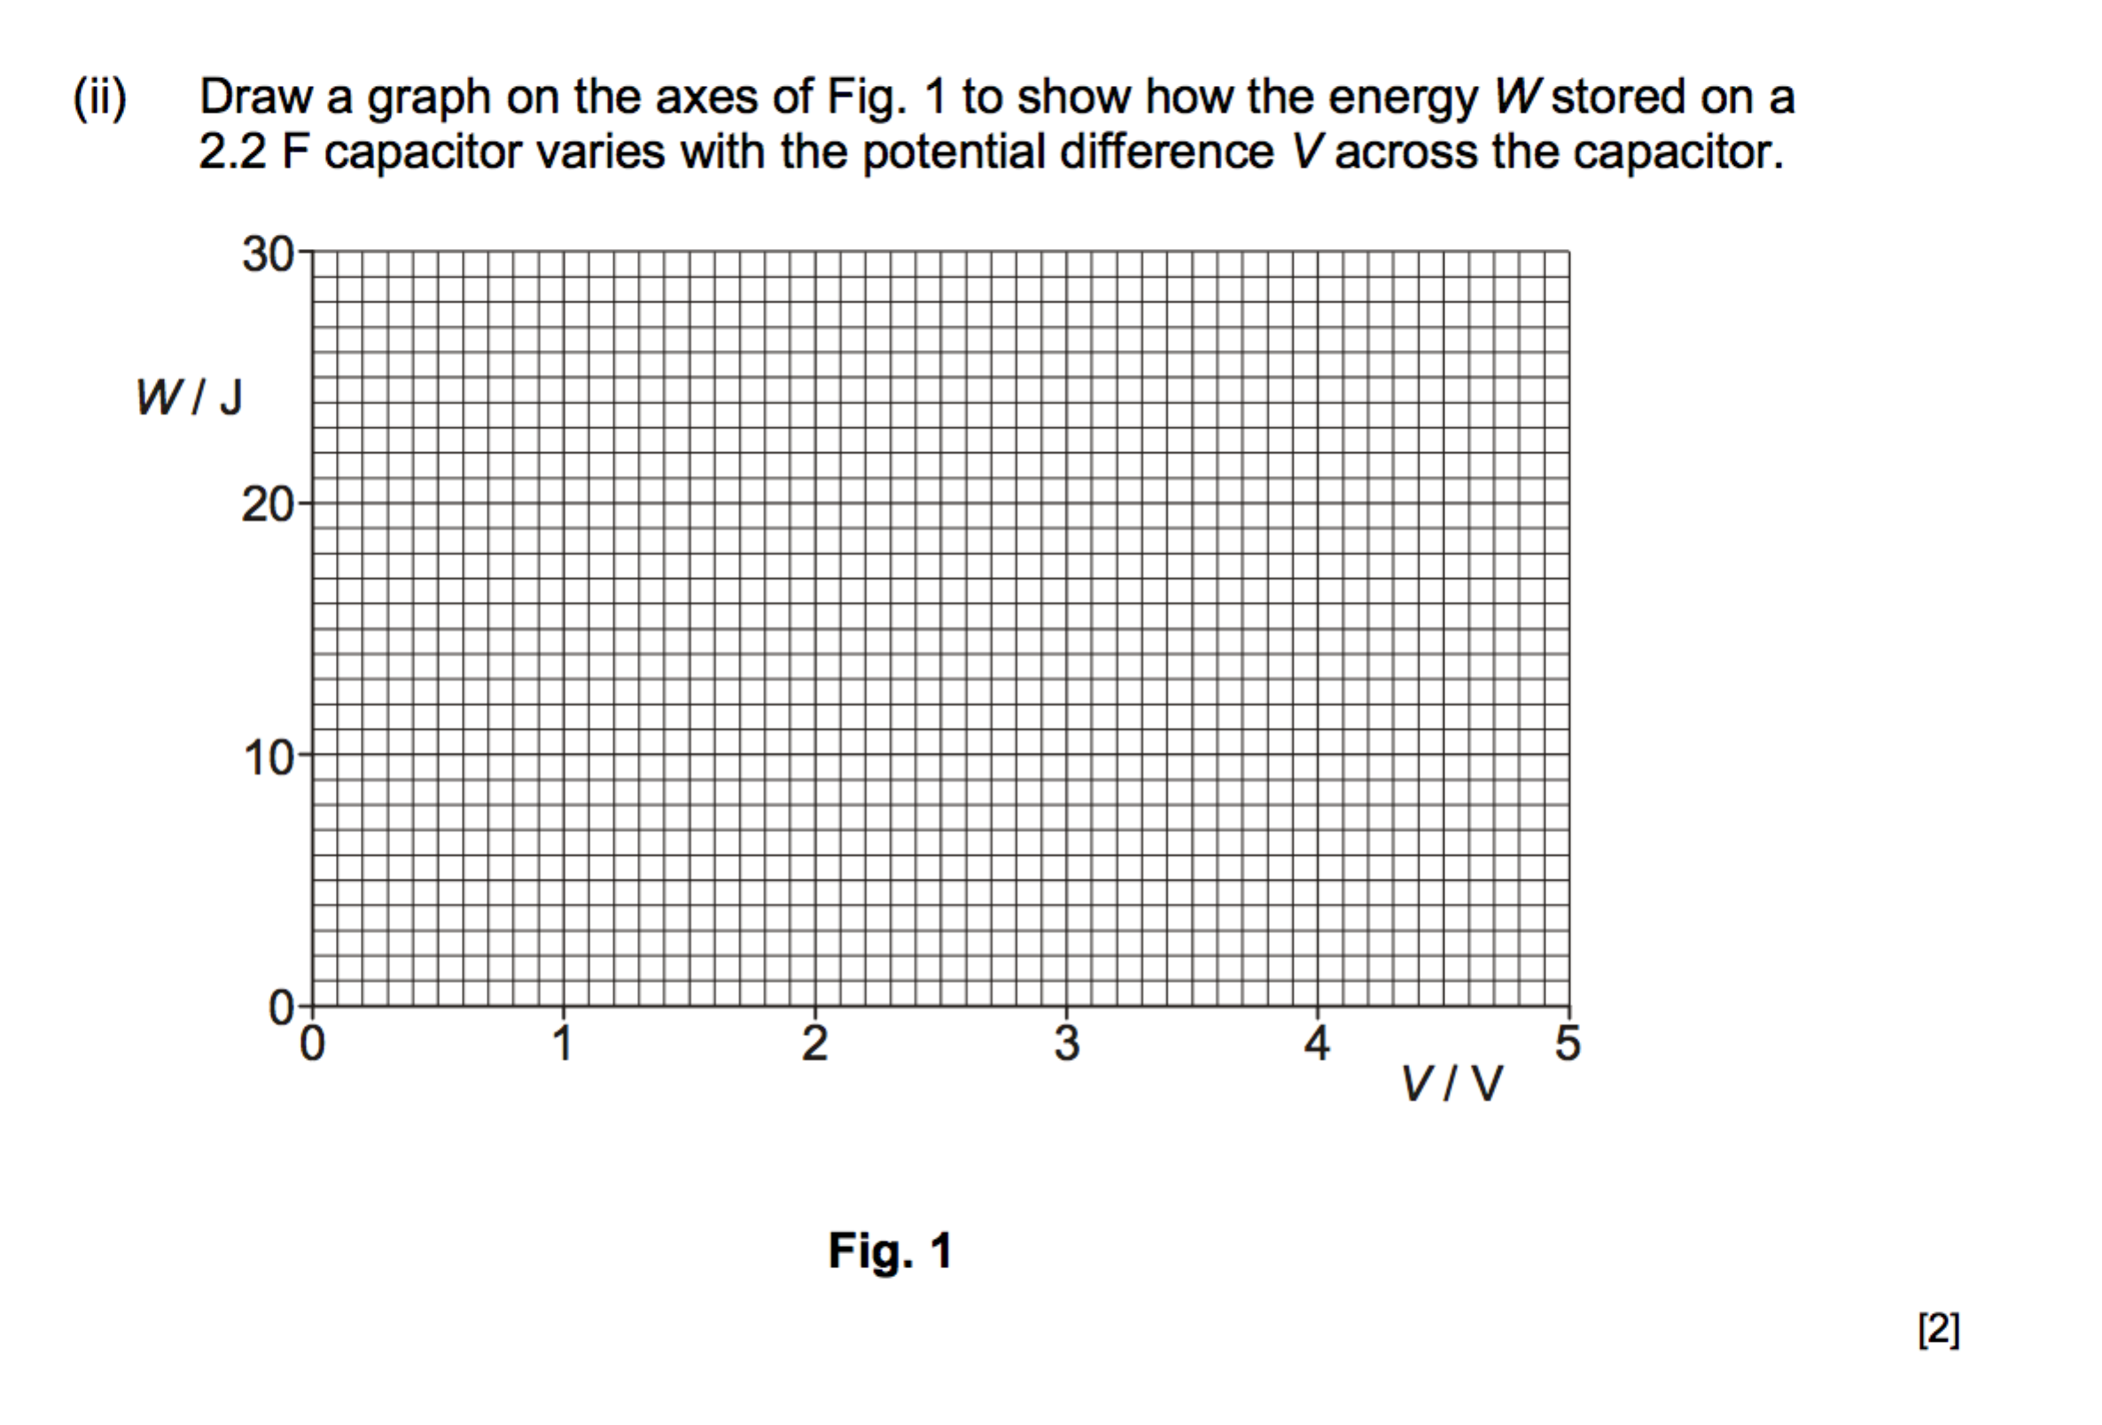

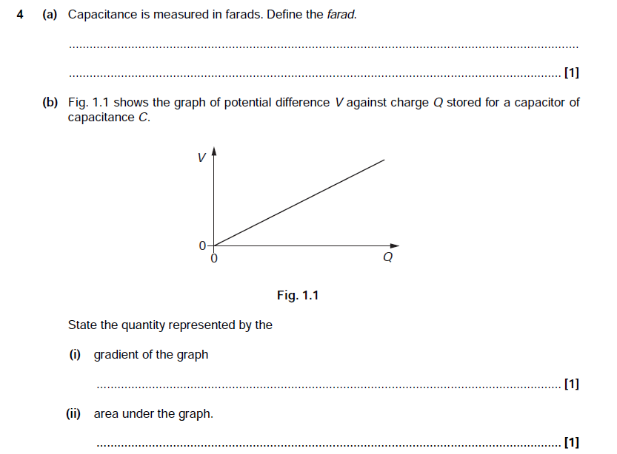

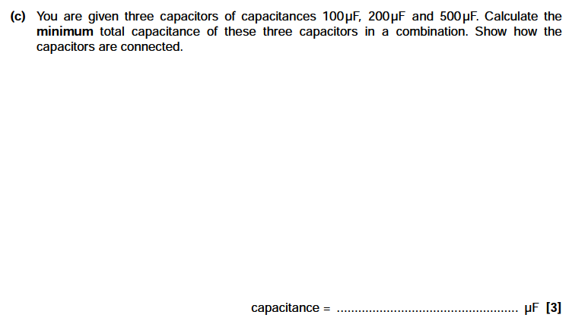

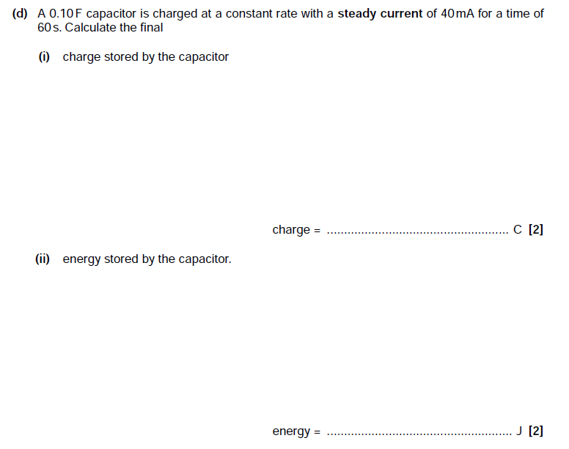

**Charging and discharging capacitors**

