Required practicals practise questions and answers
Q1.
A student wants to investigate how the current through a filament lamp affects its resistance.
(a) Use the circuit symbols in the boxes to draw a circuit diagram that she could use.

12 V battery | variable  resistor | filament  lamp | voltmeter | ammeter
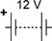

(2)
(b) Describe how the student could use her circuit to investigate how the current through a filament lamp affects its resistance.
___________________________________________________________________
___________________________________________________________________
___________________________________________________________________
___________________________________________________________________
___________________________________________________________________
___________________________________________________________________
___________________________________________________________________
___________________________________________________________________
(4)

(c) The student’s results are shown in Figure 1.
Figure 1
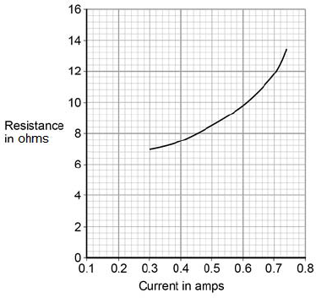
Describe how the resistance of the filament lamp changes as the current through it increases.
___________________________________________________________________
___________________________________________________________________
(1)
(d) Use Figure 1 to estimate the resistance of the filament lamp when a current of 0.10 A passes through the lamp.
Resistance = _____________________ Ω
(1)
(e) The current‑potential difference graphs of three components are shown in Figure 2.
Use answers from the box to identify each component.

diode | filament lamp | light dependent resistor
resistor at constant temperature |  | thermistor

Figure 2
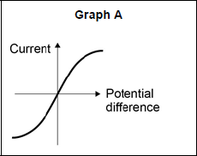 __________________________
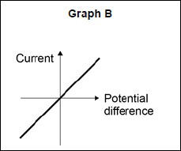 __________________________
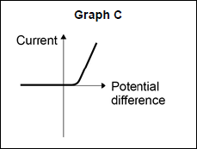 __________________________
(3)
(Total 11 marks)

Q2.
A student investigated the insulating properties of newspaper.
Figure 1 shows the apparatus the student used.
Figure 1
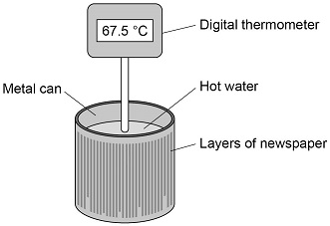
The student’s results are shown in Figure 2.
Figure 2
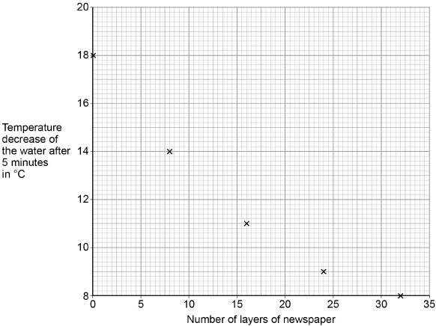

(a) Describe a method the student could have used to obtain the results shown in Figure 2.
___________________________________________________________________
___________________________________________________________________
___________________________________________________________________
___________________________________________________________________
___________________________________________________________________
___________________________________________________________________
___________________________________________________________________
___________________________________________________________________
___________________________________________________________________
___________________________________________________________________
___________________________________________________________________
___________________________________________________________________
(6)
(b) The student could have used a datalogger with a temperature probe instead of the digital thermometer.
Figure 3 shows the readings on the digital thermometer and the datalogger.
Figure 3
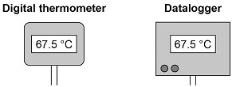
The datalogger records 10 readings every second.The student considered using a temperature probe and datalogger. Explain why it was not necessary to use a temperature probe and datalogger for this investigation.
___________________________________________________________________
___________________________________________________________________
___________________________________________________________________
___________________________________________________________________
___________________________________________________________________
(2)
(Total 8 marks)
Q3.
The specific heat capacity of aluminium can be determined by experiment.
- Draw a labelled diagram showing how the apparatus used to determine the specific heat capacity of aluminium should be arranged.

(3)
(b) Describe how you could use the apparatus you drew in part (a) to determine the specific heat capacity of aluminium.
___________________________________________________________________
___________________________________________________________________
___________________________________________________________________
___________________________________________________________________
___________________________________________________________________
___________________________________________________________________
___________________________________________________________________
___________________________________________________________________
___________________________________________________________________
___________________________________________________________________
___________________________________________________________________
___________________________________________________________________

(6)

(c) Methods used to determine the specific heat capacity of aluminium may give a value greater than the actual value.
Explain why.
___________________________________________________________________
___________________________________________________________________
___________________________________________________________________
___________________________________________________________________
___________________________________________________________________
___________________________________________________________________
___________________________________________________________________
___________________________________________________________________
(2)
(Total 11 marks)
Q4.
A student investigated how the resistance of a piece of nichrome wire varies with length.
Figure 1 shows part of the circuit the student used.
Figure 1
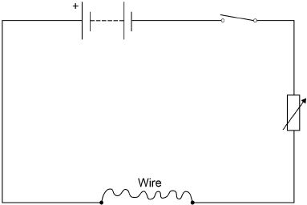
(a) Complete Figure 1 by adding an ammeter and a voltmeter.
Use the correct circuit symbols.
(3)

(b) Describe how the student would obtain the data needed for the investigation.
Your answer should include a risk assessment for one hazard in the investigation.
___________________________________________________________________
___________________________________________________________________
___________________________________________________________________
___________________________________________________________________
___________________________________________________________________
___________________________________________________________________
___________________________________________________________________
___________________________________________________________________
___________________________________________________________________
___________________________________________________________________
___________________________________________________________________
___________________________________________________________________
(6)
(c) Why would switching off the circuit between readings have improved the accuracy of the student’s investigation?
Tick one box.

The charge flow through the wire would not change.
The potential difference of the battery would not increase.
The power output of the battery would not increase.
The temperature of the wire would not change.
(1)

(d) The student used crocodile clips to make connections to the wire.
They could have used a piece of equipment called a ‘jockey’.
Figure 2 shows a crocodile clip and a jockey in contact with a wire.
Figure 2
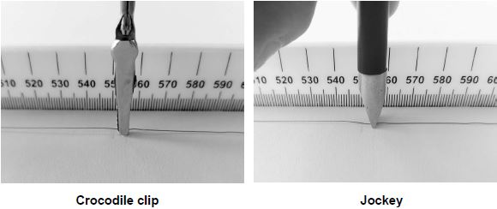
How would using the jockey have affected the accuracy and resolution of the student’s results compared to using the crocodile clip?
Tick two boxes.

The accuracy of the student’s results would be higher.
The accuracy of the student’s results would be lower.
The accuracy of the student’s results would be the same.
The resolution of the length measurement would be higher.
The resolution of the length measurement would be lower.
The resolution of the length measurement would be the same.
(2)
(Total 12 marks)

Q5.
(a) Figure 1 shows the position of three types of wave in the electromagnetic spectrum.
Figure 1

A | Microwaves | B | Visible light | C | D | Gamma rays
Which letter represents infrared in the electromagnetic spectrum?
Tick (✓) one box.

A |  | B |  | C |  | D
(1)
(b) What is infrared used for?
Tick (✓) one box.

Electrical heating
Energy efficient lamps
Satellite communications
Sun tanning
(1)
An infrared camera produces a colour image. Different colours show different temperatures.
People emit infrared radiation. Figure 2 shows how the colour of the image of a person on an infrared camera depends on the person’s body temperature.
Figure 2
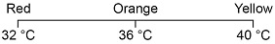
(c) Complete the sentence. Choose the answer from the box.

orange red yellow
The image produced by an infrared camera of a person with a body temperature of
37 °C is mainly _________________________ .
(1)
(d) Rescue workers use infrared cameras to search for people trapped under rubble after an earthquake.
How does the image of a trapped person change if the person’s body temperature drops from 37 °C to 33 °C?
___________________________________________________________________
___________________________________________________________________
___________________________________________________________________
(1)
A student investigated how the type of surface affects the amount of infrared the surface radiates.
Figure 3 shows the equipment used.
Figure 3
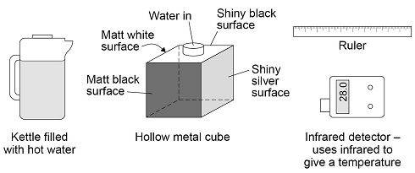
(e) Complete the sentence.
Choose the answer from the box.

a control the dependent the independent
In this investigation the type of surface is ___________________________ variable.
(1)
(f) Describe how the equipment shown in Figure 3 would be used to compare the infrared radiation emitted from the vertical surfaces of the cube.
___________________________________________________________________
___________________________________________________________________
___________________________________________________________________
___________________________________________________________________
___________________________________________________________________
(3)
The table below shows the results.

Type of surface | Temperature in °C
Matt black | 68.0
Matt white | 65.5
Shiny black | 66.3
Shiny silver | 28.0
(g) What is the resolution of the infrared detector?
Tick (✓) one box.

0.1 °C
1.0 °C
1.7 °C
68.0 °C
(1)
The bar chart in Figure 4 shows two of the results.
Figure 4
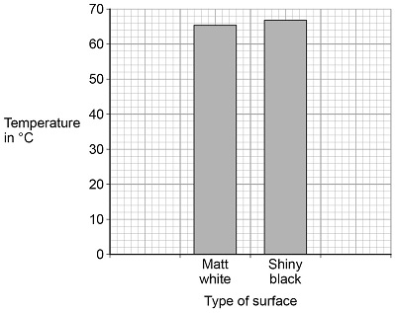
(h) Complete the bar chart to show all of the results.
(3)
(i) Give one conclusion that can be made from the results.
___________________________________________________________________
___________________________________________________________________
___________________________________________________________________
(1)
(Total 13 marks)
Q6.
A student measured the width of a solid metal cube using a digital micrometer.
The figure below shows the micrometer.
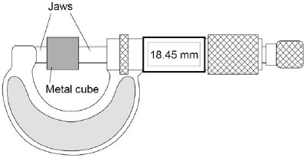
(a) The resolution of the micrometer is 0.01 mm
The student could have used a metre rule to measure the width of the cube.
Explain how using a metre rule would have affected the accuracy of the student’s measurement of width.
___________________________________________________________________
___________________________________________________________________
___________________________________________________________________
___________________________________________________________________
(2)
(b) The mass of the metal cube was measured using a top pan balance.
The balance had a zero error.
Explain how the zero error may be corrected after readings had been taken from the balance.
___________________________________________________________________
___________________________________________________________________
___________________________________________________________________
___________________________________________________________________
___________________________________________________________________
___________________________________________________________________
(2)
(c) The width of the cube was 18.45 mm. The density of the cube was 8.0 × 10³ kg/m³
Calculate the mass of the cube.
___________________________________________________________________
___________________________________________________________________
___________________________________________________________________
___________________________________________________________________
___________________________________________________________________
___________________________________________________________________
___________________________________________________________________
Mass = ________________________________ kg
(5)
(Total 9 marks)
Q7.
The data given in the table below was obtained from an investigation into the refraction of light at an air to glass boundary.

 | Angle of incidence | Angle of refraction
 | 20° | 13°
 | 30° | 19°
 | 40° | 25°
 | 50° | 30°
Describe an investigation a student could complete in order to obtain similar data to that given in the table above.
Your answer should consider any cause of inaccuracy in the data.
A labelled diagram may be drawn as part of your answer.
_______________________________________________________________________
_______________________________________________________________________
_______________________________________________________________________
_______________________________________________________________________
_______________________________________________________________________
_______________________________________________________________________
_______________________________________________________________________
_______________________________________________________________________
_______________________________________________________________________
_______________________________________________________________________
(Total 6 marks)
Q8.
A student wants to calculate the density of the two objects shown in the figure below.
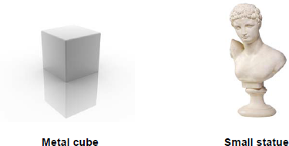
© Whitehoune/iStock/Thinkstock, © Marc Dietrich/Hemera/Thinkstock
Describe the methods that the student should use to calculate the densities of the two objects.
_______________________________________________________________________
_______________________________________________________________________
_______________________________________________________________________
_______________________________________________________________________
_______________________________________________________________________
_______________________________________________________________________
_______________________________________________________________________
_______________________________________________________________________
_______________________________________________________________________
_______________________________________________________________________
(Total 6 marks)

Q9.
A student carried out an investigation to determine the spring constant of a spring.
The table below gives the data obtained by the student.

Force in N | Extension in cm
0 | 0.0
2 | 3.5
4 | 8.0
6 | 12.5
8 | 16.0
10 | 20.0
(a) Describe a method the student could have used to obtain the data given in the table above.
Your answer should include any cause of inaccuracy in the data.
Your answer may include a labelled diagram.
___________________________________________________________________
___________________________________________________________________
___________________________________________________________________
___________________________________________________________________
___________________________________________________________________
___________________________________________________________________
___________________________________________________________________
___________________________________________________________________
___________________________________________________________________
___________________________________________________________________
___________________________________________________________________
___________________________________________________________________

(6)
(b) The student measured the extension for five different forces rather than just measuring the extension for one force.
Suggest why.
___________________________________________________________________
___________________________________________________________________
(1)
The diagram below shows some of the data obtained by the student.
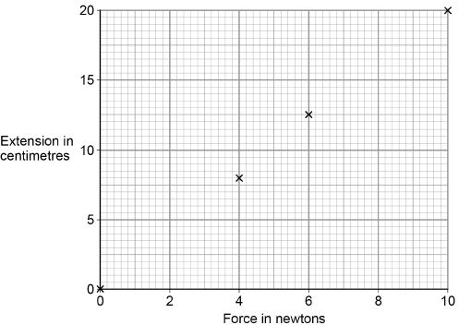
(c) Complete the diagram above by plotting the missing data from the table above.
Draw the line of best fit.
The table above is repeated here to help you answer this question.

Force in N | Extension in cm
0 | 0.0
2 | 3.5
4 | 8.0
6 | 12.5
8 | 16.0
10 | 20.0
(2)
(d) Write down the equation that links extension, force and spring constant.
___________________________________________________________________
(1)
(e) Calculate the spring constant of the spring that the student used.
Give your answer in newtons per metre.
___________________________________________________________________
___________________________________________________________________
___________________________________________________________________
Spring constant = ______________________ N/m
(4)
(f) Hooke’s Law states that:
‘The extension of an elastic object is directly proportional to the force applied, provided the limit of proportionality is not exceeded.’
The student concluded that over the range of force used, the spring obeyed Hooke’s Law.
Explain how the data supports the student’s conclusion.
___________________________________________________________________
___________________________________________________________________
___________________________________________________________________
___________________________________________________________________
(2)
(Total 16 marks)

Mark schemes
Q1.
(a) battery, lamp and ammeter connected in series with variable resistor
1
voltmeter in parallel with (filament) lamp
1
(b) Level 2 (3–4 marks):
A detailed and coherent description of a plan covering all the major steps is provided.
The steps are set out in a logical manner that could be followed by another person to
obtain valid results.
Level 1 (1–2 marks):
Simple statements relating to relevant apparatus or steps are made but they may
not be in a logical order. The plan would not allow another person to obtain valid results.
0 marks:
No relevant content
Indicative content
• ammeter used to measure current
• voltmeter used to measure potential difference
• resistance of variable resistor altered to change current in circuit or change potential difference (across filament lamp)
• resistance (of filament lamp) calculated or R=V / I statement
• resistance calculated for a large enough range of different currents that would allow a valid conclusion about the relationship to be made
4
(c) (as current increases) resistance increases (at an increasing rate)
1
(d) any value between 6.3 and 6.9 (Ω)
1
(e) A: Filament lamp
1
B: Resistor at constant temperature
1
C: Diode
1
[11]
Q2.
(a) Level 3: The design/plan would lead to the production of a valid outcome. All key steps are identified and logically sequenced.
5–6
Level 2: The design/plan would not necessarily lead to a valid outcome. Most steps are identified, but the plan is not fully logically sequenced.
3–4
Level 1: The design/plan would not lead to a valid outcome. Some relevant steps are identified, but links are not made clear.
1–2
No relevant content
0
Indicative content
• Wrap N layers of newspaper around the metal can
• Heated water in a kettle
or
Using a Bunsen burner
• Put hot water in the metal can
• Use a measuring cylinder to measure the volume of water
• Measure initial and final temperature with the digital thermometer
• Use a stopclock / stopwatch to measure a time of 5 minutes
• Calculate temperature decrease
• Repeat with different number of layers of newspaper
• Repeat with no layers of newspaper
• Use same initial temperature of hot water
• Use same volume of water each time
Level 3: Workable method which includes changing the number of layers and includes at least one control variable (same volume of water or same starting temperature)
(b) the digital thermometer and the datalogger have the same resolution
allow both measure to 1 d.p.
ignore accuracy
ignore precision
they give the same result is insufficient
1
only need to measure the start and end temperature
or
only need 2 readings
or
only need to calculate the temperature change
1
[8]
Q3.
(a) apparatus diagram to show:
• aluminium block (surrounded by insulation)
1
• thermometer and immersion heater inside (or in contact with) aluminium
1
• joulemeter connected to immersion heater
or
ammeter and voltmeter connected correctly around immersion heater
full credit can be given for a correct alternative method
ignore position or absence of stopclock
ignore position or absence of electric balance
1
(b)
Level 3: The design/plan would lead to the production of a valid outcome. All key steps are identified and logically sequenced. | 5-6
Level 2: The design/plan would not necessarily lead to a valid outcome. Most steps are identified, but the plan is not fully logically sequenced. | 3-4
Level 1: The design/plan would not lead to a valid outcome. Some relevant steps are identified, but links are not made clear. | 1-2
No relevant content | 0
Indicative content
measurements:
• energy (transferred) using joulemeter or ammeter, voltmeter and stopclock
• mass using electric balance
• temperature change using thermometer
SHC calculation:
E = mcθ
or
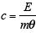
valid results:
• repeat practical and calculate a mean
• plot a graph of temperature against time and use linear section of graph for temperature change
• small (eg 10 °C) temperature change (so cylinder isn’t significantly hotter than surroundings)
safety:
immersion heater gets very hot so avoid touching (heating element) with bare hand
6
(c) some thermal energy
transferred to the surroundings
(not to the metal block)
allow not all of the energy (as measured by the joulemeter) is transferred to the block
1
(so) temperature increase not as high as it should be for the total energy transferred
allow justification using the equation:
1
[11]
Q4.
(a) ammeter and voltmeter symbols correct
1
voltmeter in parallel with wire
1
ammeter in series with wire
1
(b) Level 3: The method would lead to the production of a valid outcome. All key steps are identified and logically sequenced.
5−6
Level 2: The method would not necessarily lead to a valid outcome. Most steps are identified, but the method is not fully logically sequenced.
3−4
Level 1: The method would not lead to a valid outcome. Some relevant steps are identified, but links are not made clear.
1−2
No relevant content
0
Indicative content
• length measured
• length varied
• current measured
• potential difference measured
• repeat readings
• calculate resistance for each length
• 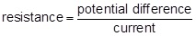
• plot a graph of resistance against length
• hazard: high current
• may cause wire to melt / overheat
• may cause burns (to skin)
• use low currents
(c) the temperature of the wire would not change
1
(d) the accuracy of the student’s results would be higher
1
the resolution of the length measurement would be higher
1
[12]
Q5.
(a) B
1
(b) electrical heating
1
(c) orange
allow a correct answer indicated in the box provided the answer space is blank
1
(d) becomes (more) red
allow changes from mainly orange to mainly red
1
(e) the independent
allow a correct answer indicated in the box provided the answer space is blank
1
(f) pour (hot) water into the (hollow metal) cube
1
point the IR detector at each / a side and take a reading
allow point the IR detector at the cube and take a reading
allow IR detector touching the surface and take a reading
allow take the temperature for take a reading
1
keep the detector the same distance from each surface
1
(g) 0.1°C
1
(h) one bar drawn to 68.0 (°C)
ignore the position of the bars on the x-axis
1
one bar drawn to 28.0 (°C)
1
tallest bar labelled Matt black and shortest bar labelled Shiny silver
1
(i) any one from:
• (matt) black is the best emitter
• shiny silver is the worst emitter
allow matt white and shiny black are (almost) the same at emitting
allow black is a good emitter
allow silver is a poor emitter
allow an answer in terms of highest / lowest temperature
ignore any reference to absorption / reflection
1
[13]
Q6.
(a) metre rule has a lower resolution
allow metre rule has a resolution of 1 mm / 1 cm
fewer decimal places is insufficient
1
so is less accurate (than the micrometer screw gauge)
1
(b) record the value of the zero error when there is no object on the balance
subtract / add the value of the zero error
1
subtract / add the value of the zero error
1
(c)
an answer of 0.0502 (kg) scores 5 marks
V = (18.45 × 10⁻³)³
or
V = 0.01845³
this mark may be awarded if width is incorrectly / not converted
1
V = 6.28 × 10⁻⁶ (m³)
this answer only
1
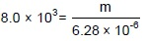
allow
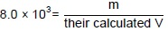
1
m = 8.0 × 10³ × 6.28 × 10⁻⁶
allow m = 8.0 × 10³ × their calculated V
1
m = 0.0502 (kg)
allow an answer consistent with their calculated V
1
[9]
Q7.
Level 3 (5–6 marks):
A detailed and coherent plan covering all the major steps is provided. The steps in the method are logically ordered. The method would lead to the production of valid results.
A source of inaccuracy is provided.
Level 2 (3–4 marks):
The bulk of a method is described with mostly relevant detail. The method may not be in a completely logical sequence and may be missing some detail.
Level 1 (1–2 marks):
Simple statements are made. The response may lack a logical structure and would not lead to the production of valid results.
0 marks:
No relevant content.
Indicative content
place a glass block on a piece of paper
draw around the glass block and then remove from the paper
draw a line at 90° to one side of the block (the normal)
use a protractor to measure and then draw a line at an angle of 20° to the normal
replace the glass block
using a ray box and slit point the ray of light down the drawn line
mark the ray of light emerging from the block
remove the block and draw in the refracted ray
measure the angle of refraction with a protractor
repeat the procedure for a range of values of the angle of incidence
possible source of inaccuracy
the width of the light ray
which makes it difficult to judge where the centre of the ray is
[6]
Q8.
Level 3 (5–6 marks):
Clear and coherent description of both methods including equation needed to calculate density. Steps are logically ordered and could be followed by someone else to obtain valid results.
Level 2 (3–4 marks):
Clear description of one method to measure density or partial description of both methods. Steps may not be logically ordered.
Level 1 (1–2 marks):
Basic description of measurements needed with no indication of how to use them.
0 marks:
No relevant content.
Indicative content
For both:
• measure mass using a balance
• calculate density using ρ = m / V
Metal cube:
• measure length of cube’s sides using a ruler
• calculate volume
Small statue:
• immerse in water
• measure volume / mass of water displaced
• volume of water displaced = volume of small statue
[6]
Q9.
(a) Level 3: The method would lead to the production of a valid outcome. All key steps are identified and logically sequenced.
5−6
Level 2: The method would not necessarily lead to a valid outcome. Most steps are identified, but the method is not fully logically sequenced.
3−4
Level 1: The method would not lead to a valid outcome. Some relevant steps are identified, but links are not made clear.
1−2
No relevant content
0
Indicative content
set up a clamp stand with a clamp
hang the spring from the clamp
use a second clamp and boss to fix a (half) metre ruler alongside the spring
record the metre ruler reading that is level with the bottom of the spring
hang a 2 N weight from the bottom of the spring
record the new position of the bottom of the spring
calculate the extension of the spring
measure the extension of the spring
add further weights to the spring so the force increases 2 N at a time up to 10 N
for each new force record the position of the bottom of the spring and calculate / measure the extension
possible source of inaccuracy
not fixing the ruler in position but simply holding the ruler next to the spring
not clamping the ruler vertical
misjudging the position of the bottom of the spring
parallax error
allow any other sensible suggestion that could reasonably lead to inaccuracy in the data
allow a description that would increase accuracy
repeating the measurements is insufficient
(b) to identify any anomalous results
allow calculate an average for the spring constant
or
to reduce the effect of random error
allow (more) accurate
to obtain an average is insufficient
to be able to draw a graph is insufficient
1
(c) both points plotted correctly
1
correct line of best fit drawn
to pass through (0,0) and (10,20)
1
(d) force = spring constant × extension
allow F = ke
1
(e) extension = 0.2
allow 0.035 / 0.08 / 0.125 / 0.16
1
10 = k × 0.2
force value must match extension
this mark may be awarded if e is in cm
1
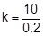
allow correct transformation of their chosen values
this mark may be awarded if e is in cm
1
k = 50
an answer 0.5 scores 3 marks
1
an answer of 50 scores 4 marks
(f) the line is straight
allow the line does not curve
1
and passes through the origin
this mark is dependent on scoring the first mark
allow a correct description of direct proportionality for 2 marks
ignore the line shows they are directly proportional
1
[16]

