Module 5.2 Circular motion

|  |  |  |  |  |
| --- | --- | --- | --- | --- |
| **Topic area** | **Text book pre-reading** | **Syllabus ref** | **Max possible score in exam questions** | **Your score in exam questions** |
| Angular velocity and the radian | p38-40 | 5.2.1 | 8 |  |
| Centripetal acceleration | p 41-42 | 5.2.2 | 3 |  |
| Centripetal forces | p 42 | 5.2.2 | 9 |  |
| Investigating centripetal forces | p 43-44 | 5.2.2 | 10 |  |
| **Total** | | | 30 |  |

**By the end of this topic you should be able to….**

* Define what is meant by a radian and be able to complete calculations using these
* Describe period and frequency for objects in circular motion
* Describe and calculate angular velocity
* Describe why objects travel in circular motion
* Calculate the speed of objects in circular motion and describe the factors that affect this
* Describe and calculate centripetal acceleration
* Describe and calculate centripetal force
* Describe an experiment to investigate circular motion of a whirling bung

**By the end of module 5.1 you need to be able to define the following key terms:**

Radian

Angular velocity

Frequency

Period

Centripetal force

Centripetal acceleration

**Equations given in exam**

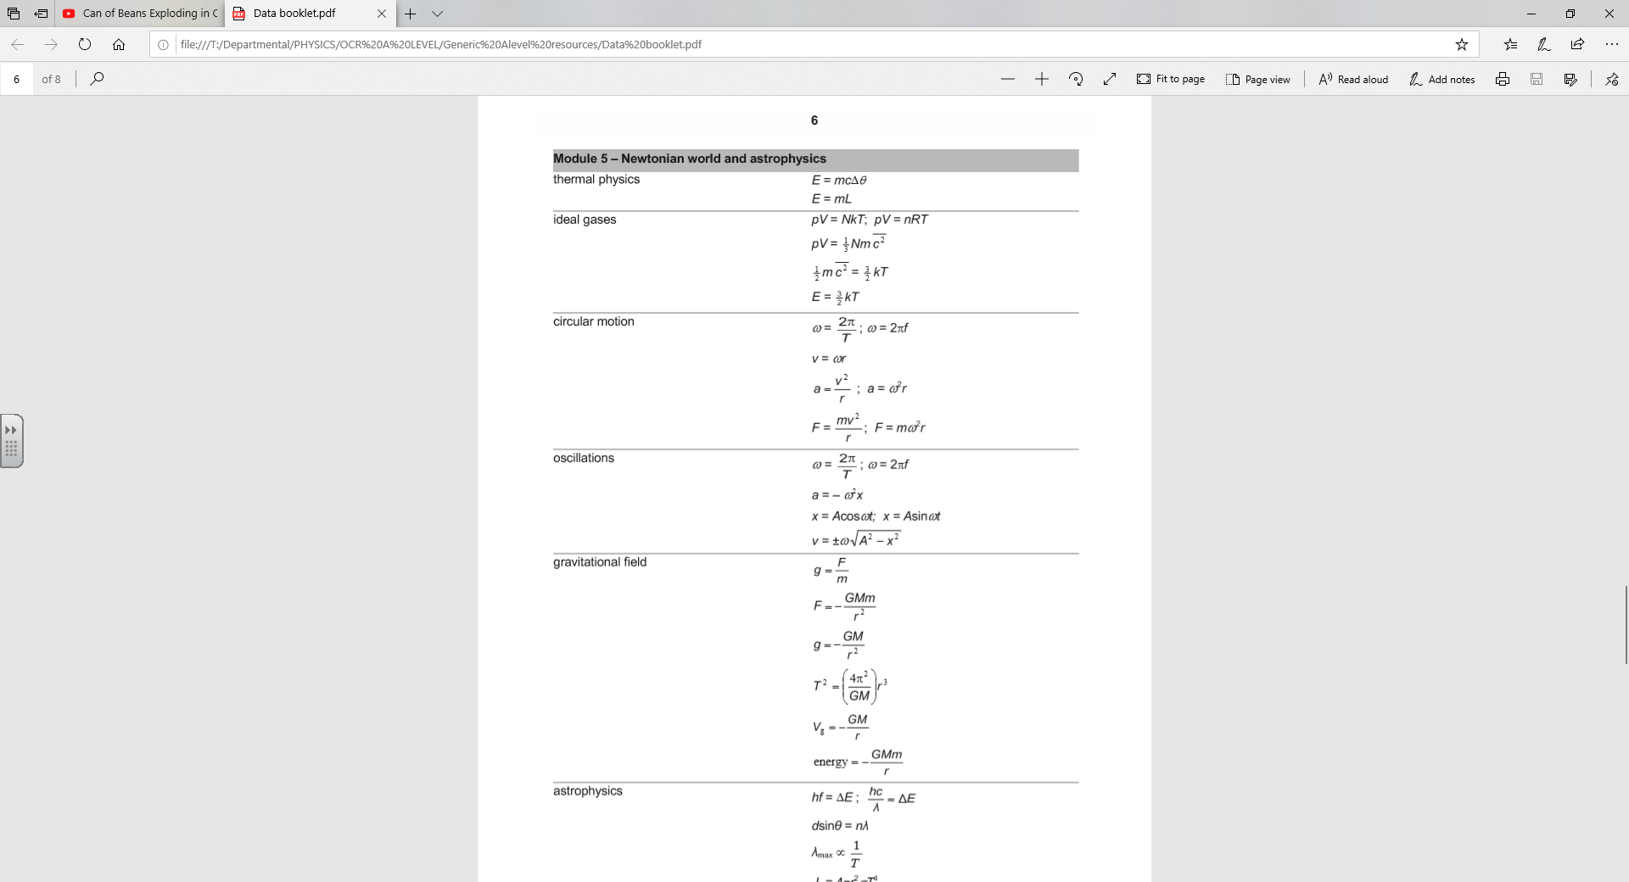

**Angular velocity and radians**

1. Define a radian and draw a diagram to represent one radian. (2)

2. A car windscreen-wiper moves backwards and forwards through an angle of 2.0 radians. Assume the wiper blade changes direction instantly at the end of its motion.  
a) What is the angle in degrees (1)

b) It takes 1.0s to move from one end of its motion to the other. Plot a graph of its angular displacement in radians starting from the rest position against time for a period of 4.0s. (2)

c) Plot a graph of its angular velocity against time for the same period. (2)

d) Explain how these two graphs are related. (1)

**Centripetal acceleration**

1) The figure below shows the London Eye. It has 32 capsules equally spaced around the edge of a large vertical wheel of radius 60 m. The wheel rotates about a horizontal axis such that each capsule has a constant speed of 0.26 m s–1.

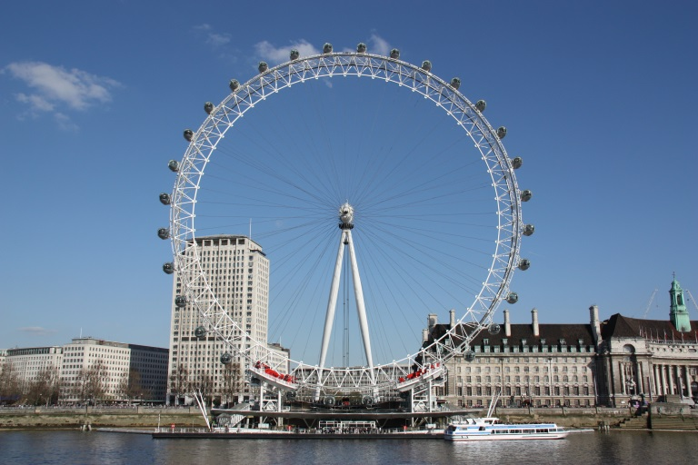

(i) Calculate the time taken for the wheel to make one complete rotation.

time = ...................................................... s

[2]

(ii) Calculate the acceleration of a person travelling on a capsule.

Acceleration = ...................................................... ms-2

[1]

**Centripetal Force**

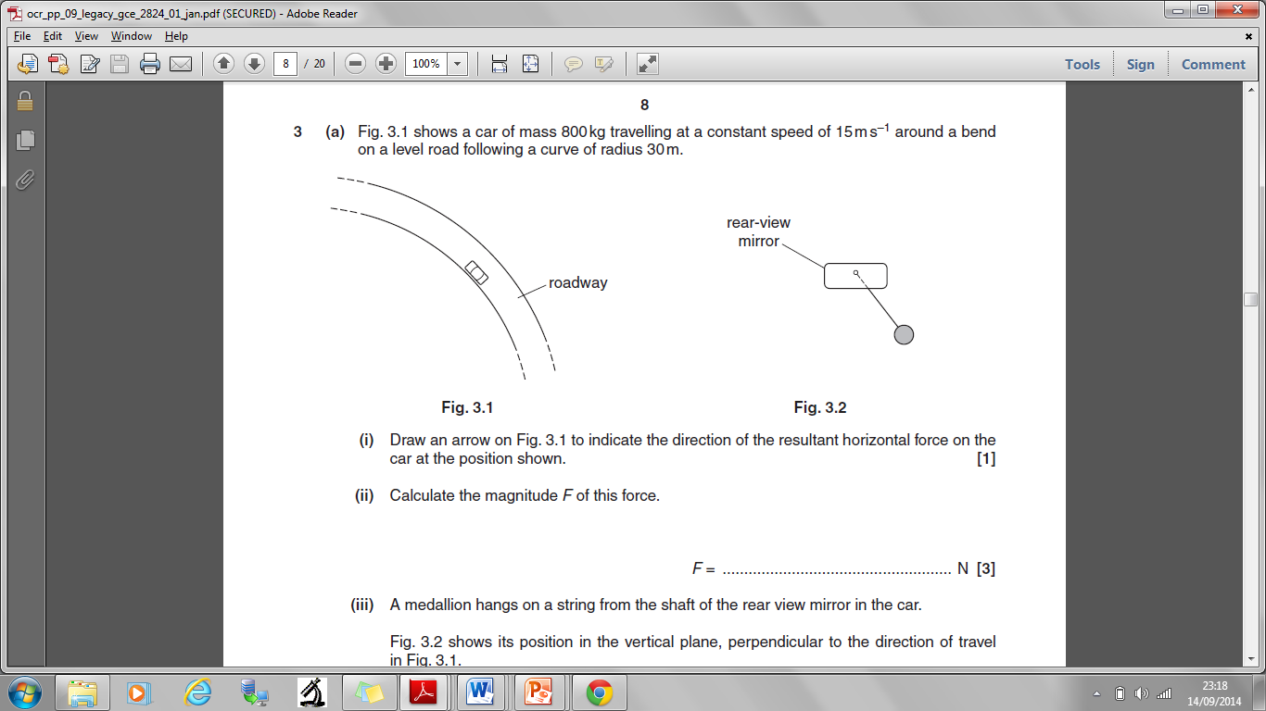

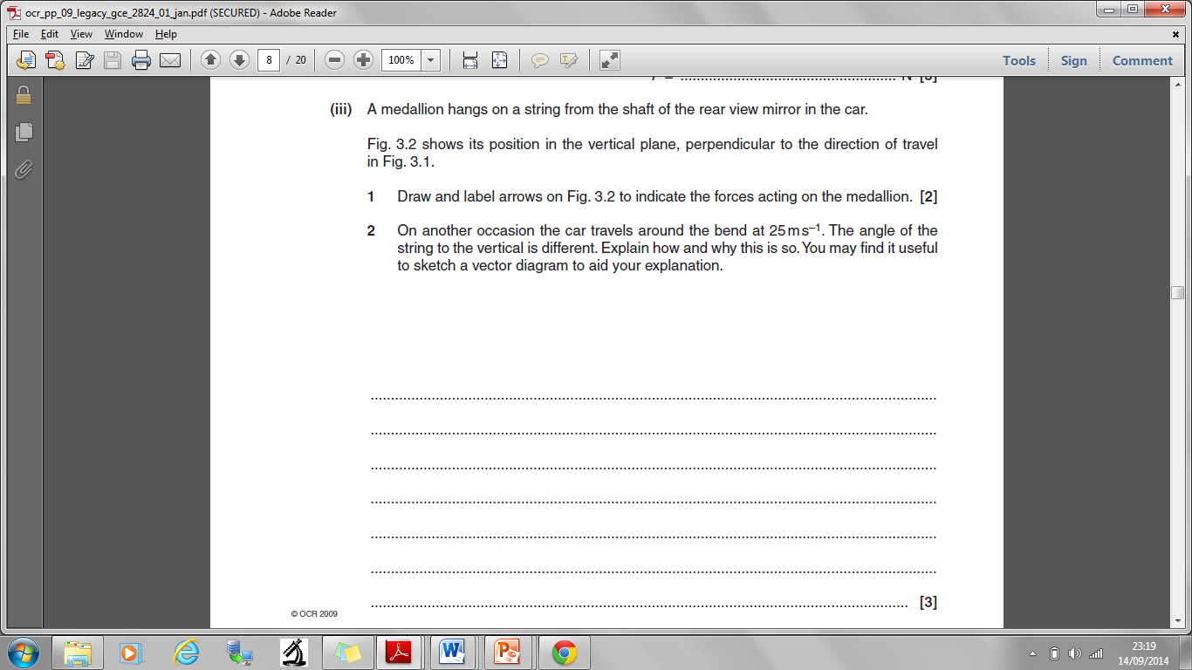

**Investigating circular Motion**

