  Particles practise questions and answers
  Name: | ________________________
  Class: | ________________________
  Date: | ________________________

Time: | 50 minutes
Marks: | 50 marks
Your score:

What went well:

How to improve:

Q1.
The specific heat capacity of aluminium can be determined by experiment.
(a) Draw a labelled diagram showing how the apparatus used to determine the specific heat capacity of aluminium should be arranged.
(3)
(b) Describe how you could use the apparatus you drew in part (a) to determine the specific heat capacity of aluminium.
(6)
(c) Methods used to determine the specific heat capacity of aluminium may give a value greater than the actual value.
Explain why.
___________________________________________________________________
___________________________________________________________________
___________________________________________________________________
___________________________________________________________________
___________________________________________________________________
___________________________________________________________________
___________________________________________________________________
___________________________________________________________________
(2)
(Total 11 marks)
Q2.
The diagram shows three cups A, B and C.
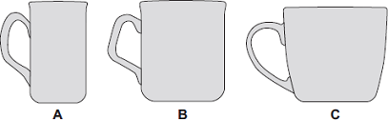

Energy is transferred from hot water in the cups to the surroundings.
(a) Some students investigated how the rate of cooling of water in a cup depends on the surface area of the water in contact with the air.
They used cups A, B and C. They poured the same volume of hot water into each cup and recorded the temperature of the water at regular time intervals.
The results are shown on the graph.
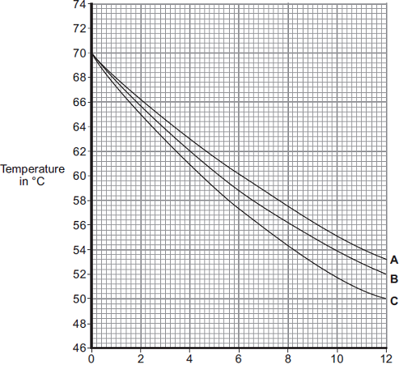
Time in minutes
(i) What was the starting temperature of the water for each cup?
Starting temperature = ____________________ °C
(1)
(ii) Calculate the temperature fall of the water in cup B in the first 9 minutes.
______________________________________________________________
Temperature fall = ____________________ °C
(2)
(iii) Which cup, A, B or C, has the greatest rate of cooling? 
Using the graph, give a reason for your answer.
______________________________________________________________
______________________________________________________________
(2)
(iv) The investigation was repeated using the bowl shown in the diagram.
The same starting temperature and volume of water were used.
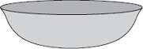

Draw on the graph in part (b) another line to show the expected result.
(1)
(v) After 4 hours, the temperature of the water in each of the cups and the bowl was 20°C.
Suggest why the temperature does not fall below 20°C.
______________________________________________________________
(1)
(b) (i) The mass of water in each cup is 200 g.
Calculate the energy, in joules, transferred from the water in a cup when the temperature of the water falls by 8°C.
Specific heat capacity of water = 4200 J / kg°C.
______________________________________________________________
______________________________________________________________
______________________________________________________________
Energy transferred = ____________________ J
(3)
(ii) Explain, in terms of particles, how evaporation causes the cooling of water.
______________________________________________________________
______________________________________________________________
______________________________________________________________
______________________________________________________________
______________________________________________________________
______________________________________________________________
______________________________________________________________
______________________________________________________________
(4)
(Total 14 marks)
Q3.
A student wanted to determine the density of a small piece of rock.
(a) Describe how the student could measure the volume of the piece of rock.
___________________________________________________________________
___________________________________________________________________
___________________________________________________________________
___________________________________________________________________
___________________________________________________________________
___________________________________________________________________
___________________________________________________________________
___________________________________________________________________
___________________________________________________________________
___________________________________________________________________
(4)
(b) The volume of the piece of rock was 18.0 cm³.
The student measured the mass of the piece of rock as 48.6 g.
Calculate the density of the rock in g/cm³.
Use the equation:
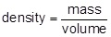
___________________________________________________________________
___________________________________________________________________
___________________________________________________________________
___________________________________________________________________
Density = _______________________ g/cm³
(2)

The graph below shows the densities of different types of rock.
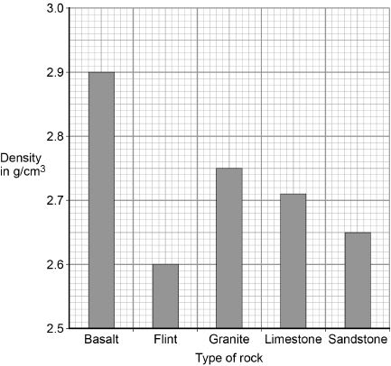
(c) What is the most likely type of rock that the student had?
Tick one box.

Basalt | 
Flint
Granite
Limestone
Sandstone
(1)
(d) Give one source of error that may have occurred when the student measured the volume of the rock.
___________________________________________________________________
___________________________________________________________________
(1)

(e) How would the error you described in part (d) affect the measured volume of the rock?
___________________________________________________________________
___________________________________________________________________
(1)
(Total 9 marks)
Q4.
The figure below shows a balloon filled with helium gas.
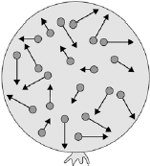
(a) Describe the movement of the particles of helium gas inside the balloon.
___________________________________________________________________
___________________________________________________________________
___________________________________________________________________
___________________________________________________________________
(2)
(b) What name is given to the total kinetic energy and potential energy of all the particles of helium gas in the balloon?

Tick one box.
External energy | 
Internal energy
Movement energy
(1)
(c) Write down the equation which links density, mass and volume.
___________________________________________________________________
(1)
(d) The helium in the balloon has a mass of 0.00254 kg.
The balloon has a volume of 0.0141 m³.
Calculate the density of helium. Choose the correct unit from the box.

m³ / kg kg / m³ kg m³
___________________________________________________________________
___________________________________________________________________
___________________________________________________________________
___________________________________________________________________
Density = __________________ Unit _________
(3)
(Total 7 marks)
Q5.
(a) The diagrams, X, Y and Z, show how the particles are arranged in the three states of matter.
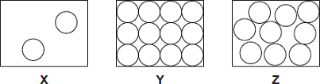
(i) Which one of the diagrams, X, Y or Z, shows the arrangement of particles in a liquid?
Write the correct answer in the box. 
(1)
(ii) Which one of the diagrams, X, Y or Z, shows the arrangement of particles in a gas?
Write the correct answer in the box.
(1)

(b) Draw a ring around the correct answer in each box to complete each sentence.

 |  | vibrating in fixed positions.
(i) | In a gas, the particles are | moving randomly.
 |  | not moving.
(1)

 |  | stronger than
(ii) | In a solid, the forces between the particles are | equal to | the
 |  | weaker than
forces between the particles in a liquid.
(1)
(c) The picture shows a puddle of water in a road, after a rain shower.
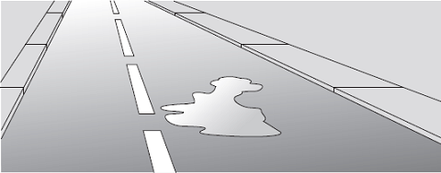
(i) During the day, the puddle of water dries up and disappears. This happens because the water particles move from the puddle into the air.
What process causes water particles to move from the puddle into the air?
Draw a ring around the correct answer.

condensation | evaporation | radiation
(1)
(ii) Describe one change in the weather which would cause the puddle of water to dry up faster.
______________________________________________________________
______________________________________________________________
(1)
(Total 6 marks)

Q6.
The electric kettle shown below is used to boil water.
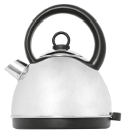
©leeser87/iStock
(a) After the water has boiled, the temperature of the water decreases by 22 °C.
The mass of water in the kettle is 0.50 kg.
The specific heat capacity of water is 4200 J/kg °C.
Calculate the energy transferred to the surroundings from the water.
___________________________________________________________________
___________________________________________________________________
___________________________________________________________________
Energy = ____________ joules
(2)
(b) Why is the total energy input to the kettle higher than the energy used to heat the water?
Tick (✔) one box.

Tick (✔)
Energy is absorbed from the surroundings.
Energy is used to heat the kettle.
The kettle is more than 100% efficient.
(1)
(Total 3 marks)
Mark schemes
Q1.
(a) apparatus diagram to show:
• aluminium block (surrounded by insulation)
1
• thermometer and immersion heater inside (or in contact with) aluminium
1
• joulemeter connected to immersion heater
or
ammeter and voltmeter connected correctly around immersion heater
full credit can be given for a correct alternative method
ignore position or absence of stopclock
ignore position or absence of electric balance
1
(b)
Level 3: The design/plan would lead to the production of a valid outcome. All key steps are identified and logically sequenced. | 5-6
Level 2: The design/plan would not necessarily lead to a valid outcome. Most steps are identified, but the plan is not fully logically sequenced. | 3-4
Level 1: The design/plan would not lead to a valid outcome. Some relevant steps are identified, but links are not made clear. | 1-2
No relevant content | 0
Indicative content
measurements:
• energy (transferred) using joulemeter or ammeter, voltmeter and stopclock
• mass using electric balance
• temperature change using thermometer
SHC calculation:
E = mcθ
or
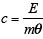
valid results:
• repeat practical and calculate a mean
• plot a graph of temperature against time and use linear section of graph for temperature change
• small (eg 10 °C) temperature change (so cylinder isn’t significantly hotter than surroundings)
safety:
immersion heater gets very hot so avoid touching (heating element) with bare hand
6
(c) some thermal energy
transferred to the surroundings
(not to the metal block)
allow not all of the energy (as measured by the joulemeter) is transferred to the block
1
(so) temperature increase not as high as it should be for the total energy transferred
allow justification using the equation:
1
[11]
Q2.
(a) (i) 70
accept ± half a square
(69.8 to 70.2)
1
(ii) 15
accept 14.6 to 15.4 for 2 marks
allow for 1 mark 70 − 55
ecf from (b)(i) ± half a square
2
(iii) C
1
biggest drop in temperature during a given time
accept it has the steepest gradient this is a dependent
1
(iv) starting at 70 °C and below graph for C
must be a curve up to at least 8 minutes
1
(v) because 20 °C is room temperature
accept same temperature as surroundings
1
(b) (i) 6720
correct answer with or without working gains 3 marks
6 720 000 gains 2 marks
correct substitution of E = 0.2 × 4200 × 8 gains 2 marks
correct substitution of E = 200 × 4200 × 8 gains 1 mark
3
(ii) the fastest particles have enough energy
accept molecules for particles
1
to escape from the surface of the water
1
therefore the mean energy of the remaining particles decreases
accept speed for energy
1
the lower the mean energy of particles the lower the temperature (of the water)
accept speed for energy
1
[14]
Q3.
(a) Level 2: The method would lead to the production of a valid outcome. Key steps are identified and logically sequenced.
3−4
Level 1: The method would not necessarily lead to a valid outcome. Some relevant steps are identified, but links are not made clear.
1−2
No relevant content
0
Indicative content
• part fill a measuring cylinder with water
• measure initial volume
• place object in water
• measure final volume
• volume of object = final volume − initial volume
• fill a displacement / eureka can with water
• water level with spout
• place object in water
• collect displaced water
• measuring cylinder used to determine volume of displaced water
(b) 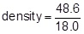
1
density = 2.70 (g/cm³)
1
an answer of 2.70 (g/cm³) scores 2 marks
(c) limestone
1
(d) eye position when using measuring cylinder
or
water level in can (at start) not at level of spout
or
not all water displaced by stone is collected in container
1
(e) volume would be lower / higher
1
[9]
Q4.
(a) range of speeds
1
moving in different directions
accept random motion
1
(b) internal energy
1
(c) density = mass / volume
1
(d) 0.00254 / 0.0141
1
0.18
1
accept 0.18 with no working shown for the 2 calculation marks
kg / m³
1
[7]
Q5.
(a) (i) Z
1
(ii) X
1
(b) (i) moving randomly
1
(ii) stronger than
1
(c) (i) evaporation
1
(ii) any one from:
• becomes windy
• temperature increases
accept (becomes) sunny
“the sun” alone is insufficient
• less humid
1
[6]
Q6.
(a) 46 200
accept 46 000
allow 1 mark for correct substitution
ie 0.5 × 4200 × 22 provided no subsequent step
2
(b) Energy is used to heat the kettle.
1
[3]

